Page 1: Cover Page
Life Skills GO

Empowering students, championing teachers. A whole school approach to wellbeing.
With Life Skills GO, you can measure and improve whole school and student wellbeing in real-time, ensuring every student is supported to thrive both academically and emotionally.

Page 2: Introduction
At Life Skills GO, our mission is simple: to empower student voice through technology, helping schools drive better outcomes by providing evidence-based wellbeing data—from the students, for the students.
Our Vision:
Every child is seen, heard, and supported to thrive in life.
Life Skills GO brings together a team of experts—teachers, wellbeing professionals, curriculum advisors, psychologists, engineers, neuroscientists, and researchers—working hand in hand with the education community to build a platform that supports whole-school wellbeing for every teacher and student.
Life Skills GO is an innovative wellbeing platform built for the K-12 sector, providing real-time and crucial wellbeing data, metrics, insights, and reports along with evidence-based, trauma-informed, and curriculum-aligned resources to schools. This enables educators to make informed, data-driven decisions regarding whole school and student wellbeing, ensuring that every student is empowered, and every teacher is equipped to support them.
Uniquely, it also allows schools to measure the effectiveness of their wellbeing programs, offering a groundbreaking tool for continuous improvement and supporting school leaders to make informed resourcing decisions about their wellbeing initiatives.
With a wealth of actionable data at their disposal, schools and educators can better detect patterns and deploy precise interventions. This capability also lays the groundwork for proactive and preventative strategies in educational environments. 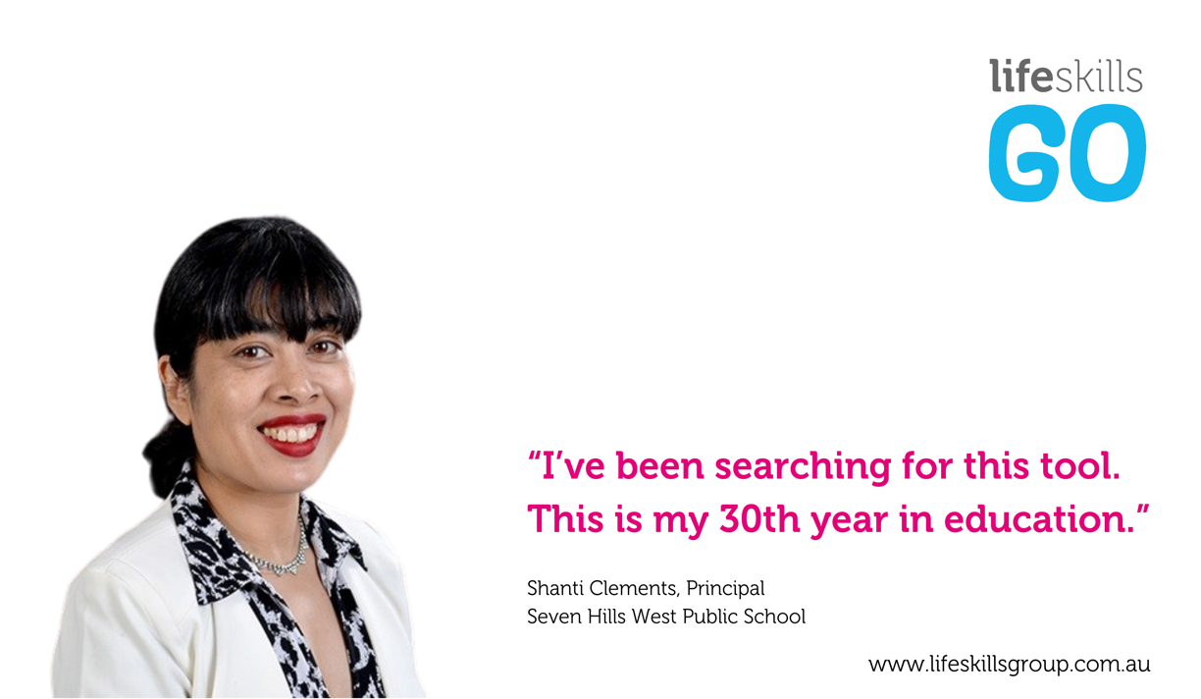

Page 3: The Challenge of Student Wellbeing
In today’s educational landscape, student wellbeing is increasingly recognised as a critical factor in academic success. However, traditional methods of assessing wellbeing often rely on infrequent and anonymous surveys or anecdotal observations. These approaches provide a limited, static snapshot, hindering schools from making timely interventions or planning strategically.
Yet, schools are often left in the dark.
Traditional wellbeing assessments, such as attendance records, behavioural incidents, and teacher observations have a place however, they fail to capture students' real-time experiences and often exclude student voice. Anonymous surveys, conducted infrequently, provide only a snapshot rather than ongoing insights, making it difficult to identify immediate concerns. Without a structured way for students to regularly express how they feel and develop the skills needed to self-regulate, their voices go unheard, and opportunities for early or proactive intervention are missed.
Bridging the Gaps in Whole School Wellbeing
Schools are incredibly busy places, and while student wellbeing is a priority, educators often don’t have the time or tools to track, analyse, and act on wellbeing data in real-time.
Lack of Real-Time Whole School Wellbeing Data and Student Voice – Students often lack a safe, consistent, and structured opportunity to share their feelings, resulting in unmet wellbeing needs and missed opportunities for early intervention.
No Integrated Wellbeing Data – Schools rely on fragmented data points and do not have a dedicated data analyst, making it challenging to identify patterns and take proactive, data-driven actions to support student wellbeing.
Missed Opportunities for Early Intervention – Without timely, actionable insights into student wellbeing, schools often remain reactive rather than proactive, which research shows can lead to escalating behavioural issues and a loss of valuable learning time.

Page 4:
Real-Time Data Visualisation
Key Benefits of Real-Time Wellbeing Data, Automated Reports and Insights
- Strategic Planning: Identify trends, patterns, and areas of need in real-time, allowing schools to make informed decisions.
- Resource Allocation: Proactively deploy resources where they are most needed based on data insights.
- Impact Measurement: Measure the effectiveness of your wellbeing programs with confidence by drawing upon relevant and reliable evidence coming directly from your students.
Immediate Insights and Interventions
Life Skills GO updates student wellbeing data in real-time, enabling educators to swiftly identify at-risk students and implement timely interventions, reducing identification-to-support time significantly.
Wellbeing Baseline Data
Life Skills GO enables schools to establish a wellbeing baseline and assess programs effectiveness, enabling data-driven adjustments to enhance student and school outcomes effectively.
Empowerment Through Student Voice
Life Skills GO prioritises student voice as a primary date source in measuring wellbeing, fostering a sense of belonging by understanding students' real-time experiences and needs, enhancing wellbeing and community connection in schools.
Integration with School Systems
Life Skills GO integrates seamlessly with School Information and Administration Systems like Sentral and School Bytes, simplifying data management and reducing staff workload by consolidating key metrics and insights automatically into one platform enabling triangulation between attendance, behaviour and emotions.
Comprehensive Skill Development
Life Skills GO emphasises on developing emotional literacy, self-regulation and self-awareness, and to reduce classroom disruptions, boost academic performance, and foster lifelong personal and professional success in students.
Automated Wellbeing Data Analysis
Life Skills GO automates wellbeing data analysis, offering schools easy-to-understand dashboards, real-time insights, and automated reports. This automation saves time, improves decision-making, and empowers schools to take proactive measures based on accurate, actionable data.
Proactive Rather Than Reactive
Life Skills GO's real-time data supports proactive school and student wellbeing, enabling early issue anticipation and effective intervention, thereby enhancing student outcomes and school environments significantly.
"It's just easy compared to any other platform" - Ilona Watkins, Principal, Noorat Primary School

Page 5: Evidence-based, trauma informed & curriculum-aligned content
Life Skills GO is built on research demonstrating that when students' wellbeing is prioritised, they can thrive in school and life—demonstrating increased engagement, fewer absences, and enhanced emotional literacy, awareness, and self-regulation skills.
The increasing recognition of student wellbeing as a critical factor in academic success necessitates a shift towards data-driven approaches for its effective management and improvement (Dodge et al., 2012). The evolution of Life Skills GO argues for the implementation of real-time visualisation of student wellbeing data through dashboards, insights and reports. Ultimately empowering educators to proactively address student needs and promote a positive learning environment that fosters students to be ready to learn and emotionally resilient.
Firstly, real-time data visualisation enables strategic planning. Aggregated data on wellbeing indicators, such as state of emotion, attendance, and behaviour, can reveal trends and patterns within the student population. School leaders can use this information to identify areas of strength and weakness, informing the development of targeted wellbeing initiatives (Christenson et al., 2012). Without real-time data, such responsive planning is significantly hampered, relying instead on lagging indicators and reactive measures. Furthermore, visualised data can be disaggregated by demographics, year level, or other relevant factors. This allows for a more nuanced understanding of needs within specific groups within the school such as class, year or individual students which in turn enables educators to facilitate more tailored interventions.
Secondly, real-time dashboards facilitate resource allocation. By identifying specific areas or student groups experiencing heightened wellbeing challenges, schools can strategically allocate resources, such as counselling services, support staff, or targeted programs. This data-driven approach replaces reactive resource allocation with a proactive, needs-based model.
Thirdly, real-time data enables measuring the impact of wellbeing programs. When schools implement wellbeing initiatives, it is crucial to assess their effectiveness. Real-time data dashboards provide a mechanism for tracking the impact of these programs on relevant wellbeing indicators. This feedback loop is crucial for continuous improvement and ensures that wellbeing initiatives are evidence-based and impactful (Weare & Nind, 2011).
Finally, and perhaps most importantly, real-time wellbeing data acts as a lead indicator for proactive interventions. Traditional wellbeing assessments often provide lagging indicators, revealing problems after they have already escalated. Real-time data, however, can identify emerging trends and potential issues before they significantly impact student wellbeing or academic performance. Recent research has further highlighted the importance of proactive, data-driven approaches to student wellbeing, emphasising the need for schools to move beyond reactive measures and embrace preventative strategies (Markham & Aveyard, 2023).
Incorporating a tool like Life Skills GO in schools has the opportunity to promote a range of positive outcomes, including improved academic engagement, greater emotional regulation, and stronger social relationships. The Life Skills GO platform supports these outcomes by providing teachers with actionable, real-time data, which can be used to differentiate learning, promote wellbeing, and monitor the impact of specific wellbeing interventions. By integrating these strategies into everyday school practice, Life Skills GO contributes to creating a more inclusive and supportive whole school environment.
References
Christenson, S. L., Reschly, A. L., & Wylie, C. (Eds.). (2012). Handbook of research on student engagement. Springer.
Darling-Hammond, L., Flook, L., Cook-Harvey, C., Barron, B., & Osher, D. (2017). Implications for educational practice of the science of learning and development. Applied Developmental Science, 21(3), 97-140.
Dodge, K. A., Dishion, T. J., & Lansford, J. E. (Eds.). (2012). Handbook of social development. Guilford Press.
Greenberg, M. T., Weissberg, R. P., O'Brien, M. U., Zins, J. E., Fredericks, L., Resnik, H., & Elias, M. J. (2003). Enhancing school-based prevention and positive development: Issues and challenges. American Psychologist, 58(4), 294–302.
Hamilton, L., Halverson, R., Jackson, S., Mandinach, E., Supovitz, J., & Wayman, J. (2009). Using data to improve schools: What works. Corwin Press.
Markham, U., & Aveyard, P. (2023). A rapid evidence assessment of school-based interventions to improve mental wellbeing in secondary school students. Child and Adolescent Mental Health, 28(4), 488-502.
Weare, K., & Nind, M. (2011). Mental health promotion and problem prevention in schools: What does the evidence say? Health Promotion International, 26(suppl_1), i29–i67.

Page 6: Embed a data-driven whole school process for supporting student wellbeing
By implementing daily check-ins, schools gain a real-time insight on student wellbeing in the form of easy-to-use dashboards, insights and reports. This proactive approach ensures that no student falls through the cracks, enabling educators to see trends in metrics and at the click of a button, analyse data, and act fast—before small concerns turn into bigger issues.
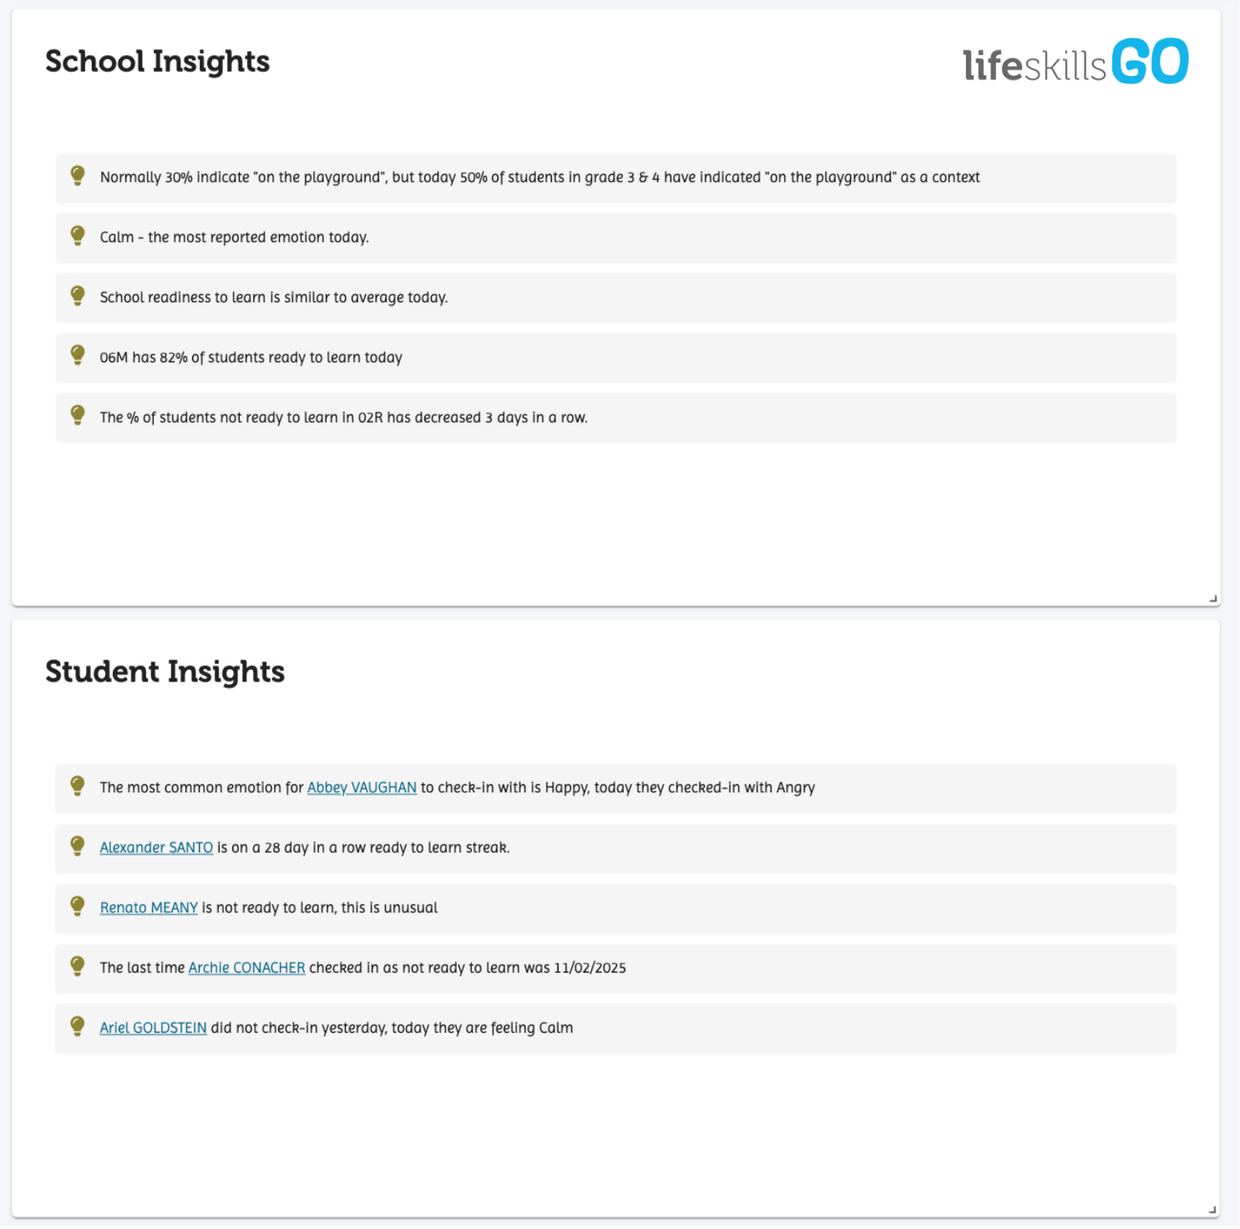
Transforming Wellbeing Data into Actionable Support
Life Skills GO provides schools with an automated, real-time wellbeing tracking system, allowing educators to instantly access trends, elevate student voice, and make data-driven decisions—without adding to their already heavy workload.
Empowering Student Voice
Provides students with a safe, structured way to express how they’re really feeling, fostering trust and inclusion.
Instant, Actionable Insights
Teachers and school leaders receive real-time data to inform decisions and interventions.
Building Emotional Literacy & Self-Regulation Skills
Helps students develop the skills to recognise, express, and manage their emotions and reactions, improving engagement, behaviour, and resilience.
Integrated Wellbeing Data
Allows schools to have check-in results with attendance and behaviour data, offering a comprehensive view of whole school and student wellbeing.
Stronger School Communities
Creates a culture where students feel seen, heard, and supported—leading to better relationships, learning outcomes, and overall wellbeing.
"The conventional methods of assessing wellbeing through sporadic surveys, attendance, and behavioural data failed to propel us towards proactive measures; instead, we found ourselves in a cycle of reactive responses. Now that has all changed" St John the Apostle Catholic School Stefanie Thom - Assistant Principal | Principal

Page 7
For School Executives
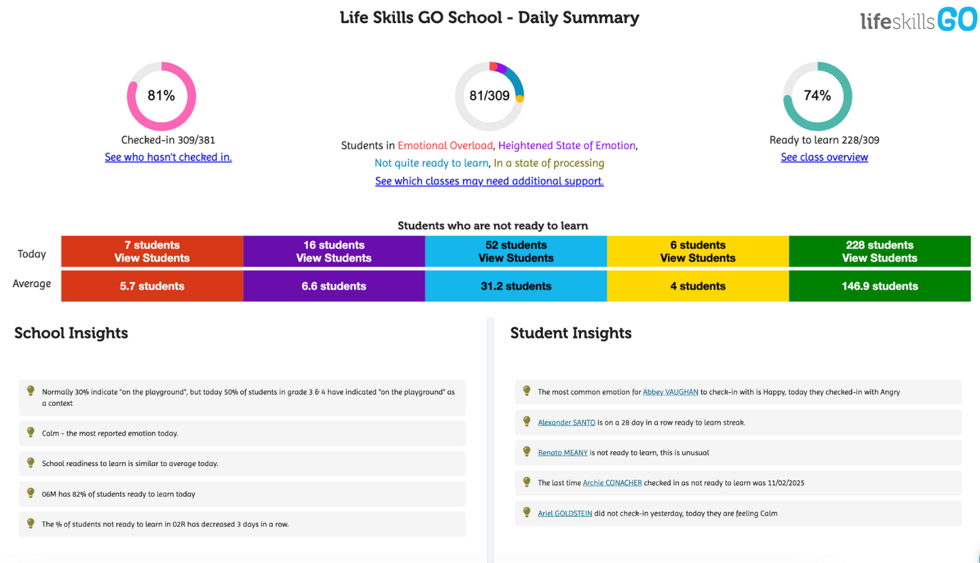
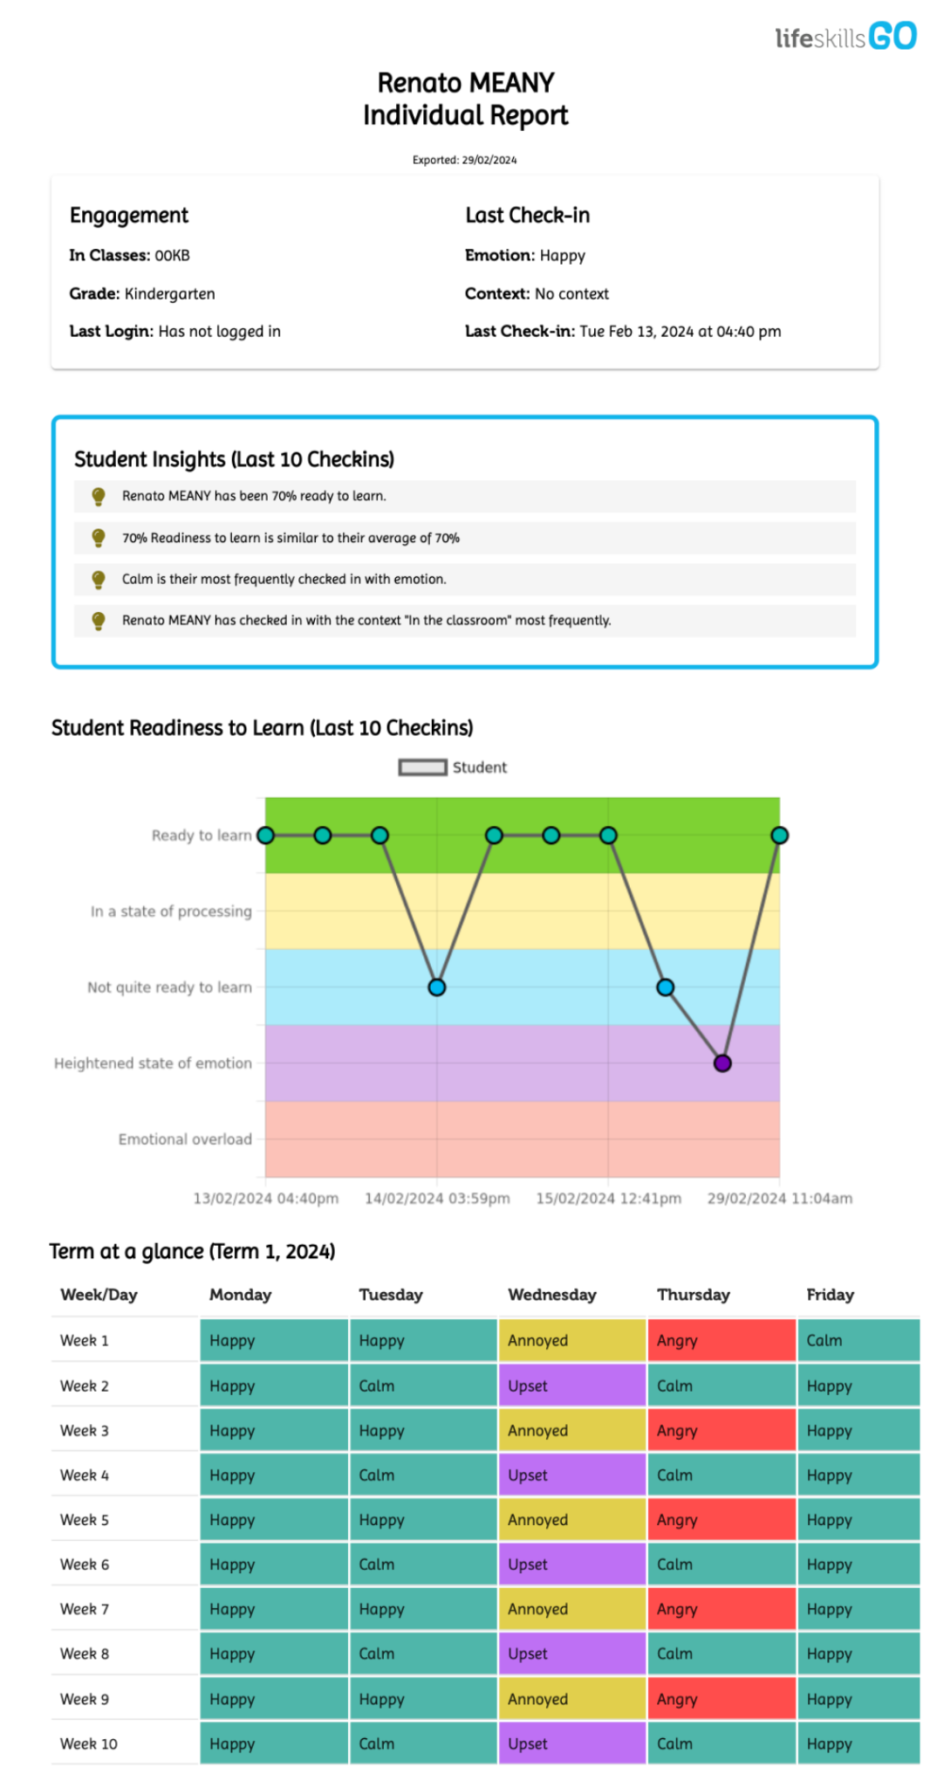

Executive access provides access to dashboards, reports, class usage data and individual learner profiles.
Schools can customise executive access for anyone attached to the school with an account.
Dashboards
Real-time displays of student emotions and context such as online, playground and in the classroom, and monitoring of student readiness to learn to identify the students and parts of the school that need wellbeing support.
Dashboards are dynamic and customisable allowing educators to easily access the right information at the right time so everyone can make informed decisions and actions to support students based on their real needs.
Automated Reporting
Periodic reports (weekly, fortnightly, 5 weekly, termly, semesterly and annually) are generated at class, stage, school and individual students level. These reports analyse the patterns and trends of student emotion check-ins and surface insights for educators so you have the data at your fingertips.
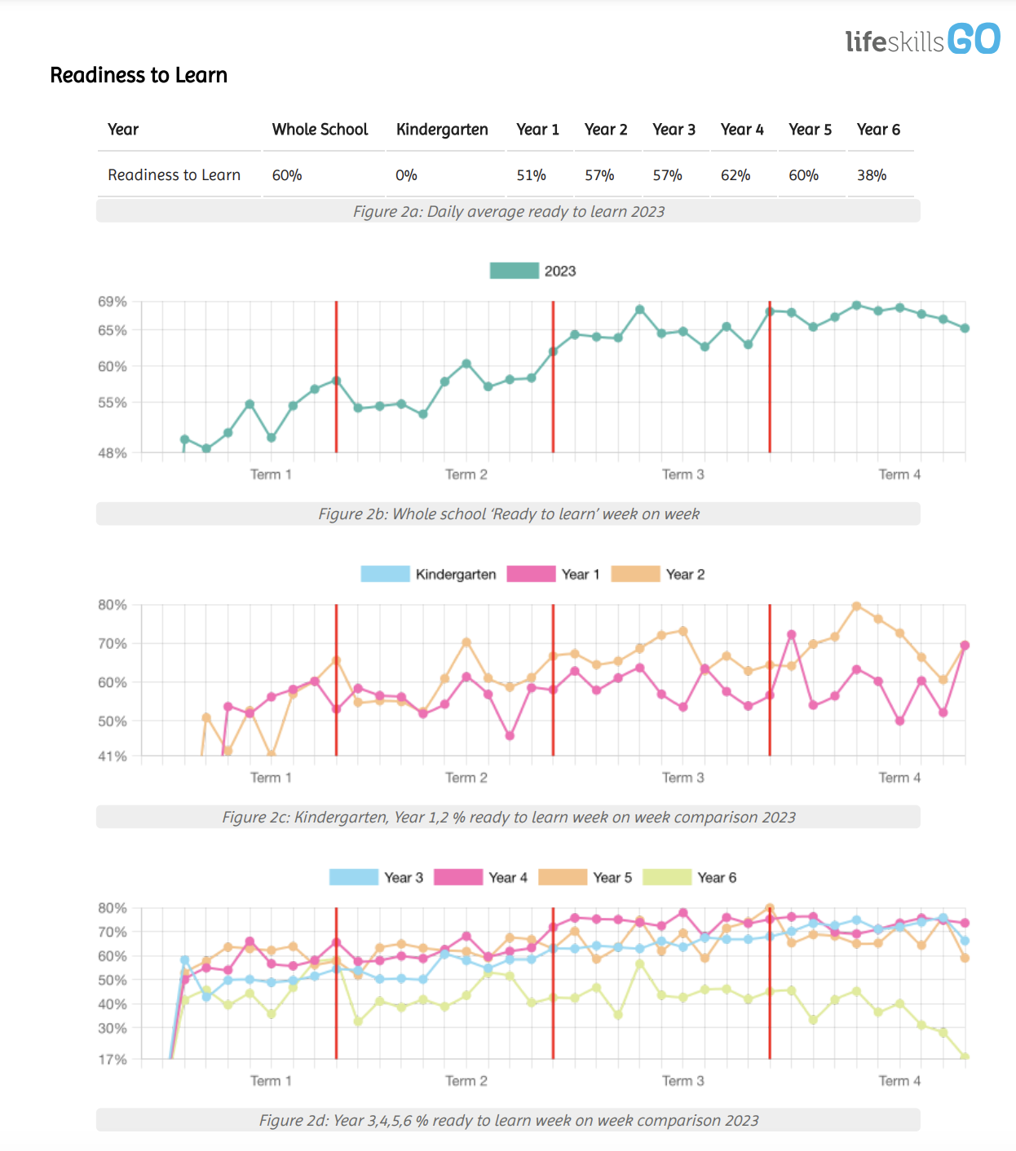

These reports can be easily embedded in executive, learning support and stage meetings, ensuring that there is a whole school approach to data-informed wellbeing programs.
Individual learner profiles can be embedded in school reporting processes and parent/carer-teacher interviews for further insight about student wellbeing.

Strengthened Learning Support Processes
Life Skills GO uniquely provides relevant and reliable data about student emotional wellbeing and readiness to learn. This data can be highly informative for monitoring the effectiveness of individualised strategies, recognising patterns and trends in emotion and behaviour and as evidence in applications for funding and access requests.
The nature of the data also allows student voice to be empowered in dialogue with parents and carers.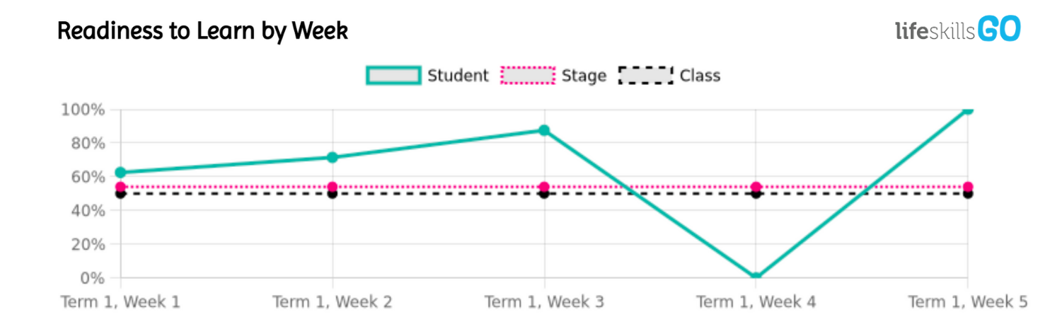
Annual Reporting, Strategic Planning & Continuous Improvement
As part of your executive reports, you have access to an annual report that provides analysis of trends in your whole school population. This provides insights in relation to student readiness to learn, emotion check-ins, including a dissection of context (online, playground, classroom, home).
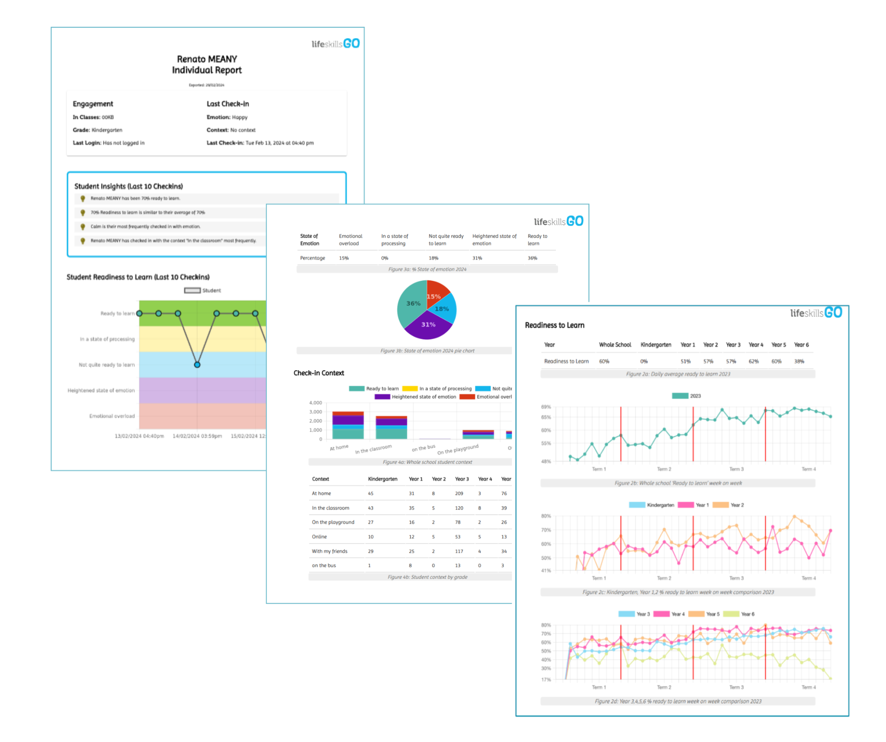
The reports can be customised by date range so you can use the data to evidence the impact of wellbeing programs when you reflect against your school plan or as evidence for any validation or self reflection process that you undertake.
For those using Sentral or School Bytes, these reports can be integrated to triangulate data points such as behaviour, attendance, readiness to learn and academic achievement.

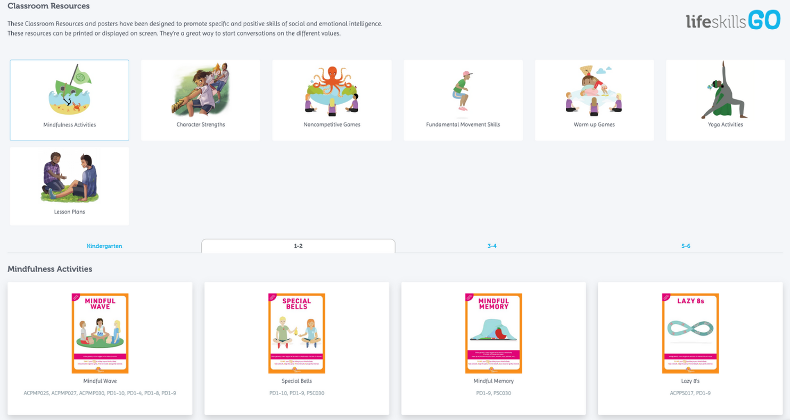
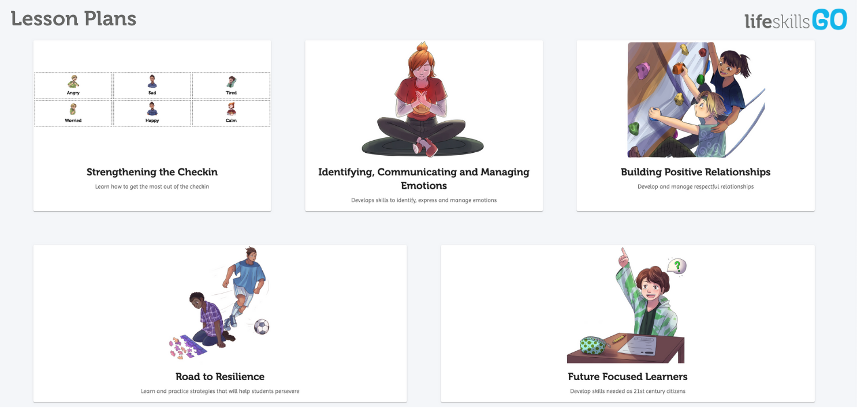

"The lessons I created... gave me so much time back. I can clearly find the content I need. Students were surveyed and preferred GO lessons over their traditional PBL lessons."
Candice Taylor Assistant Principal Curriculum and Instruction, Killarney Vale Public School
"Life Skills GO - it is a great resource to help schools have the evidence their programs work."
Allyssa Nelson Assistant Principal, Thornton Public School

Page 8: Call to Action
Start Your FREE Trial Today
Experience the Benefits of Life Skills GO in Your School
- Capture wellbeing data for your entire school without taking up valuable teaching time.
- Measure the effectiveness of your wellbeing programs with real-time, actionable insights.
- Know how many students are ready to learn and what support they need.
- Empower your staff with real-time data to make informed decisions that improve student wellbeing and academic performance.
- Measure the impact of your wellbeing programs so they have a real impact in the areas that matter.
- If you use Sentral or School Bytes, you can access Life Skills GO within your existing account - no new log in or website to remember.
Start capturing wellbeing data with Life Skills GO today.
Scan to start your FREE trial now

