To the Designer:
I appreciate you being part of this competition and taking the time to showcase your skills. I’m looking for a clean, premium, and easy-to-read design that makes the content shine. You’ll have full creative freedom within the brand guidelines, and I’m excited to see your approach.
If this works out, there’s potential for future projects too. Thanks again—I can’t wait to see what you create!

You can find all the brand colours, images, logos, and other inspiration here:
https://drive.google.com/open?id=13zAw60SdyrnFwoSNwWKHz2ol9eOTrlSJ&usp=drive_fs

Below you’ll find the content.
As well as in the folder above, you can find more inspiration here:
https://heroshotphotography.com/

I’m looking forward to seeing what you can do.
Adrian

----------Begin Content-------------------

1. Cover Page
- logo & branding
- Title: Corporate Headshot & Branding Photography
- Sub-heading:
Professional, approachable, consistent headshots for your team
—no awkward or stiff poses
- Breakout Text: Easy relaxed process – even if you hate photos
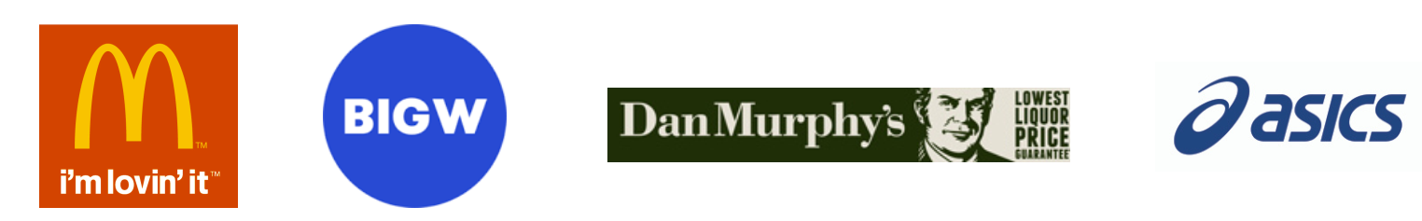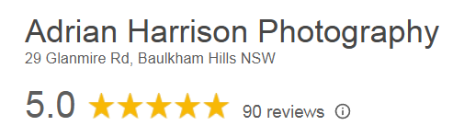

Title: Outdated, low-quality, or awkward headshots?
A bad photo sends the wrong message about your company.
My team and I work with companies to deliver professional, consistent, and natural-looking headshots every time—without the awkwardness. Let’s make your team look amazing!
Adrian Harrison
Studio Owner
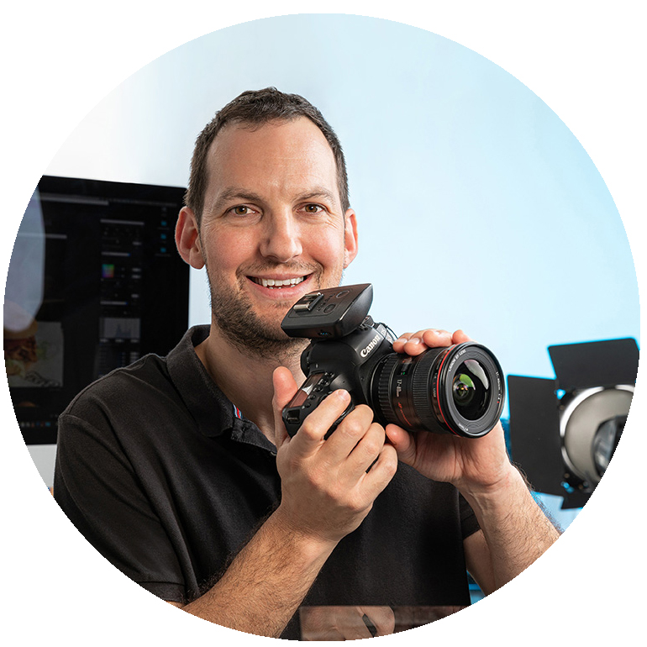

Title: Why 500+ Companies Trust Us
- Genuine Expressions—No awkward photos here
- Easy, Comfortable Process – even if you hate photos
- Consistency —consistent professional results
- Mobile studio—save time & hassle of studio shoots
[insert testimonial]
[insert client logos]
[insert Google reviews image]

Title: Headshot Packages

Designer Note: 1-2 pages. Two main options (Perfect Pose and Express Headshots) presented in side-by-side columns for easy comparison. (if possible)

All Packages Include:
- Preshoot planning, advice and tips
- 1 final image per person
- Mobile studio at your location
- 5-7 working days turnaround (Express service available)
- 6 mths free backup & digital enhancements
- Images suitable for websites, LinkedIn, social media & printing

Perfect Pose Headshots (Premium Service)
Ideal for teams seeking professional, polished images with a personal touch. Each person collaborates with the photographer to choose their best shot in real-time.
- Personalised Guidance: Get the perfect shot with expert posing tips.
- Collaborative Shoot: See your images as we shoot and provide feedback to get the perfect shot.
- Takes 5-7 mins per person
Costs:
Price Per Person
$XX ea (7-15 people)
$XX ea (16-25 people)
$XX ea (26-40 people)
40+ people: call
Mobile Studio $XXX

2. Express Headshots (Fast & Economic)
Perfect for large teams needing quick, high-quality headshots. Same image quality but without on-site review—similar to a school photo setup, only less awkward!
- Quick & efficient shoot (1-2 mins per person)
- Photographer selects final images
Costs:
$XX per person (min 15 people)
Mobile Studio $XXX

*All prices exclude GST. Parking expenses charged at cost + 15%

Add-Ons & Upgrades
Maybe this section should be 2 pages? You decide.
Try to align example images with each service

New page perhaps??
Portrait Tidy-up Retouching – $XXX (full team, not per person)
My most popular upgrade! Everyone will look fresher and slightly younger! We tidy hair, reduce wrinkles, and brighten eyes and teeth, keeping the look natural—no overdone edits.
Additional Images – $XX per image
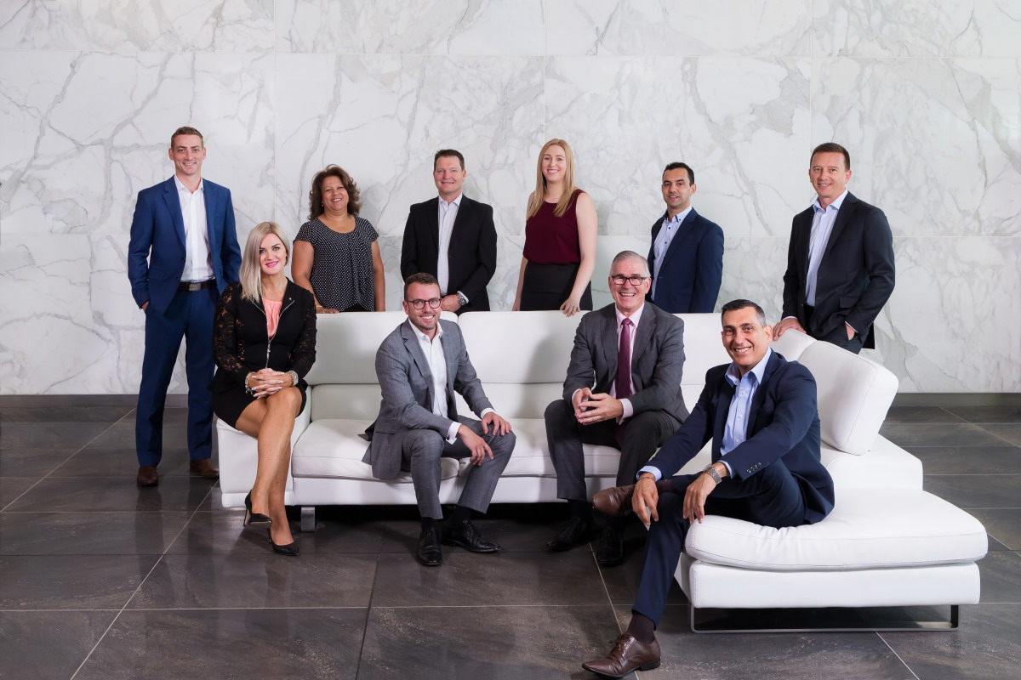Select extra professionally edited images to keep.
Team & Group Photos
Up to 5 people = $XXX ea
6-15 people = $XX ea
15+ people = $xx-$XXX ea

Express Delivery (48 hrs) – 20% extra

Office & Lifestyle Shots – Capture your workspace & team in action - $XXX per final image

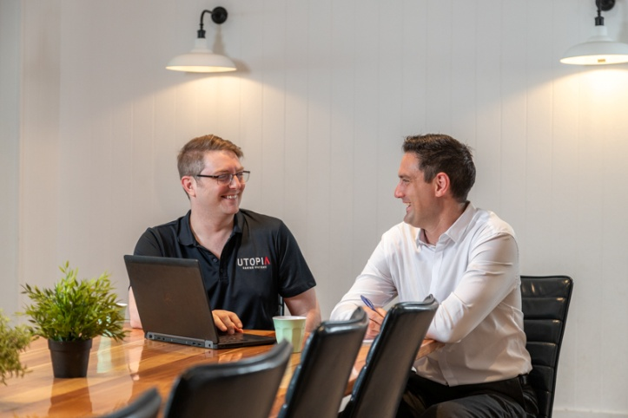
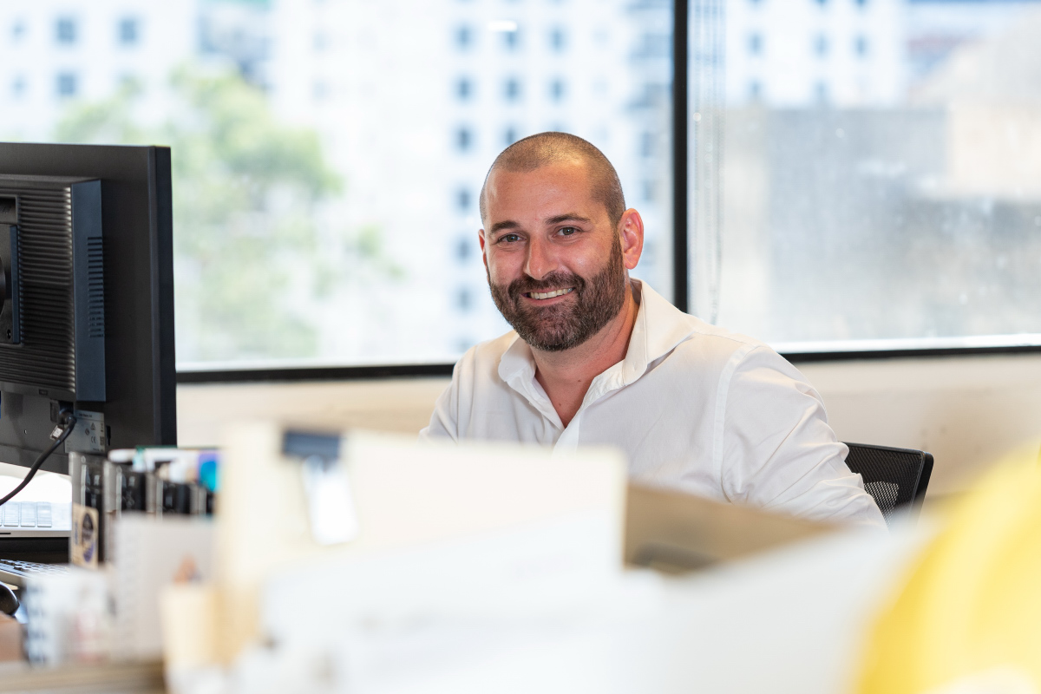

Video Services – Bring your brand to life with professional video
- Team Introduction Video – Showcase your people in a polished, engaging way
- Behind-the-Scenes Office Tour – Give clients a feel for your workplace & culture
- Client Testimonial Videos – Build trust with real customer stories
- Social Media Clips – Short, engaging content for LinkedIn, Instagram & more
Minimum Booking Requirements
For small teams (7 or fewer), we only offer a Headshot & Branding Package which includes a combination of headshots, team photos, staff action shots/lifestyle, building photos. Packages start at $XXX
*All prices exclude GST. Parking expenses will be charged at cost + 15%

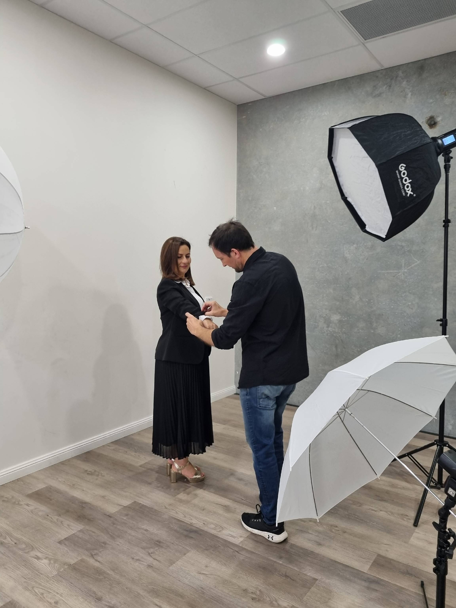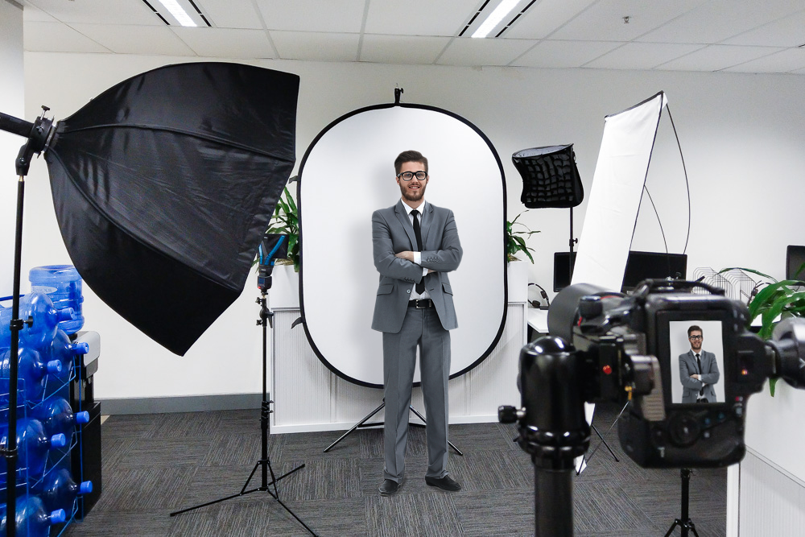5. Behind-the-Scenes

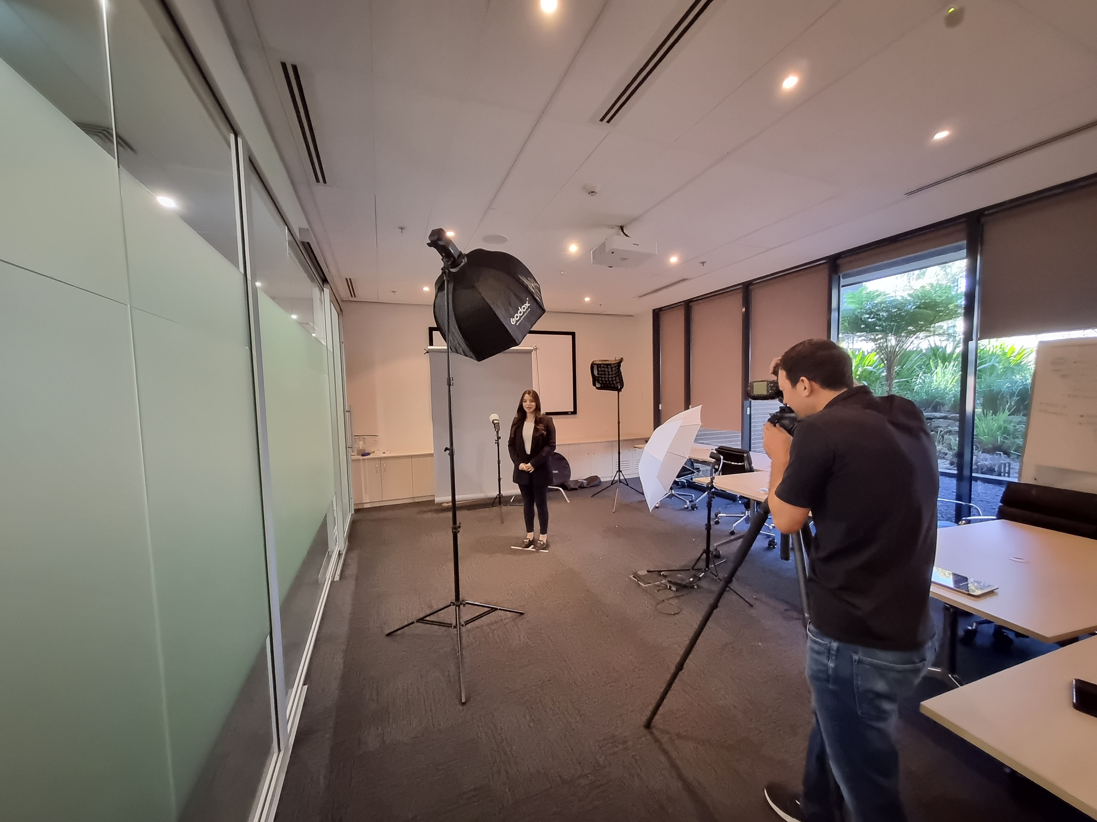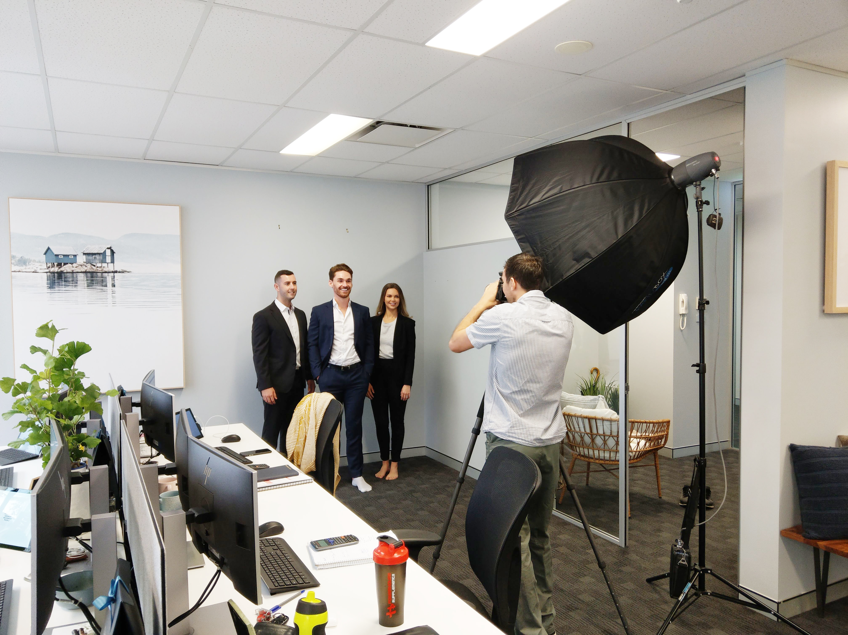

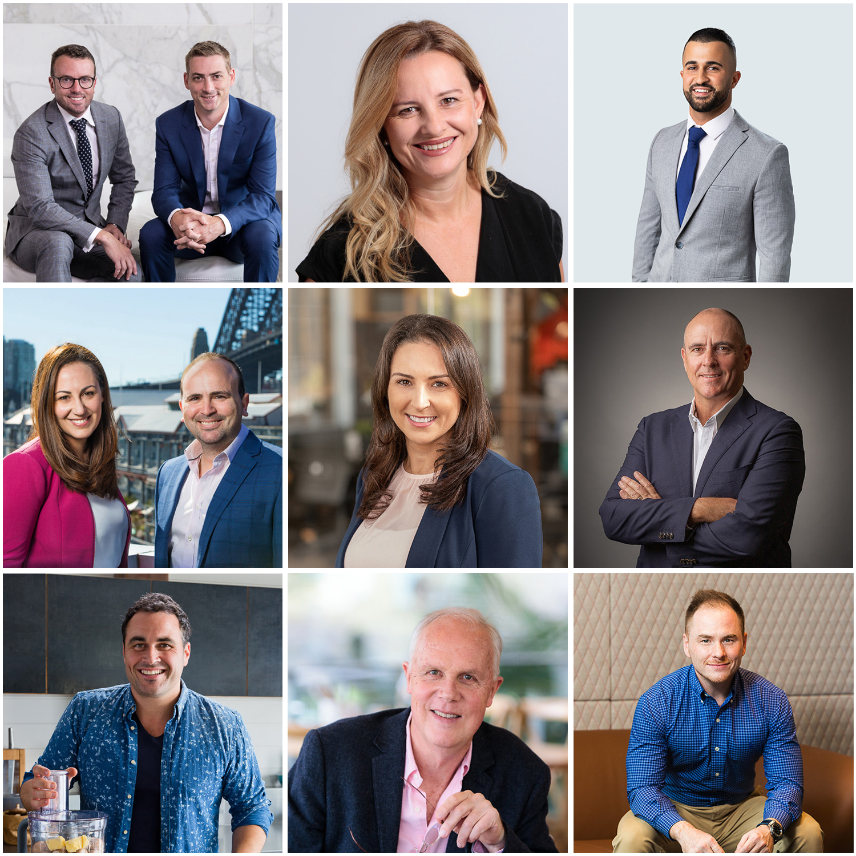6. Client Results

How It Works – Simple & Stress-Free
1. Book Your Shoot
Contact Adrian to secure your date—spots fill up fast!
2. Shoot Day – We Bring Everything
We bring lighting and backgrounds and guide your team to get consistent, professional shots with no awkward posing.
3. Hassle-Free Delivery
Your edited images are delivered directly to your inbox, ready to use.

[insert testimonial – if there is space]

Frequently Asked Questions
Which is the best package?
Choose Option 1. (Perfect Pose) if staff satisfaction is a priority. Each person reviews their photos, works with the photographer, and selects their favourite—ensuring a perfect shot for everyone.
Choose Option 2. (Express Headshots) if time and budget are the focus. You’ll still get professional headshots, but without individual selection—faster and more cost-effective
I’ve seen cheaper options. Why choose you?
With 15 years of experience and 90+ 5-star reviews, we ensure your team feels relaxed and looks their best.
What if my lighting is terrible?
We bring professional lighting to make sure every headshot looks great, no matter the environment.
We don’t have a white wall
No problem! We bring our own backgrounds.
What should my team wear?
Solid colors work best. Dress like you’re seeing your best clients. Team shirts or uniforms are great too.
Can we mix headshots with group photos or other staff action photos?
Yes! Check our Add-Ons for pricing.
Do we need a big space for setup?
A small meeting room is all we need. We'll bring the rest!

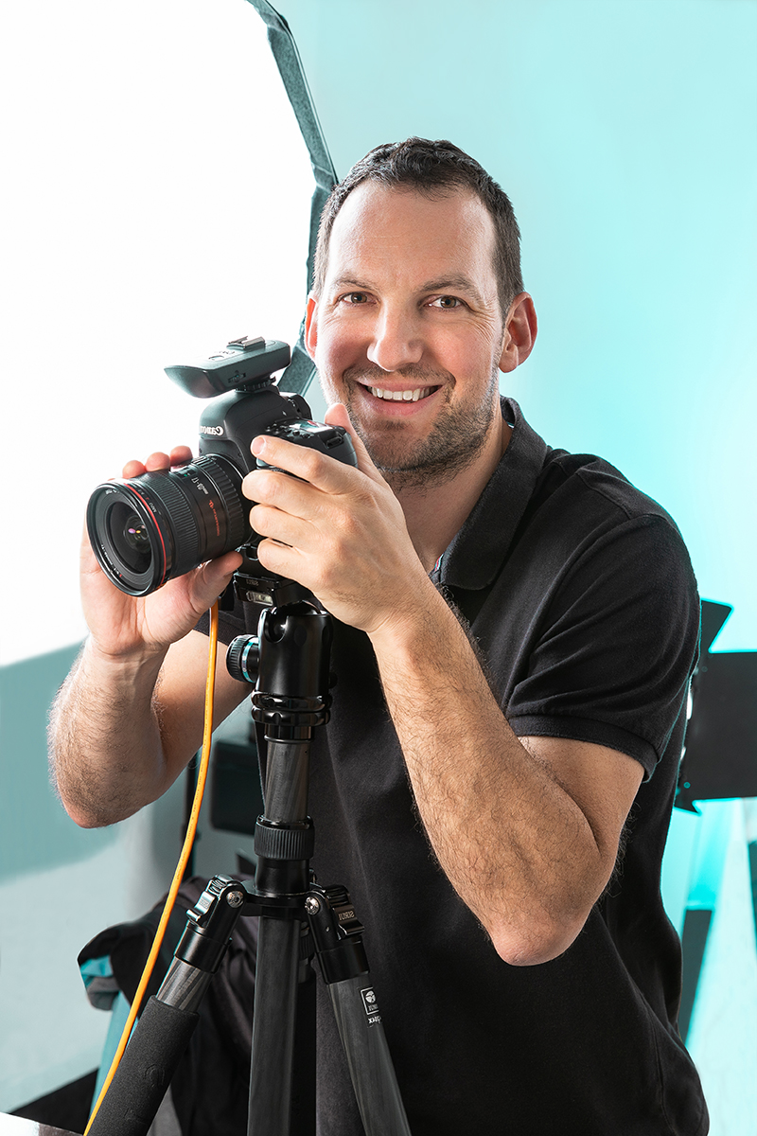Let’s Make Your Team Look Their Best
Contact Adrian today on 0401 787 908 or info@adrianharrison.com.au

Breakout box for testimonial
The thought of having a professional photographer come to our business brought back memories of school photos.
But Adrian made it all very relaxed and easy and readily put us all at ease knowing our faces were in good hands.
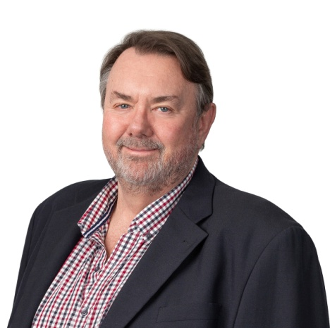
Jeremy Thew
Symbion

Here are testimonials you can use throughout the brochure.

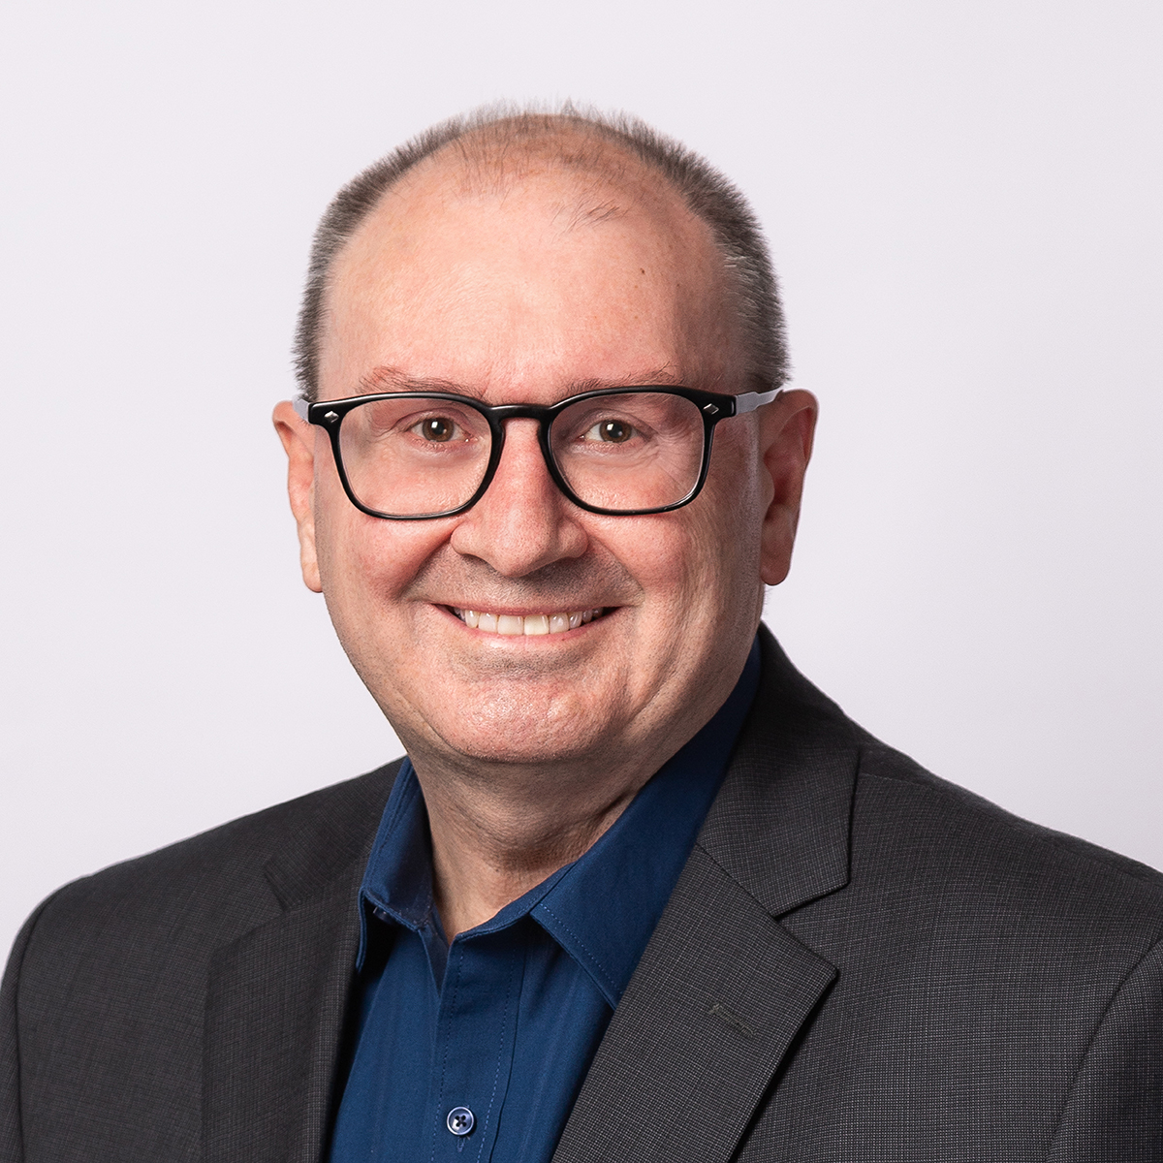"Adrian demonstrated his professionalism, helped me relax, and directed me to get the shots I was looking for. The photos turned out really well, and I've already put them to use on my website and LinkedIn."
— Tony Cocks
The alternative board

I'd highly recommend Adrian for any photographic needs. He clearly cares about his clients being happy with his work.
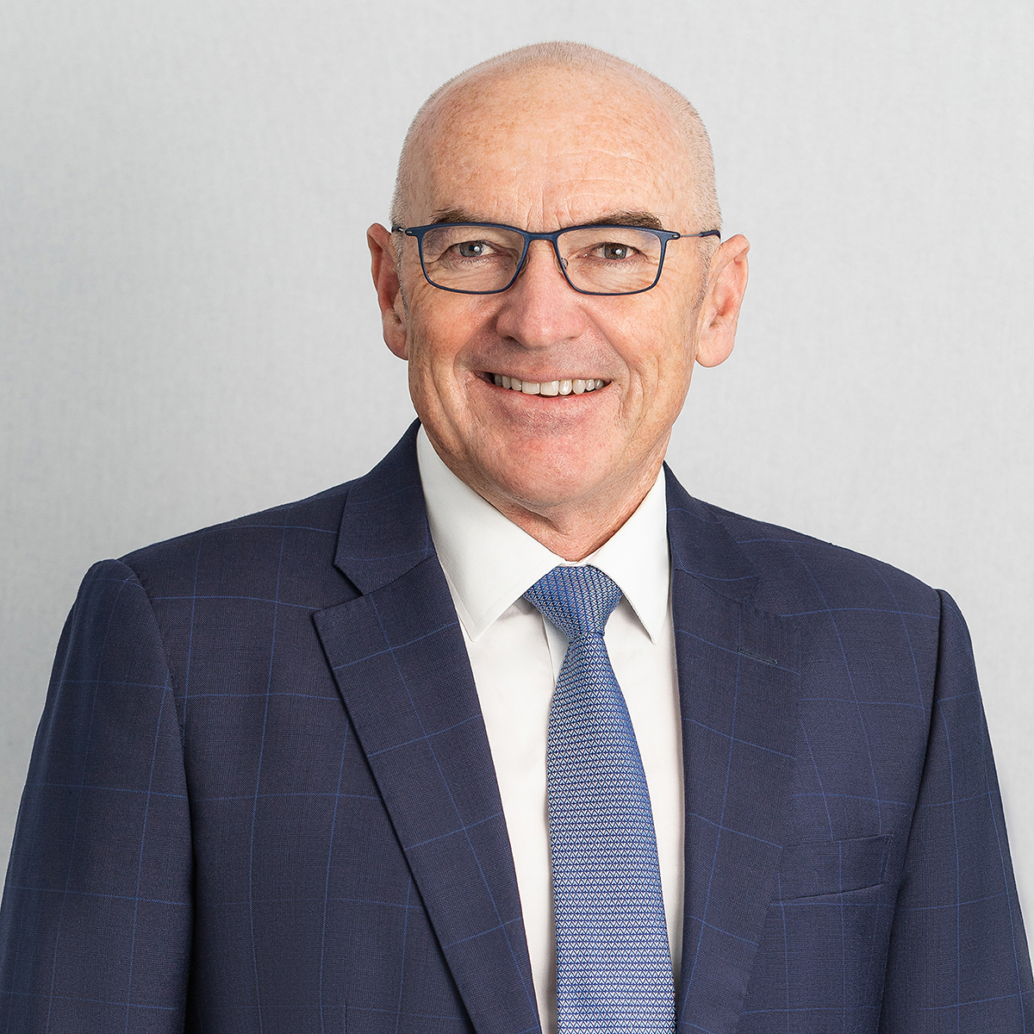Dan Blyde
Fultus

Fantastic service.Really professional.Friendly and easy to work with. Importantly the end results were fantastic. I will definitely use them again.
James France
Managing Director,
Vanguard Luxury Brands Pty Ltd

