Design Brief for Stickburner Clothing Co. Graphic
Project Title: "Stickburner Clothing Co. Tools of the Trade" Branding Graphic
Objective: Create a visually engaging graphic for Stickburner Clothing Co. that embodies the brand's theme of wood fire cooking and the work that goes into it. The design should be bold, eye-catching, and evoke a sense of craftsmanship and skill.
Design Elements to Include:
- Text:
  - The text "WOOD, FIRE" at the top.
  - The text "SKILL" at the bottom, centered.
  - Add “Stickburner Clothing Co.” into the image in such away it is noticeable but not blatant.
- Imagery:
  - A stylized flame in the center. See attached example from my main logo, flame is centered.
  - One wood splitting axe crossing a set of long scalloped tongs.
  - Up the center will be a spade shovel.
- Style:
  - Bold and striking, with a rugged aesthetic that reflects the brand's theme of wood fire cooking.
  - Use of contrasting colors to make the design visually appealing.
  - Elements should be clearly defined and easy to recognize.
Usage: The graphic will be used across various clothing items, including t-shirts, hoodies, and hats. It should be versatile enough to be printed in different sizes and on different materials.
Deliverables:
- High-resolution graphic files in vector format (AI, EPS) and raster format (PNG, JPG).
- A black-and-white version of the graphic for use on different backgrounds.
- A style guide outlining the color palette, fonts, and usage guidelines.
Example Images: Attached is example created by AI and the previous design I got made. The formal design is the theme I want to carry.

AI created example of the overall theme
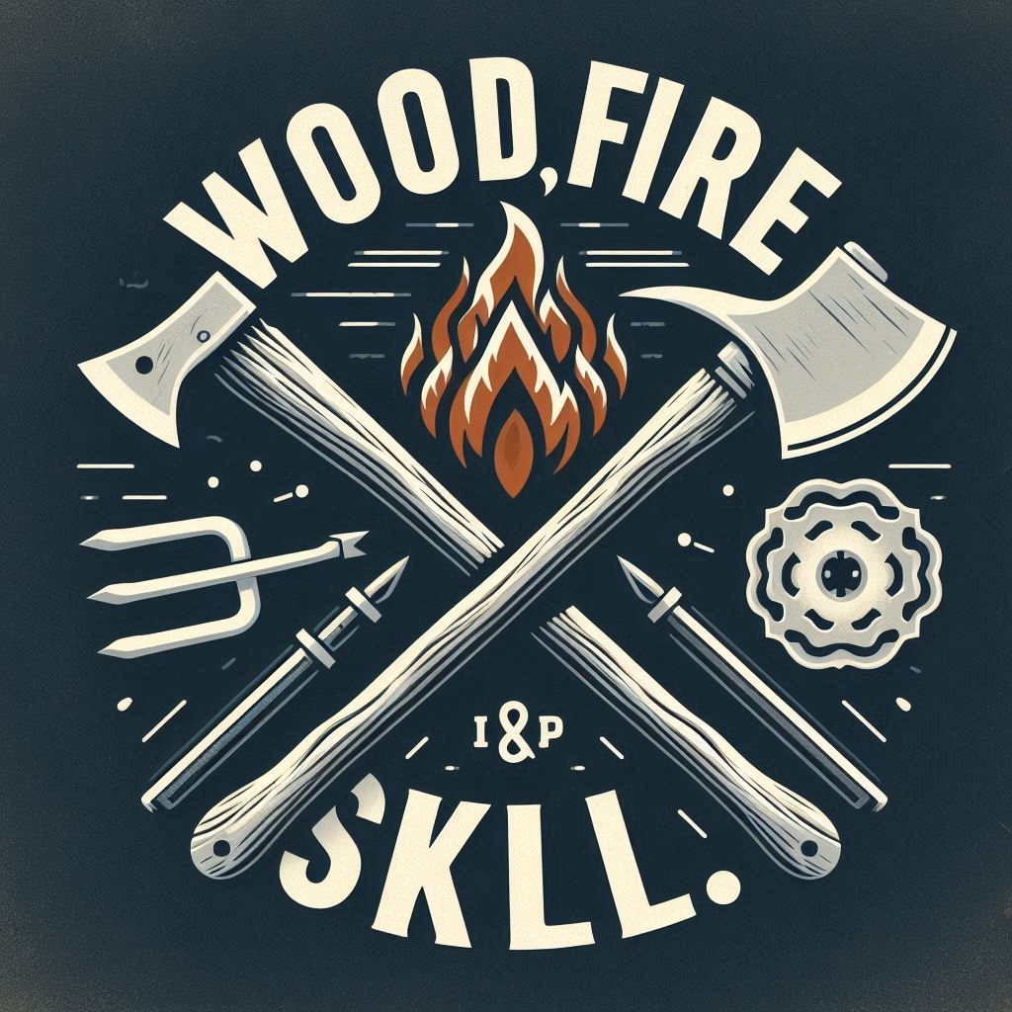
My formal design that is my main brand logo
