BMS Warehouse Gym Ltd. General Brand Guidelines
1. Brand Essence
- Brand Name: BMS Warehouse Gym Ltd. (Body Mind Soul)
- Mission: To provide a one-stop community hub for sustainable wellbeing, holistically coaching for success.
- Values:
  - Holistic Wellness: Focus on the interconnectedness of mind, body, and spirit.
  - Community: Foster a sense of belonging and support.
  - Sustainability: Promote long-term health and wellness practices.
  - Empowerment: Encourage personal growth and achievement.
2. Visual Identity
- Logos:
  - Primary Logo: 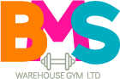

  - Secondary Logo: 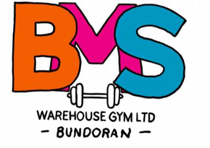

  - GymRite Logo: 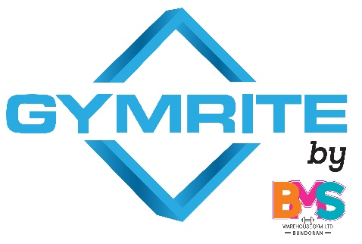

- Clear Space: Maintain a minimum clear space around the logo equal to the height of the "B" in the primary logo.
- Color Palette:
  - Primary: #04abbb, #fc7b04, #df3c99
  - Secondary: [To be determined]
- Typography:
  - Primary Font: A bold, geometric sans-serif font
- Imagery: Use high-quality images that are motivational, inspiring, and reflect the brand values.
3. Voice and Tone
- Overall Tone: Enthusiastic, supportive, and empowering.
- Language: Clear, concise, and easy to understand.
- Communication Style: Approachable, friendly, and helpful.
4. Brand Applications
These guidelines apply to all BMS Warehouse Gym Ltd. materials, including:
- Marketing & Advertising: Website, social media, print materials, merchandise, signage.
- Digital Platforms: GymRite. website and app.
- Communications: Emails, newsletters, social media posts, presentations.
5. Logo Usage
- Do not alter, distort, or recolor the logos.
- Use the appropriate logo version for the context.
- Maintain clear space around the logo.
6. Color Palette
- Use the primary colors consistently across all materials.
- Secondary colors can be used for accents and to add variety.
7. Typography
- Use the designated fonts for all text.
- Maintain consistent font sizes and styles.
8. Imagery
- Use high-resolution images that reflect the brand's values.
- Images should be diverse and inclusive.
9. GymRite Platform
- The GymRite platform should seamlessly integrate with the BMS brand.
- Maintain visual consistency and user experience across all platforms.
10. Third-Party Usage
- Any third-party working with BMS Warehouse Gym Ltd. must adhere to these guidelines.
- Provide this document to all partners and collaborators.
11. Brand Evolution
These guidelines are a living document and will be updated periodically.

