Providing Supermarkets with State-of-the-Art Retail Pricing Support
We are pricing strategy specialists that help supermarket retailers effectively manage prices and strengthen price-value image. Our proprietary methods, analytics, and decision-support tools have led to profitable sales growth at over 60 supermarket companies across North America.
Comprehensive Solution
Our comprehensive solution is tailored to your business and based on improving your price offering across each of the Six Dimensions of Price-Value Image. A successful, business-building pricing strategy requires strength within each of the Six Dimensions.
Six Dimensions of Price-Value Image
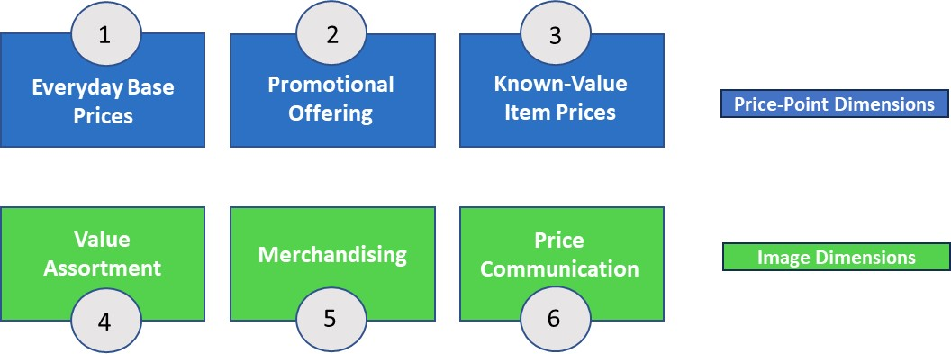

Our support is offered in three phases.
- Phase I: Discovery/Diagnostic – We’ll thoroughly analyze where you stand vs. competitors and best practice peers across each of the Six Dimensions of Price-Value Image.
- Phase II: Strategy Development – We’ll work closely with you to develop a comprehensive pricing strategy to support your overall go-to-market objectives. This strategy will be designed to strengthen your position across each of the Six Dimensions of Price-Value Image.
- Phase III: Implementation & Evaluation – We’ll recalibrate your prices to fit the new pricing strategy and help you accentuate strengths and neutralize vulnerabilities across each of the Six Dimensions. And we’ll meet with you quarterly to assess progress and ensure the strategy works for you.
Let’s Get Started
To learn more about how Price Dimensions can help your organization, please contact
Jon Hauptman at: jon.hauptman@pricedimensions.com or C: 847-226-5766.

Who We Work With

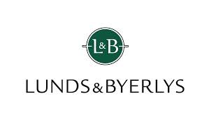
























For the past 25 years, our methods, analytics, and decision-support tools have been successfully applied at over 60 supermarket companies across North America including…

