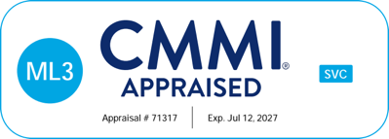
ISO 9001:2015 Standard Certificate Number: GQ-190924  ISO/IEC 20000-1:2018 Standard Certificate Number: GIT-200190  ISO/IEC 27001:2022 Standard Certificate Number: GI5241023 |  |  | 