What we do:

Modern Dreamers Slumber Company is a luxury sleepover company serving clients since 2021.
We like to say we're modernizing the standard slumber party and making sleepover dreams come true but basically, we sell an easy to set up and style slumber party kit that brings slumber party dreams to life in our clients' homes.

We make it super easy each slumber party kit comes complete with a sleepover tent, carry bag, bunting decoration, fairy lights, balloons and our signature Dream Keeper.

More info: We think slumber parties empower kids through building relationships and fostering confidence. We make it our mission to inspire kids to set goals and that’s why we created our Dream Keeper. A fun way for kids to dream big and identify goals which they record in our Dream Keeper key chain. This key chain acts as a reminder of their dreams and goals and a reminder of the memories made at their Modern Dreamers slumber party.

Statements and Sentences to Use:

- Sleep Less, Dream More
- You are almost twice as likely to reach your goals simply by writing them down.
- Never stop dreaming --- most realities were once created from dreams.
- Remember anything is possible with the right people to support you.
- What motivates you to keep going when things get tough?
- What’s one action I can take today to make my goal feel more achievable?
- "Imagine you’re going on a trip, but you don’t have a map or plan. You’d probably get lost, right? Goal setting is like making a map for your life, so you know where you’re going and how to get there!
- Setting goals helps you stay focused and gives you something to work towards. It’s like having a target to aim for, which makes everything more exciting!
- Swoon, slumber, repeat
- Don’t follow your dream chase them!
- You only fail when you stop
- The harder you work for something the greater you will feel when you achieve it
- Dream it, wish it, do it
- Do what is right, not what is easy
- There is no elevator to success, you have to take the stairs

Fonts: our main font used is- Avenir Next LT pro, but easy to read and “modern” type fonts would be great
We use a moon and a tent logo(shown below) as well as the slogan “Sleep Less, Dream More” in a number of our marketing materials
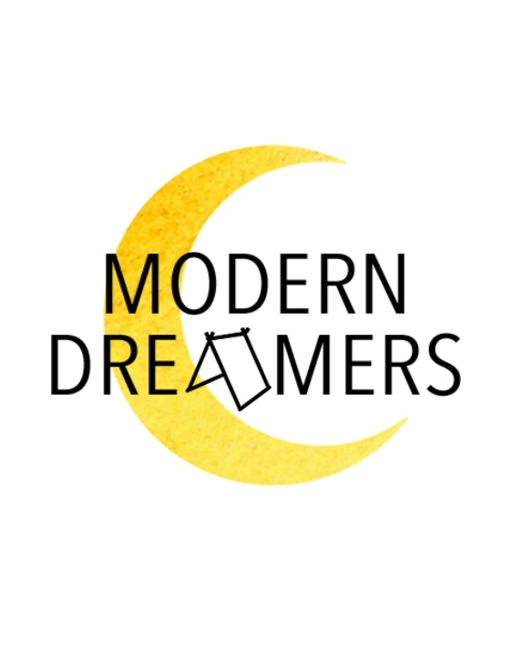

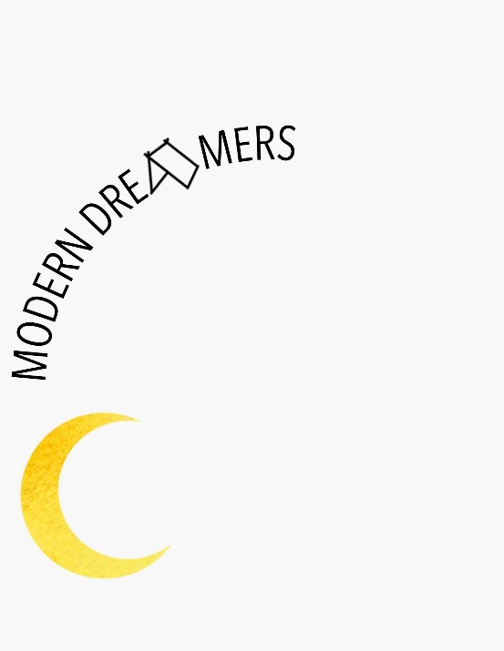

Some examples of the looking I’m aiming for, I love the use of various fonts and sizes
