Rock Hall Landing Marina is a marina in the town of Rock Hall, Maryland. We are seeking to develop new branding materials for the marina that reflect the nautical heritage of the town. The existing logo is overly generic, and is more reminiscent of a “new England” style than that of the eastern shore of the Chesapeake Bay. Here is the current logo.
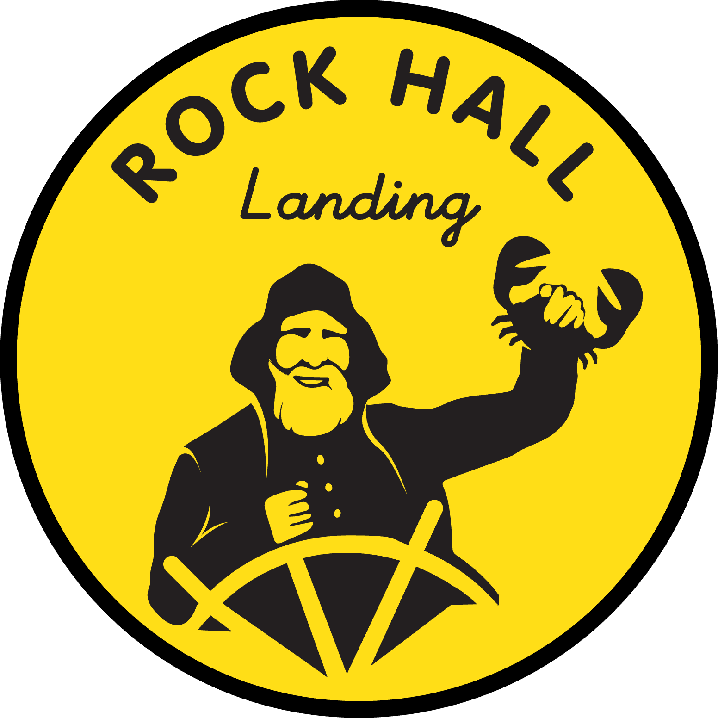

A prominent landmark in the town of Rock Hall is its water tower, seen here.

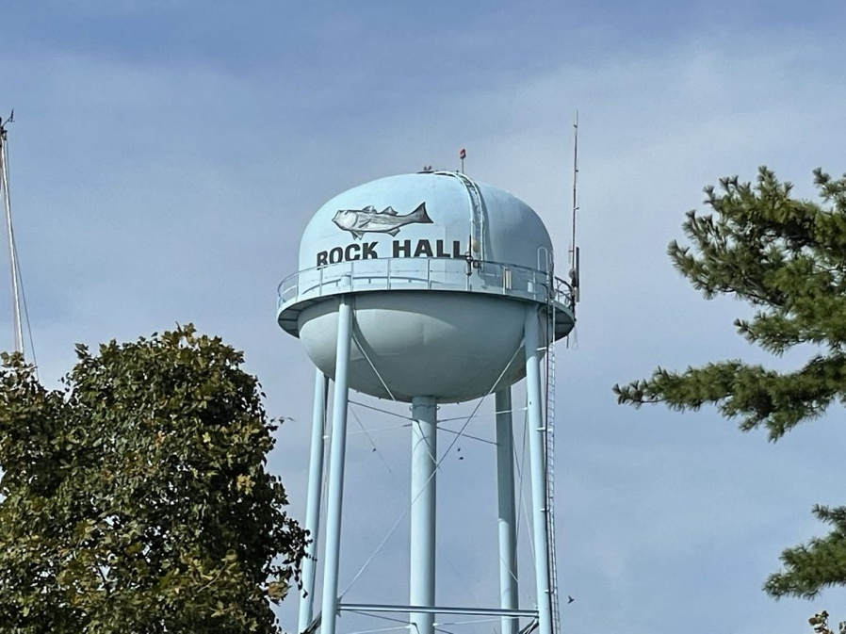

We would like to incorporate a stylized version of the water tower in the design. Here is a stylized version of the water tower that we like (source ChatGPT).
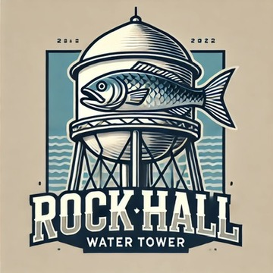
We particularly like the exaggerated depiction of the fish (striped bass, or “rock fish”) on the stylized version.

Additionally, we feel that a use of nautical signal flags would be appropriate. Specifically, the flags for the letters R, H, L & M (Rock Hall Landing Marina). Which are seen here:
R is the red with yellow cross.
H is the red and white
L is the black and yellow
M is the blue and white

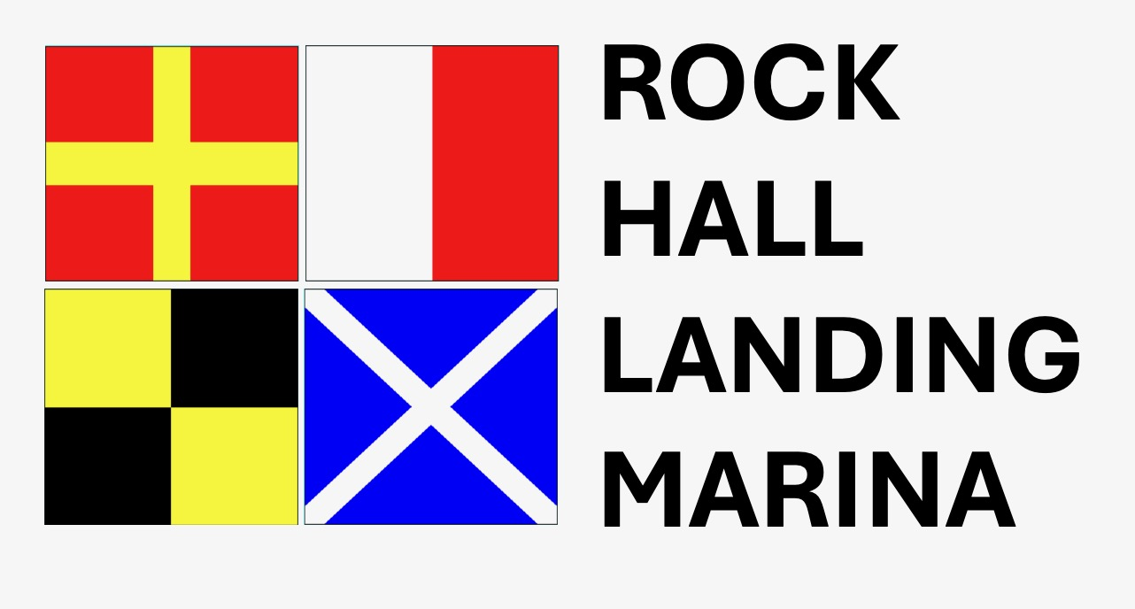

We are envisioning something along the lines of a stylized water tower being overlayed on the nautical flags as the “signage” logo, with just the stylized flags as a “simple logo”. The flags can (and should) also be stylized in some way, or at least have the color palette softened (for example, the super bright yellow could be more gold, the super bright red more like a maroon and the blue a more pleasing blue).

That said, we are open to other interpretations. Additionally, the town is known for blue crabs, which could also be included in the signage logo. This is not a must, just a thought. Here is an image of a blue crab.


So the elements requested are:

- Signage Logo for Rock Hall Landing Marina. “Signage logo” will be used on the main street sign for the marina as well as T-shirts, etc. The signage logo should also include “Est. 1990” (or Established 1990) at the bottom.
- Simple Logo for Rock Hall Landing Marina. “Simple logo” would be a smaller, simpler version appropriate for embroidering on golf shirts and hats, as well as for use on email signatures, business cards, etc. Most likely to only include the signal flags and the name, but again we are open to interpretation.

