
Sinceri Senior Living
• Website: sinceriseniorliving.com

• Overview: We are Sinceri Senior Living – a premier, forward-thinking senior living management company founded in 1986.
• Number of Properties: Over 78 communities across the U.S.
• Types of Properties: Independent Living, Assisted Living, Memory Care, Companion Living, Respite Care.
• States: Operates in multiple states, including Washington, Oregon, California, Texas, Minnesota, Wisconsin, North Dakota, South Dakota, Ohio, and Virginia.
• Key Personnel:
Chris Belford: CEO (joined 2020)

Chris Belford, a seasoned veteran, started in the Senior Living Industry in 1991.
Over the years, Chris has driven operational excellence in various senior management roles. During his time at American Healthcare REIT, Chris successfully grew the company’s assets under management (AUM) to over $4.3 billion. Previous roles also include President – West Division, Brookdale Senior Living; and Senior Vice President, Emeritus Senior Living.
Joining the Sinceri Family as Chief Executive Officer in November 2020, Chris leads day-to-day operations, while delivering on the organization’s long-term vision and strategies. In addition to Chris’ role with Sinceri Senior Living, he actively serves seniors and advocates for older adults through his service on various senior housing company boards and associations.
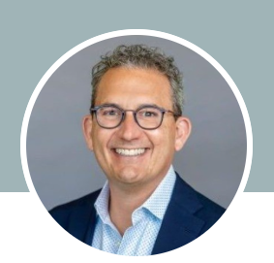
Micah Gerber: CIO (joined 2018)
Micah joined Sinceri in 2018 as the Chief Strategy Officer in conjunction with the purchase of the company by Access Industries. He has also held the positions of Chief Financial Officer and Senior Advisor.
As Chief Investment Officer, Micah sources and structures new investments, maintains financing relationships, and leads asset management of company-owned assets. Prior to joining Sinceri, Micah was with Senior Living Communities/ Maxwell Group, Inc., where he served as Chief Financial Officer. Prior to that, Micah was an investment banker.
Micah received an MBA from the Tuck School of Business at Dartmouth College and a BS from the University of Florida. Micah currently lives in Charlotte, NC, with his wife and two children.
------------------------------------------------

Charter Senior Living
• Website: charterseniorliving.com

• Overview: Charter Senior Living is a family-owned senior living organization with a successful record of providing high-quality lifestyles to seniors and their families.
• Number of Properties: 67 Communities
• Types of Properties: Independent Living, Assisted Living, Memory Care.
• States: Operates in multiple states, east of the Mississippi
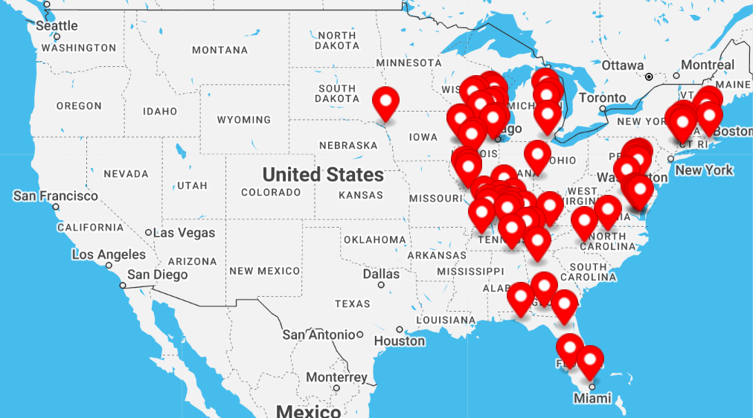
• Key Personnel:
• Keven J. Bennema: CEO & Co-Founder
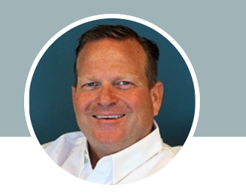
After a humbling but formative beginning as a caregiver, Keven rose to executive ranks in the senior living sector, working for several large national providers. He worked in every functional department of a skilled nursing community before ultimately earning his Nursing Home Administrator License in the state of Ohio. Concurrently, he completed his MBA, receiving his Masters of Health Care Administration from Cleveland State University. Keven continued his career in several senior living companies, serving as Executive Director, Regional Director, and eventually becoming Executive Vice President/Chief Operating Officer of Senior Lifestyle Corporation in Chicago.

Now, with 30 years of experience, Keven leads Charter Senior Living as it enters into its ninth year of operation with 60 properties in 15 states, and he is focused exclusively on advancing his team-inspired culture and vision for senior living under the Charter banner.


• Patrick Matthews: CFO / CIO
Patrick joins Charter Senior Living with over 15 years of experience in investment and operational analysis, having spent the last decade focused on senior living. His extensive work on both the operator and investment side of the business blends together to form a unique perspective that allows him the ability to connect with a wide range of key members across the industry. His dual mandate with Charter will include oversight of all financial & operational KPIs and analysis as well as continuing to expand and enhance Charter’s operational footprint through acquisitions and new investment partnerships.
Patrick comes to us most recently from Aviva Senior Living, where he was the EVP of Finance and Business Development. Prior to that, Patrick was the Director of Portfolio Management at The RMR Group, overseeing their healthcare focused REIT, and spent five years at Benchmark Senior Living prior to that where he oversaw the FP&A function. Patrick is a graduate of Brandeis University where he majored in Economics.

-----------------------------------------------------------------
Ovation Group (MorningStar Senior Living)
• Website: morningstarseniorliving.com

• Overview: MorningStar Senior Living offers Independent Living, Assisted Living, and Memory Care services, aiming to create a true home for seniors within a beautiful setting.
• Number of Properties: 40 properties
• Types of Properties: Independent Living, Assisted Living, Memory Care.
• States: 11 states including: Arizona, California, Colorado, Idaho, Iowa, Montana, Nevada, New Mexico, Oregon, Texas, and Washington
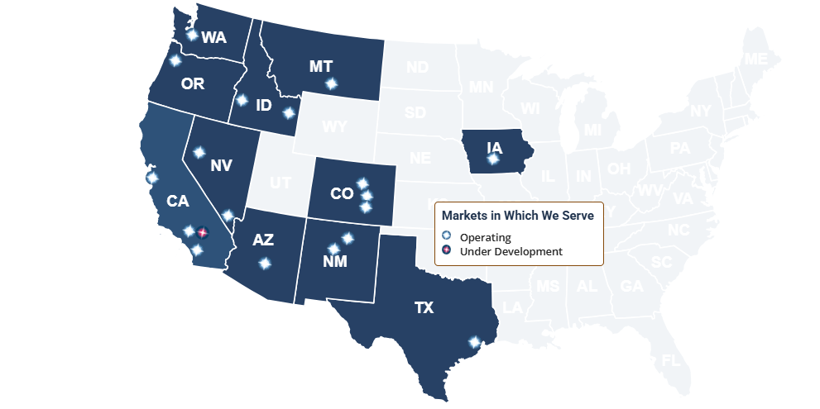
• Key Personnel:
Matt Turner: Managing Partner. Matt Turner, along with Ken Jaeger, co-founded MorningStar Senior Living, bringing a shared calling to serve seniors and a blend of complementary skills and experience.
Matt is the Founder / Managing Partner at Ovation Group (development arm or MorningStar)

------------------------------------------------------------------

American House Senior Living
• Overview: American House Senior Living has been providing housing, hospitality, and care to seniors since 1979, offering a range of living options to meet residents’ needs.
• Number of Properties: 60+
• Types of Properties: Independent Living, Assisted Living, Memory Care, Respite Care.
• States: Florida, Illinois, Michigan, New Hampshire, Ohio, and Tennessee.
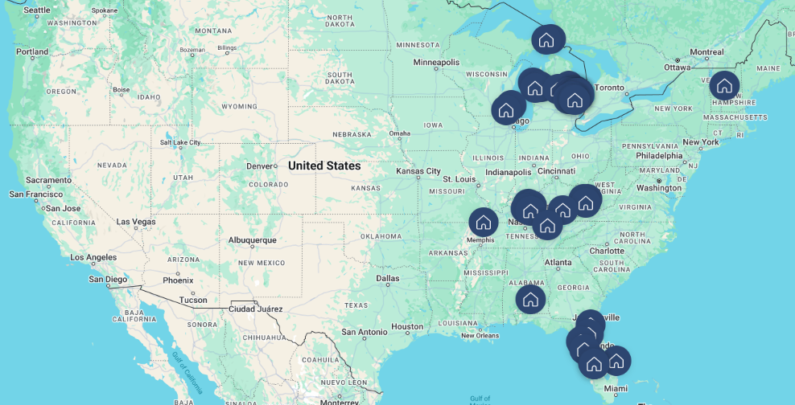
• Key Personnel:
• Dale Watchowski: President and Chief Executive Officer.
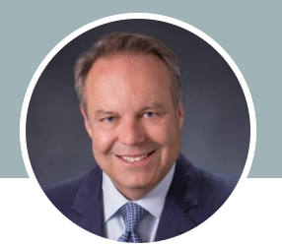
Dale Watchowski leads American House Senior Living Communities and REDICO (a full service commercial real estate enterprise affiliated with American House.), bringing a wealth of experience in real estate investment and development.

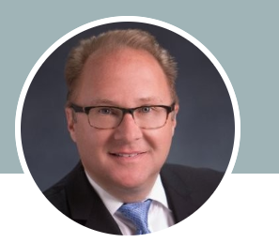
• Paul Stodulski: Chief Financial Officer. Joined in 1996
Paul Stodulski oversees the financial operations of American House, ensuring fiscal responsibility and strategic growth.
• Website: americanhouse.com

----------------------------------------------------------

The Goodman Group
• Overview: The Goodman Group manages and develops senior living and health care communities, residential communities, and commercial properties, focusing on enriching lives and providing Platinum Service®.
• Number of Properties: Information not specified in the provided sources.
• Types of Properties: Senior Living & Health Care, Residential Living, Additional Services.
• States: Operates in Arizona, California, Florida, Minnesota, Montana, Oregon, and South Dakota.
• Key Personnel:
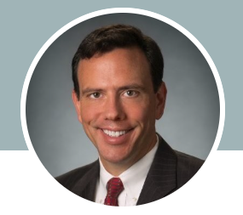
Kevin Carden: VP, Investments. Joined Sept. 2024
Kevin Carden leads acquisitions and dispositions for the Goodman Group. Proven mergers & acquisitions and finance executive focusing in senior housing, real estate, and healthcare. Diverse experience, including mergers & acquisitions, private equity, investment banking, debt and equity finance, and operations. Deep network and expertise in growing businesses—including strategic planning, capital formation, and identifying, evaluating, and executing transactions. Originated and/or completed over $1 Billion in transactions in senior housing and healthcare.
• Website: thegoodmangroup.com

---------------------------------------------------------

Discovery Senior Living
• Overview: Discovery Senior Living ranks prominently among the five (5) largest seniors housing providers in the US, and is widely renowned for designing, developing, marketing, and operating a growing portfolio of nationally and regionally branded senior living and care communities as unique as the locales and seniors they so proudly serve.
With a nearly 30-year reputation and more than 15,000 existing units or units under development, our company is a recognized industry leader with a penchant for excellence and innovation.
Now, with eyes on the future, Discovery Senior Living is strategically expanding its brand profile, and is pioneering the introduction of “Experiential Living,” our proprietary operating model that’s powering the launch of new, resident-focused programs and experiences created with the next generation of senior clientele in mind.

• Number of Properties: 340+
• Types of Properties: Active Senior Apartments, Independent Living, Assisted Living, Personal Care, Memory Care, Skilled Nursing, Respite Care.
• States: 40 states
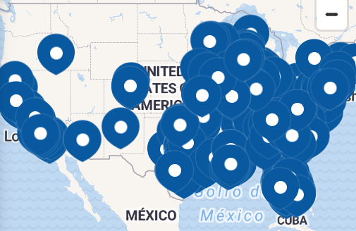
• Key Personnel:
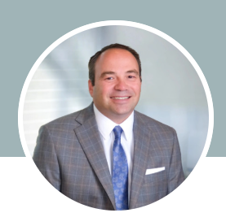
Richard Hutchinson CEO
Mr. Hutchinson is the co-founder and Chief Executive Officer of Discovery Senior Living; a family of companies which include: Discovery Management Group, Discovery Development Group, Discovery Design Concepts, Discovery Marketing Group, TerraBella and Morada Divisions, and Discovery At Home, a Medicare-certified home healthcare company.
During his almost 30-year career, he has negotiated and closed more than $5 billion in equity and debt transactions, while establishing relationships with many of the industries’ key financiers, investors and operators.
Through Mr. Hutchinson’s leadership, the family of companies has achieved significant growth; more than tripling in size over the last five years and ranking amongst the top 10 operators in the country. His vision of developing a business culture of innovation, integrity and creativity, while being analytically driven, has pushed the company to the leading edge of the industry, redefining seniors housing along the way. The companies have been recognized for their exceptionalism and ingenuity and have received accolades and awards from numerous national organizations.


Viva Senior Living
• Overview: Viva Senior Living is dedicated to creating vibrant communities that offer a range of services tailored to seniors’ needs, ensuring meaningful and fulfilling daily experiences.
• Number of Properties: 22
• Types of Properties: Independent Living, Assisted Living, Memory Care, Respite Stay.
• States: New York, New Jersey, Pennsylvania, Georgia, South Carolina, Tennessee, Maryland, and Virginia.
• Key Personnel: Specific key personnel information is not available in the provided sources.

Afrika Parks RN, MSN, LNHA
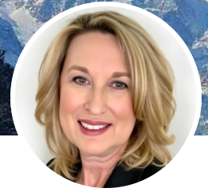
Heather Terhark, Chief Strategy Officer (Joined May 2024)
Collaborative, strategic and solutions-oriented leader with over 27 years of experience in the post-acute acute long-term care arena with expertise in Project Development, Program Development and Management, Consulting Services, Sales & Marketing and Ancillary Services for Assisted Living, Skilled Nursing and Long-Term Care Facilities. Key contributor to strategic leadership teams.
• Website: vivaseniorliving.com

--------------------------------------------------------------------------

Triple Crown Senior Living
• Website: triplecrownseniorliving.com

• Overview: Triple Crown Senior Living, formerly Vitality Senior Services, was formed in 2017 by a group having over twenty-nine years of successful business experience, including operations, sales, marketing, accounting, construction and development management. Triple Crown Senior Living manages developments that provide housing and services for the senior population with a primary focus on Senior Living, Independent Living, Assisted Living and Memory Care units. www.triplecrownseniorliving.com
• Number of Properties: 10 communities with over 870 units.
• Types of Properties: Independent Living, Assisted Living, Memory Care.
• States: Indiana, Kentucky, Ohio, and Tennessee.
• Key Personnel:

Todd Marsh: CEO
CEO Todd Marsh leads the company, drawing upon his extensive 28 years of proven, successful experience in operating developments in multiple States. Todd’s expertise encompasses a broad spectrum of responsibilities, from overseeing startup campuses to revitalizing underperforming facilities. His track record includes managing various levels of care and services in both urban and rural settings, including successful new build developments.
Todd’s proficiency extends to all facets of management, from financial planning and multi-facility oversight to P&L accountability, strategic planning, risk management, policy development, and procedure implementation. He has a history of mentoring new administrators, providing ongoing support, and spearheading quality assurance initiatives. His portfolio includes successfully managing multiple major renovations and building projects, collaborating closely with architects on design, navigating complex regulatory requirements, and overseeing day-to-day construction with site managers.
Todd has a robust background in board governance, having served on and collaborated with numerous boards of directors. His involvement has often extended to participating in subcommittees and task forces that shaped the direction of organizations and addressed emerging issues. In addition, Todd maintains a deep understanding of the political and regulatory landscape at both the state and federal levels, with a keen awareness of how these factors impact our business operations.
Todd graduated from the University of Kentucky, resides in Louisville and is proud of his three grown sons.


Bryan Culliton: President
As President of Triple Crown Senior Living, Bryan’s role is multifaceted. He oversees operations including budgeting, quality control, administration, marketing, culinary, staffing, employee development, programming, and customer satisfaction. His more than 25 years of experience in the senior housing industry is a cornerstone of Triple Crown’s operational success.
Before joining Triple Crown, Bryan held leadership positions with national senior living providers, including Emeritus, Brookdale, and Holiday. During his career, Bryan has served the senior population at all care levels, including independent, assisted, memory care, skilled, and continuing care communities.
Bryan has a proven track record of navigating operational challenges, creating sustainable revenue growth, and stabilizing occupancy. His extensive experience in the industry provides him with strong financial acumen, the ability to achieve occupancy growth, and the propensity to mentor future industry leaders. He has received numerous awards for operational excellence throughout his career, served on the Oklahoma Assisted Living Association, Utah Geriatric Society boards, and is involved with the Alzheimer’s Association.
Bryan’s academic journey gives testament to his commitment to the industry and personal growth and development. He holds a BS Degree in Health Administrative Services from Weber State University and an MBA from the University of Phoenix. In addition, he is a licensed Health Facility Administrator.

