Design Brief for Ford

- Minimalist Theme / Minimal Coverage ( see sample images)
- Brand colours- Green(logo green, Black , and Egg yolk color)
- White Background
- Brand Logo (attached)
- URL : www.greenco.food
- Email: info@greenco.food
- WhatsApp # +234 8062888494

Word on design :
Always Fresh - from GreenSpace Farms

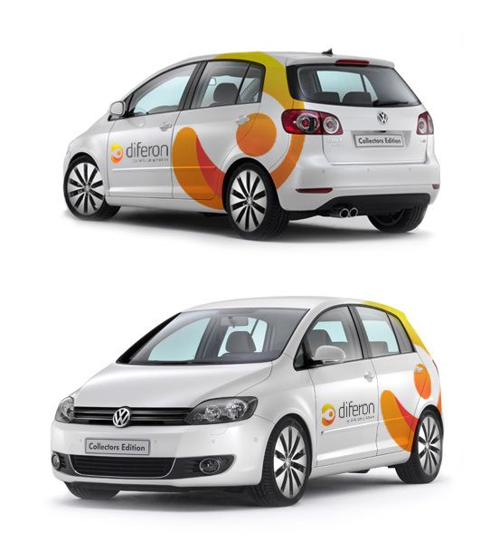 | 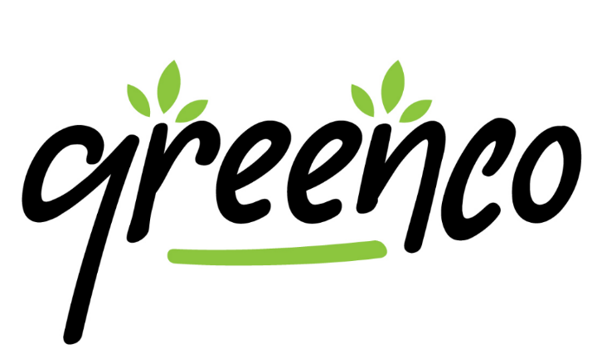
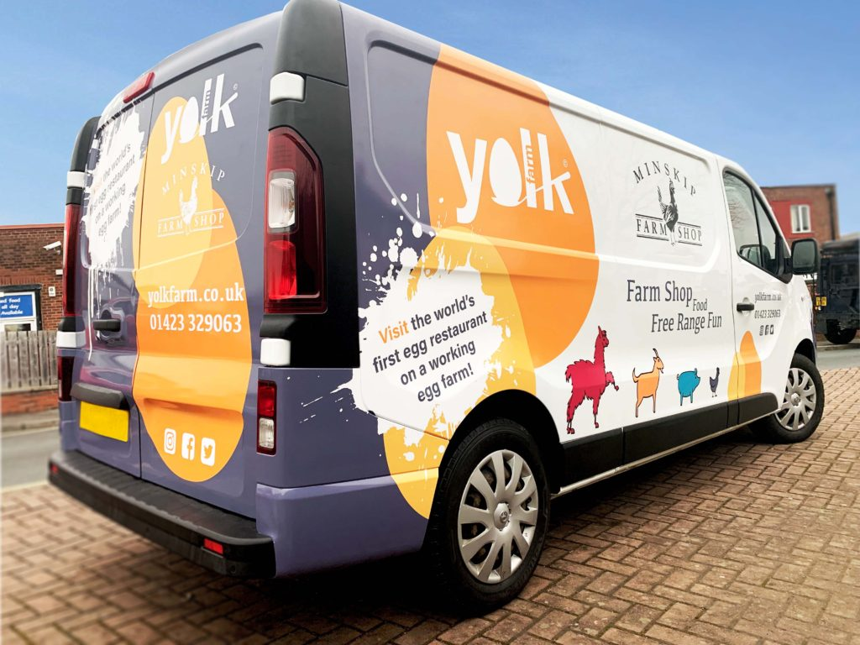

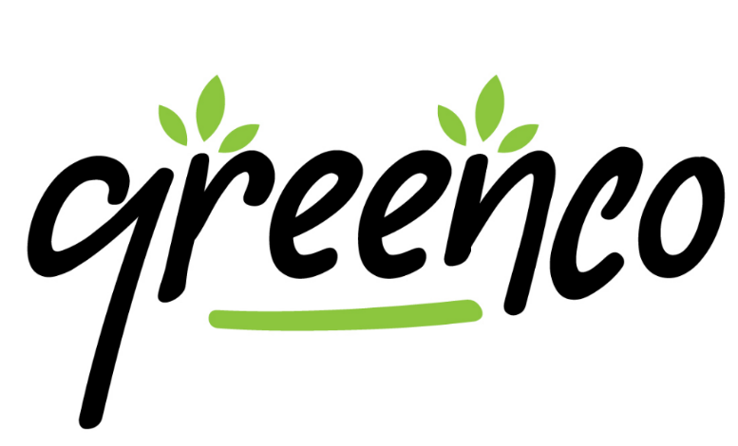
by GreenSpace Farms

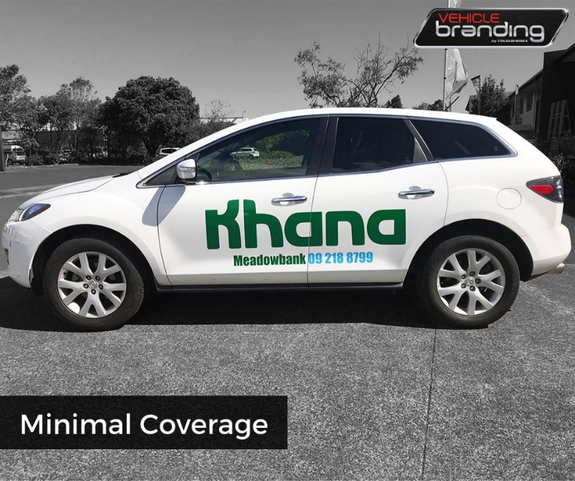

Vehicle Model : 2019 Ford Transit Van
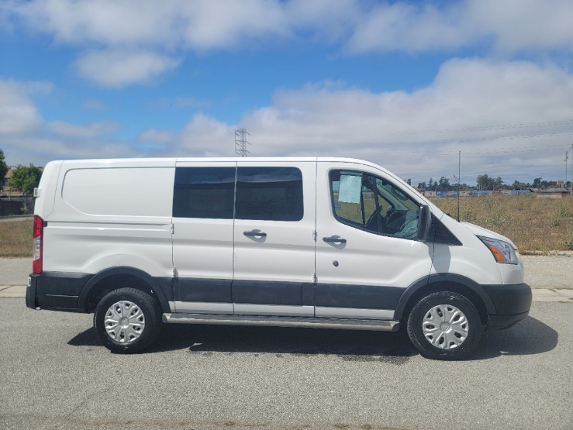 | 