Logo Design Client Questionnaire

Please take your time and answer ALL of the questions. Logo design and branding is a collaborative process and needs your involvement in all stages.

Logo Design Brief

What is the Name of the company that will appear on the Logo? | Specialty Insurance Partners and or SIP
Are there any tagline/slogan associated with the logo. | None at this time
Please give us a brief overview of your company. What are your services or what you do or produce? | SIP is a Specialized Insurance Agency focusing on Commercial Insurance. Expertise in Products Liability, for Manufactures, Habitational Risks, and Special Services within a municipalities
Who are your target audience/typical customer? | Any Business Owners, All Manufactures, Medi Spas, municipalities, Property Investors, Livery operations.
Theme, Look, Style and Feel  What sort of style do you envision? (e.g. professional, modern and clean, old world, cutting edge, vintage, sporty, futuristic, High end, etc.) | Modern, Professional, Clean
Please provide some adjectives that describe what you hope to communicate with your logo (e.g. strong, exciting, warm, welcoming, inventive, humorous, feminine, serene, athletic, etc.). Be sure to look at the logo examples we provide at the end of this questionnaire.  Are the any ideas that you like to use for the logo (or) you are open to ideas? | Strong, Innovative, Trusted
Ideas, icons, images or symbols  Do you have any particular images or symbols you associate with your product or company? (e.g. favorite animal or object, like a lion, ship, mountain or tree .) | No animals, hoping to have it
Colors  What are your color preferences? | Not current colors but nothing specific in mind

Logo Examples

These examples are a starting point to help illustrate what we mean when we use terms such as corporate, old world, illustrative, etc. There aren’t really clean divisions between these categories. Most of the logos could fall into several categories.

NOTE: Many of the logos depicted below were not created by Logo Sanctuary, US.

Corporate/Professional
Corporate logos are simple, bold and communicate strength. They don't necessarily illustrate what a company does. They are basic trademarks that come to symbolize a company even if they are start as a somewhat arbitrary choice.
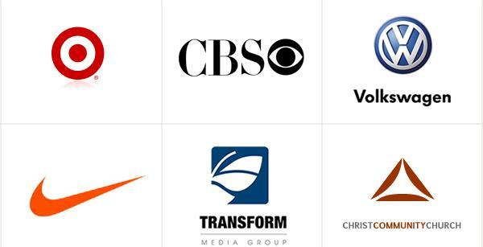

Text Only
Text-only logos are a challenge to keep unique because most fonts are so widely used. But it can provide a nice literary or legal look. Or if you want something artier, a handwritten or arty font can look very unique.
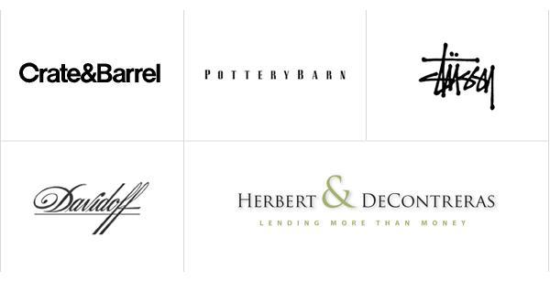

Historical/Seals
These are having a classic rich feel and also have real longevity.
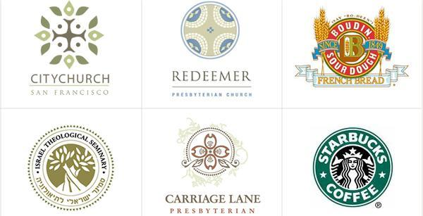

Old World
Fun and beautiful. We're huge fans of old world style.
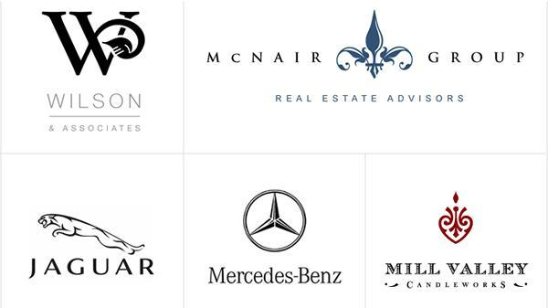

Whimsical
Whimsical logos, when they're based on illustrations take more time and more budget are more unique than any other type of logo.
