

It’s Your Turn! Launch a Million Brand in 90 Days!


VIDEO HERE

The Launch a Million Dollar Brand in 90 Days program is a 90-Day Sprint that helps you turn your idea, skill, or passion into a brand that makes money — fast.

Does This Sound Like You?
- You want to escape the paycheck-to-paycheck grind and build real wealth
- You’re done working long hours to make someone else rich
- You have good ideas but can’t figure out how to turn them into steady income
- You want a life where your schedule, income, and future are up to you—not someone else
- You want more money, but fear of failure (and bills) keeps holding you back
- You’ve tried launching a business, but it didn’t work out the way you hoped
- You’re tired of watching others succeed while you feel stuck on the sidelines.

You’re Not Alone. I’ve Been There Too.

I know how it feels to be stuck in the 9-to-5 grind, wishing for more but not knowing how to get started. I remember my days of working long hours in a cubicle making someone rich.
But I learned that success isn’t about pacing yourself over decades hoping to get rich; its about locking in for a sprint; 90 days of laser focus can completely change your life. That’s how I did it. That’s why I created this 90-Day step-by-step program to help people like YOU launch a brand confidently, even if you’re starting from scratch.

Here’s The Transformation You’ll Experience:
By the end of this program, you’ll:
- Have a fully launched business that generates real income
- Have secured your first paying customers AND know exactly how to find more
- Go from struggling with ideas to running a profitable business in just 3 months
- Save countless hours by following a proven roadmap instead of trial and error
- Feel confident and clear about your business strategy and next steps
- Gain the tools and knowledge to continue growing your business long after the sprint is over
- Be one step closer to financial freedom and building generational wealth
- No fluff. No gimmicks. Just real results.

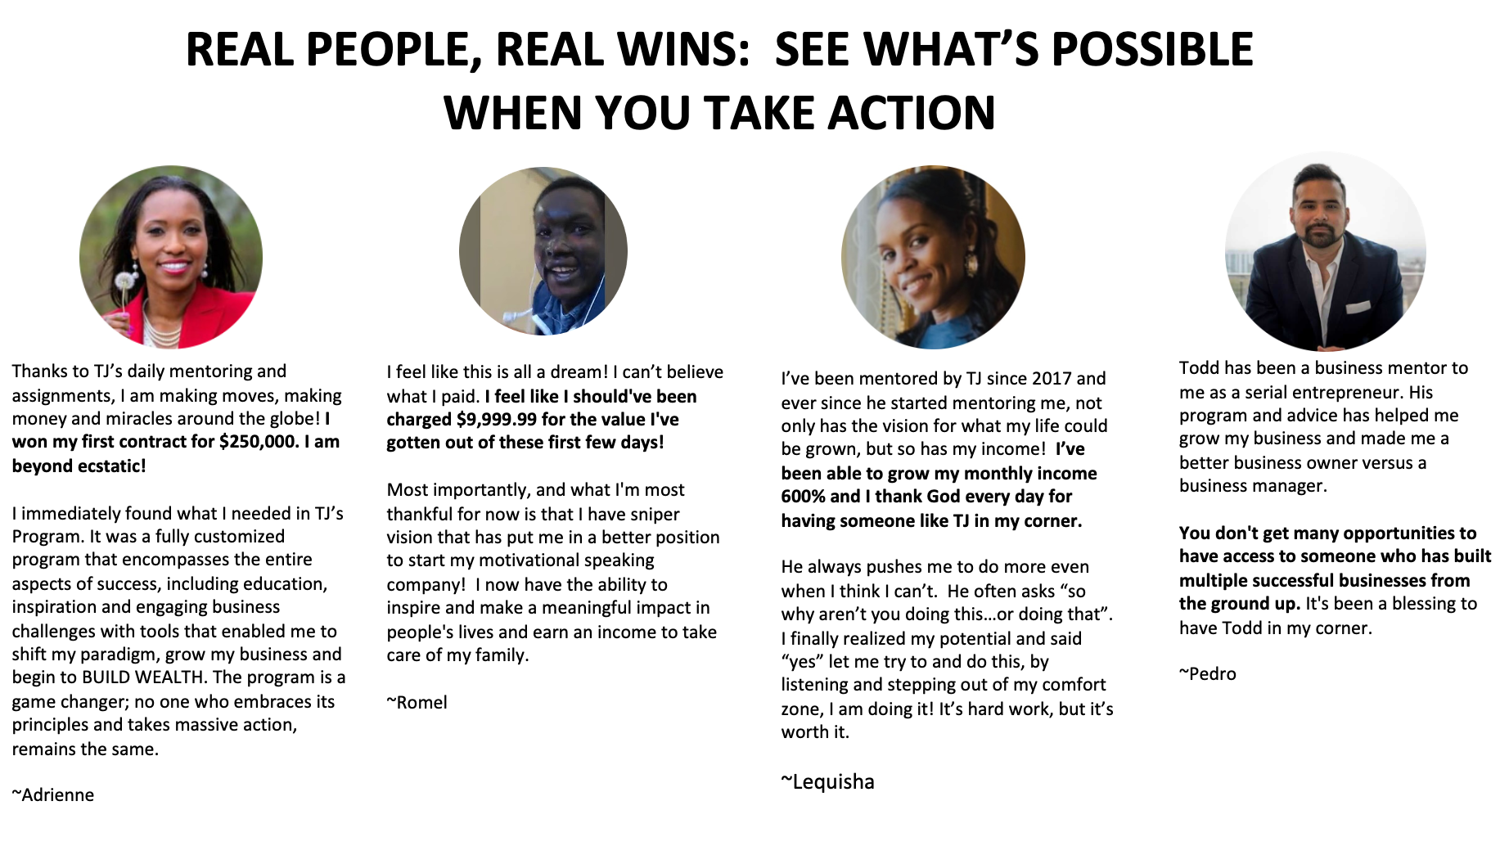

Enrollment closes soon. Secure your spot now and start building your future!
Join Now for 50% OFF button


There are 3 Killers Of A Great Business:
- Bad Habit #1: Overthinking the First Step. You keep planning, researching, and perfecting every little detail. But the longer you overthink, the longer you delay taking real action. Success comes from launching and refining as you go — not from waiting for perfection.

- Bad Habit #2: Waiting for the “Perfect” Time. You tell yourself you’ll start when you have more time, money, or confidence. The truth? The “perfect” moment doesn’t exist. Waiting just means missed opportunities and stagnant ideas.

- Bad Habit #3: Avoiding Sales and Marketing. You love your business idea but dread promoting it. Fear of rejection or discomfort with selling keeps you from putting your offer out there. No sales, no business — plain and simple.
Find out why businesses fail and master the strategies to overcome challenges and succeed faster than ever!

Meet Your Coaches
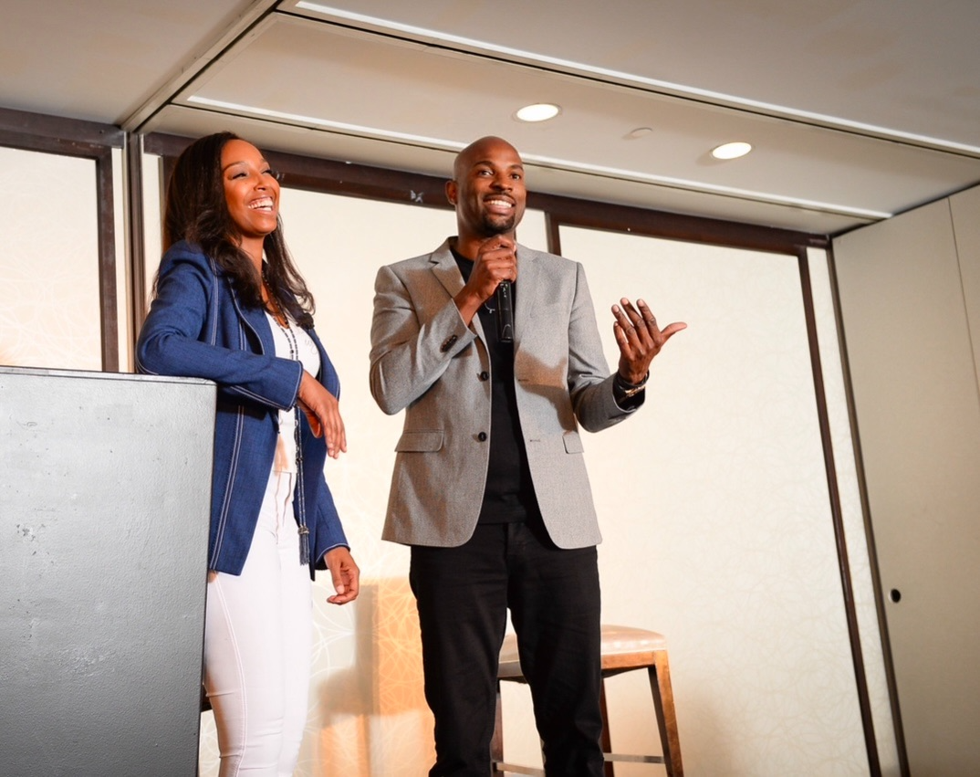

Meet JJ Smith
- #1 New York Times Bestselling Author of seven books, which have sold over 3 million copies sold across 21 countries; with over 30 years of expertise in health, wellness, and technology industries.
- Personal Brand Leader with 2.7+ million followers across social media platforms, demonstrating exceptional influence and engagement.
- Co-Founder of a Thriving Health Supplement Business, generating $45 million in revenue within five years and serving over 450,000 customers globally.
- Featured Nutrition Expert on top TV programs, including The Dr. Oz Show, The Steve Harvey Show, The View, Rachael Ray, and networks like NBC, FOX, CBS, CNN, CNBC, and CW.
- Published Thought Leader in premier magazines such as Glamour, Essence, Heart & Soul, and Ladies’ Home Journal.
- Proven Business Strategist, leveraging her experience as a top-level consultant at Booz Allen & Hamilton and equity partner in a successful tech services business.

Meet Todd “TJ” Johnson

- Founder and CEO of a High-Performing IT Consulting Firm, achieving over $50 million in annual revenue and successfully selling the company for 8 figures after 22 years of leadership.
- Co-Founder of a Health Supplement Business, generating $45 million in revenue within five years and serving over 450,000 customers globally.
- Entrepreneur with 30+ Years of Expertise, building and scaling successful ventures across diverse industries, including IT, retail, information marketing and publishing, hospitality, and commercial construction.
- Recognized by Inc. Magazine as a founder of one of the world’s fastest-growing information technology companies, showcasing exceptional growth and innovation.
- Shaped the Global Success of JJ Smith’s 7 books, overseeing negotiations and marketing efforts that have driven over 3 million copies sold across 21 countries
- Secured multiple seven-figure book deals, cementing JJ Smith’s status as an international bestselling author and global brand.

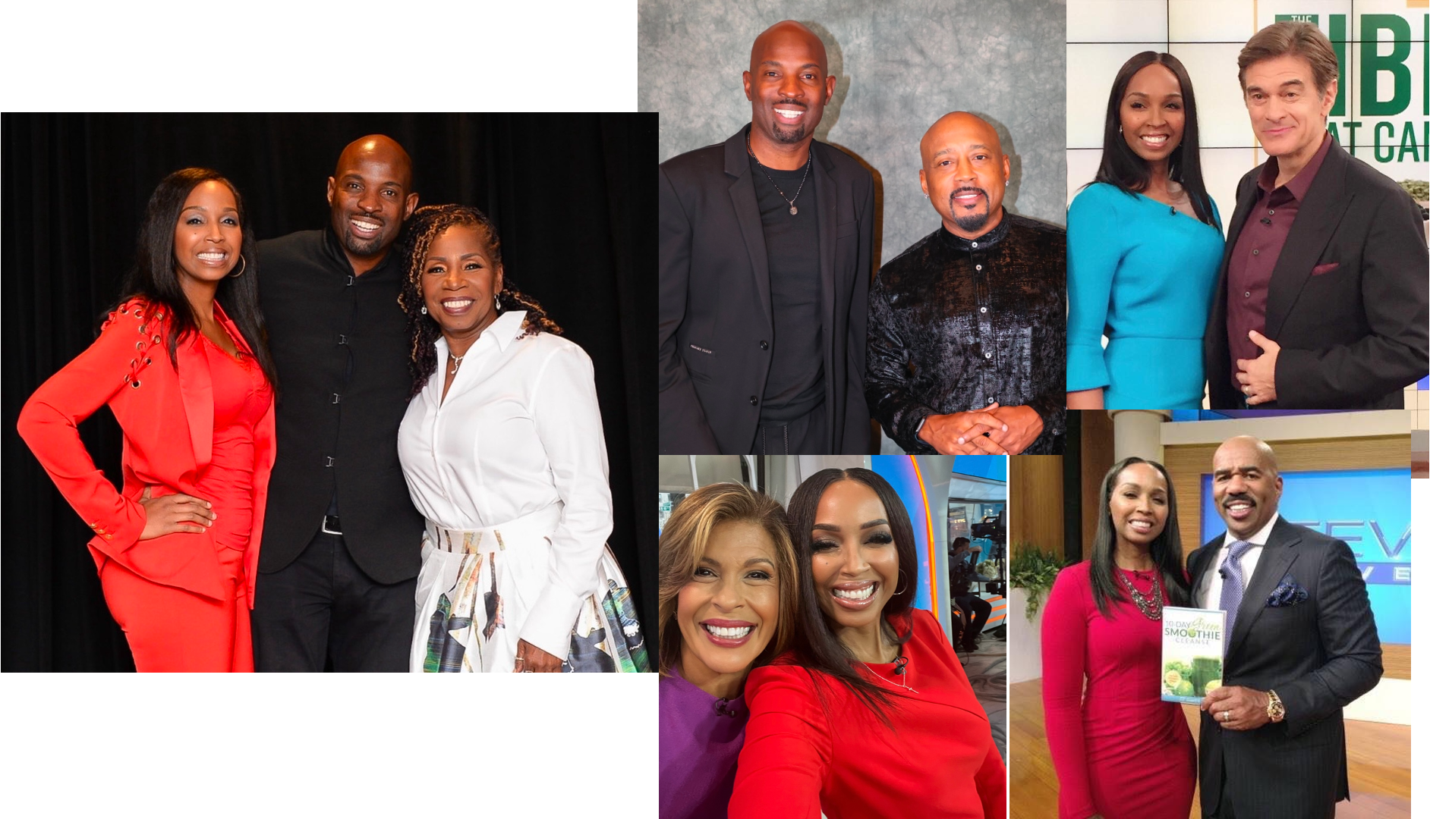

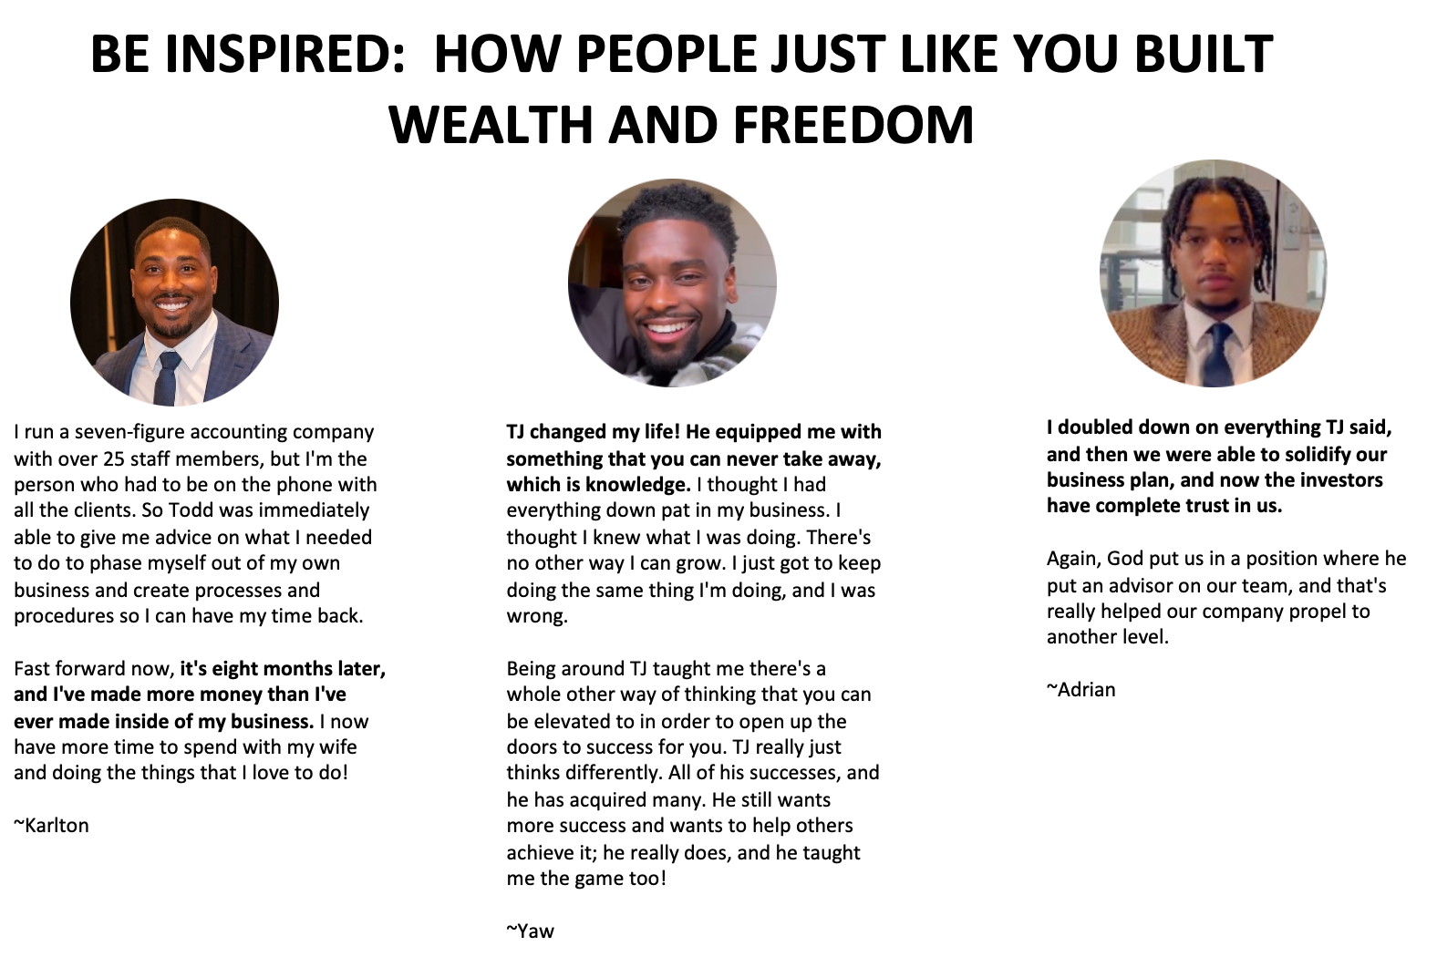

🎁 Here’s EVERYTHING YOU GET with the 90 Day Millionaire Course:
✅ A Fully Launched Business:
By Day 90, you’ll have a functional, revenue-generating business up and running
✅ Paying Customers in Hand:
You’ll have secured your first paying customers and know exactly how to get more.
✅ The 90-Day Business Blueprint:
A comprehensive, step-by-step roadmap breaking down exactly what to do each week for 90 days to launch their business.
✅ Paying Customers in Hand:
You’ll have secured your first paying customers and know exactly how to get more.
✅ Done-For-You Templates:
20+ done-for-you templates (business plans, marketing plans, email scripts)

✅ Powerful AI Training for Entrepreneurs
Equips you with the tools and strategies to harness the power of AI to transform your business. This will show you how to automate tasks, personalize marketing, enhance customer experiences, and uncover profitable opportunities with ease.
✅ Proven and Repeatable Systems for Success:
No "figuring it out as you go." You’ll have a complete system for marketing, sales, and service delivery.
✅ 12-Month Growth Roadmap:
You’ll have a playbook for success that you use to launch future businesses or scale this one.
✅ Weekly LIVE Coaching Videos and Demos with JJ & TJ, including Breakout Sessions:
Get direct advice from two proven multi-million dollar entrepreneurs.
✅ Weekly Actionable Tasks And Assignments:
Weekly tasks and assignments to teach, coach, and to ensure you’re taking consistent, focused action.
✅ Private “90 Day Millionaire” Mastermind Community
You’ll be surrounded by driven entrepreneurs and guided by JJ and TJ every step of the way, so you can ask questions, get support and celebrate wins.
✅ Confidence in Your Business
With a clear roadmap and measurable wins under your belt, you’ll have the confidence to keep going and ensure long-term success

This isn’t just a course—it’s a launch pad for your future business.

🗓️ Key Dates & Times
- Program Length: 90 Days
- Live Sessions: Weekly, 2 hours each
- Dates: February 17th May 19th

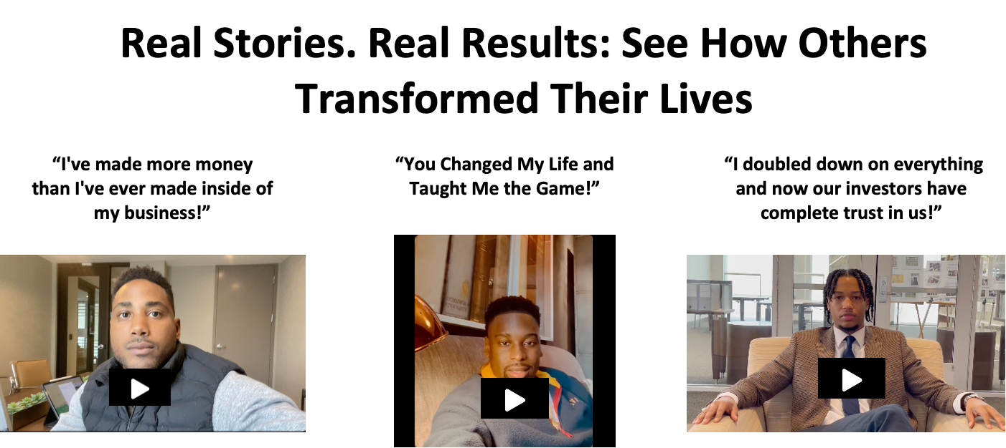

What Type of Business Can You Launch in 90 Days!
To provide targeted support, the 90 Millionaire Sprint will focus on foundational strategies while offering discussions tailored to these seven highly relevant business areas:
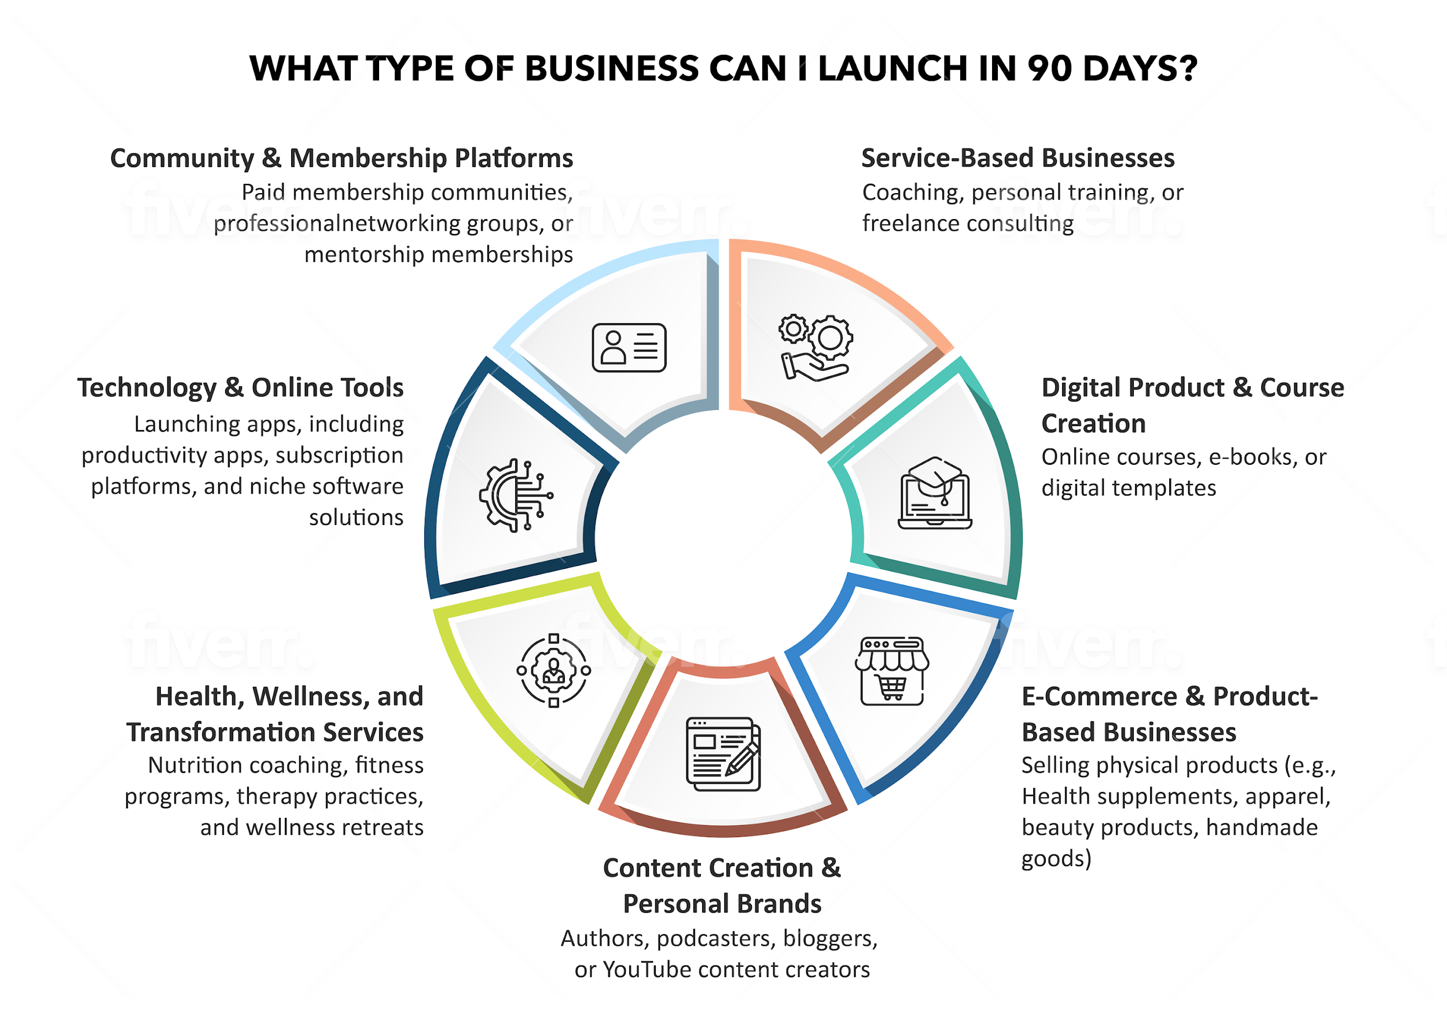

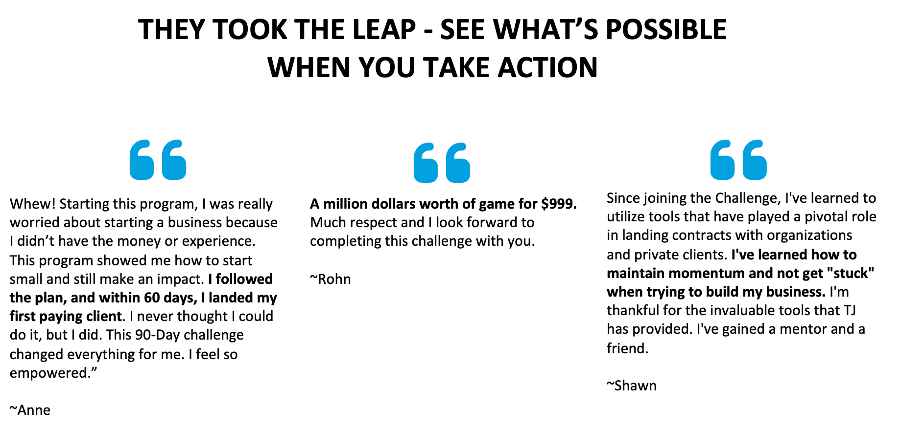

Frequently Asked Questions
What if I don’t have a business idea yet?
No problem! The course will guide you through brainstorming and validating a profitable idea.
Do I need a lot of money to start?
Nope! We focus on strategies that require minimal upfront investment.
What if I’m super busy with my 9-to-5?
This course is designed for busy professionals with actionable steps that you will complete during live course sessions.

Is this also for people who work full-time?
Yes! This sprint is perfect for you if:
- You’ve Been Sitting on a Business Idea: Turn your idea into a real business with paying customers in 90 days.
- You’re a Coach, Consultant, or Freelancer: Learn how to package and sell your services with proven systems for operations, marketing, and delivery.
- You Have a Side Hustle: Launch or grow your side business without quitting your 9-5 job
- You Have a Passion Project: Monetize your skills or hobbies and create a profitable business you love.

If I don’t like it, can I request a refund?
Absolutely! We offer a 30-day satisfaction guarantee. If you’re not happy within the first 30 days, you can request a full refund.

5. How long will it take for me to see results?
Most participants secure their first paying customers within 60 days, and by the end of 90 days, you’ll have a fully launched, revenue-generating business.

Are you ready to finally launch your business and start making real money?

Join Now for 50% OFF
Today’s Special Registration Price: $999 or (Was $1,999)
Pay in full or pay OR
Buy Now, Pay Later with ShopPay which allows you to choose a flexible payment plan
YES! I’m Ready!

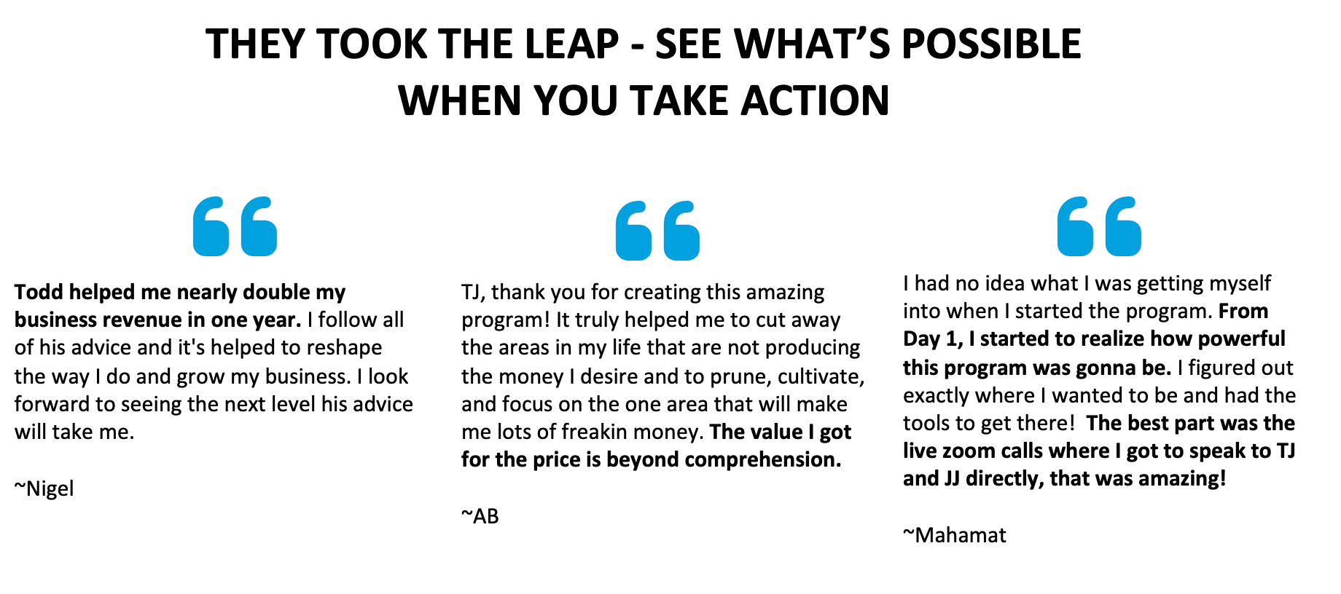

Refund Policy: Our Personal Guarantee

I need you to be confident that this is the right program for you. So if you’re not 100% thrilled within 30 days, I want to send your money back.

So, if for any reason, this online coaching program doesn’t meet your expectations, just email my support team to cancel within 30 days of your purchase date. No reason needed. And that’s my promise!

EXTRA GRAPHIC (OPTIONAL)



