JJ SOCIAL MEDIA GRAPHICS

We are looking for a series of social media graphics for Instagram (standard size 1:1 (1080x1080px) that are ALL TEXT. We want the following quotes below on each graphic; one quote per graphic. AND, In very small letters at the bottom of each graphic, add @JJSmithOnline

The look and feel of these graphics should be complimentary to the color palette attached below; but keep them simple. But the design is up to you; at the end of this document, I provided various samples of all text graphics that I like as examples.

The QUOTES:

- Wake up tomorrow with a flatter belly- yes, this overnight remedy works like magic!
- Struggling with bloating and belly fat? Try this natural solution tonight, and wake up feeling lighter!
- One supplement, one night; your belly bloat could be gone by morning. Here's how it works!
- Finally-a natural solution that flattens your belly AND eases stomach bloat
- Sis, your hormones are out of whack - that's why the weight won't budge!
- Frustrated with belly fat that won't budge? I've got the solution that finally worked for me-no crazy diets required.
- That stubborn belly fat isn't your fault - here's what no one tells you.
- You've been lied to - 'just eat less and exercise more' doesn't work in menopause
- A natural way to boost GLP-1 - no injections, no side effects, just real results. Here's how it works
- GLP-1: the magic behind the weight loss drugs. But here's the secret - you can boost it naturally without a prescription!

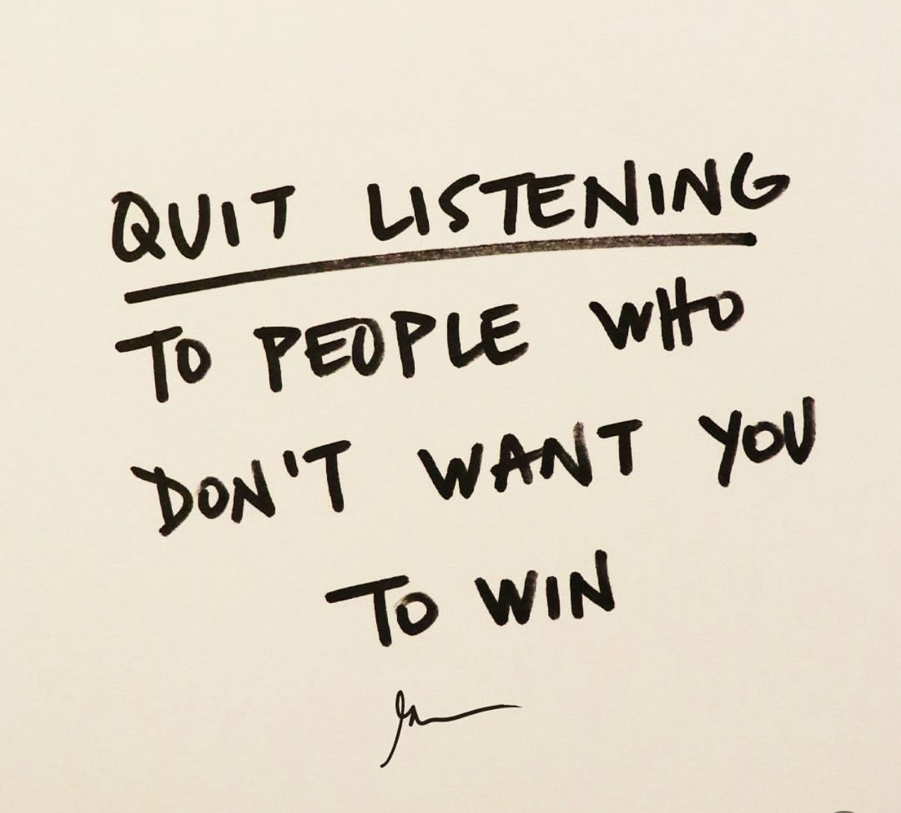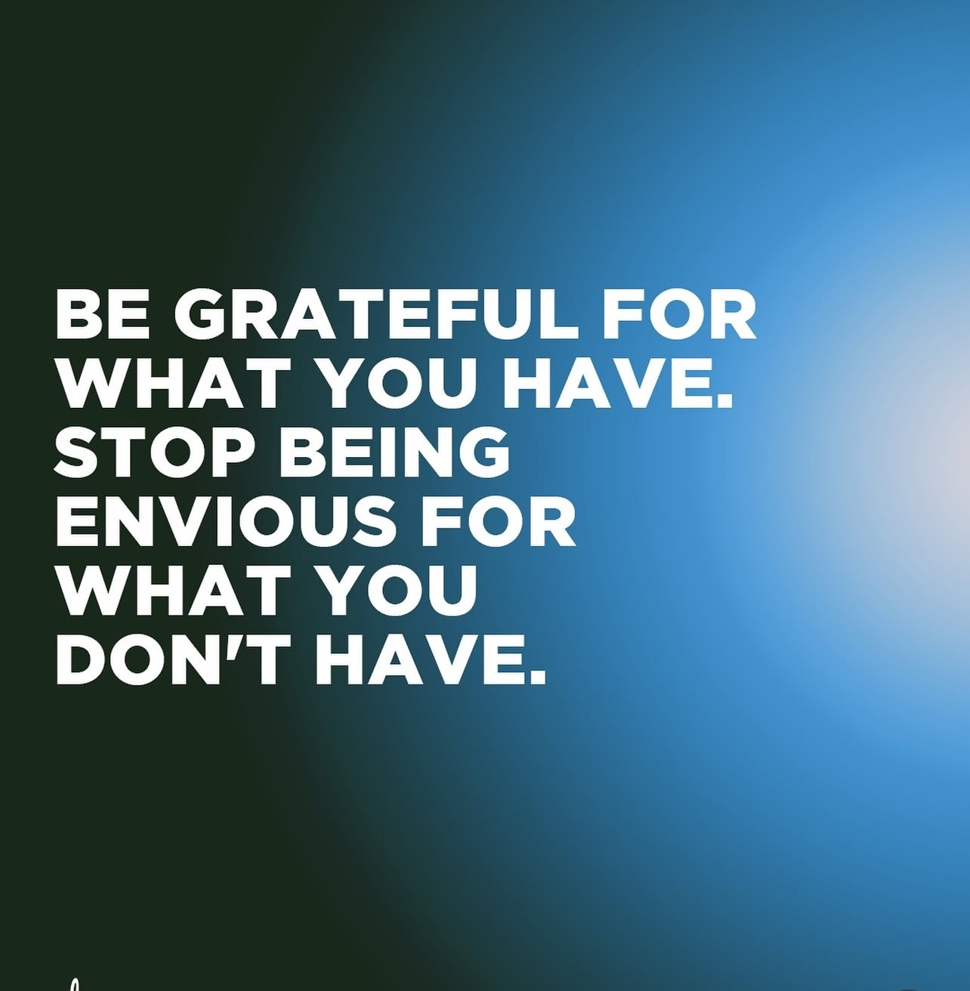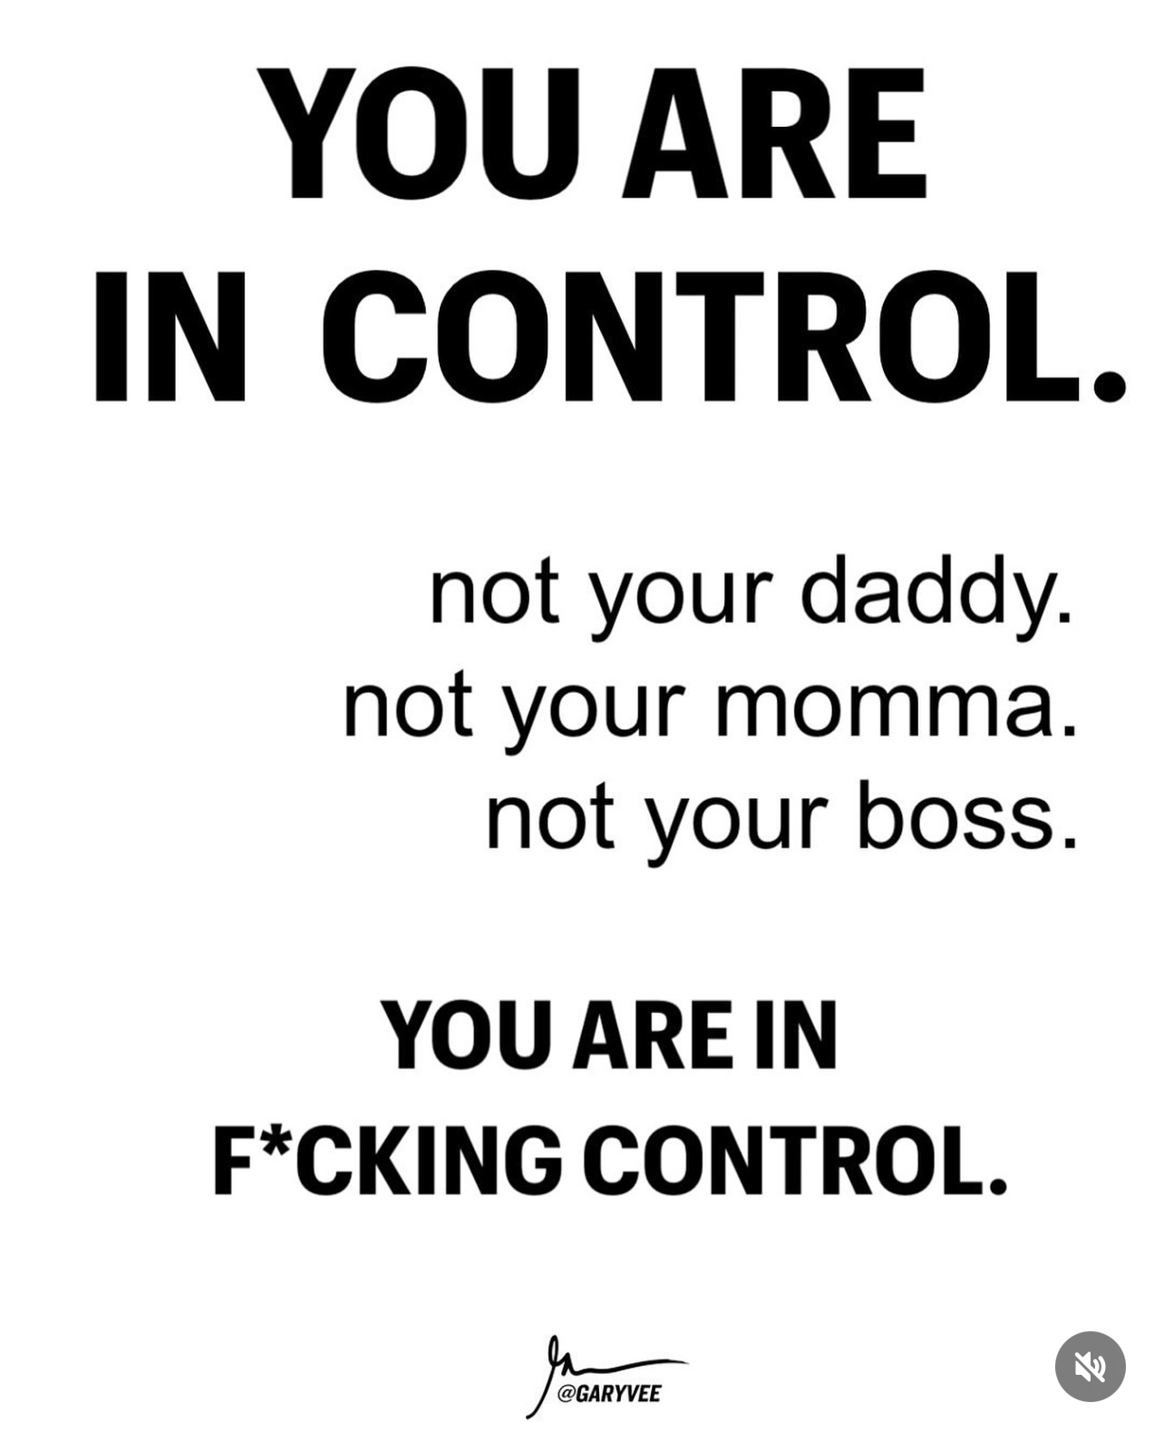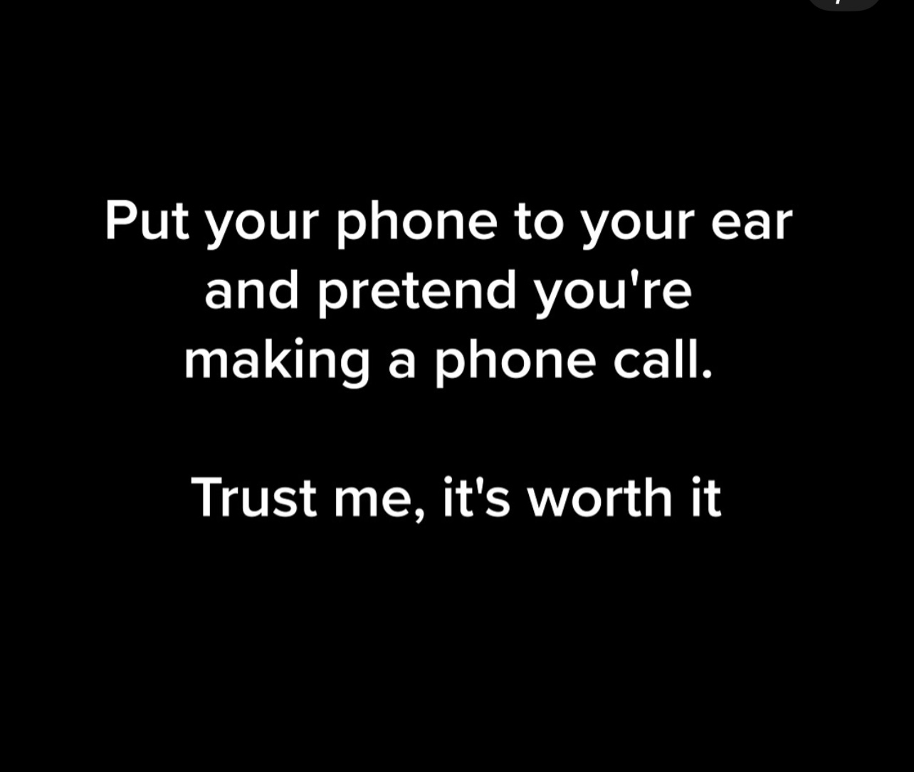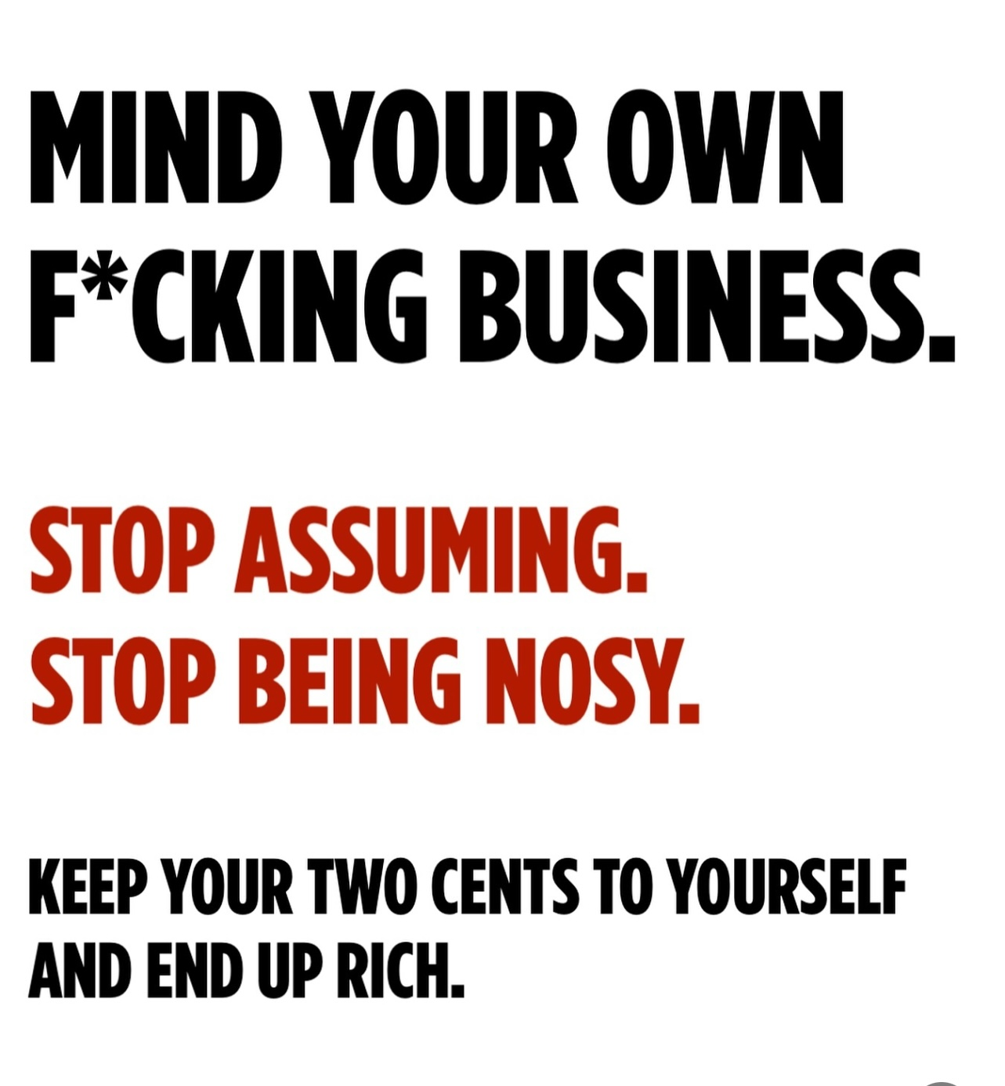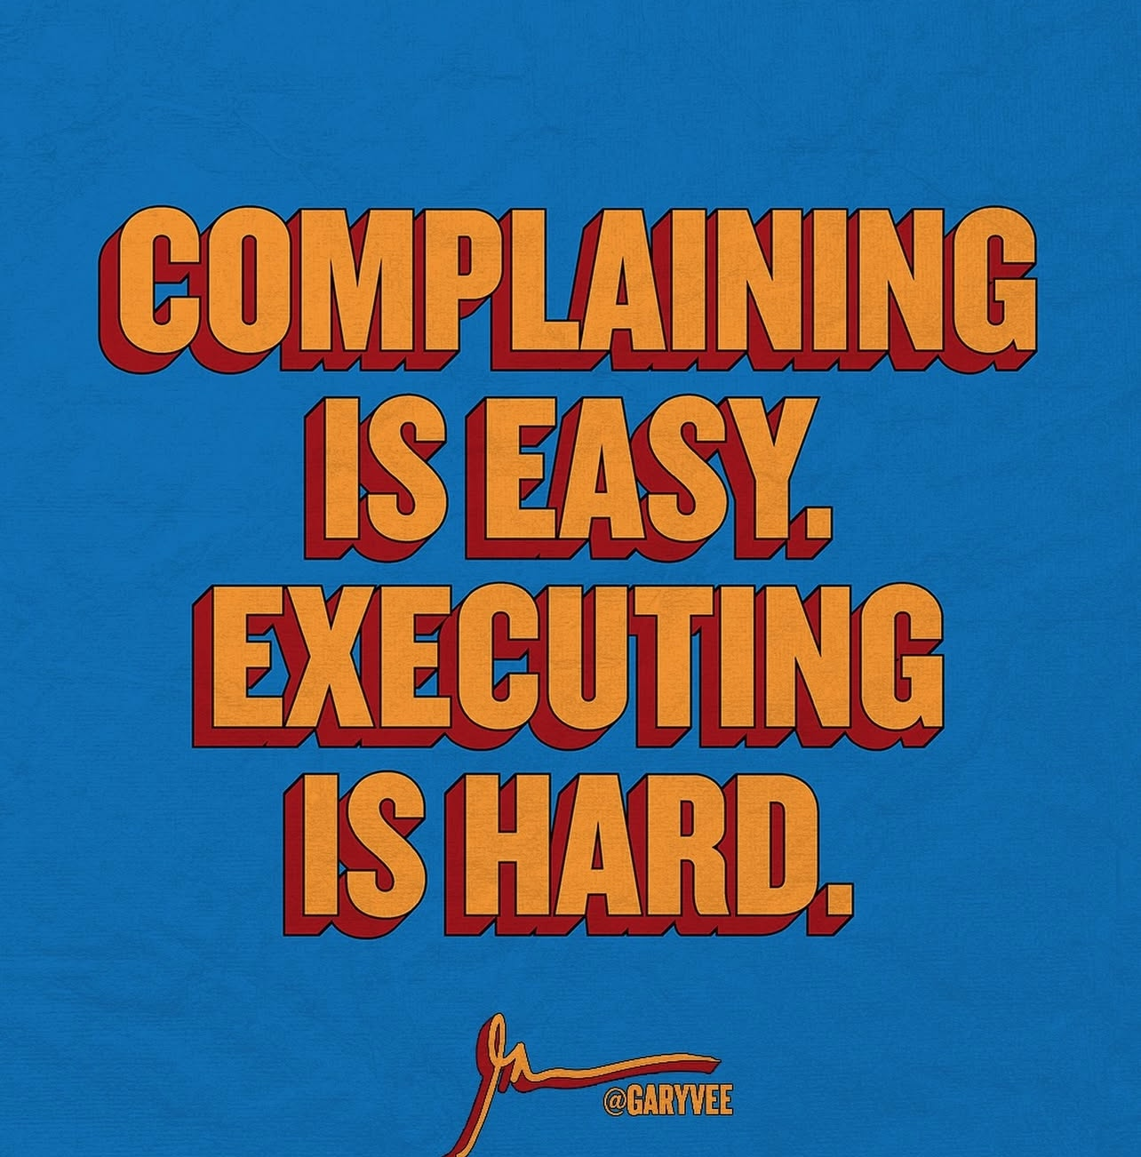

Color Palette

