Consent2Go for Childcare Website Information
There are 8 proposed pages for this site, which includes;
- Home
- Our System
- Excursions & Events
- Support & About Us
- Pricing
- FAQ
- Contact Us
- Terms & Conditions
The first 7 are included in the menu located at the top of the page, with the 8th located in the footer.
In terms of designs, we have provided a few example sites below.
- https://www.wix.com/website-template/view/html/2899?originUrl=https%3A%2F%2Fwww.wix.com%2Fwebsite%2Ftemplates%3Fcriteria%3Dclic%2B2035&tpClick=view_button&esi=ef0c0622-3eb1-4b7c-9f8e-42b176485c3b
- https://www.docusign.com/en-au/intelligent-agreement-management
- https://www.docusign.com/en-au/products/electronic-signature

Important Notes
There are a few things that you must take into consideration in regard to the creation of the website.
- There must be no animated elements or moving graphics. Meaning that we do not want assets to move across the page or zoom in when hovered over. Please keep the designs static.
- The website must be optimised for mobiles and tablets.
- We do not want the source of images to be visible to the user.
- We do not need social media icons, as they are not used by the company.
- We will organise the domain and server for the site to be hosted on.
- We require the WordPress password, this is mandatory.
- We do not need SEO optimisation; we have a person in-house who will be actioning this.
- The header menu must scroll with the customer, we do not want it to sit still at the top of the page and disappear when moving down.
- Call to action button location have not been specified as yet but will be required.
- Bullet points used in the text below serve to indicate spacing and subject sub heading they are not required or expected to be used.
- Design should compliment the text, for example on the OUR SYSTEM page in the C2G Assistant section there are ten examples outlined. While these may be all used we anticipate that the site design will accommodate these various examples and we will not be actually listing the words EXAMPLE ONE, EXAMPLE Two etc
- On the home page there will be an additional menu item in the upper most right side of the menu bar which will be LOG IN, ie the link to the log in page that our customers will log into our software product. This page location has not yet been provided.
- We wish to incorporate a Web Form from Pipedrive as our contact us form so the enquiry feeds directly into our sales database.
- Similarly, we will also use the basic Chatbot provided by Pipedrive for similar reasons. We will need further discussion and clarification as to the implementation of the above two points.
- The italic text at the bottom of the Home Page, labelled as ‘Key Benefits’ are general points that may appear at different stages through out the home page, they are not intended to be a section of their own. And they do not need to appear as a collection of points, each point can be made at various stages throughout the home page, design dependent ( the title Key Benefits is not required to be displayed)
- The section ‘And Yes’…. at the bottom of the Home page is a sub section to itself and a sub heading of the whole page it is not a sub heading of the Excursions section.

Design Notes
Colours: Our colour palette is shown below, this is rendered from the Logo to best suit the main colours.
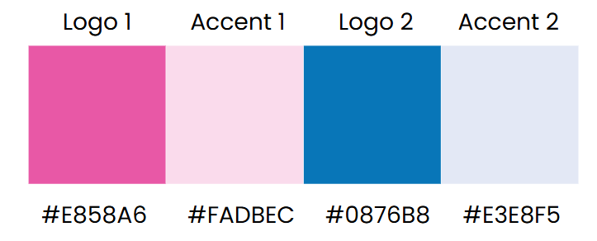
Graphics: When using graphics within the website, please stick to vector characters and monotone icons. Examples are shown below;


We will provide you with a file that contains the company Logo, Favicon and an assortment of graphics to use. If you need further sourced, please let us know.
Page Layouts: We do not have a strict idea of what we want each of the pages to look like. However, please see the link below to examples of possible options. As there is a lot of information we want to provide customers, we need to ensure the designs are set out in a way that is easy to read and hooks the viewer.

Text Notes
We have created a first draft of the text we would like to include for each page of the site. This is subject to change as we go through the design process. It is important to note that the information must be in plain English, so that it is easy to follow and understand. Our target audience may have no prior knowledge of our field, so we want to ensure they are able to comprehend every point we need to make.
Below you will find the desired first draft for the text, broken down by pages.

Home Page
The Consent2go system helps childcare providers improve the safety of a child in their care.
It will reduce staff workloads and significantly elevate your Service's 'duty of care' standards.
This five-part system is designed to aid and complement your current systems. Your Service can easily implement one or all parts to reduce your labour, risk and legal exposure.

The Consent2go System
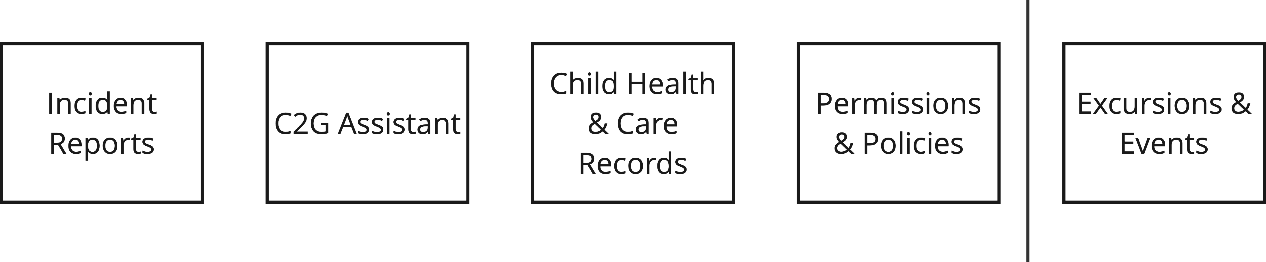

As not all Service Providers conduct excursions, the only optional add-on is 'Excursions & Events'. This option easily manages the entire excursion process, including Preference selection, Risk assessments, Parents & Guardians permission and much more.

Incident Reports
Incident, Injury, Trauma, and Illness Reports can now be done with paperless ease.
Save time issuing, tracking and finalising Incident Report paperwork.
Summary spreadsheets are automatically compiled for staff use without the need for tedious and time-consuming data entry.

C2G Assistant
The work is done for you. No set up or instructions are required.

How it works – Example 1

A child's Care Plan expiry date is approaching. The Parents or Guardians are automatically notified and asked to upload a new plan. When they do, the system will alert the appropriate staff member so they can vet the plan and check its contents.

If a new plan is not uploaded an alert will be sent to the staff member to action.

Reminders and alerts are automatically created around important expiry dates, such as:

- Eppi pen expiry
- Medication expiry
- First Aid kit components that expire

How it works – Example 2

Children and Staff emergency contact lists are automatically created. They are 100% accurate at all times as they are updated live - in real time.

How it works – Example 3

When expiry dates are approaching for all staff qualifications, certifications and training, those staff are automatically advised and asked to upload their new qualification, e.g. Working with Children Certificate, car driver's licence, etc.

Supervising staff will receive alerts if requests for new documents are not being addressed by their staff.

Child Health & Care Records

By enabling Parents & Guardians to be 100% responsible for the updating of their child's medical and care information in a simple and easy way, significant risk and liability is moved from the Service Provider to the Parent or Guardian.

More importantly, this also delivers the safest and most reliable outcome and the least risk for the child.

Care plans are easily uploaded by the Parent or Guardian.

The expiry date on a care plan creates an automatic follow-up at a future point in time.

Eppi pen expiry date, medication expiry date is also tracked by the system.

A risk minimisation plan template is built in to easily respond to a care plan.

At any time, with the touch of one button a Service Provider could request a child's Parents & Guardians to validate or update their child's health and care information.

Your Service’s emergency contact list is automatically updated with no staff involvement.

There is no need for Parents & Guardians to update information from scratch at the start of each year. Previous medical status is retained and only needs to be validated or updated.

Permissions & Policies

C2G allows all your permissions to be easily accessible and distributed from one place.

Includes:

- Photo permission
- Social media permission
- Creams & generic medicine use permission
- Ambulance permission

Policy and procedure documents can also be shared with Parents & Guardians

For example:

- Exclusions Policy
- Medical Policy
- Sun Protection Policy

Excursions & Events
Excursions & Events provides a practical, user-friendly process for staff to plan and manage Excursions, Incursions, Events or Activities.

Staff can easily manage safe and compliant excursions / events, regardless of their experience level.

Features
We provide over 150 activity-based risk assessment templates, which consider child risks, activity risks and event risks.

Using the preference selector, you can offer Parents & Guardians a multiple choice of activities or attendance days.

You can also obtain a Parent & Guardian digital consent to ensure timely response.

Allows you to communicate with one or all Parents & Guardians with the touch of a button.

Navigate risk and compliance easily and help staff understand and interpret risks to protect the child, staff and your business.

And Yes…..

Easily deal with split family requirements and court order management.

Protect privacy of all information collected with built-in security that’s designed for handing sensitive information.

Emergency medical information is still available in the app - even when you are out of range and offline.

Save time with automatic filing for archive, record keeping and accurate document retention.
If you need to revert to a paper form, e.g. help an English-as-a-second-language family, the PDF and manual override enables your people to help.

A full log of all actions and communication is easily accessible in one place to quickly confirm any enquiries.

Convenient 24 hours access for Parents & Guardians with any internet connected tablet, phone or computer. If preferred, Parents & Guardians can choose to use the free mobile app.

Key Benefits
- Decrease your labour costs, and there's no need to hire that extra person given the practical help our system provides. C2G will help you reduce your workload, not add to it.
- Help your staff to complete administration and compliance requirements quickly, easily and more thoroughly the first time.
- After sale software support is provided by our people, located across Australia. You can talk to us, email or use our support ticket system.
- Be ready to demonstrate compliance at your next audit - without the need for any preparation!
- You're in good hands... ( consent2go for schools logo ) The Consent2go for Schools platform was the foundation technology facilitating Consent2go for Childcare. Consent2go for schools was released in 2017 and has since revolutionised the landscape of school age student healthcare and duty of care management for both on-campus and off-campus education settings. Consent2go for schools processes in excess of a million event invitations per month for customers across Australia, New Zealand and International locations.

Our System

Incident Reporting
- Incident, Injury, Trauma and Illness Reports can now be done with paperless ease.
- Save time issuing, tracking and finalising Incident Report paperwork.
- Summary spreadsheets are automatically compiled for staff use without the need for tedious and time-consuming data entry.
- Although not mandatory, you can easily attach an incident photo for specific record keeping.
- Supervisor can easily check staff reports prior to sending Parents & Guardians a report.
- Receive automatic staff and supervisor alerts if reporting is not finalised:
  - Supervisor fails to check and issue report to a Parent or Guardian
  - Parent or Guardian did not acknowledge receipt

C2G Assistant
- Consent2go's Assistant ( C2G Assistant ) is the collective term we use to describe our embedded workflows.
- No set up and instruction is required for your new C2G assistant – it all happens automatically.
- A workflow might be an automatic reminder - a reminder that you did not have to set.
- Other times, the system will not only remind you of something that needs action but will automatically do the work required on your behalf.
- C2G Assistant saves you administration time and effort. In fact, in many ways we provide a safer solution as often we remove the chance of a well-intentioned human forgetting or making mistakes.
How it works:

Example 1

A child's Care Plan expiry date is approaching. The Parents or Guardians are automatically notified and asked to upload a new plan. When they do, the system will alert the appropriate staff member so they can vet the plan and check its contents.
If a new plan is not uploaded an alert will be sent to the staff member to action.
Reminders and alerts are automatically created around important expiry dates, such as:

- Eppi pen expiry
- Medication expiry
- First Aid kit components that expire

Example 2

Children and Staff emergency contact lists are automatically created. They are 100% accurate at all times as they are updated live - in real time.

Example 3

When expiry dates are approaching for all staff qualifications, certifications and training, those staff are automatically advised and asked to upload their new qualification, e.g. Working with Children Certificate, car driver's licence, etc.

Supervising staff will receive alerts if requests for new documents are not being addressed by their staff.

Example 4

If a child's medical record is accessed by event or excursion staff an automatic notification to the Parents or Guardians occurs advising that private information has been accessed.

Example 5

All details from individual incident reports are automatically collated and summarised to spreadsheets for the Service to use in a multitude of ways.

Example 6

If an incident report sent to a Parent or Guardian is not acknowledged automatic alerts will trigger so it can be followed up by staff.

Example 7

Filing and archiving of documentation for future reference occurs automatically.

Example 8

Parents and Guardians do not need to complete their child's full medical details at the start of each year, our system remembers prior information, so Parents & Guardians are merely required to validate or update information.

Example 9

Staff needing to conduct an Excursions or Event risk assessment will be automatically assisted with over 150 risk assessments templates. When documenting risk assessments our system will proactively guide your staff to consider child risks, staff risks, activity type risks, travel risks as well general risks that need to be considered.

Example 10

If an incident occurred during an excursion e.g. google maps was not accurate. At a future point in time when planning subsequent excursions to the same location an automatic warning will notify the staff member about the previous issue.

Child Health & Care Record
A major factor determining your ability to provide appropriate Duty of Care in an urgent medical situation is the knowledge you have about the child's medical condition and medical status.
Your staff and first responders will act on this knowledge. The child's health and care record need to be:
• available quickly
• relevant and complete with quality information
• 100% accurate and correct
• Current and up to date
A Care Plan...
- Care plans are easily uploaded by the Parent or Guardian.
- Should Parents & Guardians who are new to care plans need assistance there are links to external web-based guidance embedded.
- Notifications are immediately sent to staff to vet the new plans received, e.g. to check it's signed by the doctor.
- By entering the expiry date of a care plan this creates an automatic follow-up at a future point in time.
- Eppi pen expiry date and medication expiry dates are also tracked by the system.
- A Risk Minimisation Plan template is also provided to easily respond to a care plan.
A structured record…
- Parents & Guardians are stepped through options and can easily select from predefined lists addressing:
  - Medical Condition Type
  - Symptoms
  - Triggers
  - Medications
  - Care Instructions
- By having a predetermined list of medical conditions and medication names it not only makes it easier for Parents & Guardians to provide correct information but significantly decreases the chance of error and miscommunication.
Medical information becomes inaccurate over time, so it is critical that updates are made regularly and are easy to do.
Request an update...
- At any time and with the touch of one button, a Service Provider can ask childrens’ Parents & Guardians to validate or update a child's health and care information.
- Staff can instantly request updates for all children being cared for at the Service - either for a given room or group of children, or for a single child.
- Updates are requested from within the system so there's no need for separate emails or external follow-up and no time is wasted manually collating responses.
Parents & Guardians proactively update...
- Parents & Guardians can update a child’s record at any time without having to contact the Service Provider.
Incidental updates...
- Excursion, Incursions, Events and Activities planned with Consent2go for Childcare automatically seek confirmation of health status while requesting Parent or Guardian consent.
It's live information...
- New information or updates made by Parents & Guardians are instantly updated in the child's medical record.
  - Staff don’t need to transpose data.
  - Staff don’t need to do any importing or 'uploading' of data.
  - There is no delay to the availability of the information.
- A Service Providers Emergency contact list is automatically updated with no staff involvement.

Sensitive data management...
- Security is in place to protect information collected.
- Privacy protection is role-based and controls who views what information and when.
- Sealed envelope features ensure any unanticipated access i.e.. medical personnel trigger automated alerts and notification to Parents & Guardians.

And much, much more...
- Putting medical updates completely back in the hands of Parents & Guardians provides significant reduced risk for the Service Provider AND is also the least risk for the child.
- There is no need for Parents & Guardians to update information from scratch at the start of each year. Previous medical status is retained and only needs to be validated or updated.
- A dedicated mobile app for Parents & Guardians enables updates that are simple, quick and easy to follow (Parents & Guardians do not need to use a computer to update, they can use their phone if preferred).
- Colour coded medical triggers and medical symptoms help staff to quickly understand child health information.
- Save staff time with automatic medical updates:
  - no email discussion
  - no verbal update requests that can be easily forgotten
  - no paper forms that can be lost, misplaced or aren’t entered in a timely manner
- Avoid confusion around complex family structures, including court orders.
- Service Providers may only see a child on one occasion so you cannot rely on staff having personal knowledge of a child's medical condition. Consequently, it is critical that your systems provide complete, consistent, accurate and reliable information.

Permissions & Policy
Have all your permissions easily accessible and distributed from the one place.
For example:
  - Photo permission
  - Social media permission
  - Creams & generic medicine use permission
  - Ambulance permission
Custom permissions can also be included here.
Policy and procedure documents can be shared with Parents & Guardians.
For example:
  - Exclusions Policy
  - Medical Policy
  - Sun Protection Policy
Importantly, an automatic full log and history of what was shared with Parents & Guardians is created which is accurate and trackable should the need arise.

Excursions, Incursions, Events & Activities
(link to the page from here)

Excursions & Events
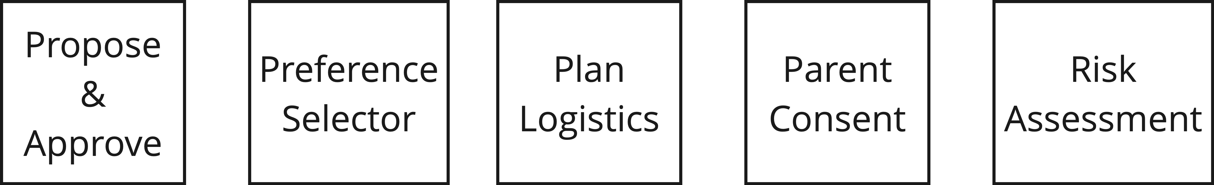
Excursions & Events provide a practical, user-friendly process for staff to plan and manage Excursions, Incursions, Events or Activities
- Staff can easily conduct safe and compliant excursions or events, regardless of their experience level.
- Customise the process for your needs, including logistics planning, transport, staff requirements, Parents & Guardians consent and, if required, excursion payments.
- We provide over 150 activity-based risk assessment templates that consider child risks, activity risks and event risks.

Propose & Approve
- If desired, Services can implement a comprehensive approval process to enable oversight of what is being organised by staff.
- Create different approval streams for various activity types and Service locations.

Preference Selector
- Mostly applicable for OSHC Vacation care when multiple excursions and daily activities are offered. Preference sector is not required when a single Excursion or Event is being conducted.
- Easily offer Parents & Guardians multiple choice of activities or attendance days.
- If desired, a maximum number of participants for each activity can be set.
- A spreadsheet is automatically created with all responses to assist staff in planning which children will be invited to attend which day or activity.

Plan Logistics
- Plan and organise:
  - Children to be invited and attend
  - Transportation
  - Required staff and supervision
- An itinerary is automatically created.
- If children with medical or catering alerts are added to an excursion / event, notifications are sent to the staff member to assist their planning.
- Pre-activity checklist 2 days prior can be used if desired e.g. remind staff to check weather.

Parent or Guardian Consent
- Communicate with one or all Parents & Guardians with the touch of a button - obtain Parent or Guardian digital consent to ensure timely response.
- We interface with payment gateways for secure digital processing of excursion payments.
- Quickly communicate with Parents & Guardians via app messages, email or SMS from within the system.
- Send and manage invitations from a single screen that captures whether Parents & Guardians have viewed, opened or accepted the excursion or event invitation. Reminders can be sent to all invitees who have not responded.
- Summary screens automatically collate all responses, covering children attending and not attending.
- The child's health and care record is fully integrated, so Parents & Guardians can simply validate or update details. There is no need to re-enter information. Medical updates are also instantly updated on the child's main health and care record.

Risk Assessment
- Navigate risk and compliance easily. Help staff to understand and interpret risks to protect children, staff and the service provider.
- Easy visualisation of risks with over 150 best practice activity-based guidelines available during planning as staff are guided to acknowledge specific risk identification and mitigation:
- Child risks - risks that may impact the safety and well-being of participants
- Activity risks - risks that are linked to specific activities being undertaken
- Transport risks - risks associated with transport to and from the activity
- General risks - general risks associated with the event

- Customisable risks and mitigations you create can be saved as future templates
- The risk framework and guidelines we provide ensure all staff will follow the same process regardless of their experience level.
- Risk assessments conducted confirms staff are aware and have controls in place for all risks associated with the event.

Conduct Excursion
- To ensure ease of use we have two different mobile Apps - one for Parents & Guardians and one for Staff.
- Parents & Guardians and staff can readily communicate via the mobile app, email or SMS from within the system while on Excursion.
- Staff can mark child attendance from within their mobile app
- The app also allows staff on excursions to view a child's medical information should it be required.
- Medical condition lists and proactive alerts for children attending are automatically created.
- Conditions are automatically categorised and colour coded for ease of reference:
  - Life Threatening
  - Urgent Attention
  - Non-urgent Attention
  - Information Only
- Emergency medical information is still available in the app if out of range offline.
- Staff can message one or all of the children's Parents & Guardians while on excursion, e.g. notify them that the bus is running late.

Review
- Compliance requires constant assessment with what went well and what didn't go well.
- Incident reporting and post-excursion reviews identify areas where risks can be further mitigated in future excursions and events.
- If an incident occurred during an excursion, e.g. a campfire was out of control due to winds in the valley etc. an automatic warning will notify staff about this issue when planning subsequent excursions to the same location.

And Yes…..
- Duplicate prior Excursions, Incursions, Events or Activities to save time.
- Automatically a full log of all actions and communication is created, the entire Excursion or Event is trackable, traceable and auditable.
- Excursions and Events system can be used whether Parents & Guardian consent is or isn't required.
- Having a replicable process for your staff to follow protects the Service Provider, Staff and Children.

- Automatic filing, archiving and record keeping is reliable and decreases staff workload.
- Overnight OSHC Camps and accommodation planning are also included.

Support
We provide after sale support for both Service Provider Staff AND Parents & Guardians.
- Support is provided during standard office hours via telephone, email or through our ticketing system.
- There are no additional costs or fees for this support.
- Instructional videos are also provided to assist staff during the welcome and on-boarding process.
- Our on-boarding process is tailored to each Service Provider as we set up the system in accordance with your preferences.
- We have in-house software developers, so our product is constantly evolving. Our product development is driven by customer feedback so we encourage your proactive discussions once we welcome you on-board.
- Our ratio of support calls to traffic is exceptionally low. We mainly attribute this to our experience with helping Schools care for school aged children.

About Us

The Evolution of C2G
The Consent2go for Schools platform was the foundation technology that has led to Consent2go for Childcare.

Consent2go for Schools was released in 2017 and has since revolutionised the landscape of school age student healthcare management and duty of care management for both on-campus and off-campus education settings.

Consent2go for Schools routinely process more than a million event invitations each month for customers across Australia, New Zealand and International locations.

Pricing
Introductory Pricing is currently on offer

Customers pay an annual fee in advance to use our software.

Pricing is based on a per 'Service' basis. The price per Service differs based on the number of approved places the Service is registered for.

With one exception, all parts of the Consent2go for Childcare system are provided as standard.

The only additional service fee applies to the 'Excursions & Events' facility.

Note that Service Providers intending to use 'Excursions & Events' must also operate the standard Consent2go Service.

The set up and on-boarding fee is ONLY applicable when setting up a new Service. It is a one-off cost and is not repeated in future subscription renewals for that Service.

While the annual fee is determined by the number of approved places a Service is registered for, it is important to note that the Service may use the software for more children than its approved number. While maximum numbers are applicable, they are generous and designed to prevent misuse.

The prices below allow for payment via direct debit authority being in place via your Service’s credit or debit card. If Service Providers select to pay on account, all prices are 10% greater than the amounts shown below.

Prices do not include an SMS telco pack if Services want to send SMS text messages across a telco network. Please note that this is not required to send in app messages and notifications or emails from within our system.

Our pricing is designed so use of Consent2go for Childcare is not a net cost to your Service. Meaning, the saving we provide in labour should be greater than what we charge you to use our software service. If this is not the case please discuss this with us.

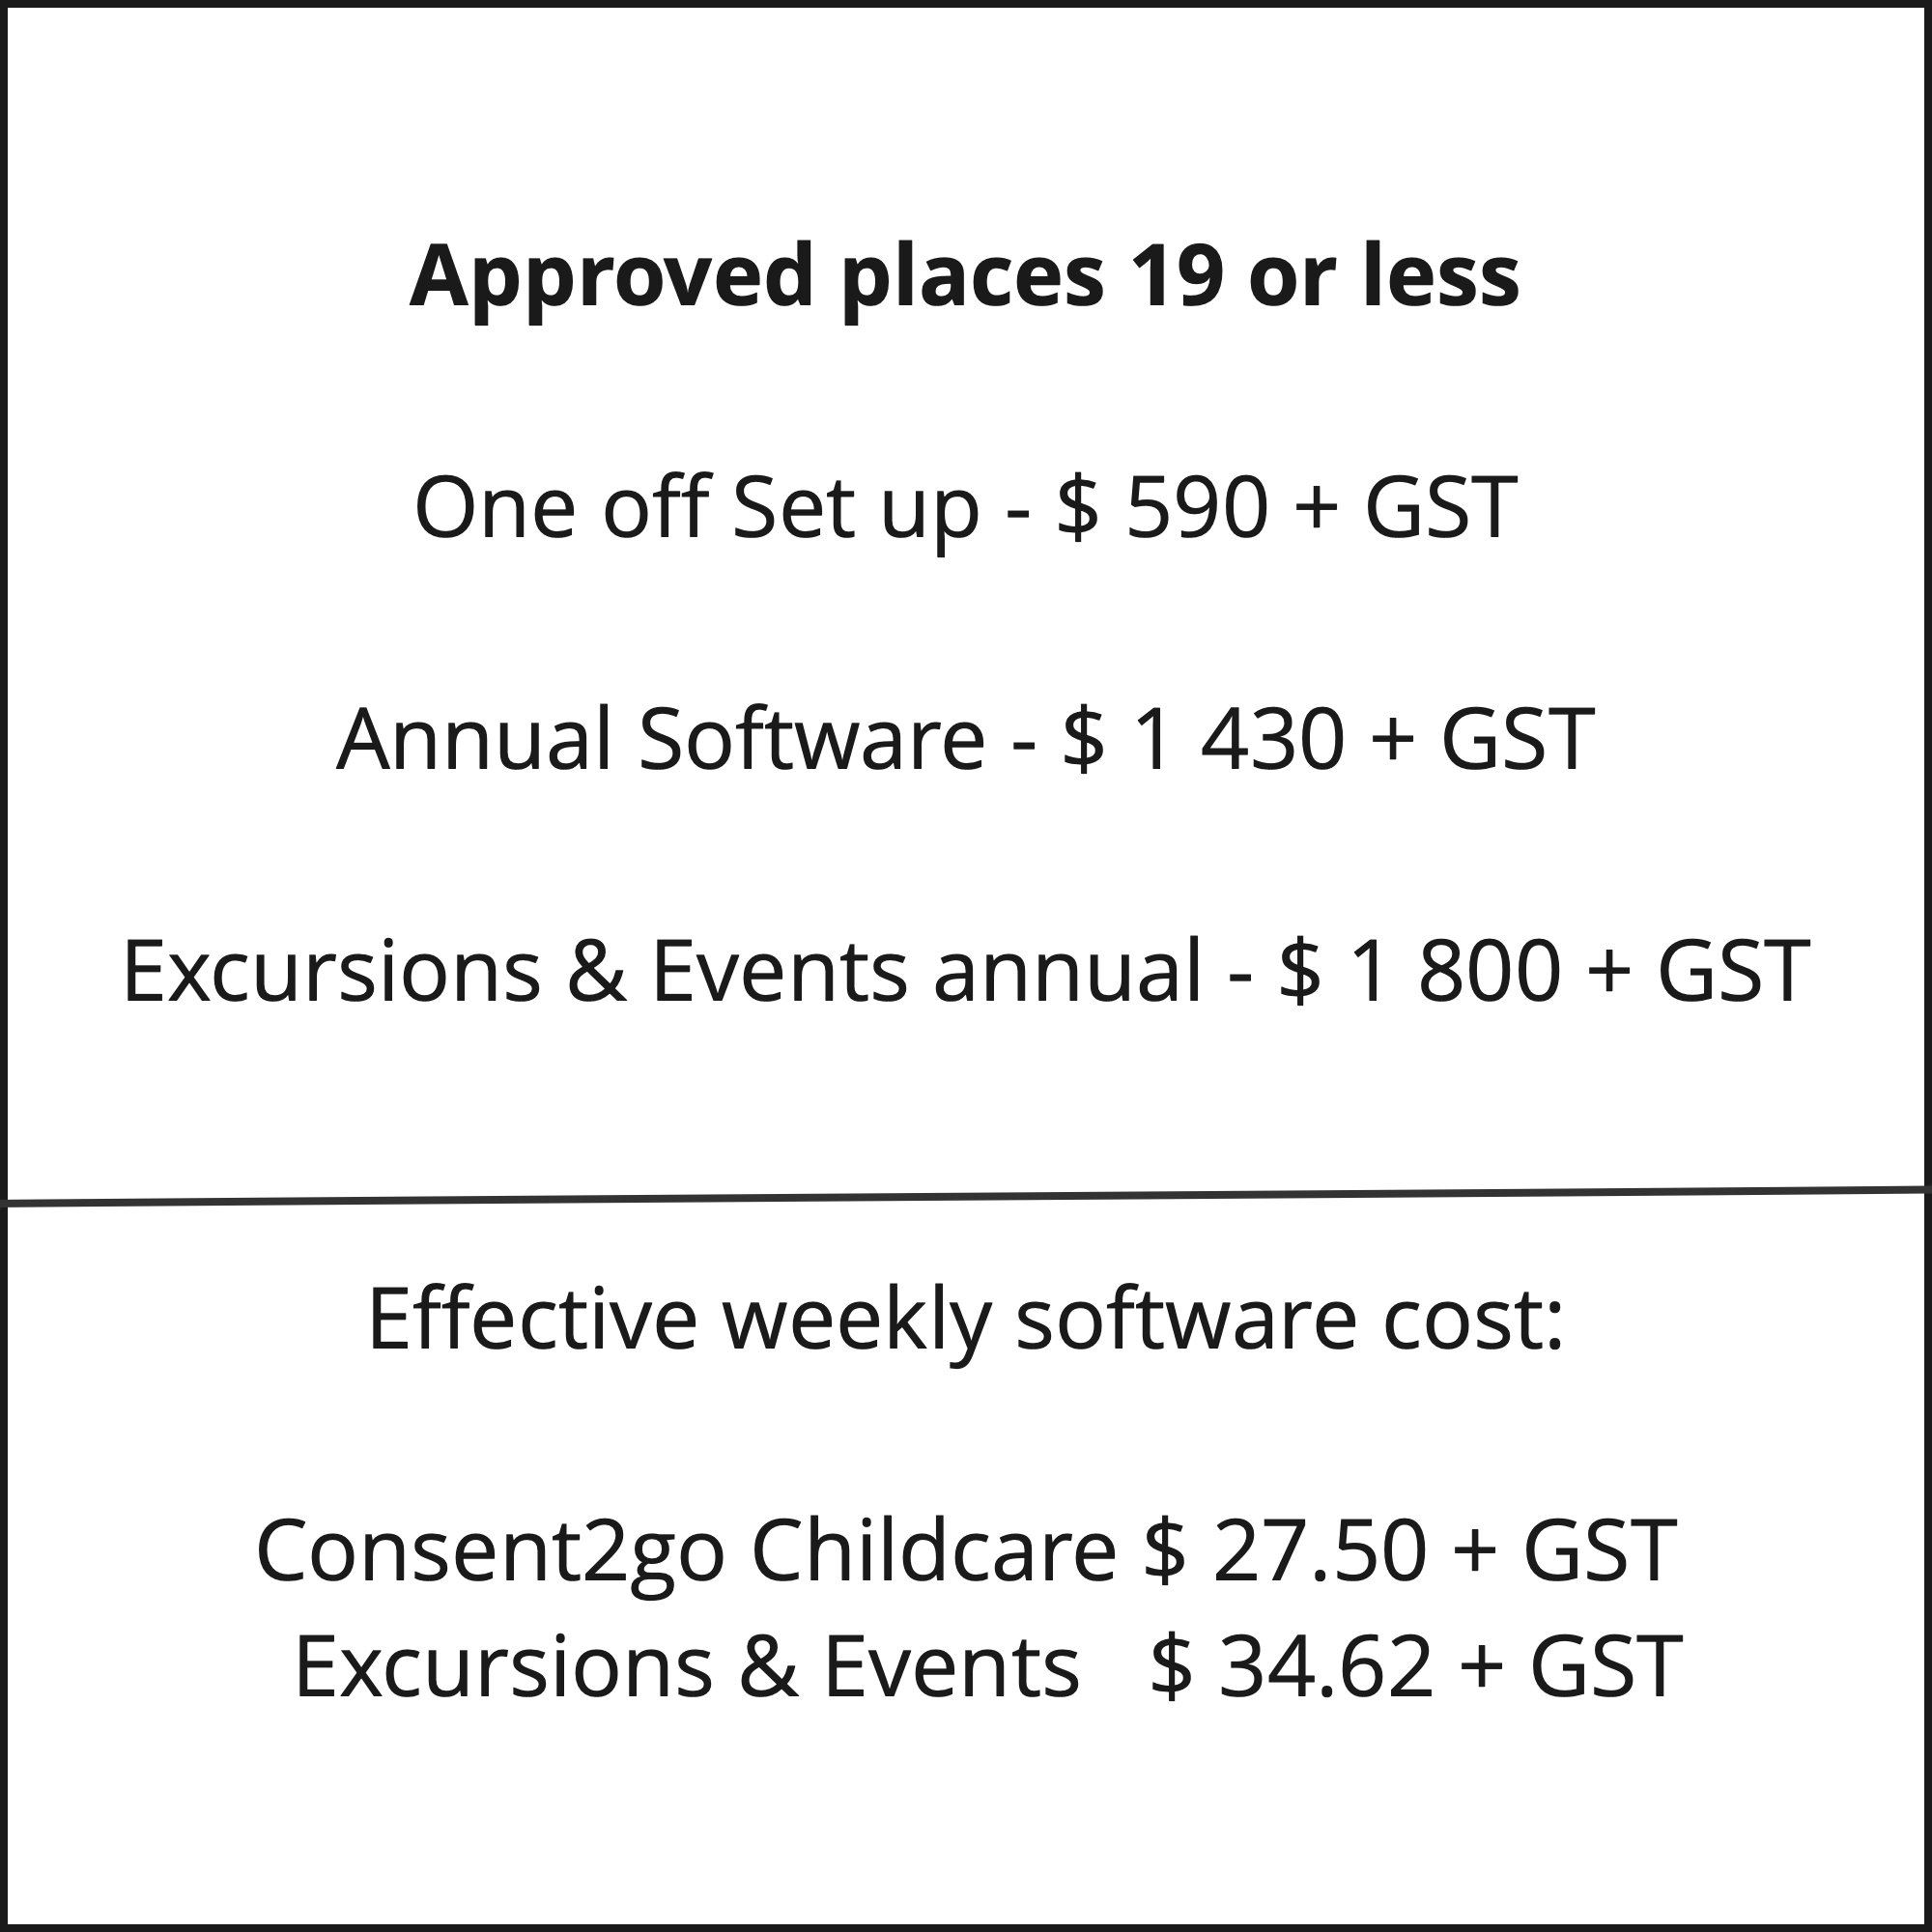
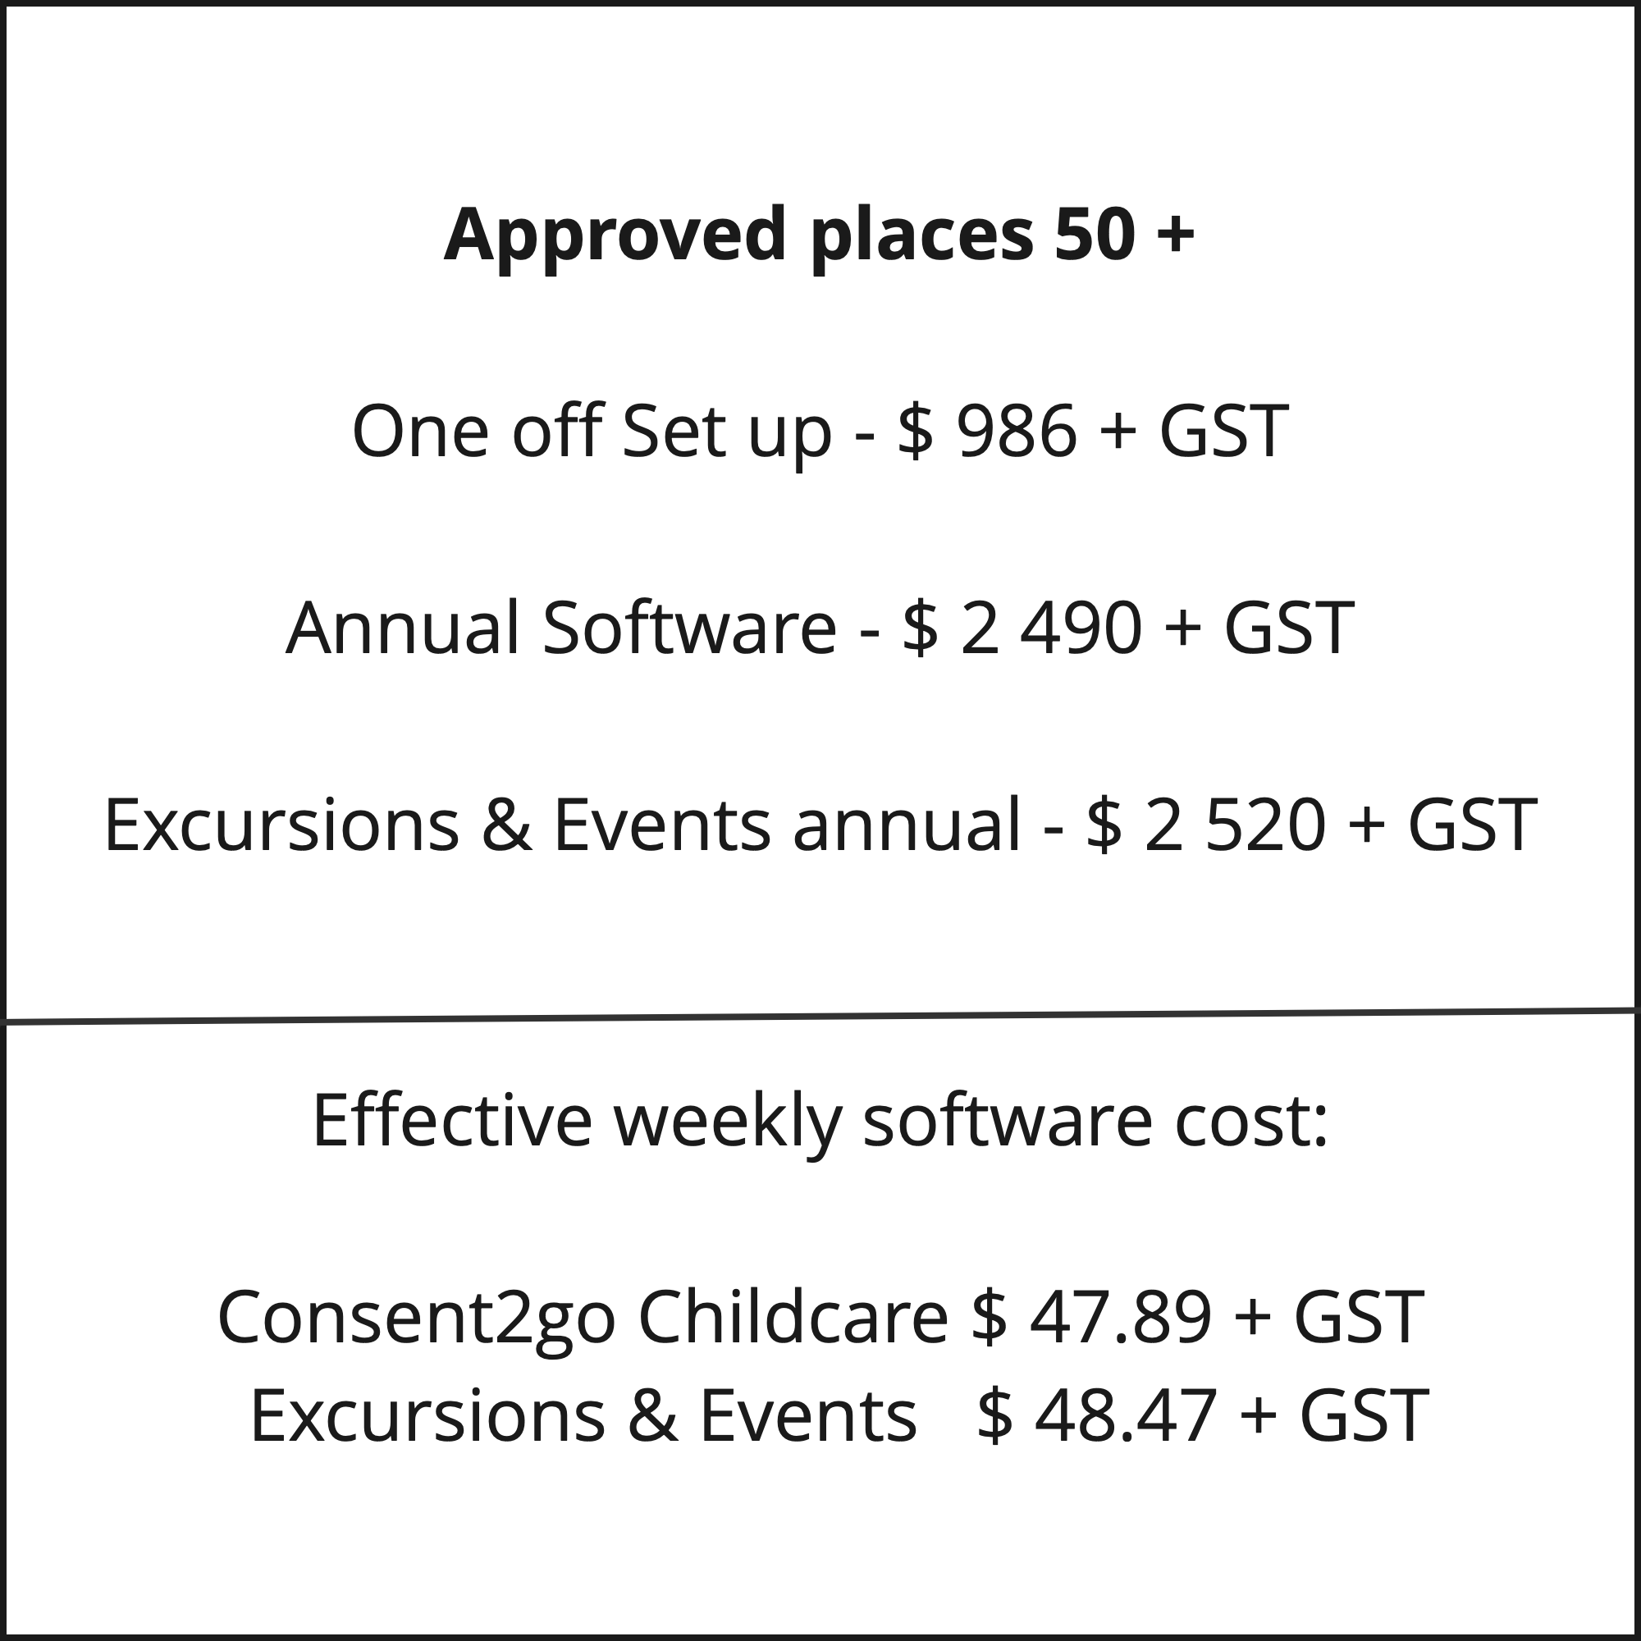
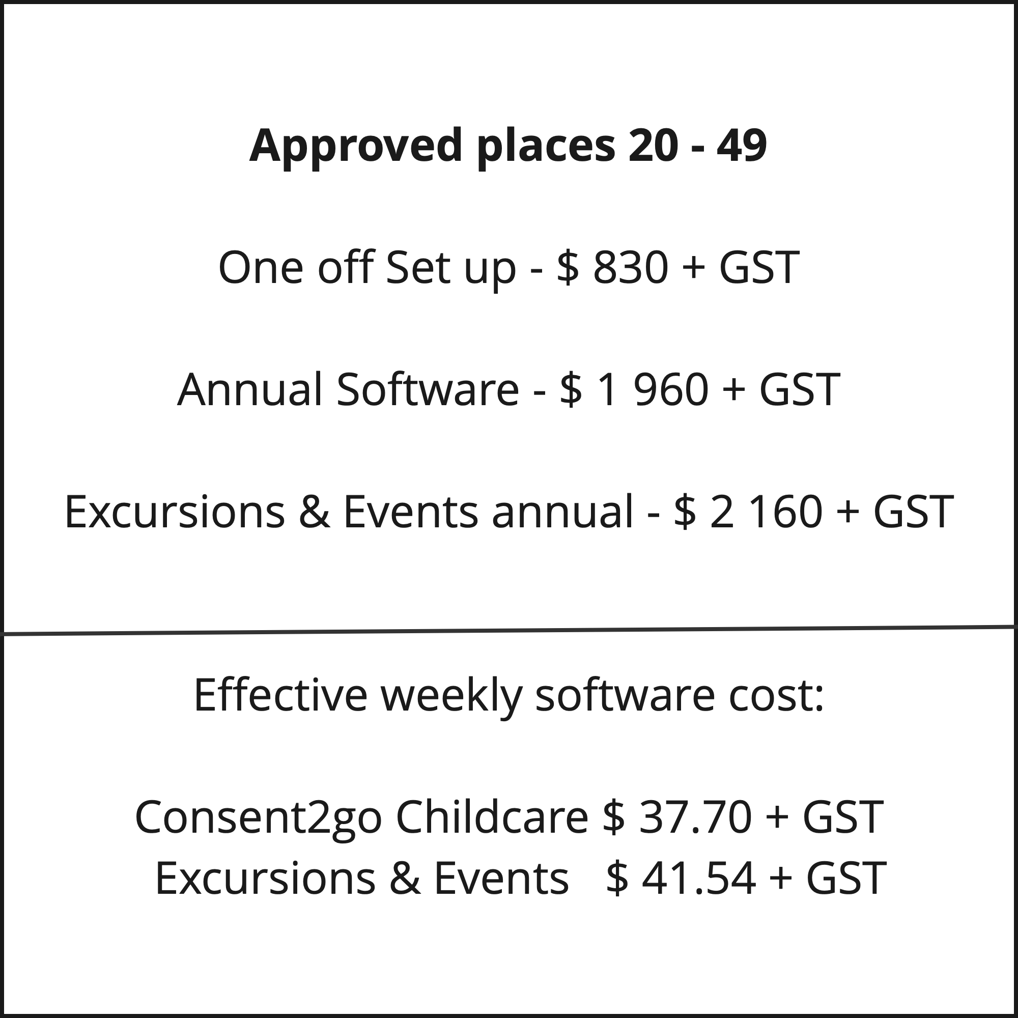

FAQ
Q: How is Consent2go for Childcare different to other admin or learning systems currently used in childcare?
A: Consent2go for Childcare helps you manage your Duty of Care responsibilities for children in your care. The privacy and complexity of the information you need to do this effectively requires a system built specifically to manage and protect that information.

Q: What standard of support can I expect?
A: We have a dedicated Australian-based support team who use telephone, email, and a ticket system to respond to both Parents & Guardians and staff requests during business hours.

Q: Do you customise the system for individual Service requirements?
A: We set up each Service with the system defaulted to the preferences of the Service Provider.

Q: Can I purchase modules separately?
All modules are supplied and included as standard, except for the 'Excursions and Events' module. It is the only add-on module as not all Service Providers require this function.

Q: How much does the system cost?
Subscription costs for Consent2go for Childcare are calculated on a ‘Approved Service’ basis. See the pricing page.

Q: How long do we need to sign up for?
A: There is no predetermined period. Customers purchase 12 months use in advance at a time.

Q: How secure is Consent2go for Childcare?
A: Consent2go for Childcare ensures that privacy and the protection of information is at the forefront of everything we do. Our products demonstrate a commitment to ensuring information is always secure and protected, through industry-leading security technology, alerts, and notifications.

Q: Who can see a child's health record?
A: Viewing is determined by user authority level. Some Excursions and Events staff have limited access, with automatic alerts in place should medical staff access details.

Q: Can you process Excursions and Events payments?
A: Yes, we interface with most major banking payment gateways.

Q: Can you capture vaccination status?
A: We capture vaccination status for staff, including a full verification process, ensuring that vaccination certificates have been cited by a supervisor or manager. While we can capture child vaccination status we recommend that these details are monitored with your childcare subsidy records to avoid duplication. We are happy to discuss any requirements you have.

Q: Do you support archiving and record keeping?
A: We fully support archiving and record keeping for both children and events. Every child record has a timeline detailing changes made and the corresponding dates. Every excursion or event can be viewed as a historical record, detailing all information available at that point in time.

Q: How long does it take to set the system up?
A: The setup requires minimal input from the Service to ensure the implementation is configured to your Service’s requirements. Upon receipt of your preferences, the system can typically be implemented in one to two weeks. At times a slightly longer waiting period may apply.

Q: Do you support providers that operate more than one Service?
A: Providers operating multiple Services have options around how their system is set up to accommodate central administration staff.

Q: Do you integrate with other childcare software systems?
A: We have in-house product software developers so we can readily connect to alternative childcare software systems if the product has the flexibility to accept specific, detailed information. In practical application we often find alternate systems are not designed to cope with the level of detail required to provide a comprehensive duty of care.

Q: Can I send SMS messages from within the system?
A: Yes, in addition to messaging via notifications on the app and emailing, Service Providers can SMS (telephone text messages) from within the system. If required, a data pack will need to be purchased to facilitate texting across telco communication channels.

Q: Do we have to use the App?
A: Parents & Guardians and Staff can access the system online via their internet browser. They also have the option of using a mobile app.

Terms & Conditions

Privacy Policy, Terms and Conditions of use and Legal Disclaimer
Please read our Privacy Policy, Terms and Conditions and Legal Disclaimer before using this site.

Childcare2go Pty Ltd trading as ‘Consent2go for Childcare’ any of it’s affiliated companies collectively referred to as, ‘Consent2go for Childcare’ advise that use of this website signifies your acceptance of the terms and conditions outlined below.
Consent2go for Childcare reserves the right to change our policy and terms and conditions from time to time without prior notice to reflect changes consistent with applicable privacy laws and principles, in addition to changes in the Consent2go for Childcare policy. Any changes will be effective immediately upon their appearance on this website. Consequently, please check our Privacy Policy and Terms and Conditions of use each time you visit the website so you may be aware of any changes.
If at any time you choose not to accept our Privacy Policy or Terms and Conditions of use, you should not use our website. Your continued use of this site after any changes have been made constitutes acceptance by you of all the terms and conditions of use and policy on this website.
You may choose to provide personal information such as your name, address, email address, telephone number, type of products or services that you are interested in and additional information about you, via pages on this website eg. new customer enquiry form. Information is primarily used for the purposes of responding to your inquiry and providing you with information about our products and services. At times, Consent2go for Childcare’s agents or suppliers may assist with the collection and management of collected information. If you contact us we may keep a record of that correspondence. By using our web site, you consent to our collection and use of information as described above.
Consent2go for Childcare will not disclose, share, rent, barter, sell or provide your personal information to any third party unless they are an agent or supplier of Consent2go for Childcare or we are required to do so by law or legal process. We reserve the right to share personal information about you with any Consent2go for Childcare agent or supplier who may assist us with the collection and management of information. We reserve the right to share personal information about you to law enforcement authorities or other government officials.
At times, Consent2go for Childcare, its agents or suppliers may collect information that is not personally identifiable. This aggregated and non-personal information does not relate to a single identifiable visitor to the website. The information is used to tell us such information as, but not limited to, how many users visited our sales web site, how they found the site and what pages they accessed.
We will take all commercially reasonable action to ensure that your personal information is treated securely in accordance with our Privacy Policy. Unfortunately, given the nature of the Internet, the transmission of information via the Internet may not be completely secure. We cannot guarantee the security of transmission of information and any transmissions are therefore at your own risk.
The site may contain links to other websites of third parties. Consent2go for Childcare is not responsible for the content, security or privacy practices employed by other websites. Any links to other websites are provided for your information and convenience.
We cannot guarantee that any file or program available for download from, or via our website, or from any website linked to our website, is free from virus or any other condition which might or could damage or interfere with data, hardware or software with which it might be used, and in accessing this website, you assume all risk of use of all programs and files on this website, and you release Consent2go for Childcare and the registered proprietors of Consent2go for Childcare and their respective affiliates, directors, officers, employees, agents, contractors, successors and assigns entirely from all responsibility or liability for any consequences of or arising out of your use of this website or any website linked to this website.
All Consent2go for Childcare trademarks, trade names and logos in this website are the exclusive property of Consent2go for Childcare. With the exclusion of some photographs and supplier/customer/partner logos, and any advertisements, all website content is the exclusive property of Consent2go for Childcare. Consent2go for Childcare retains all intellectual property and other property rights in the website and its contents. Some photographic images are used with permission or used under license from Shutterstock or other third party suppliers.
All material and information presented by Consent2go for Childcare is intended to be used for information purposes only. Consent2go for Childcare is providing this website and its contents on an ‘as-is’ basis and makes no representations or warranties of any kind, express or implied, with respect to the information, content or products and services included on this website. To the fullest extent permitted by law, Consent2go for Childcare disclaims all such representations and warranties, including any implied warranty of merchantability or fitness for a particular purpose. Consent2go for Childcare does not represent or warrant that the content of this website is accurate, complete, current and it may include typographical errors. All images are for illustration purposes only and may not reflect the product or service supplied.
Consent2go for Childcare, the registered proprietors of Consent2go for Childcare and their respective affiliates, directors, officers, employees, agents, contractors, successors and assigns will not be liable for any damage of any kind arising out of, or in connection with, the use of this website, including but not limited to direct, indirect, incidental, punitive or consequential damages.
In using this website you agree that you will not permit others to copy, transmit, upload, post, email or otherwise make available any content on this website for which you do not possess the trademark, trade secret, copyright, license or other rights to do so.
Consent2go for Childcare accepts your comments and feedback regarding this website, and any products and services we may offer. All suggestions, ideas, remarks or other information communicated to Consent2go for Childcare will forever be the property of Consent2go for Childcare. Consent2go for Childcare will not be required to treat any submissions as confidential and will not be liable for any ideas for its business. Without limitation, Consent2go for Childcare will have exclusive ownership of all present and future existing rights to the submissions of any kind. Consent2go for Childcare will be entitled to use the submission without consent and without any compensation to any person making the submission. You acknowledge that you are responsible for whatever information you submit, and you have full responsibility for the legality, originality and copyright of the submission.

Contact Us
We would like the contact us page to include the integrated form from our sales software Pipedrive.

