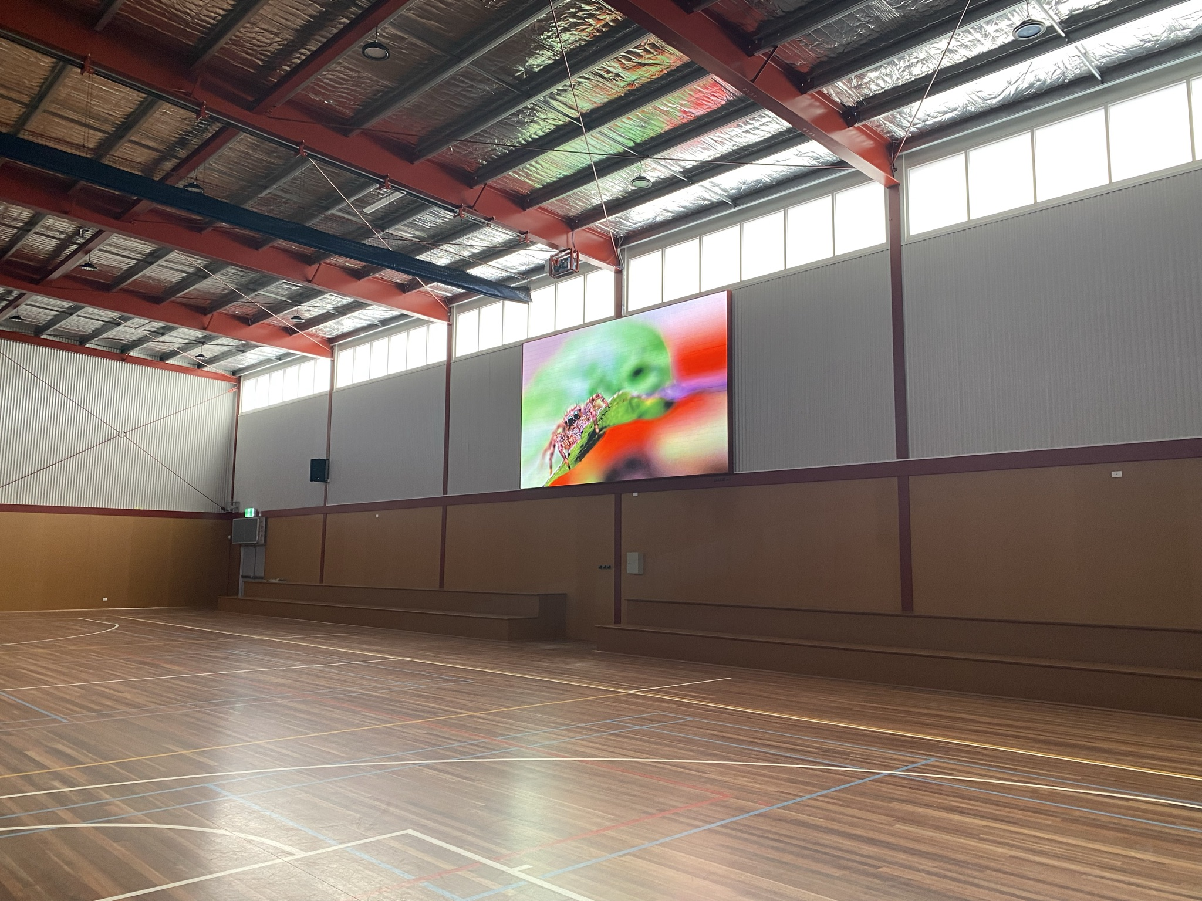

Ocean Grove Primary School

Quote # 31055

Designed For:

Scott McCumber
Ocean Grove Primary School

Issued:

10/09/2024



New South Wales
Victoria
Queensland
Western Australia

Your AV Media Systems Sales Specialist

Paul Smith
Director (Vic)

Phone: 0410 587 544
Email: paul@avsystems.com.au



"Step into the future and unleash the dazzling brillance of CUBE LED video walls, leaving traditional projectors in the DARK

Chris Kiskiras

Managing Director - av Media Systems

AV Media Systems is thrilled to present our revolutionary C.U.B.E LED walls and explore the incredible opportunities they hold for your school.
We understand the significance of creating dynamic and captivating environments within educational settings. That's why we're thrilled to present our proposal for the installation of a cutting-edge CUBE LED video wall in your school assembly area.
At AV Media Systems, we specialize in providing innovative audiovisual solutions tailored to our clients' needs. With our state-of-the-art technology and expertise, we aim to transform your assembly hall into a hub of engagement, inspiration, and excitement for students, faculty, and visitors alike.

In this proposal, we will outline the remarkable benefits of our CUBE LED video wall technology, detailing how it can enhance various school events and activities. Additionally, we will provide you with information about our C.U.B.E LED walls and a quotation tailored to your requirements.

We are eager to collaborate with you to bring this vision to life and create an immersive and unforgettable experience within your school assembly hall.

Thank you for considering AV Media Systems for this exciting opportunity. We look forward to the possibility of working together to elevate your schools audiovisual capabilities.

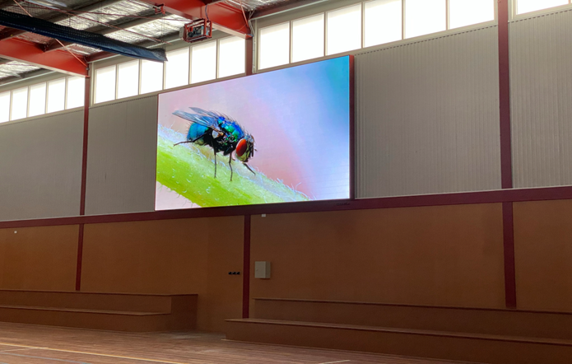

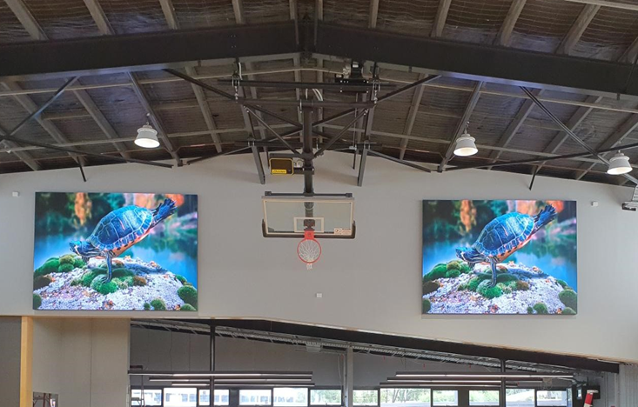
By choosing AV Media Systems for your CUBE LED video wall installation, you're not just selecting a vendor; you're partnering with a trusted ally boasting an impeccable track record of success. We specialize in making cutting-edge technology accessible and affordable for every school, simplifying what might seem complex into an effortless solution.
Our team is comprised of seasoned experts who are not only expertly trained and highly qualified but also hold valid Working With Children Checks (WWCC). As we embark on the installation process, we bring an air of excitement, and our staff's expertise shines through, making the upgrade of your school's space an enjoyable spectacle to witness. We pride ourselves on seamless integration and maximum visual impact. From the initial consultation to the final installation and beyond, we are dedicated to delivering exceptional service every step of the way.
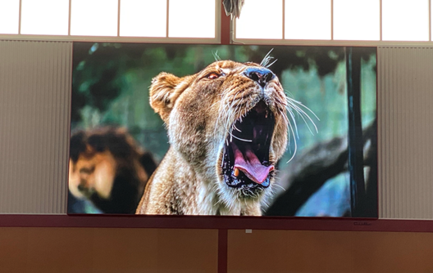
CUBE LED video walls represent a remarkable, visually captivating technology. We recognize that investing in such innovation is a significant decision, and we value the trust you place in our expertise. When it comes to guiding you through this process, nothing brings us greater joy than witnessing the delight on our customers' faces as they witness their new CUBE LED video wall in action for the first time!
Thank you for considering AV Media Systems and our CUBE LED video wall.
We're thrilled about the boundless possibilities of bringing the enchantment of CUBE LED video technology to your school. We eagerly anticipate collaborating with you to craft an extraordinary visual experience.



C.U.B.E LED Wall vs Projectors

Projectors C.U.B.E LED Wall

Requires lamp replacement  Requires a screen  Susecptible to ambient light  Additional installation requirements | Brilliant & vibrant image in almost any light with a wide viewing angle.  Brightness of between 600-1000 candela  (1 candella is aprox equal to 13 projector lumens - CUBE LED video wall is approx equal to 12,500 lumens *  Refresh rate of 3,840 Hz  Slimline 28mm thick

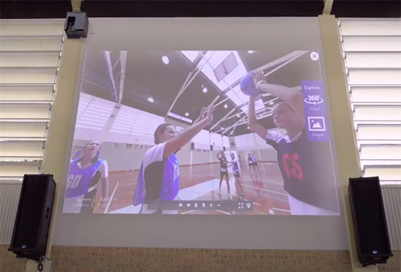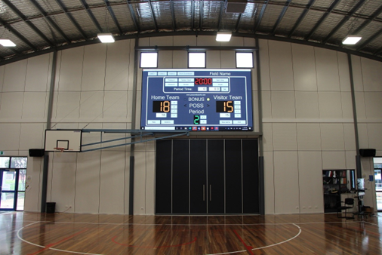
PROJECTOR CUBE LED
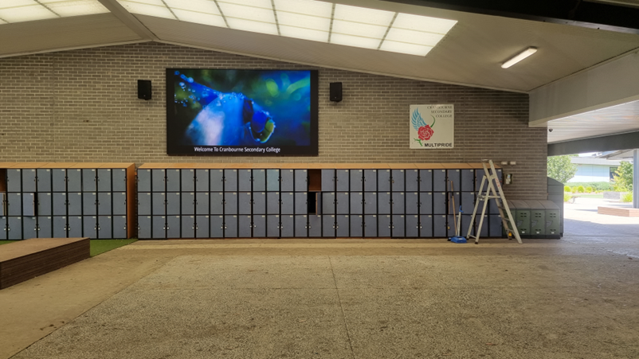

C.U.B.E LED Wall

-Ideal for high ambient light environments, ensuring stunning visuals in any lighting condition.

-Maintenance-free, providing hassle-free operation and peace of mind.

-Modular design allows for customization to any size, offering flexibility and scalability.

-Enhances school assemblies by creating captivating visual backdrops and interactive displays.

-Fosters an engaging learning environment, stimulating student interest and participation through dynamic visuals and interactive content.

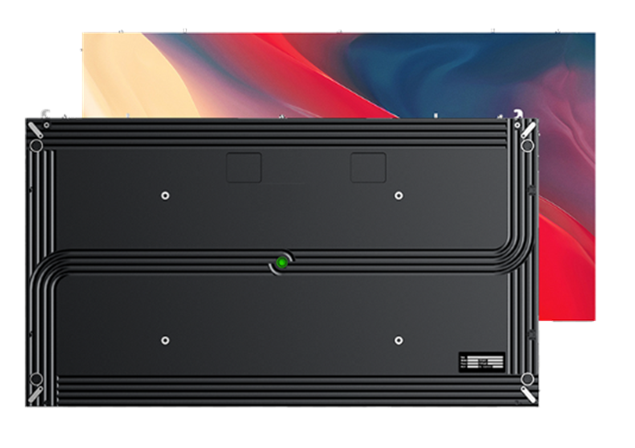
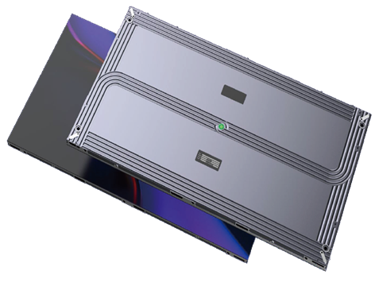

Our CUBE walls boast an elegantly sleek design, delivering flawless imagery for a monumental impact, all crafted with the highest quality standards.

Why Invest in a CUBE Wall? 

Our CUBE LED video walls represent a groundbreaking solution for schools seeking to elevate their learning environments. Unlike traditional projectors or LCD panels, our LED video walls offer unparalleled clarity, brightness, and color accuracy, ensuring an immersive visual experience for students and faculty alike.

Superior Visual Experience: Each LED pixel functions independently, delivering outstanding image quality with true-to-life color depiction. Regardless of ambient light conditions, our LED displays provide exceptional visibility and clarity, making them perfect for brightly lit environments such as school gymnasiums and auditoriums.

Easy Maintenance: Designed with user convenience in mind, our LED displays feature full-frontal maintenance capabilities. This means individual modules and components can be easily replaced without the need to dismantle the entire display, minimizing downtime and ensuring continuous operation.

Versatility and Integration: Our LED displays offer seamless integration with existing IT systems, thanks to built-in operating systems, PC environments, and wireless connectivity options. This allows for easy integration within school networks and facilitates features like screencasting and screen sharing, enhancing collaboration and inclusivity in the learning process.

Cost-Effective Digital Signage: Embracing digital signage not only enhances campus navigation and communication but also offers cost-effective and dynamic content delivery. With the ability to change content on the fly, digital signage provides flexibility and adaptability to meet the evolving needs of educational institutions.

Distinctive Branding and Modernization: Investing in high-quality LED video walls not only distinguishes schools from others but also reinforces their commitment to progress and innovation. Equipped with cutting-edge technology, schools can enhance their brand image and identity, signaling a dedication to providing the highest level of education and engaging experiences for students.

In summary, our CUBE LED video walls offer schools a versatile, high-quality solution for creating impactful visual displays that enhance learning environments, foster collaboration, and elevate campus experiences. With exceptional image quality, ease of maintenance, and seamless integration, our LED video walls are poised to revolutionize the educational landscape.

Please review the quotation below, tailored specifically for your school.
If you have any questions, feel free to reach out to us at any time.

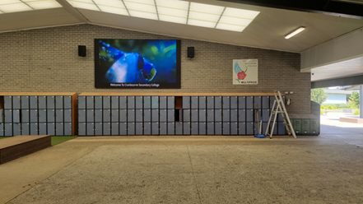

THIS PAGE WILL BE AUTOMATICALLY COMPLETED BY CRM CONTAINING PRICING INFORMATION

 | Item | Quantity |  | Unit Price | Total

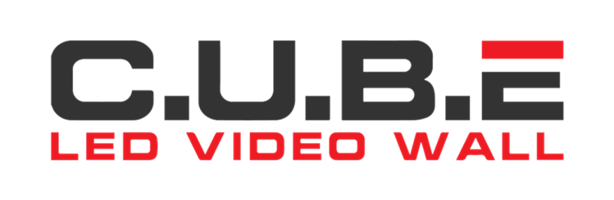

CUSTOMER REFERENCES

This was our first time working with AV Media Systems and after getting our 4m x 2.25m CUBE LED Wall installed at Wellington Secondary College, I can say the team have come through for us in terms of prompt communications throughout our project and delivering a high quality install while navigating a constrained schedule. We hope to work with them again on future projects!

James Heng (Specialist Technician)
Information Management and Technology Division
Department of Education Victoria

AV Media have been amazing from first presentation, quoting and speed of installation. Start to finish their product knowledge and customer service is second to none. Their after sale service and support has been outstanding. We would highly recommend them for any school media needs.

Business Manager
Boronia Heights Primary School
Ph: 9729 2614

We have a CUBE LED video wall in a P3 pitch and a Bose sound system which looks and sounds state of the art. We are delighted with the finished product. Throughout the process the team were professional, courteous, informative and helpful. They certainly wanted the best outcome for us and that is what we feel has been delivered. I have no hesitation in recommending AV Media Systems, and would be more than happy to showcase what they have installed at Courtenay Gardens Primary School to anyone considering the CUBE LED video wall.
Marc de Ley
Principal
Courtenay Gardens Primary School

GENERAL TERMS & CONDITIONS OF SALE
THE FOLLOWING TERMS AND CONDITIONS ARE BINDING ON YOU. PLEASE MAKE SURE THAT YOU READ THEM CAREFULLY AND THAT YOU FULLY UNDERSTAND THEM BEFORE ENTERING IN TO THIS AGREEMENT. YOUR CONSENT TO PROCEED WITH THE WORK WILL BE TAKEN AS ACKNOWLEDGEMENT THAT YOU HAVE READ AND UNDERSTOOD THESE TERMS AND CONDITIONS.

Quotations:

All prices stated exclude GST, unless expressly stated otherwise.

Firm price quotations are valid for a period of 14 calendar days after which time they may be subject to alteration.

Where quotations are based on details provided by the Customer, such quotations are subject to the accuracy of those measurements and/or information.

Payment Terms

A deposit of 50% is payable upon acceptance of the order and before works can proceed (usually for purchasing equipment). The installation date will be provided upon receipt of the deposit remittance advise. Unless prior arrangement for the provision of credit terms have been agreed, the standard payment terms are 7 business days as of the invoice date. Acceptable methods of payment are company cheque, EFT, or Credit Card. Please note Visa or MasterCard payments are subject to a 1.5% surcharge, AMEX payments are subject to a 3% surcharge. See below for banking details.

EFT details:

BANK: National Australia Bank

NAME: AMS Group PTY LTD T/A av Media Systems

BSB NUMBER: 083 004

ACCOUNT # : 872191027

Remittance email: accountsVIC@avsystems.com.au

Please email notification that payment has been made- ensuring you include the invoice number.

Installation works:

Where installation works (only) of equipment is required, payment of installation work is required within 7 business days upon completion and handover to the customer.

We will do all that we reasonably can to meet the date agreed for installation. However, in the case of unforeseen circumstances beyond our reasonable control, we may not be able to do so. In such circumstances, we will contact you for an alternative date. The Customer will do all that is reasonably possible to enable the installation to take place on the alternative date. In the case of unforeseen circumstances beyond the Customer’s reasonable control, the Customer should contact av Media Systems to agree to an alternative date.

We will carry out all installation works detailed in the quote. If additional works are required, during the course of the installation, these works will be quoted for separately and only carried out with the Customer’s permission.

It is the customer’s responsibility to ensure that, prior to the installation works commencing, all furniture is removed, all walls are cleared and free of objects and any carpet in the installation area is rolled back if needed. All access to under floor and or cavity installations are to be cleared and accessible and that av Media Systems are given reasonable notice for the Installation of pre-wiring cable before site works are completed by onsite builders. Any access after that point may incur additional charges to install cabling and or equipment.

In the interest of safety all work areas are to be cleared of all non-contracted personal.

Installation of Audio-Visual equipment by av Media Systems does not include integration into existing IT infrastructure unless by prior arrangement and or quoted on by av Media Systems.

Removal of any pre-existing equipment or old fixtures may result in minor damage to the surrounding areas. The agreed price does not cover ‘making good’. Neither does it cover painting, decorating, fitting skirting board, tiling or cutting and fitting carpet, unless specifically stated in the quote.

Removal of all packaging and general rubbish is the customer’s responsibility; unless quoted, the agreed price does not cover the removal and disposal of packaging.

General Power:

The supply of general 240v power is the customer’s responsibility unless, prior arrangement and or quoted on by av Media Systems.

Parking:

A parking fee may apply if suitable parking is not available onsite.

Consents:

The Customer is responsible for obtaining all necessary planning permission and local authority consents and permissions for the work to be carried out. In carrying out any work, we will assume that the necessary consents and permissions have been obtained and we accept no responsibility in the event that they have not.

SUPPLY AND DELIVERY:

Ownership of the invoiced goods will only pass to the Customer when full payment of the invoice is received by av Media Systems. If equipment is to be delivered to an installation site, the Customer assumes responsibility for the materials at the time of delivery, regardless if the Customer (or the Customer’s representative) is on site to acknowledge receipt of delivery. The Customer agrees to pay standard delivery charges if they apply.

Supply of Goods:

Unless prior arrangements for the provision of credit terms have been agreed, payment of goods (after the initial deposit invoice) is required prior to or upon delivery to the customer. Acceptable methods are company cheque, EFT, Visa or Mastercard. Surcharge will apply to credit card payments.

Service:

It is the customer’s responsibility to arrange for the delivery and collection of goods to be repaired to and from av Media Systems. av Media Systems will not accept any liability for damage of goods if transport is arranged by the customer.

Returns:

Except in the case of delivery of incorrectly supplied goods, returns will not be accepted without prior authorization from av Media Systems. A restocking fee may apply. Credits may or may not be applicable depending on the condition of goods and the circumstances in which the return is based.

Warranty:

av Media Systems Warranty
- 12-months on all installation defects.
- 12-months phone and remote support.
- Facilitation of all manufacturer warranties.

Product Warranty
- Unless otherwise agreed in writing, warranty of goods supplied is offered by the manufacturer and is limited to the standard warranty of those goods. As a service to our customers and at our discretion, av Media Systems may offer to address any warranty concerns or claims as an intermediary, dealing directly with the manufacturer. Warranty claims will not be accepted for deliberate or unintentional misuse or abuse of goods, physical damage or otherwise. In relation to the collection of and the return of equipment under warranty, a freight and or labour fee may be charged for this service.

Delay, Error or Omission

Inadvertent delays, errors or omissions made in connection with this Contract or any transaction hereunder shall not relieve either party from any liability which would have attached had such delay, error or omission not occurred, provided always that such error or omission is rectified as soon as possible after discovery.

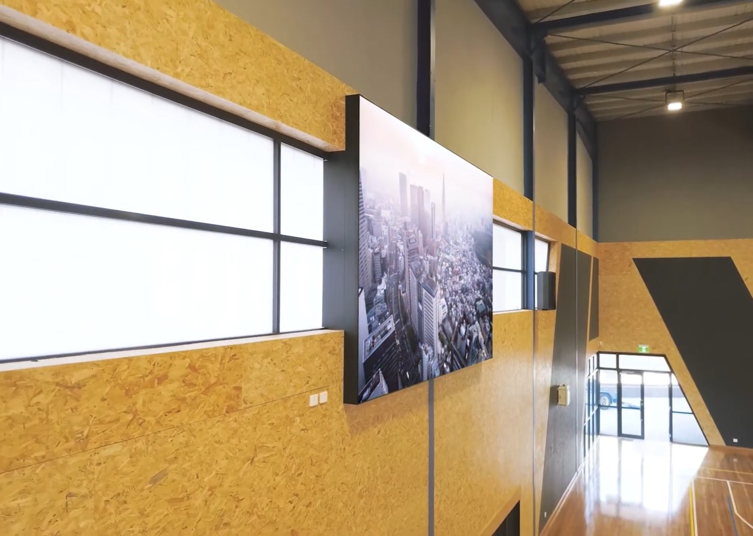


New South Wales
29/110 Bourke Road
Alexandria NSW 2015

Tel: +61 2 9572 5300

ABN 12 411 299 394

Victoria
16/45 Normandy Road
Notting Hill VIC 3168

Tel: +61 3 9543 6772

ABN 32 093 794 702
Queensland
1/1a Byth Street
Stafford QLD 4053

Tel: +61 7 3356 8130

ABN 90 312 078 956
Western Australia
87a Frobisher Street
Osborne Park WA 6017

Tel: +61 8 9444 1774

ABN 34 437 325 328

