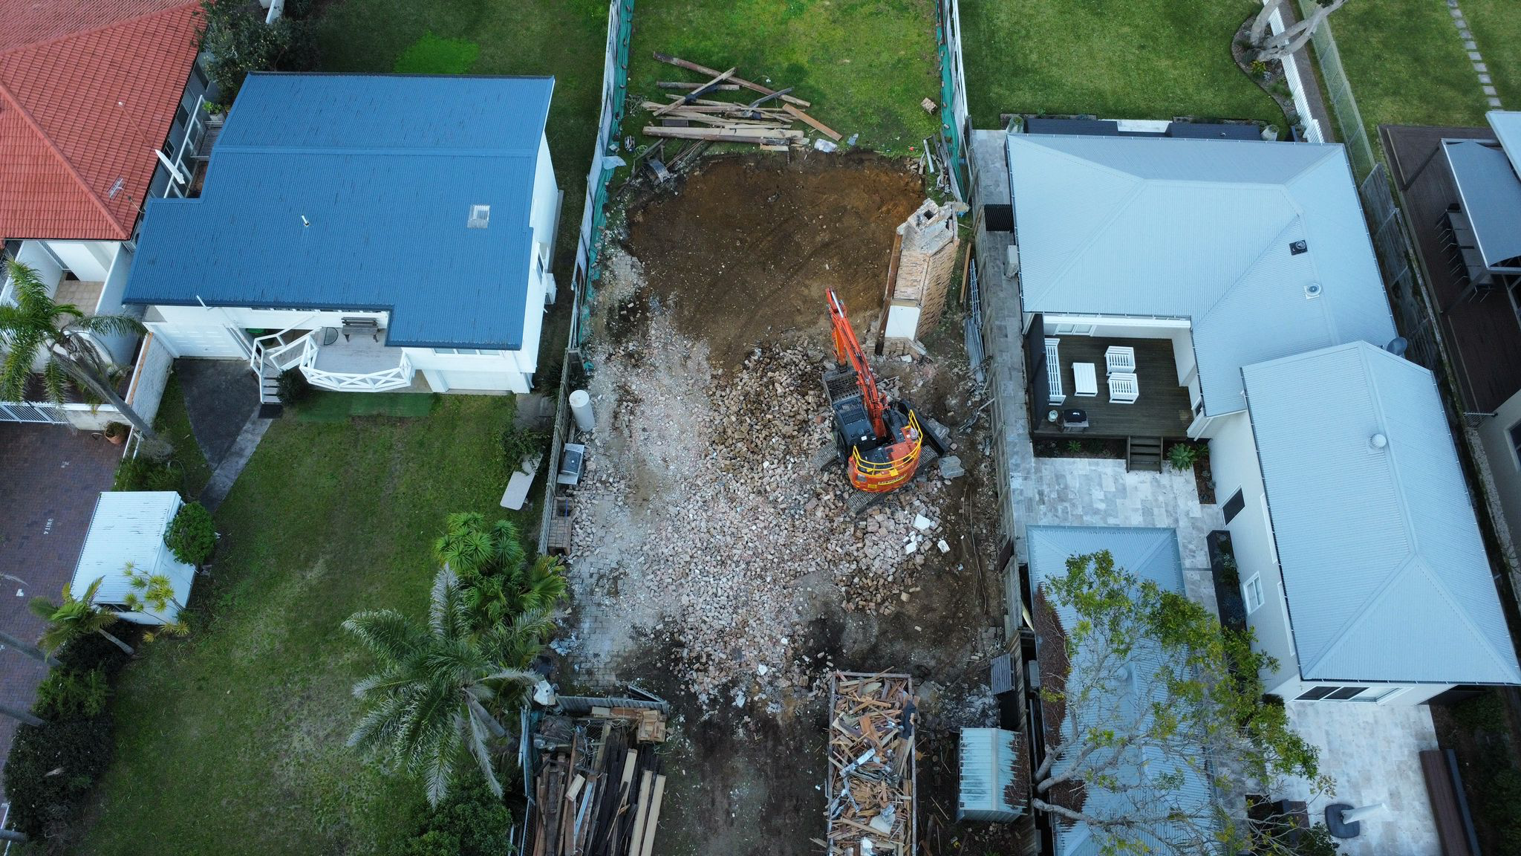HOMe Demolition

Asbestos removal

site excavation


  - Welcome Pack

WHAT WE DO
Combined Demolition Services Pty Ltd (CDS) stands at the forefront of demolition and asbestos removal services in New South Wales. With a base on the Central Coast, we offer our specialised services across the Greater Sydney, Central Coast, Hunter, Newcastle, Illawarra, North Coast, South Coast and surrounding areas. Our reputation for excellence is built on a deep understanding of client needs, combined with innovative approaches to complex demolition challenges.

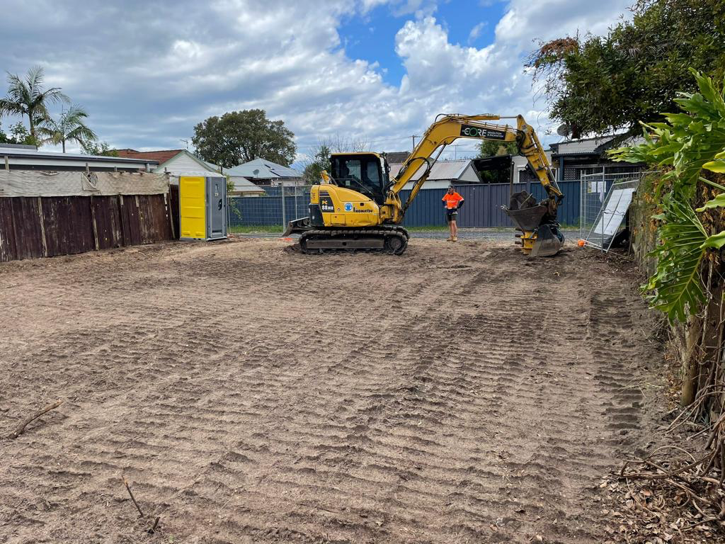
ABOUT US
Our Mission
Safety, Customer Satisfaction and sustainability
Our Vision
To be the #1 leader in our industry for customer service and sustainability
Our Commitment
We are committed to reducing landfill and recycling all possible materials for re-use to provide a greener future for our children.
Our People
At CDS our greatest asset is our team. We are committed to fostering an environment where our team members can thrive and achieve lasting success. Our workforce is characterised by its experience, professionalism, and client-centric approach.

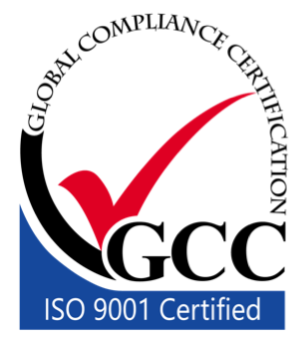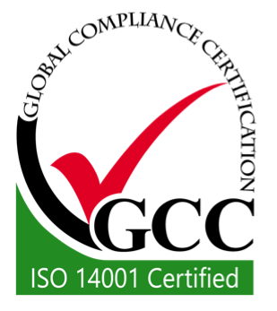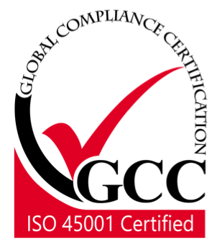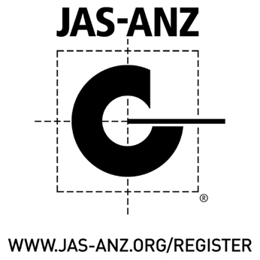

THE PROCESS
- Free Quote
One of our experienced staff will arrange a site inspection and obligation free quote
- Permits & Compliance
We organize all legal requirements and approvals which includes notifying Safework and surrounding residents

- Permits & Compliance
We organize all legal requirements and approvals which includes notifying Safework and surrounding residents
- Disconnection & Safety
Temp fencing will be installed and services disconnected
- Site Set Up
We will identify the hazards and consider precautions to be taken
- Hazard removal
Asbestos & hazardous materials are professionally removed by our experts
- Demolition
The area or house will be carefully brought down whilst separated materials are collected for recycling
- Site Preparation
The site is levelled ready for work to continue
- Clearance Certificates
All the paperwork and documentation is released

WHATS INCLUDED
We include the following when quoting your package:-
Admininstrative
- Neighbour notifications
- Regulatory approvals and documentation for the demolition
- Demolition certificate
- Asbestos surveys by an independent hygienist
- Clearance certification upon completion
Site
- Site fencing
- Power Abolishment
- Sewer Capping
- Sediment Control
- Tree lopping
- Water metre Relocation

WHAT ELSE CAN WE DO
Our expansive team can also offer the following services:-
- Excavation
- Structural landscaping
- Concrete Slabs
- ????

WHATS NEXT?
Once the quote is accepted we need days to organise the paperwork.
We can assist you by providing you with all the information you require, or
you can utilise the services of our private certifiers.
You will need the following documentation:

Section 10.7
Planning Certificate
Request your certificate online
through your council’s website
or give them a call.

Site Plan

Showing all proposed structures to
be demolished. Your builder,
architect, or surveyor will have a
copy they can email you.

We will provide you with the following documentation:
- Demolition licence
- Asbestos licence
- Certificate of currency of general & products liability insurances
- Certificate of currency of workers compensation
- Waste management plan
- Safe work method statements
- Asbestos clearance certificate by an independent assessor
- Ausgrid diagram
- Gas utilities diagram
- Sydney water diagram
- Telecommunications infrastructure diagram
- Demolition clearance certifi

