Below are the requirements as we see them. This website is to be hosted on Wix.

Look & feel
Clean and simple, but not too plain. Maybe this could be used for inspiration? https://noworryhome.com/

Example of do NOT like: https://tjhandymanservicesllc.com/

Homepage
We like the layout of the info on this homepage: https://newton-mr.handyman-ma.com/. Please note that it is NOT the look & feel of this site that we want. It is the separation of information.

Header:
Header should include logo, , and a button that says “Call xxx-xxx-xxxx” which links to a VOIP app.
Also include these links: Home, Services, Contact us (which links to contact form at the bottom of homepage or maybe a separate Contact Us page?), Testimonials (which for now, links to the testimonials section on the homepage).

Intro Section:
We need to provide the copy for this section which will include our value proposition (Trust, Responsiveness, Guaranteed Workmanship, Insured) and info about us. You can use this copy as a headline for this section, “It's time to take back your free time, enjoy your home to its fullest, and let us complete your to-do list!”
We are open to your ideas for the images to use on this banner.

Testimonials Section
This section should be titled “What Our Customers Are Saying”. Maybe use a slider? We will eventually provide 5-6 testimonials for this section. You can create your own testimonials as “placeholders”.

Contact Us Section (We also may need an additional separate page to include the Calendar)

Similar to this page: https://noworryhome.com/contact-us/, include the following:

A contact form (first name, last name, email address, and phone number but not required.
My contact information, phone and email address. Use “placeholders”. Service area: Newton, Needham, Brookline, Waltham, Watertown
A link to a calendar widget for scheduling.

At the bottom if this page https://newton-mr.handyman-ma.com/
is an example of the layout & copy we think we want

Footer
You can use the information on this page as placeholders for the design of this section, except do not include a privacy policy, and definitely NOT us it as design inspiration.

Services Page
Below is a sample list of services. They are grouped into 5 major categories.

We do not want this:
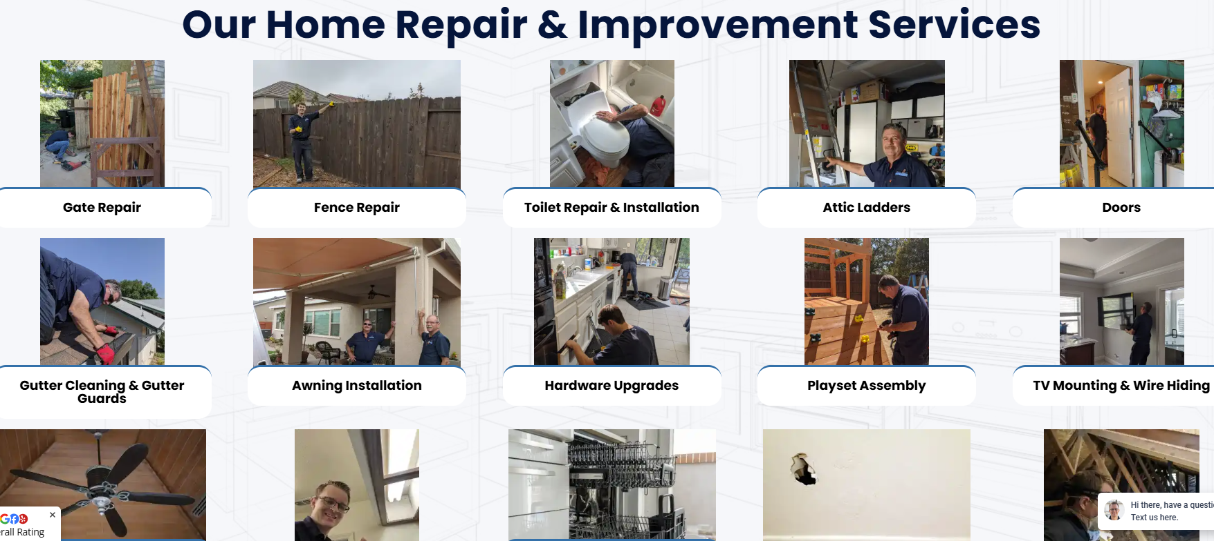

This section should be easy to read and for users to be able to find their needed service easily. Each group should have a SIMPLE, easily recognizable icon or image next to the title of the group.
example: https://www.servgrow.com/industries

Sample List of Services
Maintenance & Safety
Baby-proofing
Grab bar installation
HVAC filters replacement
Smoke/CO detector batteries/replacement
Door & Window Repairs
In the Bathroom
Toilet repair/replacement
Faucet repair/replacement
Vanity Installation
Grab bar installation
Ceramic tile repair
Clean exhaust fans
Grout Repair & Recaulking
Home Décor
Light fixture replacement
Shelf/art work/mirror hanging
SmartHome upgrades
TV wall mounting
Furniture assembly
Furniture refinishing/repair
Wall Repair
Window coverings
Painting
Outdoors
Winterize exterior hose bibs
Grill assembly
Grill cleaning
Swingset assembly
Clean out window wells
Light carpentry
In the Kitchen
Garbage Disposal Replacement
Change in-fridge or in-line water/ice filter
Dishwasher Installation
Ceramic tile repair
Clean range hood filter

