Thursday, April 17th, 2025
Tournament: 8AM to 2PM

Mandatory Captains Check-In: Thursday, April 17th From 6:30AM – 8AM
Awards Ceremony & Dinner: Thursday, April 17th From 3PM – 7PM
Check-In and Awards Ceremony to be Held at Finn’s Dockside Bar & Grill in Apollo Beach
Save The Date
Please Respond to CharityFishing@TECOEnergy.com with your Sponsorship Level Selection
Payment is not needed at this time. You will receive a separate invoice once you respond to this email with your selection
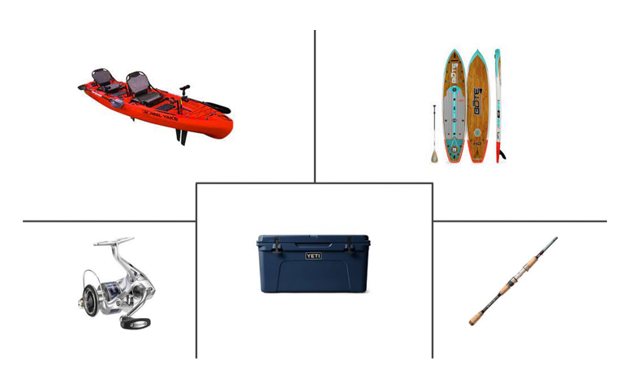
Please email your company logo in a Vector File or High-Resolution JPEG File (at least 300 DPI or 1000 pixels) by March 1st, 2024
Sponsorship Levels

Donate to the Charity!  Scan the QR Code or Click the Link Above to Donate to the Charity | Presenting - $10,000
 | - 5 Professionally Guided Fishing Boats (hosting 3 anglers on each boat)
 | - All Anglers Receive A Custom Bull Bay Fishing Rod
 | - All Anglers Receive an Event Shirt and Custom Embroidered Items | Raffle Items Needed!  Please Respond to CharityFishing@TECOEnergy.com with the raffle items you would like to donate
 | - Includes a Captain’s Bucket
 | - 20 Buffet Tickets to the Awards Ceremony
 | - Recognition at the Awards Ceremony
 | - Company Logo Prominently Featured on Tournament Swag (Hats, Cups, Etc.)
 | - Company Logo Prominently Featured on the Tournament Shirt
 | - Company Logo Prominently Featured on the Tournament Banner
 | - Company Logo on an Individual Tournament Banner
SLAM - $6,000 | Redfish - $4,000 | Snook - $2,500
- 3 Professionally Guided Fishing Boats (hosting 3 anglers on each boat) | - 2 Professionally Guided Fishing Boats (hosting 3 anglers on each boat) | - 1 Professionally Guided Fishing Boats (hosting 3 anglers)
- All Anglers Receive A Custom Bull Bay Fishing Rod | - All Anglers Receive an Event Shirt and Custom Embroidered Items | - All Anglers Receive an Event Shirt and Custom Embroidered Items
- All Anglers Receive an Event Shirt and Custom Embroidered Items | - Includes a Captain’s Bucket | - Includes a Captain’s Bucket
- Includes a Captain’s Bucket | - 8 Buffet Tickets to the Awards Ceremony | - 4 Buffet Tickets to the Awards Ceremony
- 12 Buffet Tickets to the Awards Ceremony | - Recognition at the Awards Ceremony | - Recognition at the Awards Ceremony
- Recognition at the Awards Ceremony | - Company Logo on the Tournament Shirt | - Company Logo on the Tournament Shirt
- Company Logo Prominently Featured on the Back of the Tournament Shirt | - Company Logo on the Tournament Banner | - Company Logo on the Tournament Banner
- Company Logo on the Tournament Banner
- Company Logo on an Individual Tournament Banner
Dinner Sponsor - $2,000 | Drink Sponsor - $2,000 | Entertainment Sponsor - $1,000
- 4 Event Shirts and Custom Embroidered Items | - 4 Event Shirts and Custom Embroidered Items | - 2 Event Shirts and Custom Embroidered Items
- Company Logo on an Individual Banner (Near Dinner Area) | - Company Logo on an Individual Banner | - Company Logo on an Individual Banner (Near DJ)
- 4 Buffet Tickets to the Awards Ceremony | - 4 Buffet Tickets to the Awards Ceremony | - 2 Buffet Tickets to the Awards Ceremony
- Recognition at the Awards Ceremony | - Recognition at the Awards Ceremony | - Recognition at the Awards Ceremony

