Paint Protection Options

Ceramic Coatings | Paint Protection Film (PPF)
Ceramic coatings are liquid polymer coatings that bond to a vehicle’s painted surface. The coatings are formulated to retain the showroom finish by protecting against corrosion and contaminants like UV damage, oxidation, road salt and acid rain. Ceramic coatings give your car a deep, glossy finish that reflects light and makes your paint look more vibrant while greatly extending the paint's lifespan.  The chemical bonding process improves color depth and leaves a smooth finish. The hydrophobic (water repellent) properties repel water and dirt as well as protect against damaging pollutants. This makes care and maintenance a breeze while retaining the show room finish. Never wax again!  - Enhance and retain showroom finish  - Protect against corrosion and contaminants  - Reduce care and maintenance | Paint Protection Film (PPF) is a transparent, thermoplastic urethane film that is applied directly to the car’s painted surfaces. PPF excels at shielding your vehicle from rock chips, scratches, and other physical damage. It has self-healing properties that can repair minor scratches and swirl marks over time.  Every piece of PPF is custom cut to fit each panel of your vehicle and provide maximum coverage. The film protects your vehicle from scratches, rock chips, staining, corrosion, fading, chemicals, insects, and road debris. It helps keep your paint looking new, saving you money and improving your resale value.  - Protect against rock chips, scratches, and physical damage  - Easily repair minor scratches and swirl marks  - Protect against corrosion and contaminants
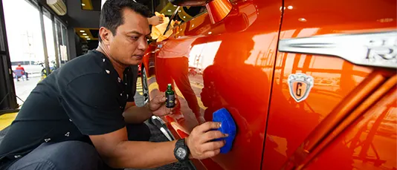 | 