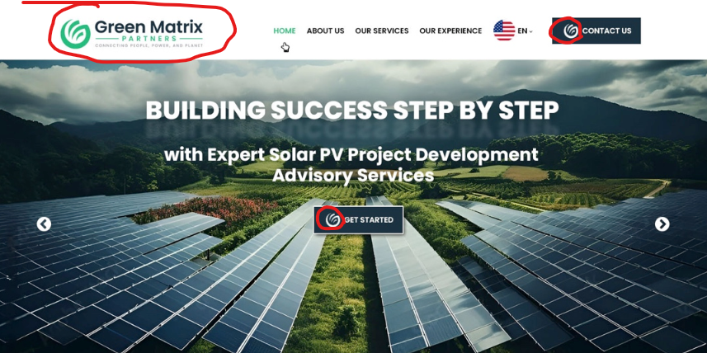
- This is the page I want us to use with the changes below
- I will send updated logo (will look similar to the one below)

- The small logo in Contact and Get Started action buttons need to be updated
- Banner image: I like better this image, instead of the one above *leave text from image above)
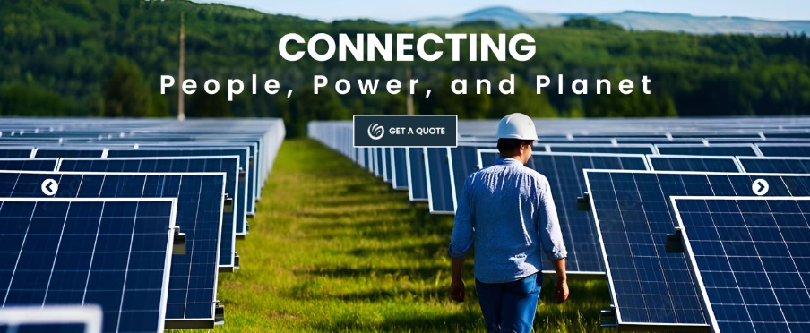

ABOUT US
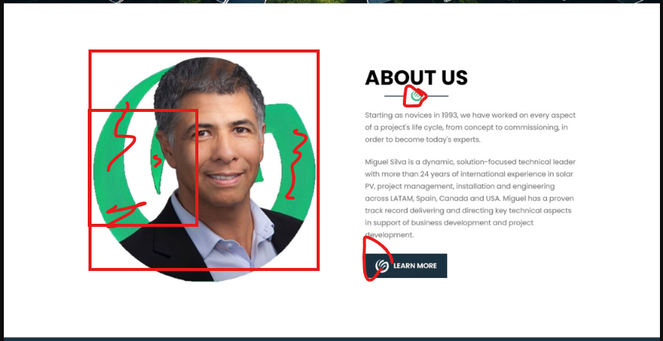

- Remove logo from behind
- Make photo smaller and square and align top with text on the right (lower photo a bit as needed)
- Update smaller logos *need to be rotated, using the new logo I will upload)
- We will add few team member and their brief bios (In the future I should be able to add or remove directly in Squarespace):
  - Miguel Silva
  - Alfonso Munoz
  - Brandon England
  - Jose Luis Colmenarez
  - Alberto de Mattos
  - Norelia Beltran
  - Allan
  - Ivan
  - Natalia

- Add Vision, Mission and Core Values (Tagline goes in this section)

- Vision:
To act as a fiduciary to society and the environment by responsibly utilizing entrusted resources and delivering high-quality consulting services in the energy generation sector, improving people's quality of life worldwide.
- Mission:
At Green Matrix Partners, our mission is to empower our clients with innovative and reliable energy solutions tailored to their unique needs. We are dedicated to delivering measurable value by combining technical excellence, sustainable practices, and a commitment to building lasting partnerships. Our focus is on helping our clients achieve their energy goals while creating a positive impact on the environment and communities we serve.
- S.M.A.R.T. Values:
- Sustainability: We are committed to environmentally responsible practices that prioritize the long-term health of the planet.
- Mastery: We strive for excellence, continually improving our expertise and services to deliver the best results for our clients.
- Accountability: We take ownership of our actions and are dedicated to fulfilling our commitments with integrity.
- Respect: We value diversity, foster inclusion, and build respectful relationships with clients, partners, and communities.
- Teamwork: Collaboration and mutual support drive our success and enable us to achieve shared goals with our clients.

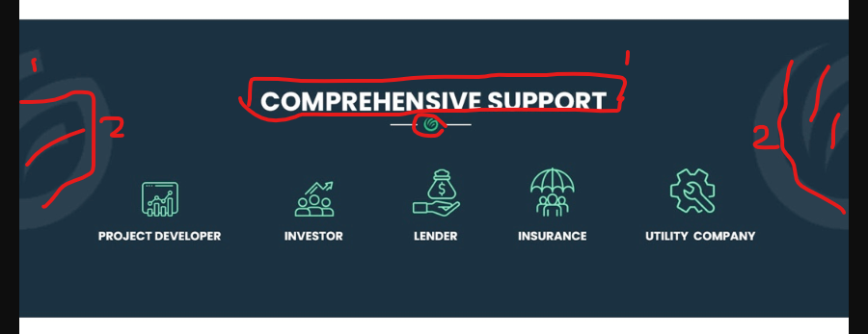

    - Replace text with “STAKEHOLDER SUPPORT”
    - Remove the logos on the left and right
    - Update little logo using latest version
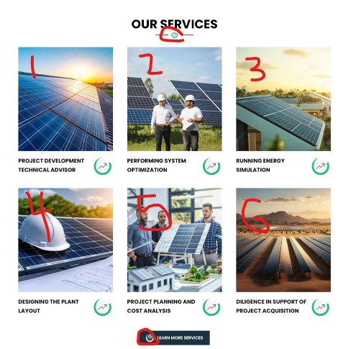
- “Project Development Engineering (PDE) Senior Advisory Services”
  - Use photo #2 here
- “System Modeling and Performance simulations”
  - Use photo #1 here
- “Remote Sensing and Geospatial Services Support”,
  - Use this image instead:

- Conceptual, Preliminary and Detailed Design Support
- EPC Bidding Support
- Use this text instead “M&A Technical Due Diligence Support”
- Each one must take user to a place in which we will briefly describe each service respectively
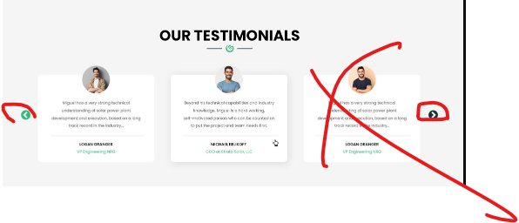
- I do not want a carrousel; I only have two quotes for now
- Update titles for Logan and Mike as follows:
  - Mike: Mill Creek Renewables, President https://www.linkedin.com/in/michael-belikoff-07665612/
  - Logan: Brightnight, Chief Technical Officer https://www.linkedin.com/in/logangranger/

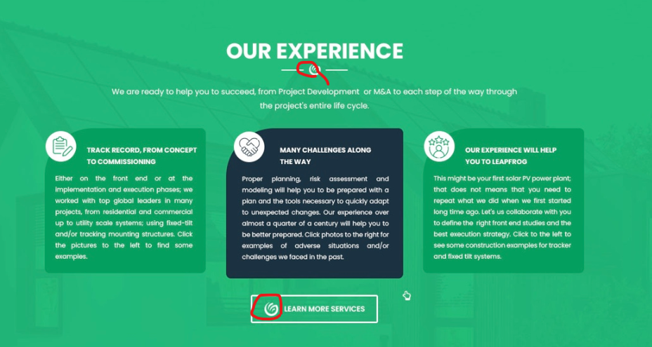
I want similar approach as in https://www.8760.work/experience page, with the images switching from one to another

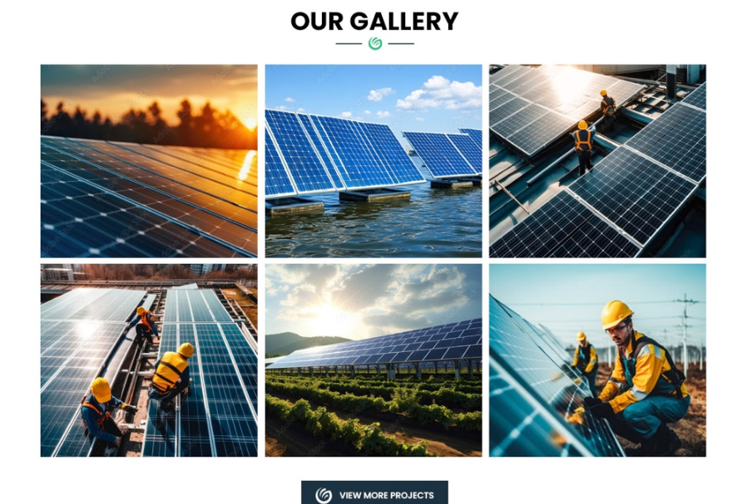
I want this page but not public, I need more time to prepare the content

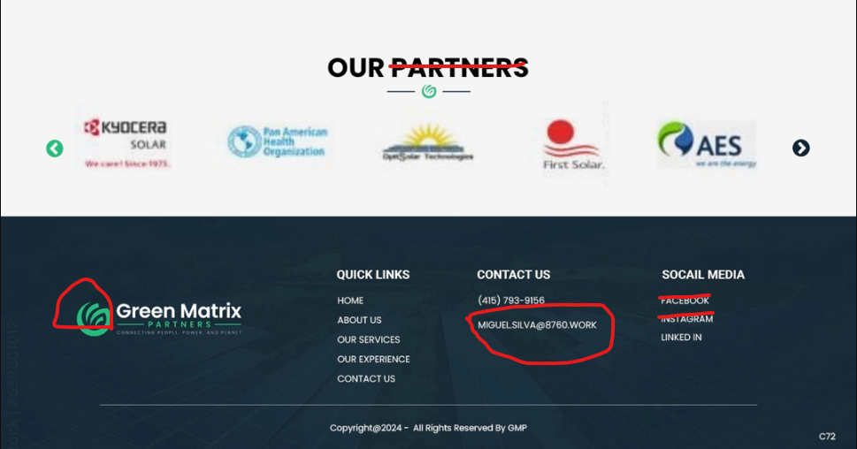
- Instead of “PARTNERS” use “CLIENTS”
- Update the small logo
- Update email address: Miguel.Silva@GreenMatrixPartners.com
- Remove Facebook & Instagram
- LinkedIn: I want links pointing to my LinkedIn articles:
  - https://www.linkedin.com/pulse/digital-twins-competitive-advantage-bad-news-miguel-silva-ha2vc/?trackingId=yHF63vBXQZCF30WvEoZJag%3D%3D
  - https://www.linkedin.com/pulse/empowering-renewable-energy-digital-twins-iot-model-miguel-silva-e605c/?trackingId=mcUJuPKuQ5yRu5BU21dMog%3D%3D

