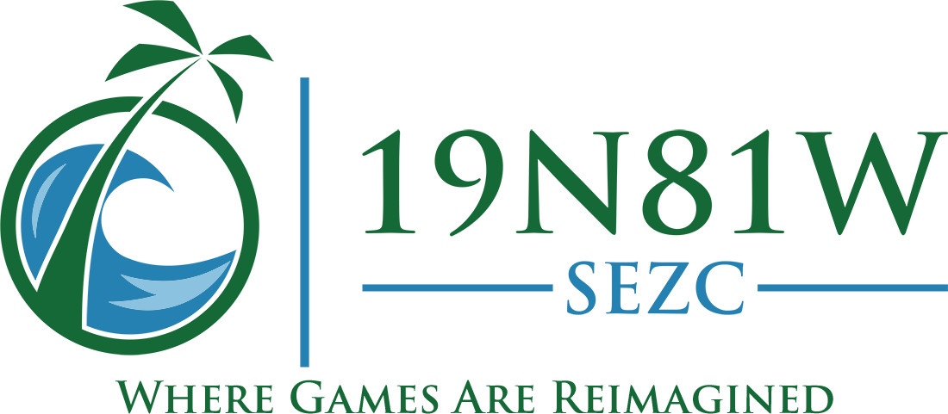
Lance Mason
lance@19n81w.ky
Abstract
This UI Design Requirements document provides a single point of reference for the development of the Pix UI. Pix is a colouring-in / paint-by-numbers (PBN) app that delivers puzzles to target users (primarily people aged 18-44, keen to escape the pressures of the modern world). The target competitors are Pixel Art (EasyBrain), Paint-By-Numbers (Oakever) and Happy Color (X-Flow).
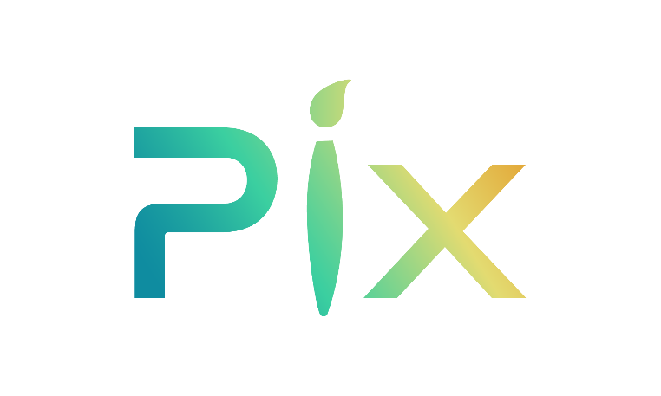
www.pix-by-numbers.com

Version Control
Author Lance Mason
Last Update 11/12/24

Design Requirements
With respect to a new Paint-By-Numbers / Colouring-In app called Pix, we need UI designs for:
- the (4) Gameplay Control Icons,
- the (1*) Gameplay Palette Colour Icons,
- the (8) Non-Gameplay Navigation Icons,
- the (3) Non-Gameplay Carousel Icons,
- the (1) Non-Gameplay Filter Buttons,
- the (5) Non-Gameplay Thumbnail Icons,
- the (9) Non-Gameplay Cropping Icons,
- the (6) Non-Gameplay Text Icons, and
- the (1) 300x300 image that represents a “mystery” item.
* The Palette Colour icon requires that its face colour is set programmatically. See below.

Sizes
All fractional and percentage sizes reference the short-edge length of the device. i.e. on a 1920x1080 device, they are referencing the 1080.
While tablet resolutions are usually lower than mobile phones, this means that the graphics need to scale elegantly.

Background
The screen backgrounds are likely to be flat colours (black #000000, white #FFFFFF, pink #FFB6C0, yellow #FDFD96, blue #D7E5F0, lilac #E4CBFF).

Pix Logo
For reference purposes, here is the Pix logo:


Page Layouts
The various page layouts are provided for context.

Gameplay Layouts
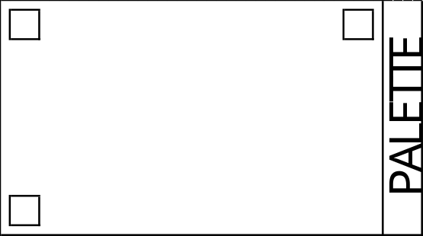
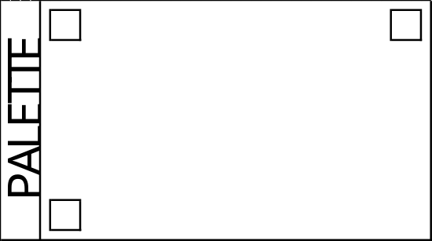
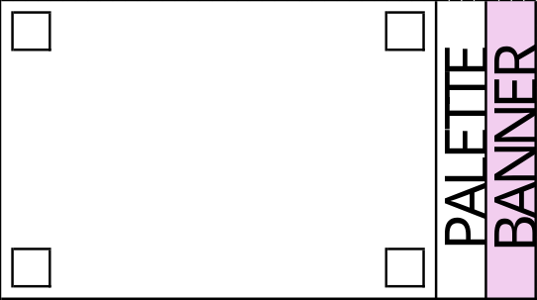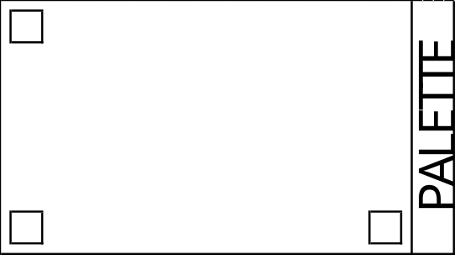
- Gameplay Control Icons:
Gameplay Control Icons are only visible during gameplay. Their positions are indicated by the small corner squares in the images above, which are 1/8th (12.5%) in size².
  - Back Icon
    - The Back icon is in the top-left corner and triggers exiting gameplay.
  - Hints Icon
    - The Hints icon is in the top-right corner and is overlaid by the number of hints available to Non-Subscriber users: 00-99, or * when a Subscriber or there are more than 99.
  - Info Icon
    - The Info icon is in the bottom-left corner and will be used to trigger an overlay with a vertically scrollable (if necessary) area displaying the stored puzzle information.
  - Hints Extra Icon (Non-Subscriber Users Only)
    - The Hints Extra icon is in the bottom-right corner and is temporarily displayed to Non-Subscribers for four seconds whenever the user has not clicked something for at least thirty seconds. It is then disabled for two minutes to ensure that it is not displayed too often. This only appears on the portrait orientation gameplay screen that includes banner adverts.
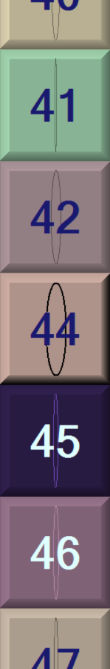
- Gameplay Palette Colour Icons:
The Palette Colour icons are within square areas (notably, most competitor Palette Colour icons are actually round in shape) that are 1/6th (16.6666%) in size² and which can be displayed in portrait or landscape orientation (see layout images above) and have the following functionality:
  - can be in a “selected” or “unselected” state.
  - clearly display one particular colour.
  - indicate the colour paint-by-number numeral.
  - indicate how much of the colour remains in play.
This was achieved for prototyping purposes (shown on the left) by:
- Edge bevel colours could be reversed to make the button appear indented and the percentage indicator ellipse could be made black (#000000) or white (#FFFFFF).
- Button face colour was the required colour, while bevel edges were lighter or darker tones.
- White numerals on dark colours and black numerals on light colours.
- An elliptical overlay ranged from fully round (100%) to a thin vertical line (1%).
Please note - This should not be taken as indicative of what we desire, but simply one very basic design iteration that we employed to demonstrate the gameplay functionality. We are open to other options if they are intuitive, attractive and functional.

Non-Gameplay Layouts
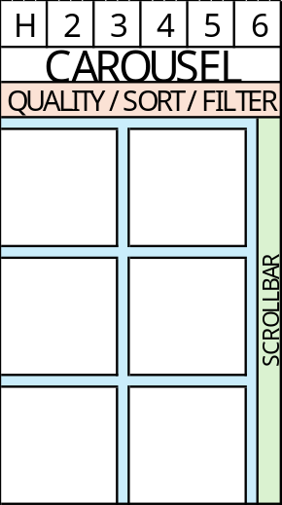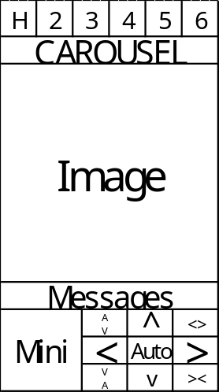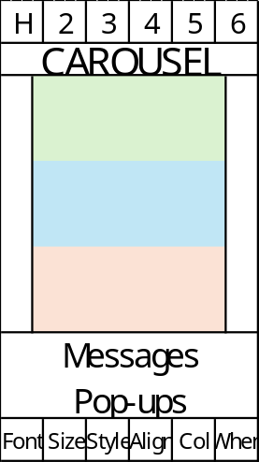
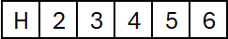
- Non-Gameplay Navigation Icons
The square Navigation Icon areas will be positioned at the top of the screen, and are 1/6th (16.6666%) in size².
The six available slots used for primary navigation outside of gameplay can hold the following:
  - Hamburger Menu Icon
    - A standard hamburger menu icon always position in the left-most slot and in keeping with the colours and style used for all other in-app icons.
  - Notifications Icon
    - The Notifications icon is overlaid by the number of unread notifications: 00-99, or * where there are more than 99 unread notifications.
    - The Notifications icon could be a Bell or Exclamation Point. Its purpose should be obvious.
  - Favourites Icon
    - Keep in mind that the Favourites icon is used as a Navigation icon in this context, but is also used as a Thumbnail icon (overlaid on the Thumbnail images) as detailed below.
    - The Favourites icon could be a heart or a star.
e.g.
  - My Pix Icon
    - The My Pix icon will link to the My Pix Page, which contains a collection of four different categories of puzzles, primarily consisting of personal content.
  - Pix Icon
    - The Pix icon links to the Pix Page, which contains multiple collections / categories of generally available puzzles.
  - Store Icon
    - The Store icons links to the Store Page, which is a hub for the various in-app-purchase options.
  - Account Icon (Subscriber only)
    - The Account icon links to the Account Page, where a subscriber can modify their personal information.
  - Turtle Icon (Non-Subscriber only)
    - Keep in mind that the Turtle icon is used as a Navigation icon, as well as a Thumbnail icon (overlaid on the Thumbnail images).
    - The Turtle icon links to the Turtle Page. The Turtle icon is overlaid by the number of user Turtles: 00-99, or * where there are more than 99 user Turtles. Turtles provide access to Subscriber-only puzzles.
- Non-Gameplay Carousel Icons:
A horizontally re-sizeable Carousel (cartouche-shaped) icon used to display horizontally scrolling text options. The text will be centred within it. Please provide three variations. They are 1/8th (12.5%) in height with a variable width that is dependent upon the text used.
- Non-Gameplay Filter Buttons:
One Filter Button (using 1/3rd of the display width) to display Quality, Sort and Filter text options. It is 1/8th (12.5%) in height.
- Non-Gameplay Thumbnail Icons:
The Thumbnail Grid, shown here in the lower left section, is a vertically scrolling display of Thumbnails.
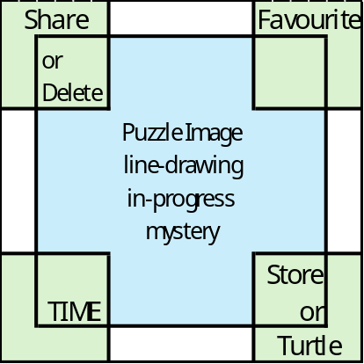
Each Thumbnail area consists of a centred Puzzle image, accompanied by up to four satellite Thumbnail Icons, shown here in green, positioned in the corners.
The seven possible Thumbnail icons are used as overlays on the centred Thumbnail images.
They are unlikely to be more than 1/6th (16.6666%) in size² and may be resized to slightly smaller sizes on tablets. We will optimise them separately.
  - Favourites Icon
    - The Favourites icon is displayed in the top right corner of a Grid and is a simple on/off toggle. A user can click the Favourites icon to toggle the status. Please see notes about the Favourites Non-Gameplay Navigation Icon.
  - Share Icon
    - A standard email icon in keeping with the colours and style used for all other in-app icons. Sharing is always accomplished via email.
    - The Share icon is displayed in the top left corner of a Thumbnail Grid. The Share icon is overlaid by a number (00-99, or * if greater than 99) indicating how many shares remain available.
  - Delete Icon
    - A standard bin icon in keeping with the colours and style used for all other in-app icons.
    - The Delete Icon is displayed in the top left corner of a Thumbnail Grid.
    - This icon should also be displayable in a “faded” style, although we could make it semi-transparent if necessary.
  - Storage Icon
    - The Storage Icon is displayed in the bottom right corner of a Thumbnail Grid and is a simple on/off toggle. Clicking this will toggle the “store locally” status of the puzzle, for offline play purposes.
    - This icon should also be displayable in a “faded” style, although we could make it semi-transparent if necessary.
  - Turtle Icon
    - The Turtle Icon is displayed in the bottom right corner of a Thumbnail Grid on the Pix Page where the user is a Non-Subscriber only. The Turtle icon is overlaid by a number (1-9) indicating how many Turtles are required to access the puzzle.
    - The Turtle icon, if realistic in nature, should loosely resemble (in form and/or colour) one of the four following species:
      - Chelonia mydas,
      - Eretmochelys imbricata,
      - Caretta caretta, or
      - Dermochelys coriacea
  - Time
    - This is simply text and does not require designing
- Non-Gameplay Cropping Icons:
The Cropping Page layout is shown here for context.
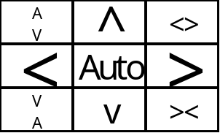

The nine control icons, shown above, are 1/8th (12.5%) in height and 5/24th (20.8333%) in width, and consist of:
- Increase height
- Decrease height
- Increase width
- Decrease width
- Move up
- Move down
- Move left
- Move right
- Auto-crop
- Non-Gameplay Text Icons:
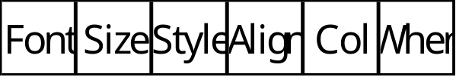
The Text Editing Page layout is shown here for context.
The six text control icons, shown here, are 1/6th (16.6666%) in size², and consist of:
- Font Family will display a list
- Font Size will display a list
- Font Style will display Bold / Italic toggles
- Text Alignment will display a list
- Text Colour will display a grid
- Text When Appear will display Before / After toggles

- Mystery item:
This is simply a square (of fixed 300x300 size) replacement for a puzzle image, which indicates that the puzzle is a “mystery” puzzle. We simply used a mixture of question-marks and exclamation-marks in the prototype, but we are open to suggestions.

Deliverables
As well as the icons and controls, please provide page mock-ups, using the layouts provided, and against different flat colour backgrounds, so that we can gauge how the separate items look when combined.
All final supplied images should be in PNG and/or TIFF format, employing transparency where appropriate.
Thanking you in anticipation.

