I MADE THE SWITCH…… to CARDI B WIRELESS.

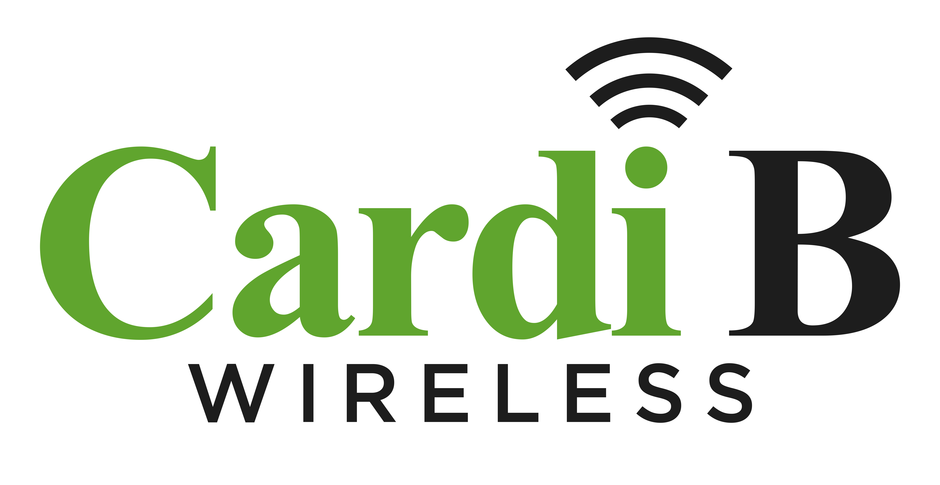
Instructions:
Show picture of Ice Cube holding an Iphone or Android Smart Phone speaking out:

‘I made the switch…..”

Format this flyer so that other celebrities like Floyd Mayweather, Tyra Banks, Fat Joe can be inserted instead of Ice Cube…

See images to get an idea of making this flyer look hip like old school Boost Mobile flyers and commercials…. Some of which featured Fat Joe.

Text to Include:
Unlimited Talk, Text, Data - $50/month. No Contract – see attachments for font suggestions.

Cardi B Wireless Operates on the T-Mobile Network, America’s Largest 5G Network.

Cardi B Wireless offers the Same Prices and Same Plans as Metro-by-T-Mobile.

Cardi B Wireless Customer Care and Billing Provided by Plum, a T-Mobile customer care division

Cardi B Wireless Subsribers receive “Exclusive Access” to SMS urban entertainment happenings

Cardi B Wireless Subscribers receive “Member Access” to Cardi B Wireless Instagram Show

Cardi B Wireless Instagram Show Includes 2025 Chevy Camaro Give-Away (bi-weekly)

Make the Switch Today….
www.CardiBWireless.com

