Hi,
I would like to present this illustration differently for a textbook, but nothing should change in terms of content.

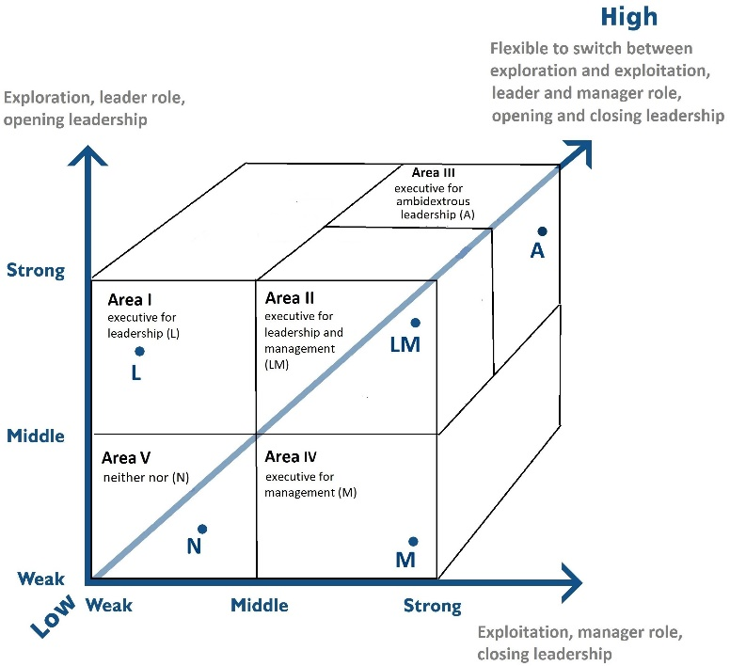
In the new figure, these areas should still exist.
- executive for leadership
- crosses the "middle" boundary on the exploration/leader role/opening leadership axis.
2) executive for leadership and management
- crosses the "middle" boundary on the exploration/leader role/opening leader axis, and
- also crosses the middle line on the axis of exploitation, manager role, closing leadership.
3) executive for ambidextrous leadership
- crosses the "middle" boundary on the exploration/leader role/opening leader axis, and
- also crosses the middle line on the axis of exploitation, manager role, closing leadership and
- crosses the middle boundary on the flexibility axis.
4) executive for management
- crosses the "middle" boundary on the exploitation/manager role/closing leadership axis.
5) the three middle limits are not exceeded.

Idea for an alternative:
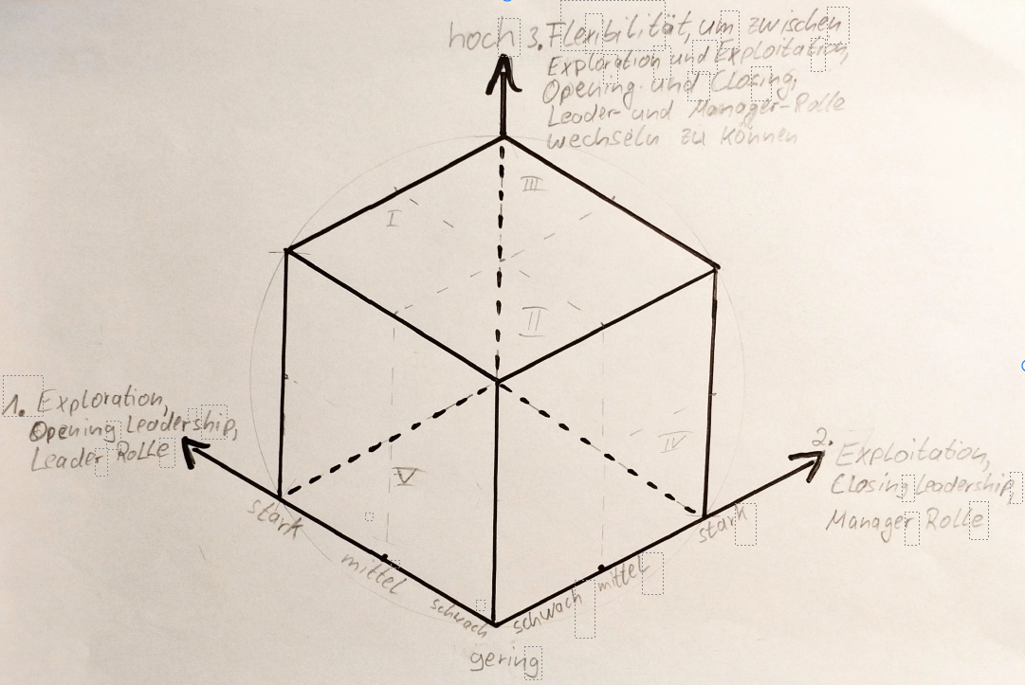
This illustration is just an idea that I don't like so much myself, because I'm not sure to what extent readability is impaired, how can the respective categories, especially categories II and V, be visualized here, for example?
Requirements: The information should be recognizable at a glance, so the image should not be overloaded. If a colour distinction is helpful, then gladly, otherwise it can also be omitted. The illustration is to be used in a textbook, so it should look serious and modern.
Labeling:
The labeling should generally be in German, which is why I list the labeling here.
Axes
1.Axis: 1. Exploration, Opening Leadership, Leader-Rolle
schwach, mittel, stark
2.Axis: 2. Exploitation, Closing Leadership, Manager-Rolle
schwach, mittel, stark
3.Axis: 3. Flexibilität, um zwischen Exploration und Exploitation, Opening und Closing Leadership, Leader- und Manager-Rolle wechseln zu können
gering, hoch
Labeling per area/category in the figure
Kategorie I: Führungskraft fürs Leadership (L)
Kategorie II: Führungskraft fürs Leadership und Management (LM)
Kategorie III: Führungskraft fürs Ambidextrous Leadership (A)
Kategorie IV: Führungskraft fürs Management (M)
Kategorie V: Weder fürs Management noch Leadership geeignet (N)

Best regards
Jan

