Intention: To give the current packaging an upgrade to incorporate more of a Y2K theme design with a minimalistic approach mixed in so its not too heavy on the Y2k side.

Current
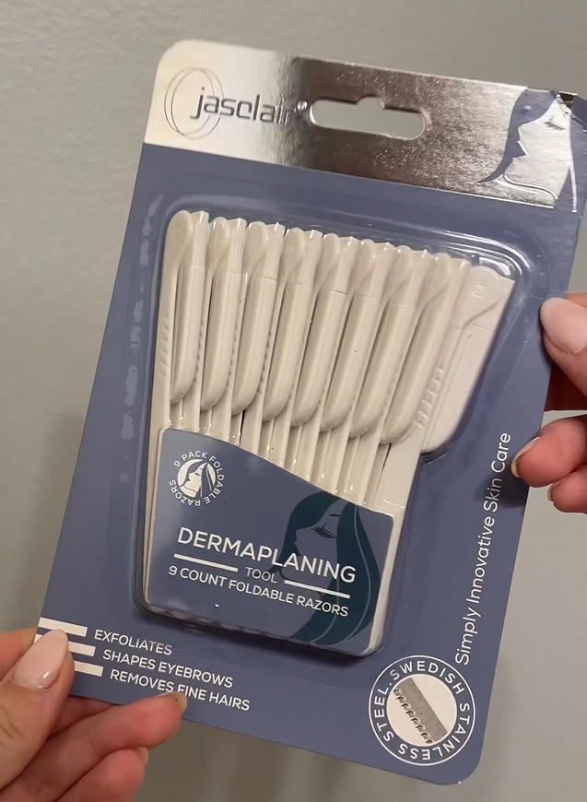
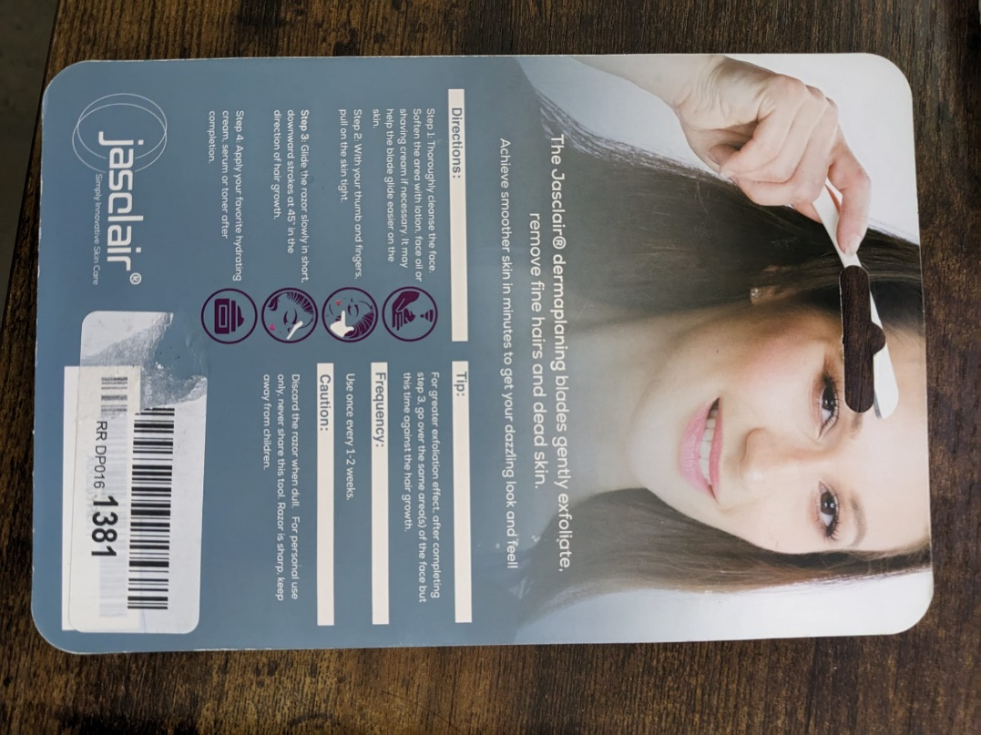
Inspiration for Future: Used ChatGPT to give me these outputs.
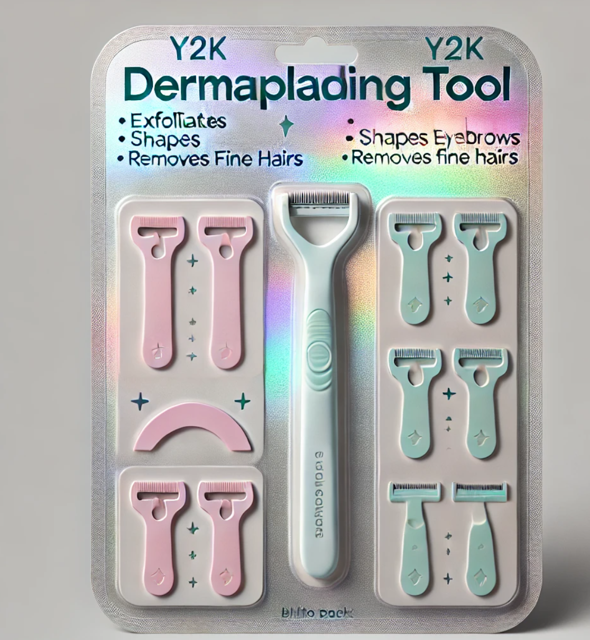
Here are two options for the back design of the dermaplaning tool blister pack, combining Y2K and minimalist aesthetics:
- Option 1: Features a soft matte holographic background with neon accents and a clear "Directions" section. The layout includes minimalist icons and subtle Y2K symbols, giving it a trendy, nostalgic feel.
- Option 2: A matte silver background with a more structured layout, dividing "Directions," "Tips," "Caution," and "Frequency" into clearly defined sections. This option has a cleaner, more organized look with minimalistic Y2K elements.

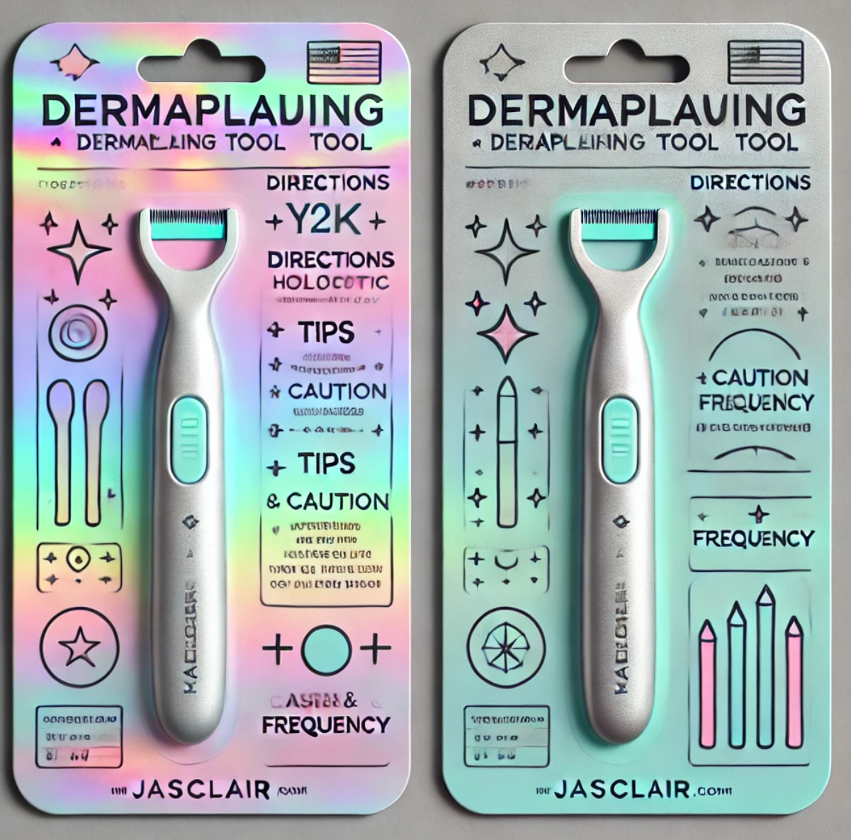
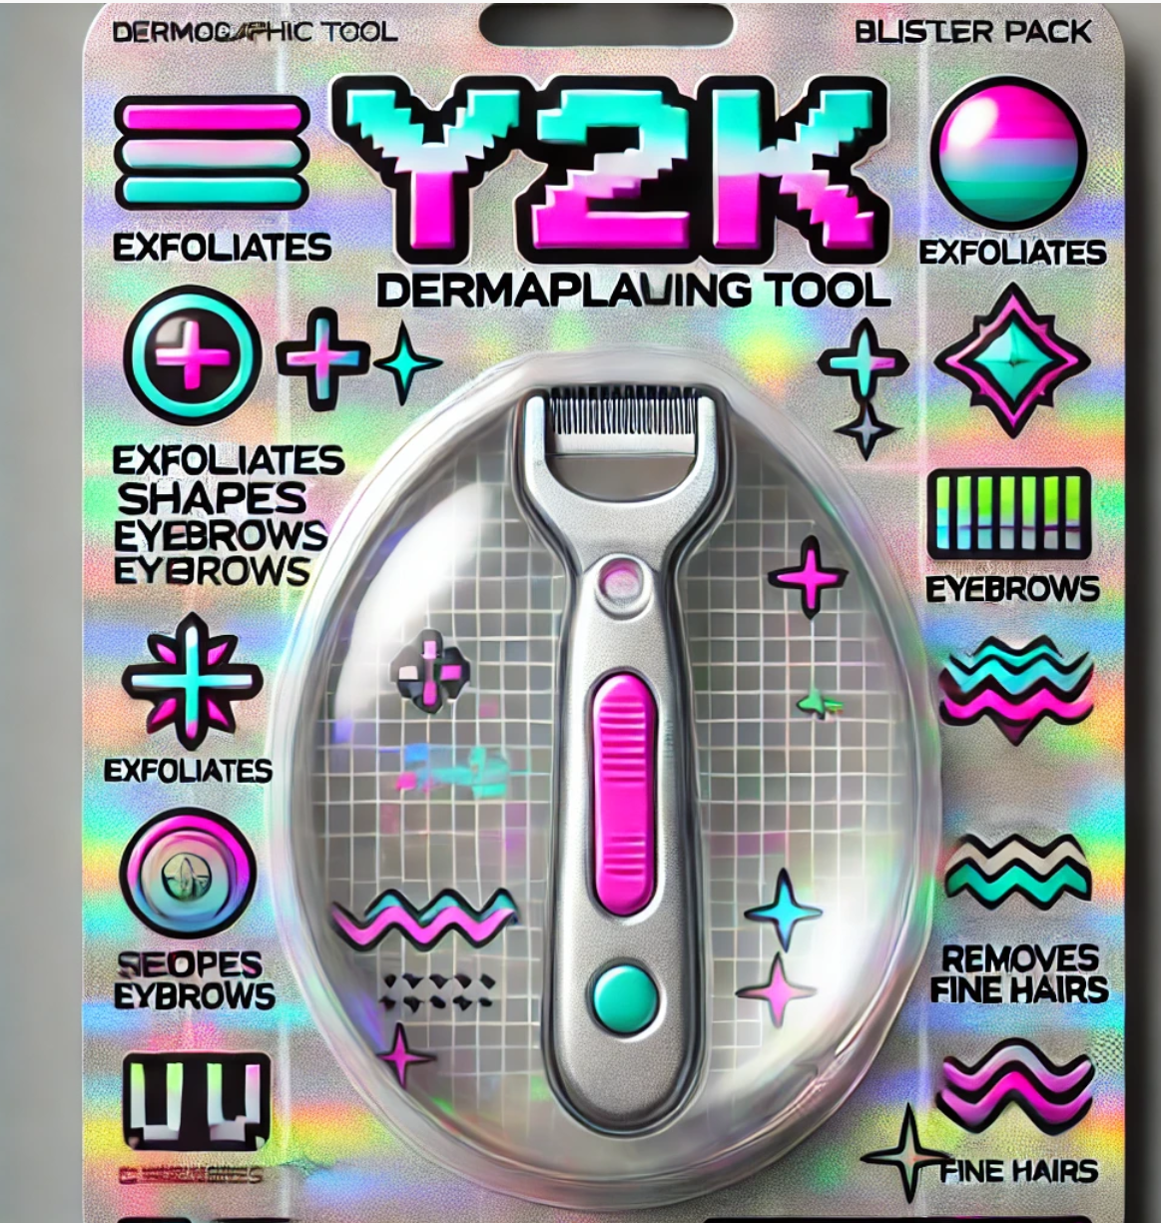
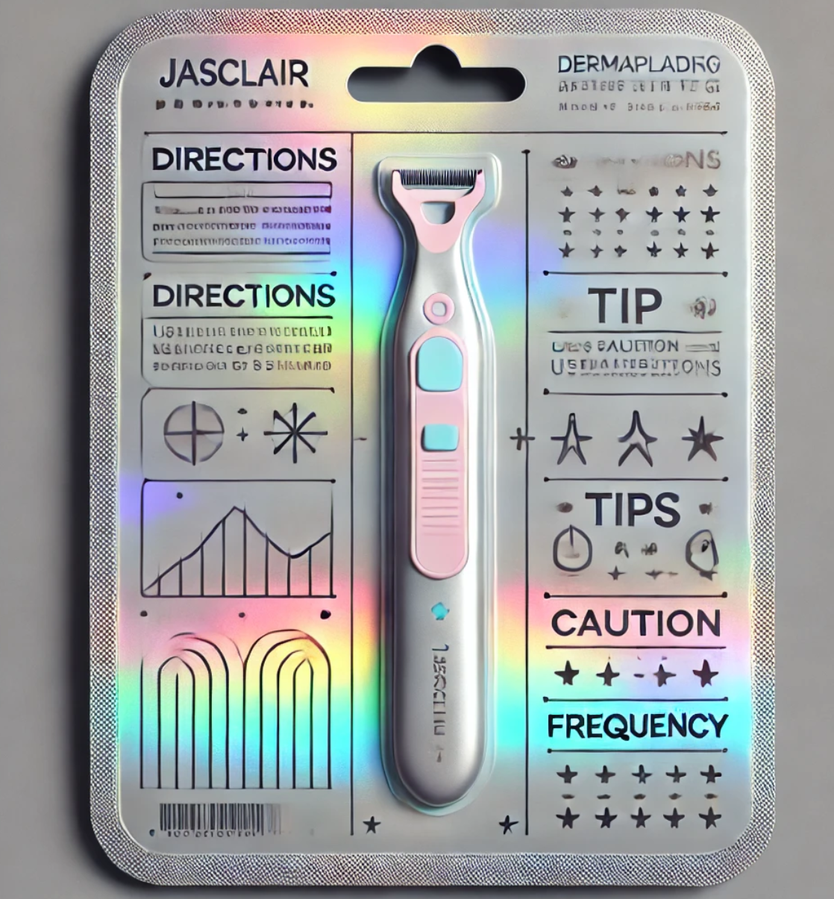
I would like to present an initial design to the manufacturer to see if they can incorporate either a full silver for the main section and then the middle insert can incorporate something that contrasts with the silver and the font inside there can stand out.
Or just have the silver foil at the top as current and then the middle section is also silver foiled.
We also have to update the title to make it stand out more.
Title: I would like it to stand out as it currently does not in the current packaging.
We can remove the circle of 9-Pack Foldable razors and image to create more space if needed and that can be moved elsewhere or completely removed.

Title should be:
DERMAPLANING TOOL
Subtitle: FOLDABLE COMPACT RAZORS
And the 9 COUNT should be moved else where and be prominent as well so it stands out too.
The rest of the information
The rest the information on the front and back can remain as is.

The main competitors also changed their packaging:
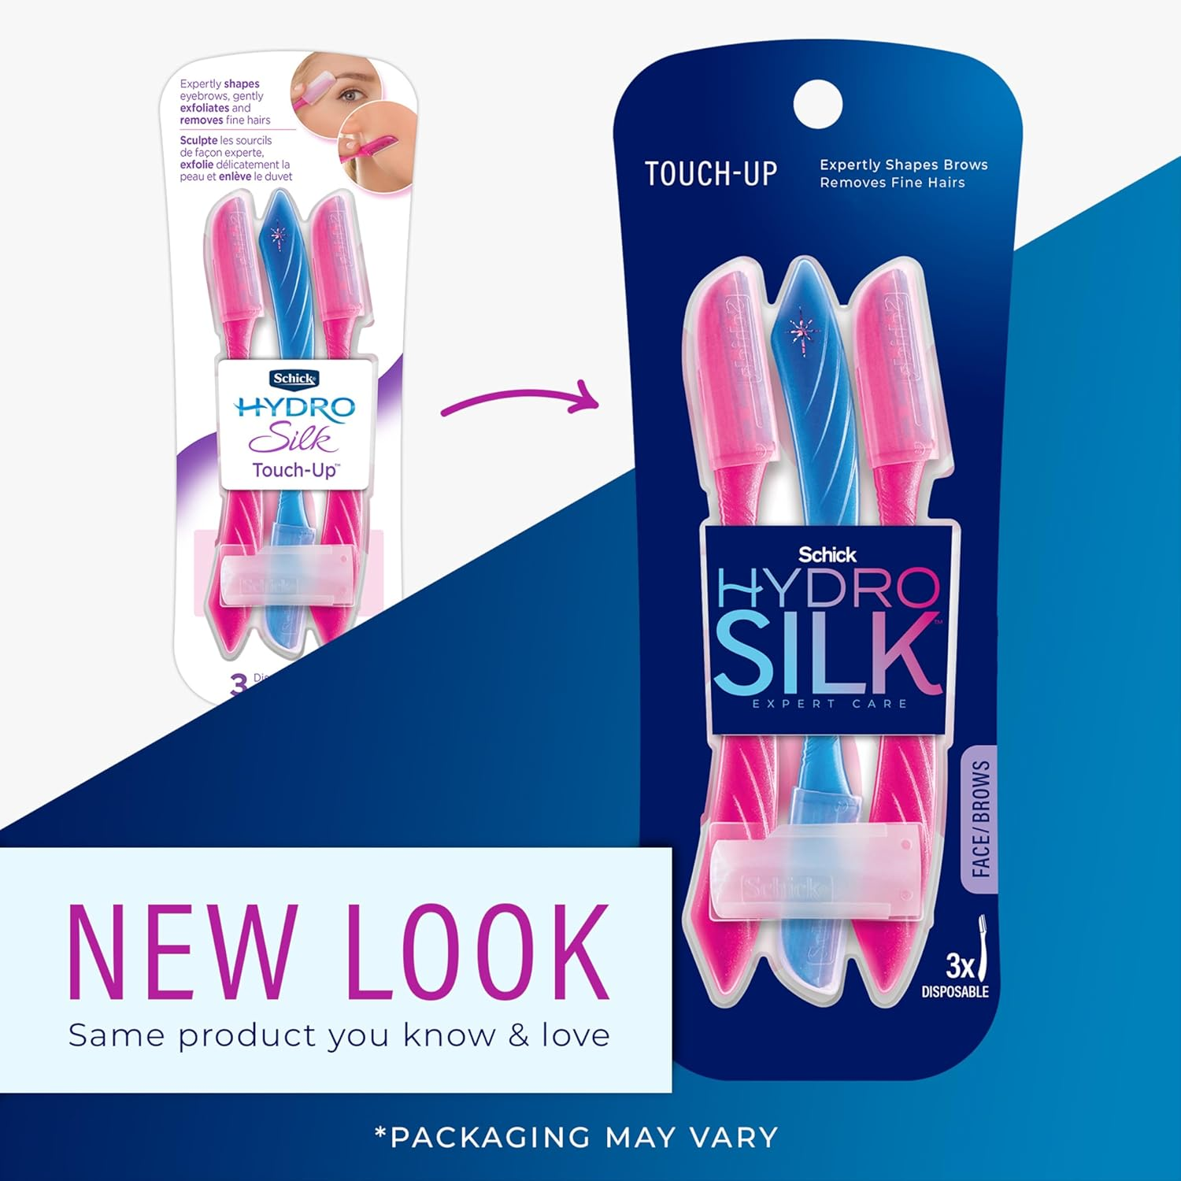
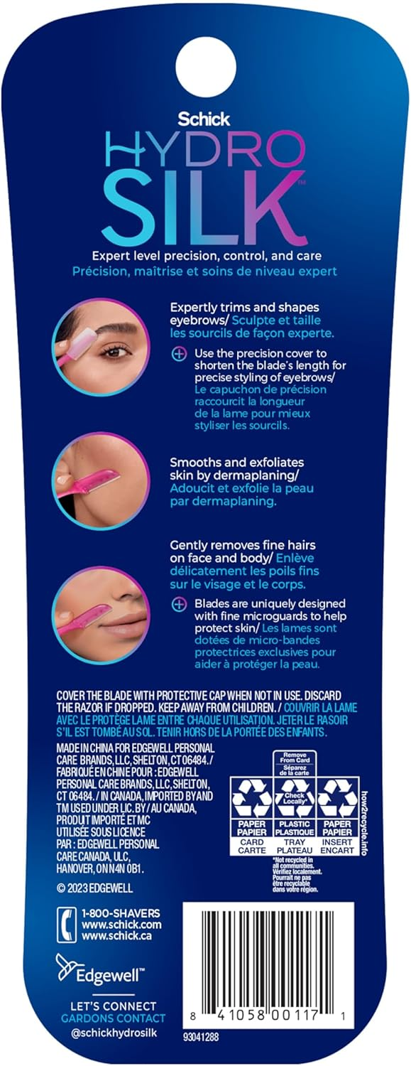
Here is another top competitor.
