

Name_________________________________________Address______________________________________________
City______________________________ST_____Zip___________PH#__________________PO#____________________
E-Mail_______________________________________________________________________________________________
Location___________________________________ Salesperson______________________________________________
Year______Make_________Model_____________Vin________________________________Stock#_________________

Ceramic Paint Protection | Paint Protection Film
Ceramic coatings are hydrophobic (water repellent) coatings that bond to a vehicle’s painted surface. Ceramic coatings are formulated to retain the showroom finish by protecting against corrosion and contaminants like UV damage, oxidation, road salt and acid rain. | Paint protection film (PPF) is a clear, thin layer of self-healing urethane applied to the painted surfaces to protect against scratches, stone chips, bug splatters, swirl marks, corrosion and contaminants like UV damage, oxidation, road salt and acid rain.

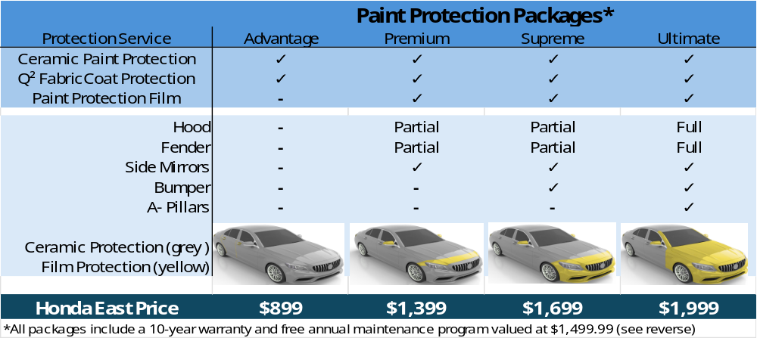
As a Tint World Preferred Customer you will have the option of having your interior professionally cleaned and renewed by Tint World at a discounted rate. We will reapply your Q² FabricCoat Protection at no charge during your annual renewal. The interior must be cleaned prior to reapplication. Customer Initials________

WAIVER OR AGREEMNT TO PURCHASE

______ YES, I want to purchase the Tint World Paint Protection Package marked below. I have been explained the benefits of this protection, the 10-year warranty program and the annual renewal service requirements. I also understand that I must have my vehicle processed within 30 days.

Advantage _______ Premium _______ Supreme _______ Ultimate _______

______ NO, I do not wish to purchase this protection for my vehicle. I assume full responsibility for any damage to my vehicle that is not covered by the manufacturer’s warranty but would have been covered under this protection.

Customer Signature ____________________________ Signed Date__________________

