Graphic Deliverables
All elements need to be as separate layers, so it can be animated in a Broadcast Live graphics software.

Scoreboard + TEAM SCORE “points”
Team points in right corner
Match score in the left corner

Scoreboard

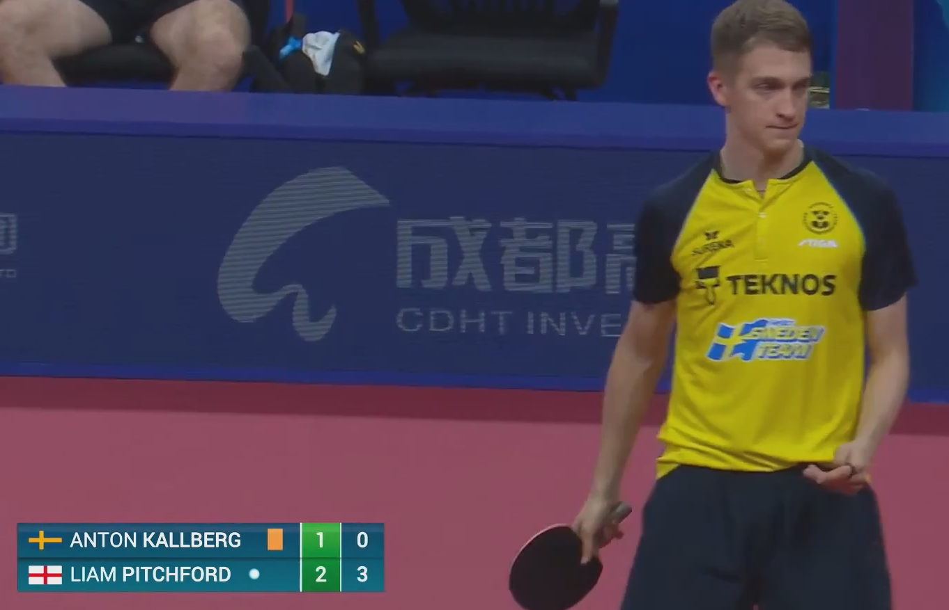
-white dot for the next server
-sets first, running points last
No “flags” just player names and colour of team

LED WALL:
Need also a score board design for a LED wall (her må svenskene inn og mene noe iom. De har størrelsene på LED overflatene)
WINNER theme - TEAM x WINS (2 alternatives)
Timeout theme
Walk on theme \ Player presentation

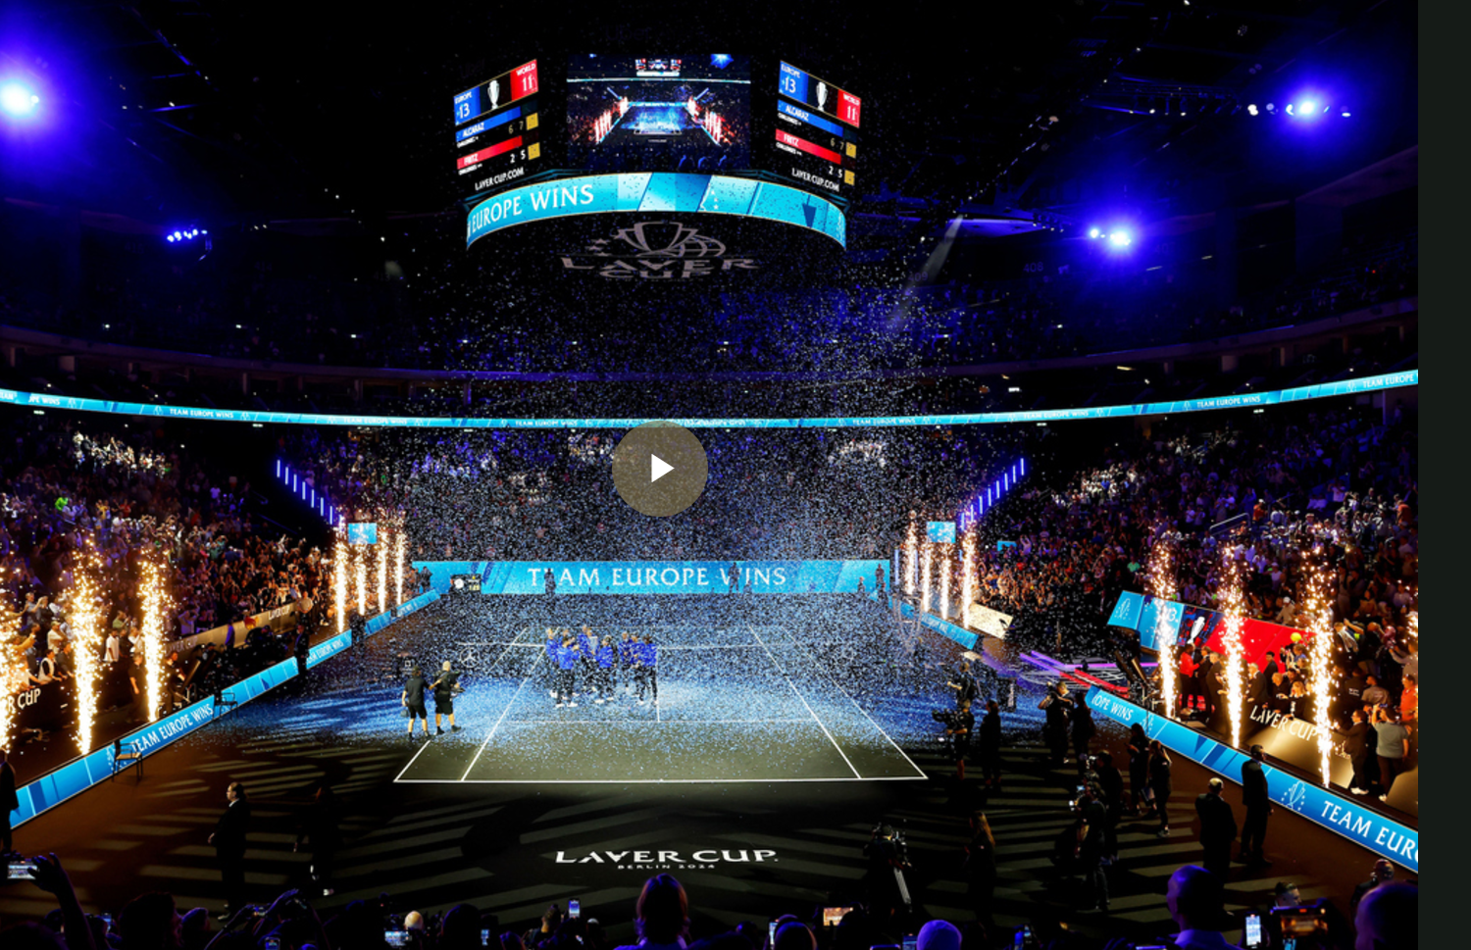

Moving background for On-air graphics and LED walls:
Keep logo placement clean as possible, the logo needs to “pop out” and not get lost in the background. Slow movements, and fill corners as the center will have a graphic layer on top.

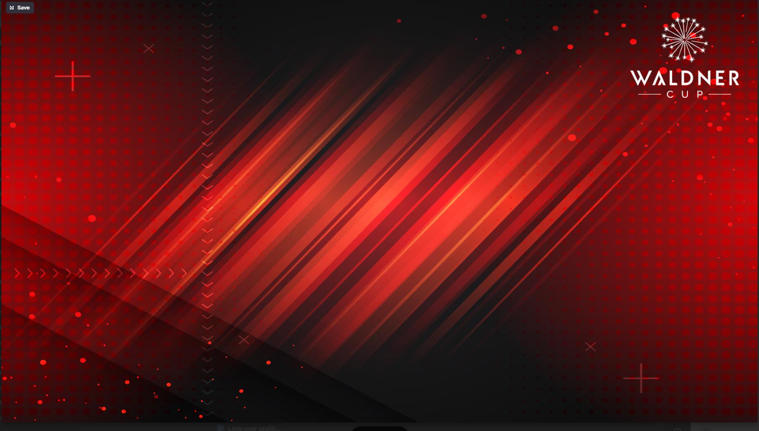

Lower thirds:

Generic name and title E.g.
Nils Marius
Mayor of Oslo


TEAM player name and Captain Lower third

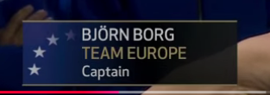

Location “upper Corner” e.g “TOWN HALL” or “OSLO NORWAY”
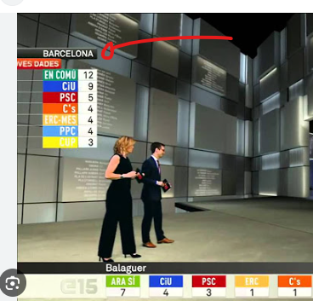

Todays Matches “matchups” and next day “tomorrow” matchups (teaser at end of day 1)
Team World NAME vs Name Team Asia
Without the results
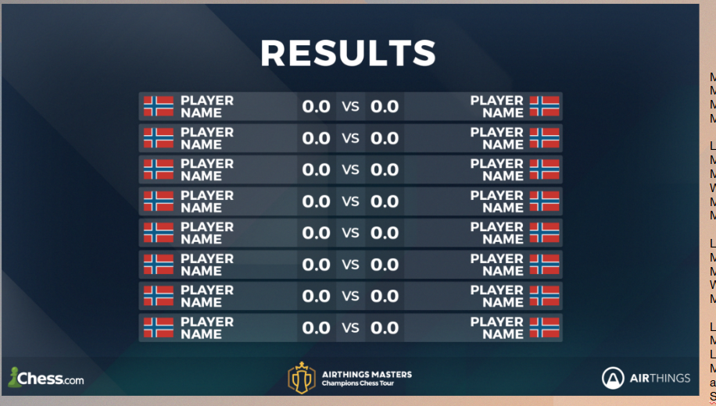

Results Day 1 and Day 2
highlight of the player that has won
Team Score should be added somewhere
Should we see points 1-0 or
Sets won\lost 2-1 and count the team points in the bottom

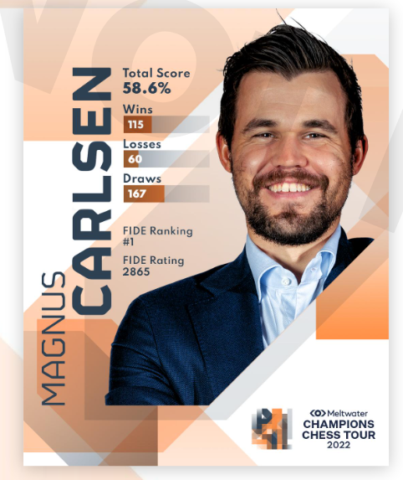
Player Bio\stats:

Stats: need input
- Name
- Age
- Ranking
- Country
- Favorite serve
- Left or right hand

Head2head:
player vs player Stats, need input

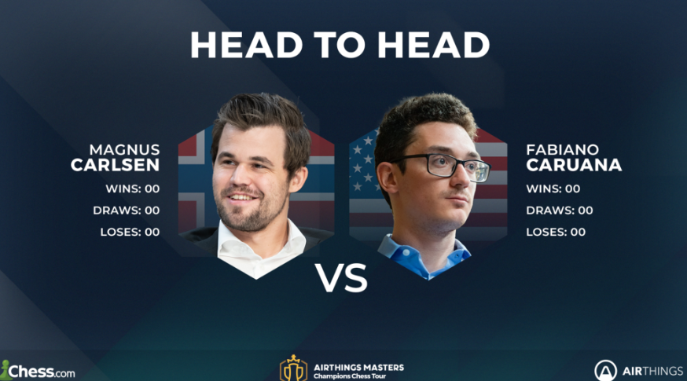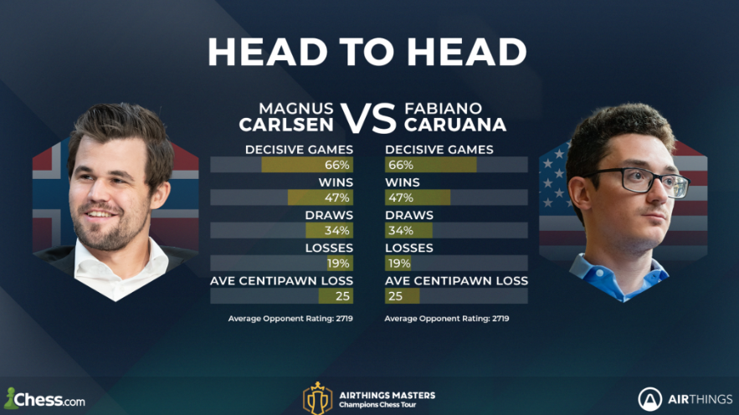

Open and closing animation
5+ sec LOGO animation with Alpha channel
https://youtu.be/TuHsi27GXjs?t=920

WIPE
In and out of action Replay
https://www.behance.net/gallery/16302147/LIGA-BBVA-wipe

Splits:
When there are time outs, we need to see both teams in a “split view”

50/50 - Generic

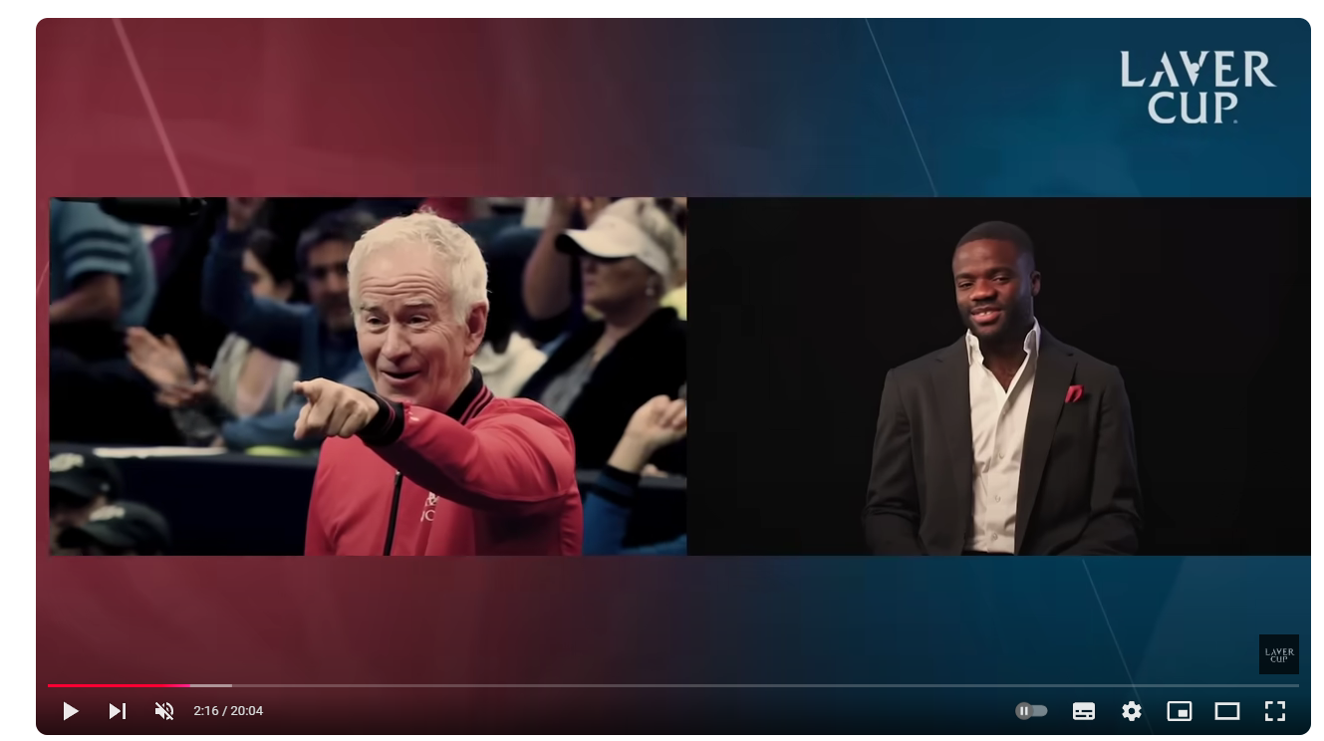

30/70 - “TIME OUT” view
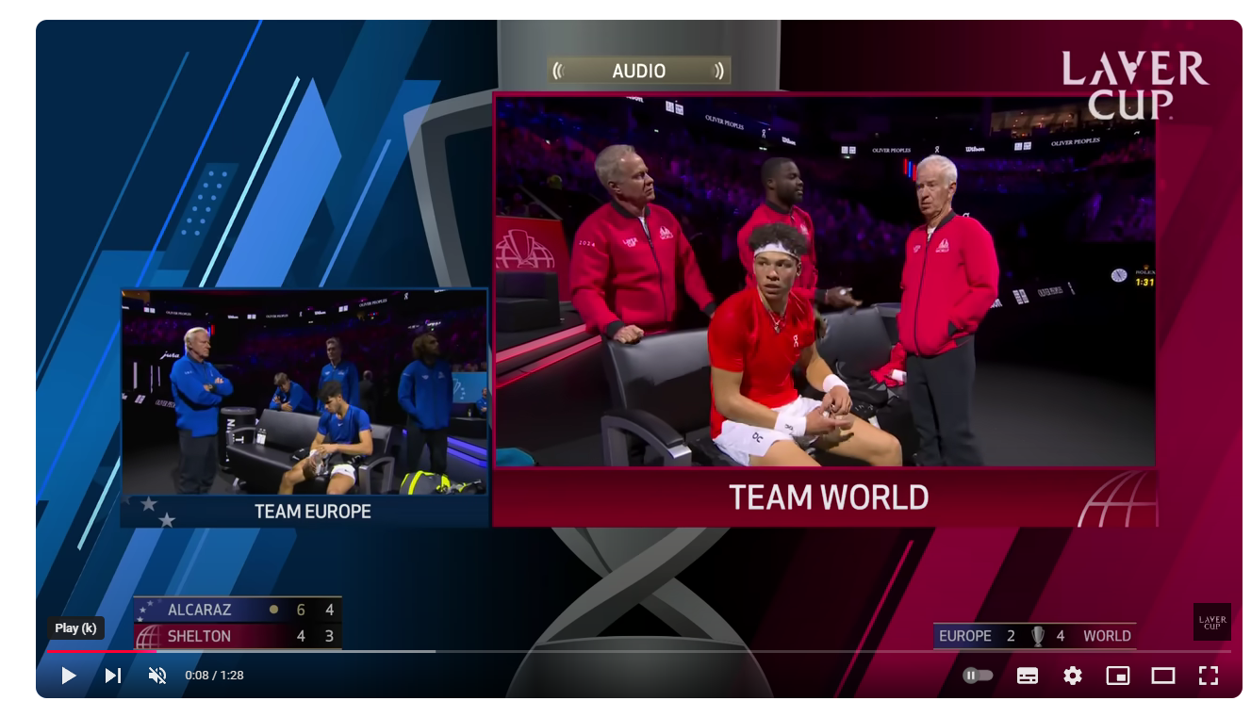
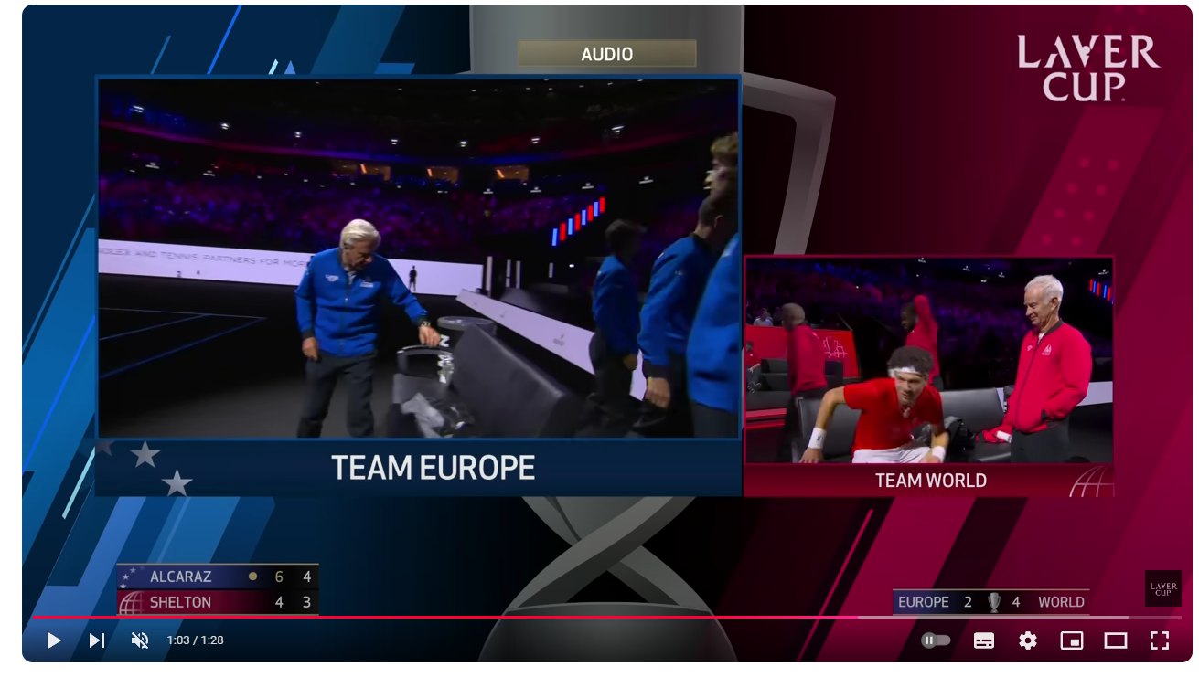

Other TBD:

