We are looking for a website using company name and colour scheme. Needs to be responsive and mobile friendly for all browsers and coded for both Android & IOS. SEO is also important. Want something visually grabbing that displays growth, quality and confidence.
WordPress or Joomla – must be desktop and mobile friendly with fast page load speed. Need the ability to edit ourselves.
4 pages
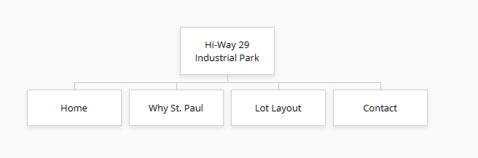
HOME
The property is located on the west side of the Town of St. Paul, a growing municipality located northeast of Edmonton, with a regional population of 13,649. The area has a very strong local economy due to its location between Edmonton and Cold Lake, but with a stronger agricultural base. It serves as the focal point for the Smoky Lake area, with an unemployment rate of 5.0% lower than the provincial average of 8.2%.

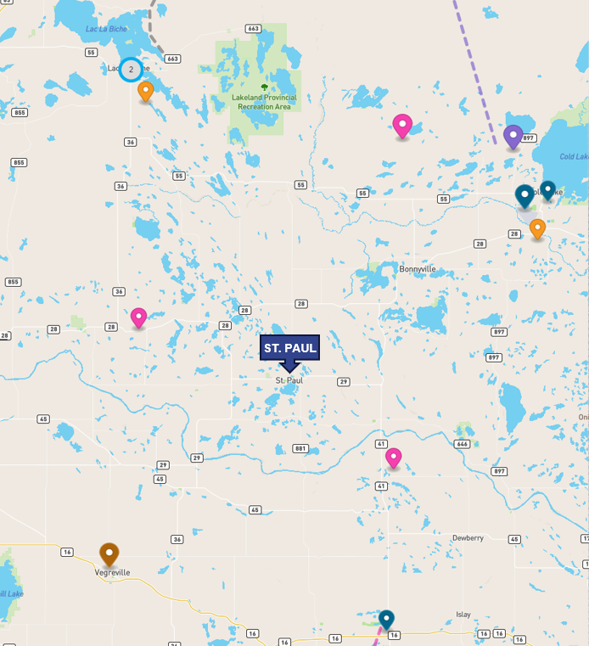
Call to action – LEARN MORE – linking to WHY ST PAUL?
WHY ST PAUL?
LOCATION ADVANTAGE
- Prime location to service “Alberta’s Industrial Heartland”
- Lower property tax
- Better visibility for highway commercial

Located in the County of St. Paul business area, which is currently short of product for sale or lease in both residential and commercial real estate. The area is also in a current influx of population due to its close proximity to the development occurring in the Industrial Heartland. The County of St. Paul is a designated community under the Rural Renewal Stream (RRS) of the Alberta Advantage Immigration Program.

Major Projects in St. Paul service area:
- Vilna Solar Project
- Northern Valley Wind Project
- Pathways Alliance Carbon Capture Storage Hub (Phase 1)
- CFB Cold Lake Expansion
- Cenovus First Nations Housing Initiative
- Marguerite Lake Compressed Air Energy Storage

Recent Commercial Developments or Expansions
- Agland
- Caouette & Sons Implements Ltd
- Location Cats Heavy Equipment
On Track Contracting (Pile Driving)

DEVELOPMENT PLANS

It is currently anticipated that the process of sub-dividing the property and installing the required services to allow for sub-division will take 18 months to complete. The developer is proposing to develop the industrial park to include a truck/RV service centre including a restaurant, a truck/RV car wash and three buildings with 6 bays of office warehouse condos averaging 2,400 square feet per bay. These units will be offered for sale or lease. Presently there is no available space of this nature in the area.
INDUSTRIAL CONDOMINIUM COMPLEX
Upon re-zoning and sub-division, the project will move forward with construction on as many as three industrial office warehouses. Each of these buildings will consist of a building footprint of roughly 14,500 SF and 6 individually titled units as part of a condo complex. Each building will be situated with highway frontage to maximize exposure, and yard space in the rear. The developer has found this to be the ideal product for small to medium-sized businesses, which is currently lacking in the St Paul market. They have built a similar project in Sherwood Park, Alberta known as The Altaland Business Condominiums.
EXISTING SHOP
The existing shop will be parcelled together with a storage yard and sold as is. This will allow for the shop to be purchased or leased along with 2-3 acres of gravelled and fenced yard space.
Upon sub-division, the developers intend to sell this property for an estimated price of $1,400,000. This property is presently being leased and a Letter of Intent to purchase has been agreed to by the existing tenant.
APPRAISAL LOT LAYOUT
This Area Structure Plan is preliminary and will require modification. Alberta Transportation is considering our proposal for access to the property off Range Road 100 to alleviate significant costs related to access from Highway 29.
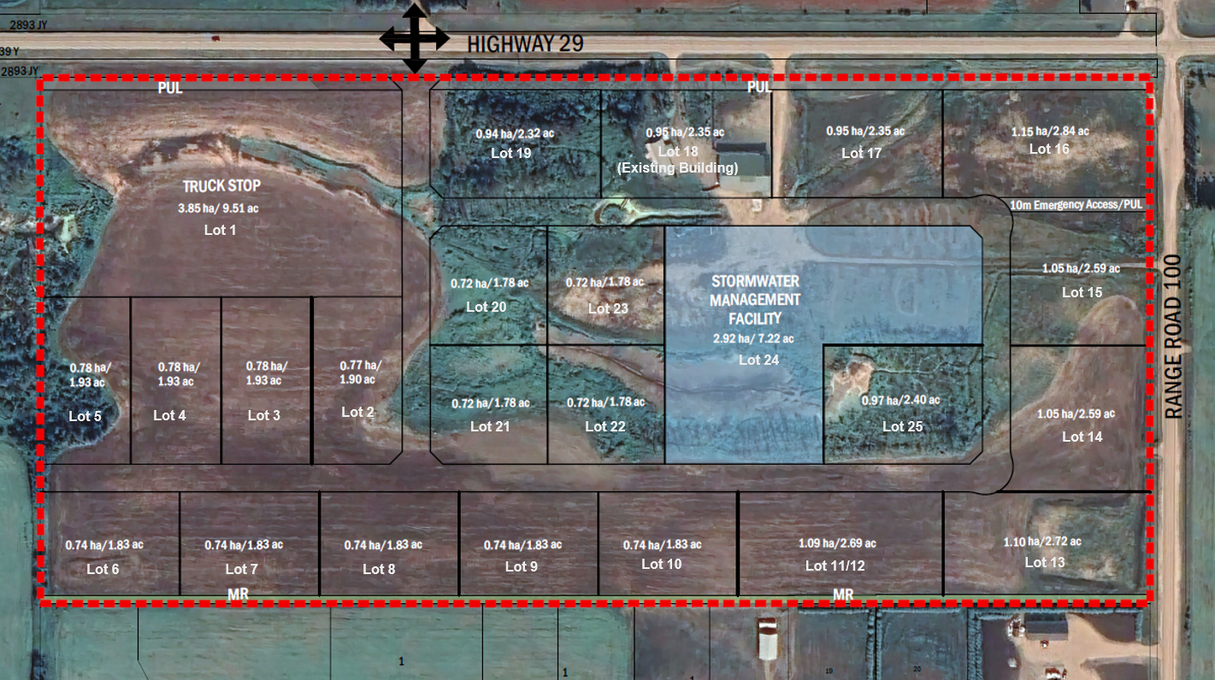

CONTACT
info@hi-way29.com
Domain is www.hi-way29.com

