We would like a logo design for a upmarket safari company based in Tanzania. Our company offers wildlife photographic safaris in East Africa. Colours should be earthy – khaki, sage green, cream, brown, beige. Clean, crisp, modern font.
This is an example of another safari company’s logo we like. The lines represent the tall grass of the African savannah.

This is an example of a logo design we’ve been playing around with an online logo maker. We like the idea of a circular logo and incorporating abstract yin yang to represent the balance in nature.
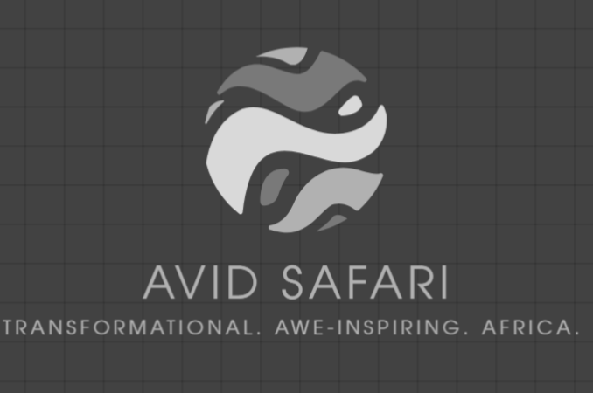
Safari photos for inspiration
