SUMO CONNECT-AFRICA
Digital, Technology & Data
CREATIVE BRIEF
Key Elements
- Home Page
- Services Page
- Digital Marketplace Page
- About Us Page
- Blog or Insights Page
- Contact Page
1. Home Page
- Hero section: A strong, visually appealing header with the tagline, "Empowering Innovations & Digital Transformation Across Africa."
- Introduction:

Sumo Connect Africa is a consultancy firm and digital marketplace dedicated to supporting Africa’s digital transformation. We provide data-driven insights, strategic guidance, customised solutions to empower public and private sectors.
We aim to tackle complex challenges, optimize operations, and unlock growth through innovative technology.
Our marketplace offers a curated selection of digital products and tools designed to support strategic growth, expand knowledge, strengthen data capabilities, and streamline operations. With deep expertise in digital transformation and a focus on Africa’s unique opportunities, Sumo Connect Africa is your trusted partner in navigating today’s dynamic digital landscape.
Together, we’re advancing Africa’s digital future.

- Quick Links
  - Services:
-Digital Strategy
-Technical Expertise
-Data Analytics
-Artificial Intelligence (AI) & Machine Learning (ML)
  - Marketplace
-e-Commerce for digital products. {Refer for inspiration to AppSumo https://appsumo.com/courses-more/
Product Categories: Organized into easy-to-navigate sections (e.g., templates, guides, courses).
Product Grid: Display products as a clean, visually appealing grid with short descriptions, thumbnails, and “Add to Cart” or “Buy Now” buttons.
Product Pages: Each product’s own page with a detailed description, images, pricing, and customer reviews.
Secure Checkout: Include payment options like credit cards, PayPal and mobile money.

- Featured Products/Services:
Showcase popular digital products (templates, e-books, software) with quick links to the shop and or ‘Learn More’ links

2. About Us

- Our Purpose:
Why we do what we do

At Sumo Connect Africa, we’re driven by a mission to empower Africa to thrive in a digitally connected world. We apply the right digital transformation strategies, tools, and insights to address complex challenges and unlock new opportunities.

We don’t just drive digital change; we make digital transformation work for Africa, one solution at a time.

Our Values:
- Innovation
We are committed to staying at the forefront of digital transformation, continuously exploring new technologies and solutions that drive impactful change.
- People-Driven
We work in collaboration with our clients, employing a customer-centric approach that puts people at the centre of what we do.
- Passionate
We're passionate about helping businesses live up to their full potential and grow beyond conventional market boundaries
- Integrity
Trust is at the core of everything we do. We maintain the highest standards of honesty, transparency, and ethical conduct in all our interactions.
- Eco-Conscious
We believe in doing what we can to promote a sustainable low-carbon economy.
- Continuous Evolving
To discover breakthrough ideas and solutions, our motto is to keep evolving by challenging conventional thinking.

- Our Team:
*Below format for all team members
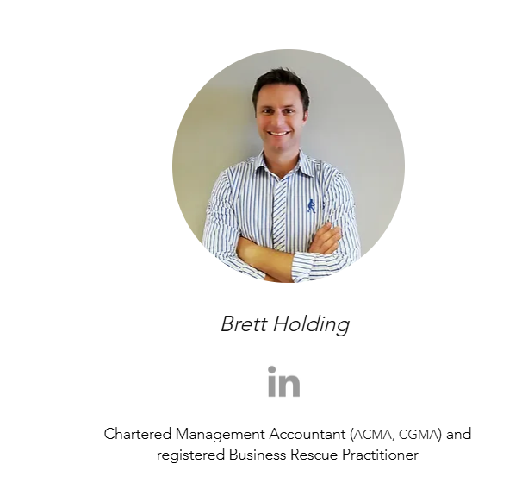

3. Services
- Consulting Services
- Technical Expertise
- Advisory Solutions
- Analytics
- e-commerce
4. E-commerce Page (Digital Marketplace)
- Product Categories: Organize products into categories: templates, guides, courses, software, and toolkits.
- Product Pages: Each product should have its own page with a description, benefits, price, and a “Buy Now” button. {Refer for inspiration to AppSumo https://appsumo.com/courses-more/
- Secure Checkout: Include payment options like credit cards, PayPal and mobile money.

5. Blog or Insights Page
- Content Categories: Articles or insights divided by theme (e.g., digital transformation, data analytics, African tech).
- Featured Articles: Highlight important or trending articles.
- Search Functionality: To help users easily find relevant content.

6. Contact Page

- Contact Page
- Contact Form: A simple form for inquiries.
- Social Media Links: Icons linking to LinkedIn, Facebook, twitter, Instagram, TikTok
- Map & Address (Vanga Rd, Lavington, Nairobi Kenya)

**********************************************************************************
- Technical Considerations
- Platform: Consider a platform like WordPress with WooCommerce for seamless digital product purchases.
- SEO Optimization: To attract organic traffic, optimize each page with relevant keywords, alt text, and meta descriptions to boost organic search rankings.
- Security: SSL certificates, secure payment gateways, and anti-spam measures on forms.
- Newsletter Integration: Mailchimp or another service to capture email leads
- User Experience: Ensure the site is responsive and intuitive, even on mobile.
- Theme & Layout
• Modern and Clean: Choose a theme that’s minimalistic yet visually impactful, with ample white space to keep the site professional and easy to navigate.
• Responsive Design: The site should adapt seamlessly across devices (desktop, tablet, mobile), as many users may access it on mobile.
• Visual Hierarchy: Strategically placed content blocks, bold headings, and intuitive navigation guide visitors smoothly from section to section.
• Sticky Header: A sticky navigation menu at the top will provide easy access to main sections, like Home, Services, Marketplace, About Us, and Contact.

- Color Scheme (Feel free to choose colours, keeping with website theme)
- Primary Colors: Deep Blue for trust and professionalism, with Vibrant Green for innovation and growth.
- Accent Colors: Touches of Warm Gold for premium offerings, and Neutral Grey for text and background elements.
- Contrast and Readability: White or light backgrounds with dark text for readability, using color accents to draw attention.
- Visual Assets
- High-Quality Images and Icons: Professional images reflecting African innovation and teamwork; custom icons to illustrate services.
- Graphics and Infographics: Visual elements to break up text and present data or processes clearly.

