Logo Info for Blood Rite
Theme: Gritty, realistic, dark fantasy. The players will take their characters through stories and conflicts they should not survive. Their victory is secured through their unique ability to sacrifice their life force and bend fate to their will, allowing them to take on odds that would be impossible to a regular person. They are heroes in a world of brutality. They are the stones that stand against the tide. The willow that withstands the hurricane. And those that take shelter in their branches will survive too.
Setting: The system is setting ambiguous but the world we use for testing is generally considered at a medieval level of technology with magic thrown in. European medieval is likely what most people will assume, but we would like to do other places across the globe like medieval Congo and Great Plains-style stuff.
The Blood Rite: This is the core mechanic that gives the game its name and is pivotal at all levels of play. The players can at any time, give up their life force (HP) to increase their odds of success on any given roll.
Ideas: Admittedly, I know little about what makes a good logo. Besides the obvious (colors and design need to be attention-grabbing), I would imagine simplicity is king concerning design complexity. Unfortunately, I don’t know how to execute on these design philosophies and would love your input. My only ideas are something involving the first two letters of the words “Blood Rite” or maybe coming up with a unique kind of crest that could be used thematically when designing characters. I thought it would be cool for a “true adventurer” who has been blessed with the blood rite to have some kind of mark or brand on them that becomes a kind of insignia that those who are defenseless against the hordes of monsters within the world can use to identify someone who can help (or maybe a culture thinks they’re evil?). Let me know what you think!
Example Logos:
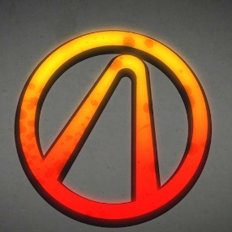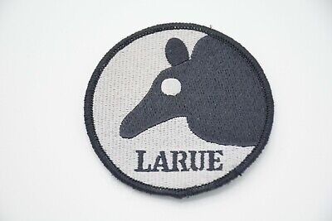
Preferred Colors: Open to suggestions but want to avoid any light shades. The colors I was considering heavily were blacks, greens, and reds.

