

Posh Outdoors Website Design Brief for
Design Crowd Campaign

Hi designers, we are looking for a website design and lay-out that is business-like, compelling while being high-design

A. Company Background --

Posh Outdoors is in the luxury glamping business. Here is some background on Posh Outdoors

- “Coming Soon” page -- https://www.posh-outdoors.com/

- Our Wefunder page has several pages describing Posh Outdoors business model -- https://wefunder.com/poshoutdoors

Here is link to our Google Drive to access the following collateral asset/files -- https://drive.google.com/drive/folders/19t7zf7r234BEbCaT0TsD71BoUqG_jJFD?usp=sharing
(Please let me if you have any difficulties accessing these files)
Below are the collateral asset/files on the Google Drive
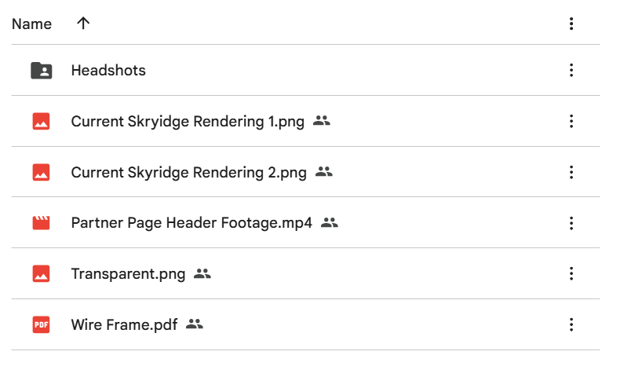

B. A few points re the Above Uploaded Files --

- Wire Frame pdf -- Has the pages and website flow/layout we are looking for.
A few notes –

  - Text Boxes – We are still working on content. I am wondering what designers think of using WordPress as website content management system so we can easily enter/edit content. Please lmk your thoughts on using WordPress for our website

  - Photos/Images – We also have a rendering artist doing new glamping structures renderings and should have the week of November 4th to upload

- Partner Header Footer Footage mp4 File – The uploaded video is the one we are using for a Wefunder page and would like to use on out home page

- Transparent png – Is our logo

C. Design Goals & Ideas –

We are hoping to get compelling colors, maybe use icons, great page layout to make the pages come to life….wide open to all design ideas!

Below are both 1) luxury glamping websites where we like design elements and 2) non-glamping website with design elements we like

- Luxury Glamping Website Designs We Like --

- OOD -- https://oodhouse.com/
- Stay Onera -- https://stayonera.com/
- Wilding Design Labs -- https://wildingdesignlabs.com/
- Sage Outdoor Hospitality – https://sageoutdooradvisory.com/

i) OOD https://oodhouse.com/ –
What we like: Thought they did a good job with use of icons
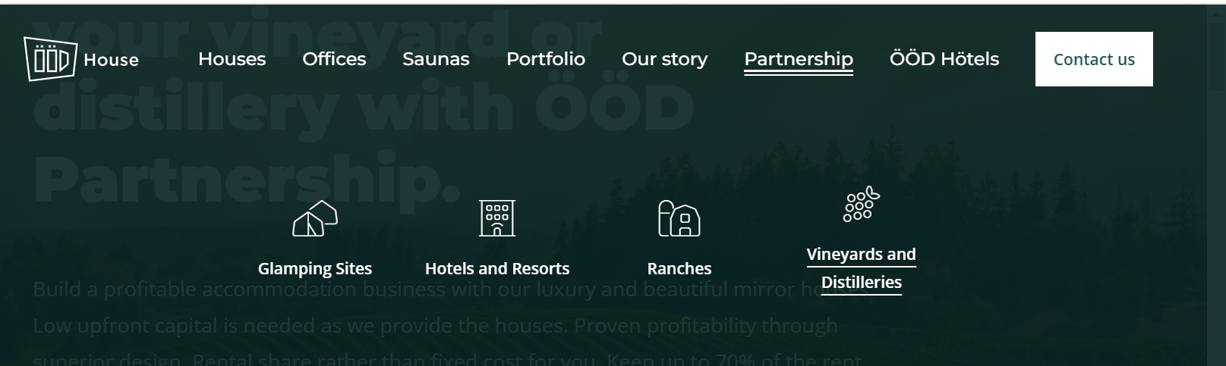

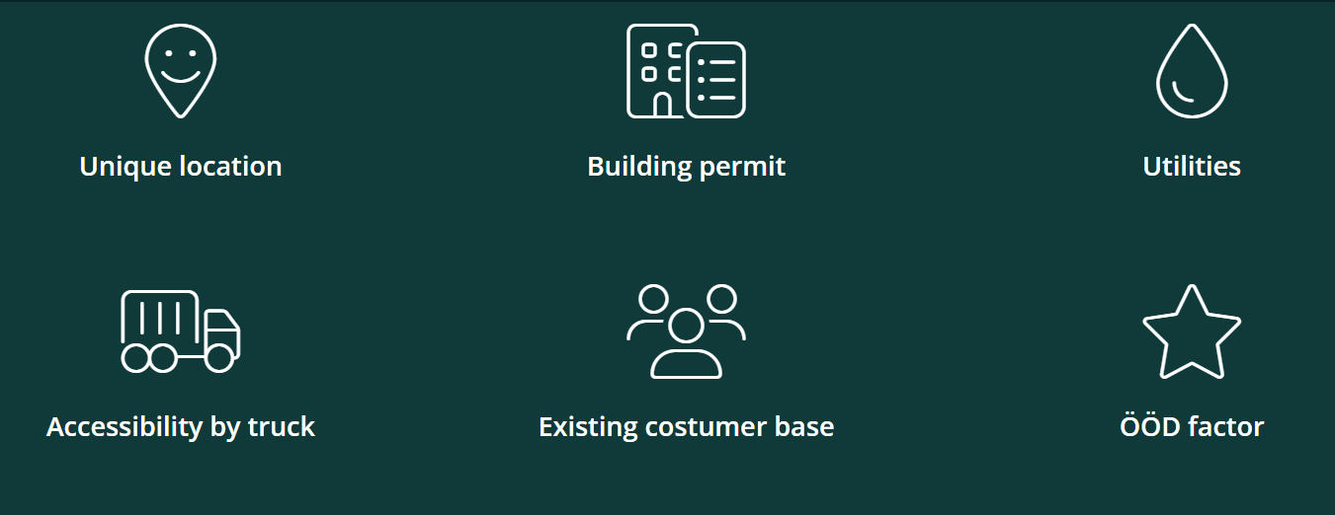

ii) StayOnera -- https://stayonera.com/
What we like: Very clean, simple page layout

iii) Wilding Design Labs -- https://wildingdesignlabs.com/
What we like: Great font, use of colors and again use of icons

iv) Sage Outdoor Hospitality – https://sageoutdooradvisory.com/
What we like: Very clean, simple page layout

- Other Websites Designs We Like --
i) Nieubergen -- https://nieuwbergen.com/
What we like: Great page layout, use of colors

Hope the above helps. Designers, please forward any questions or ideas
Look forward to great website designs and page layouts!

Thanks!
Kevin O’Brien

