TRUCK SUBWOOFER PACKAGES

PREMIUM PACKAGE - $849.99

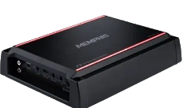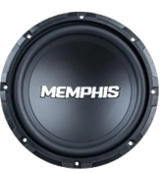  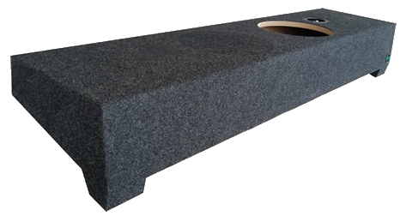 | Single 10” Subwoofer – 300W  - Power Handling (RMS) – 300W  - Power Handing (Peak) – 600W  - Progressive poly cotton spider  - Anodized aluminum voice coil  Class-AB Amplifier – 250W  - Textured aluminum heatsink  - Variable crossover network  - Variable subsonic filter

SUPREME PACKAGE - $1,299.99

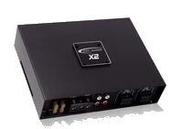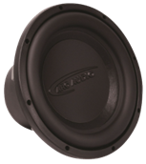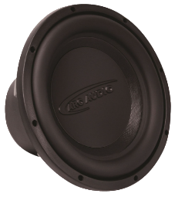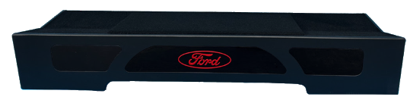  Custom Ford Downfire Enclosure Included | Dual 10” Subwoofers – 200W  - Power Handling (RMS) – 200W  - Power Handing (Peak) – 400W  - High-Temperature Anodized Copper Coated Voice Coil  - Linear Design & Dynamics  Class-D Amplifier – 600W  - Microprocessor-Controlled  - High-Frequency Power Supply  - Aluminum CNC Design  - Signal sense and DC detect

SUPREME PACKAGE - $1,599.99

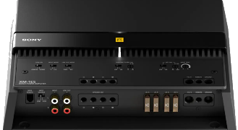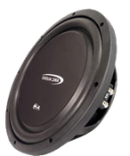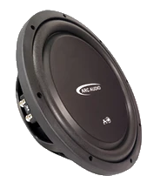  Custom Ford Downfire Enclosure Included | Dual 12” Subwoofers – 300W  - Power Handling (RMS) – 300W  - Power Handing (Peak) – 600W  - Multi-point geometric basket  - Copper wire voice around a unique spun-laced layered Nomex  Class-D Amplifier – 1,000W  - Optimized power blocks  - Toroidal core transformer  - High-capacity electrolytic capacitors  - Cross-bracing press design

