General Information and Frequently Asked Questions
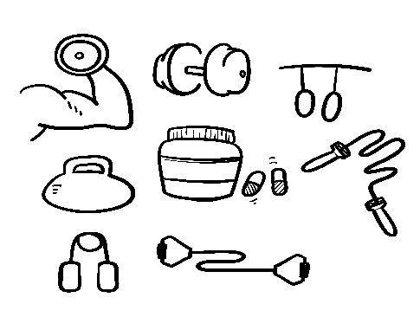

General Advice
You should be mobile and on your feet from the day of discharge. Apart from general recovery this will help prevent clots forming in your legs (deep venous thrombosis)

Work
Most people will be fine to return to work after two weeks. Some with office jobs or home based work may prefer to go back after one week or even earlier. Physically demanding jobs where heavy lifting or strenuous activity is required should only be recommenced after four weeks unless light duties can be allocated
Walking
You can go walking outside the house as soon as you feel comfortable. Aim to increase the amount of walking progressively over the weeks after your surgery
Swimming
Swimming is fine one week post surgery as long as you have well attached, waterproof dressings. After the dressings have been removed, swimming is ok as long as all the wounds are nicely sealed and no longer gaping
Gym
Cardio exercises like running, power walking, step machine etc. are fine from two weeks post surgery. Lifting weights should not occur until at least four weeks
Driving
You can drive a car 5 days after surgery as long as your pain levels are under control and you are no longer requiring strong or sedative pain killers
Lifting
Heavy lifting should be avoided until 4 weeks post surgery. Avoid lifting 10kg or more during this time if practical. Lifting small children is sometimes unavoidable however find other alternatives where possible. Strenuous pushing and pulling activities should be treated similarly
Anti-inflammatories
This class of drugs (NSAIDS) include things like Ibuprofen, Voltaren, Celebrex, Meloxicam and others. These medications can irritate the stomach and bowel and in some cases cause ulceration. Ideally they are to be avoided in the first 6 weeks after surgery to encourage healing of the tissues. If required regularly and ongoing in most cases it is best to take a low dose anti-acid tablet as well such as Somac or Nexium 20mg daily to protect the stomach and bowel lining. This is particularly important in gastric bypass surgery.

Alcohol
Avoiding alcohol for six weeks after surgery is sensible whilst the surgery is healing. Going forward be mindful that alcohol will affect you more quickly and its effects may be stronger after having bariatric surgery. If you are driving be aware that your blood alcohol level may rise faster with less standard drinks than with a normal stomach.

Sex
A common sense approach should be taken with respect to sexual activity. After four weeks there are no specific restrictions on any activities. With care sexual activity could potentially resume earlier as long as you feel comfortable and pain free

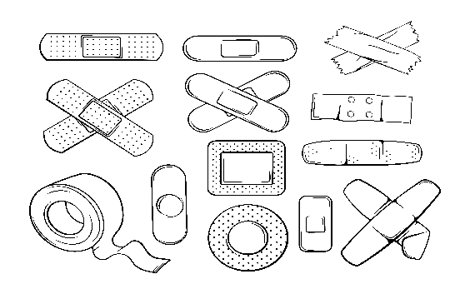
Wounds

Dressings
The dressings should be waterproof and allow you to shower. If the dressings are tatty, dirty or blood-soaked in the first ten days you can change one or more dressings with the replacements provided. Note that if you have had a drain tube after surgery, that particular wound where the drain has been tends to take longer to seal properly and may require dressings for a full two weeks. Dressings can otherwise be removed (by anyone including yourself) after 10 days or you can wait until your post-operative appointment. Past 14 days it is advisable to remove the dressings as they are usually getting a bit mucky by this stage. Underneath as long as the wounds are sealed you can shower as per normal
Lumps, Threads
Lumpiness/firmness under the wound is typical and will resolve over several weeks. If you see suture thread sticking up from a corner of the wound it may need to be removed. Your doctor can do this or if you are feeling brave, pick up the thread with tweezers, pull as much out as you can then cut it off at skin level
Discomfort, pain
It is normal to experience some discomfort, pain or pulling related to one or more wounds either at skin level or deeper. Discomfort should improve with time
Redness, smelliness, pus
These are signs of possible wound infection. You should organise to be seen by your GP or surgeon and a short antibiotic course may be necessary
Allergy, intolerance to dressings
Many patients have minor allergies or intolerances to dressings. If the skin becomes excessively itchy or red underneath the whole extent of the dressing it is best simply to remove the dressing and leave the wound uncovered

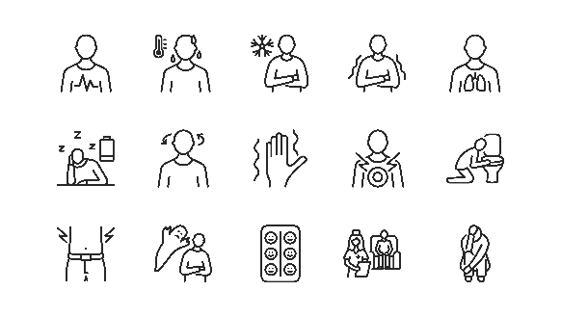
Symptoms

Pain
If you have been discharged from hospital, your pain levels should be well manageable with oral tablets. For most patients paracetamol is the basis of pain relief and can be taken regularly every 6 hours. If necessary stronger pain relievers can be taken additionally and are typically chosen by your anaesthetist (e.g. Endone, Palexia). If your pain and discomfort is manageable it is preferrable to reduce or avoid these stronger tablets as they can contribute to nausea, constipation and general immobility.
Nausea
If you are suffering nausea transiently or ongoing, be reassured that this will settle with time! You should have been prescribed anti-nausea medications such as Ondansetron/Zofran which you should take as recommended for as long as you need to. Keep track of your fluid intake over the day and how you are feeling generally. If you are tolerating very little fluid (e.g. less than 500ml in 24 hours) and are feeling very flat then contact your surgeon. If you are vomiting persistently over the day without relief you should also contact your surgeon.

Reflux
Reflux symptoms may be in the form of “heartburn” (a rising burning sensation behind the middle of your chest) or acid or bile coming up into your mouth or the back of your throat. Reflux can sometimes be caused or exacerbated by bariatric procedures. The symptoms may be transient or occasionally ongoing. Sometimes certain foods can be triggers for reflux or perhaps overeating. In the absence of excessive vomiting or food regurgitation it is unlikely there is any serious anatomical issue underlying. At night it may help to sleep propped up on two or more pillows. Antacids such as Mylanta, Gavison, Quikeze etc. can be useful in mild cases. For ongoing significant symptoms a more powerful medication such as Somac (pantoprazole) or Nexium (esomeprazole) can be very helpful. Low dose Somac or Nexium can be obtained from your chemist without prescription. For higher doses or ongoing requirements seek prescription from your GP or specialist. For more severe intractable cases of reflux where medication is not sufficient further investigation may be warranted and corrective surgery may be possible.
Gas
It is a common experience after most bariatric procedures that burping or gas related symptoms can arise. This may be best explained by the fact that the large reservoir of the stomach is no longer able to store gas for periods of time before expelling it. Hence the gas sometimes tends to move wherever it likes! For some people excessive air swallowing during eating, drinking or speaking can exacerbate the problem. There is no easy solution for excessive gas – you can try De-Gas medication from the Chemist which may help. For most people these symptoms will settle with time.

Constipation
Reduced intake, dehydration and taking strong pain killers can predispose patients to constipation in the early weeks after surgery. Keeping up with fluid intake and ensuring some fruits and vegetables are part of your diet is the first step. A fibre supplement taken at least twice a day (e.g. Benefibre) can help as can Lactulose syrup. Both of these can be purchased over the counter from your chemist. If you are experiencing ongoing pain or problems related to constipation try a Microlax enema.

