
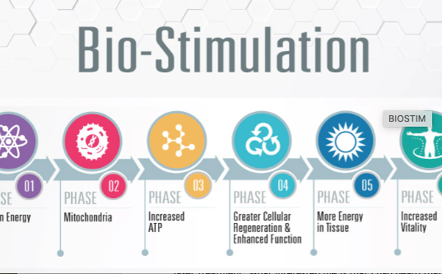
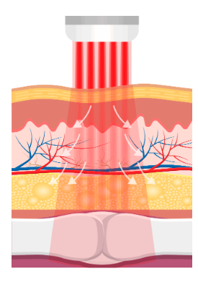
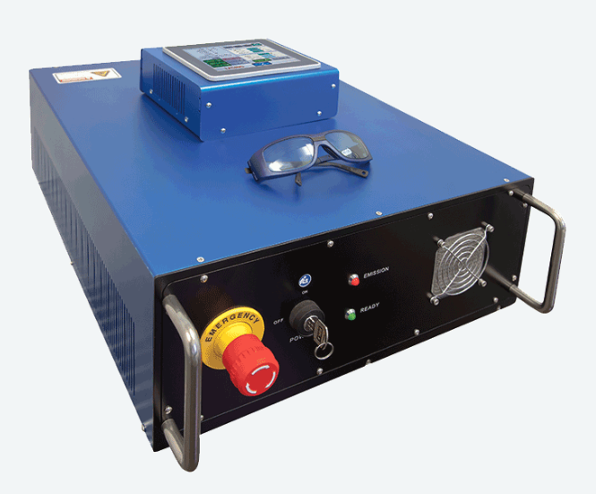
Competitive Advantage

The eSpot Laser System
  - eSpot* Testimonials
“My experience with the cold laser system has been nothing short of amazing. I have had sprains, torn ligaments, broken bones, and the laser system has fixed every single injury. It has become a key piece of my rehabilitation, and I do not know where my body would be without the laser. I would recommend the laser system to any and every athlete looking for a competitive advantage.”  Reduction in Pain & Scaring  “My name is Andre “Sean” Bunn, and I am 46 years old. I have several friends and family members that have benefited from the eSpot Laser System. What interested me was that I had heard that the eSpot Laser could be used on my skin type and that it would help with pain and scaring, and boy were they right!  After just three treatments the eSpot Laser had almost eliminated the scar from my bicep surgery, incision as well as significantly reduced my pain and inflammation.
  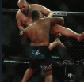
  Mohammed Usman – MMA Fighter
  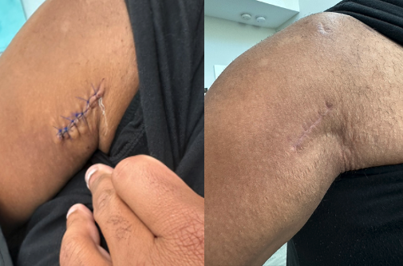
  Andre “Sean” Bunn – Bicep Reattachment Patient
eSpot Medical. The eSpot Laser System. Carmel. IN. 46032
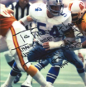 |  | Randy White NFL Hall of Fame  “I played professional football for the Dallas Cowboys for 14 years as a defensive tackle only missing one game; that was a lot of football, conditioning, and practices. During my career I received a lot of physical abuse particularly my knees and neck. I have gone through a lot of different types of rehabilitation, including injections, physical therapy, and surgeries, but nothing worked like the laser system. I honestly believe if I had found the laser system while I was playing football and had been able to rehab my neck, I would have played until I was 40!”
Guy Mezger HHP, PhD  5X World Champion  “The laser system therapy has been surprisingly effective. I have had laser therapy in the past with marginal results. This was a completely different experience. Let me preface this by telling you that I receive multiple injuries in my 17-year career as a professional combat athlete. The most severe was a neck injury. I had a C5 and C6 vertebrae fused in 2011 and have a degenerating disc above and below the fusion. The laser has reduced the symptoms of pain, numbness and weakness in my left and right arms to a great deal, allowing me to pick up my training level significantly.” |  | 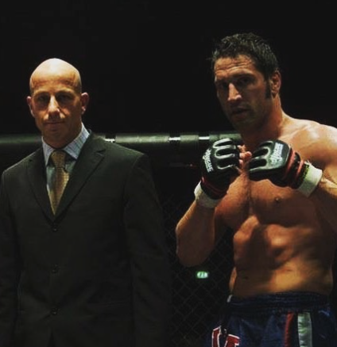
 |  | Betty Cosgrove Patient  “I had an open incision from surgery 11 weeks ago that was not healing. This was the result of stitches being taken out too soon after the procedure. A friend of mine told me about the cold laser system and suggested that I set up an appointment and I’m so glad I did! The results were incredible. Within three treatments, the wound had completely closed, and I am thrilled! I have already recommended this cold laser therapy to many of my friends.

*The eSpot Laser System is powered by Phoenix Thera-Laser Systems
eSpot Medical. The eSpot Laser System. Carmel. IN. 46032

