Page 1: Card Machines
Payment Solutions for Your Business
Ingenico Move 5000

Picture

Castle Saturn 1000

Picture

PAX A920 PRO

Picture

- Latest SMART Card Terminals
- Same / Next Day Funding
- Best Deals In The Market
- Apple Pay & Google Pay

All Your Payment Needs Under 1 Roof
Show these features with icons
Here’s a more concise version of the list:

• High-Risk Merchants: Secure, compliant solutions for high-risk industries.
• Ecommerce & Website Payments: Seamless online payment gateways.
• Phone/MOTO Payments: Secure payments via phone or mail.
• Pay-by-Link: Easy payment collection via email/SMS links.
• Tokenization: Protect customer payment data.
• 1Tap: Accept payments directly on mobile devices with SoftPOS. (Show logo)
• Tap-N-Give: Digital solutions for charity donations. (Show logo)
• POSBridge: Integrated EPOS & card payments. (Show logo)

Page 2 & 3: EPOS Solutions
Page 2 and 3 will be dedicated to our EPOS solutions and two other products that support them:
- Orderbuddy: Online Ordering System
- MenuVue: Digital Displays for Customers
These 2 pages will showcase these products in the setting of an entire Restaurant. The two pages will show 3 areas:
- Counter with bar
- Dining area
- Kitchen
- Collection and Delivery Area
Please see the link below for reference:
https://kuula.co/share/5gJft/collection/7cnlN?logo=1&info=1&fs=1&vr=0&sd=1&thumbs=1

Please see the respective services to be demonstrated visually in all these 3 areas. You may pick up the visuals given from the given websites.
Number each product and show the names in a list for reference
Counter Area with a Bar
- EPOS System on the Counter:
  - Rear Display (Promotional Digital Screen):
    - Place a promotional screen on the EPOS screen’s rear to display rotating ads, special offers, and menu highlights.
    - Website: https://icrtouch.com/articles/blog/customer-media-display-getting-the-most-from-your-rear-till-screen/- A customer-facing display designed to engage diners with promotions.
  - Touchscreen Terminal (TouchPoint) – to be shown in a box pointing towards the EPOS since the front screen would not be visible to the viewer:
    - A modern touchscreen terminal that serves as the core interface for managing orders and payments.
    - Website: www.icrtouch.com/products/touchpoint - Explore the comprehensive features that make it a vital tool in restaurant operations.
  - TouchOffice Web :
    - Display a laptop or tablet at the counter showing a cloud-based business management dashboard with real-time data.
    - Website: www.icrtouch.com/products/touchoffice-web - Learn how this tool provides critical insights into sales and inventory management.
    - This should be shown in a small box with an arrow pointing towards the laptop.
  - CollectionPoint:
    - Display a digital screen showing the order display with a customizable interface and promotions space.
    - Website: www.icrtouch.com/products/collectionpoint
  - MenuVue:
    - Integrate a digital display that allows centralized control of menu content, highlighting specials and promotions.
    - Website: www.menuvue.com
  - TouchStock (Inventory Management):
    - Include visuals of staff using a handheld device to manage stock levels in real-time.
    - Website: www.icrtouch.com/products/touchstock - Learn how it helps streamline inventory tracking for your business.

  - Cash Drawer and Receipt Printer:
    - Position these devices on the counter next to the terminal as part of the payment setup.
- Self-Service Kiosk:
  - Position a self-service kiosk near the entrance or in a prominent area of the restaurant. This kiosk should allow customers to place orders and make payments independently with a card machine.
  - Website: [Insert Website Link Here]
Other features to be mentioned in visuals or text.
Take pictures from here: www.order-buddy.co
  - Effortless Online Ordering
  - Facebook Ordering
  - Digital Menu Creation & Management
  - Performance Tracking & Analytics
  - Inventory Management
  - Loyalty Programs & Customer Promotions
  - Own Branded Google & iOS Apps
Show these images

  - Multiple Payment Options: Allow customers to pay with cards, Apple Pay, or Google Pay.
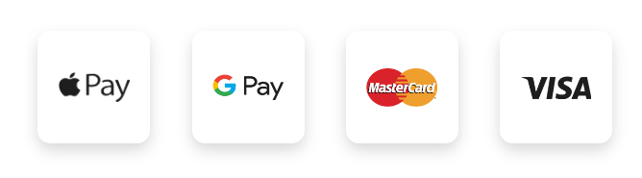

Dining Area (Seating Area for Customers)
- QR Code Table Ordering (Orderbuddy):
  - Show QR codes on each dining table that customers can scan to access a digital menu directly on their smartphones.
  - Website: www.orderbuddy.com - Discover how Orderbuddy streamlines the ordering process for guests.
- Online Reservation (Orderbuddy):
  - Depict signs for reservations on some tables.
  - Website: www.icrtouch.com/products/touchreservation
- PocketTouch Device (Handheld Ordering):
  - Depict a waiter using a handheld device to take orders at the table, providing real-time updates to the kitchen.
  - Website: www.icrtouch.com/products/pockettouch - This portable device makes order-taking efficient and accurate.
- Digital Review Board:
  - Include a display board near the exit or in the dining area that showcases positive customer testimonials and reviews.
- TouchStock (Inventory Management):
  - Include a staff member in the background holding a handheld device, managing stock levels in real-time.
  - Website: www.icrtouch.com/products/touchstock

Kitchen Area
- TouchKitchen Display Screen:
  - Mount a digital screen showing active orders with real-time updates for kitchen staff.
  - Website: www.icrtouch.com/products/touchkitchen - Optimizes the kitchen workflow by displaying orders clearly.
- Kitchen Printer:
  - Position a compact printer for printing order tickets in the kitchen.

Order Pickup and Delivery Area (Click & Collect)
- Click & Collect Counter:
  - Create a dedicated pickup area where customers can quickly pick up their online orders, with a screen displaying the order status.
- Delivery Driver Interaction:
  - Show a delivery driver collecting orders, indicating low-fee delivery options.

Training and Support
- Setup Assistance Icons:
  - Use icons or visuals to represent available training resources and setup support for restaurant staff, emphasizing ease of adoption.

Page 4
Merchant Cash Advance
Does your business accept payments through a card machine, e-commerce platform, or food delivery services like UberEats, JustEat, or Deliveroo?
Receive up to 150% of your monthly card turnover, and repay through a small percentage (10%-30%) of daily transactions—ideal for businesses with fluctuating cash flow.
• Unsecured funds Up To £500,000
• Decision Within 24-28 hours
• Funds Received Within 5-7 Days
• No Hidden Fees
• No Proof of Income
• No Security
• 95% Approval Rate
• Cash Earnings Untouched

Create a similar picture and add an ecommerce cart to the design as well with cash coming out of it as well.

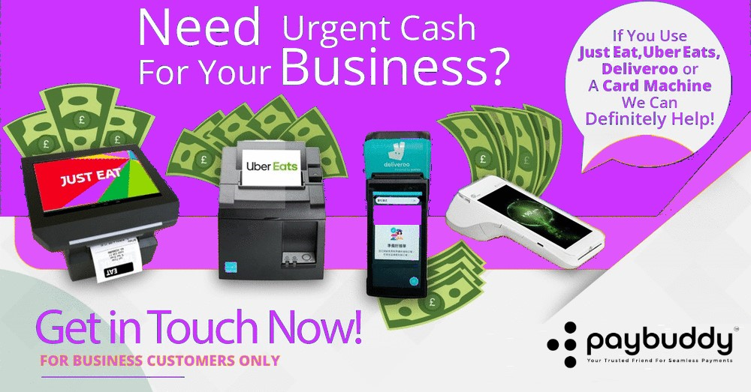

Create a design similar to this as well to explain how the repayments would be deducted from a card transaction
