Complete EPOS Solutions
• Essential EPOS Bundle: Includes an EPOS system, cash drawer, and receipt printer—all the essentials for smooth, efficient operations.
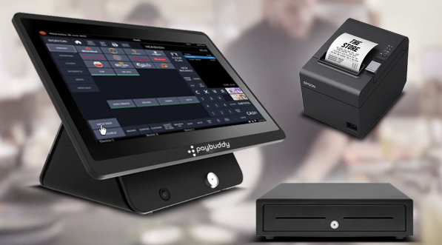
Instruction: Take he EPOS from the wall banner file. Printer and cash drawer pictures are given in the folder.
• Integrated Card Machine Solution: Adds a card machine to the Essential Bundle for seamless, secure payment processing.
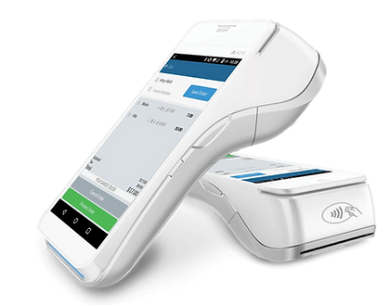
Instruction: Take he EPOS from the wall banner file. Printer, cash drawer and card machine pictures are given in the folder.

• Self-Service Kiosk Counter with Card Machine: Allows customers to order and pay independently, perfect for fast-food and quick-service setups.
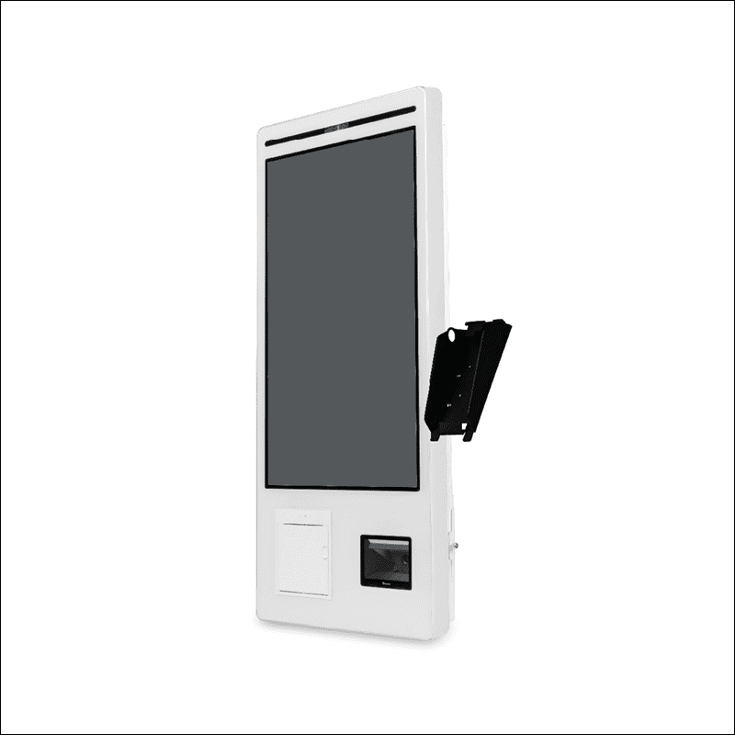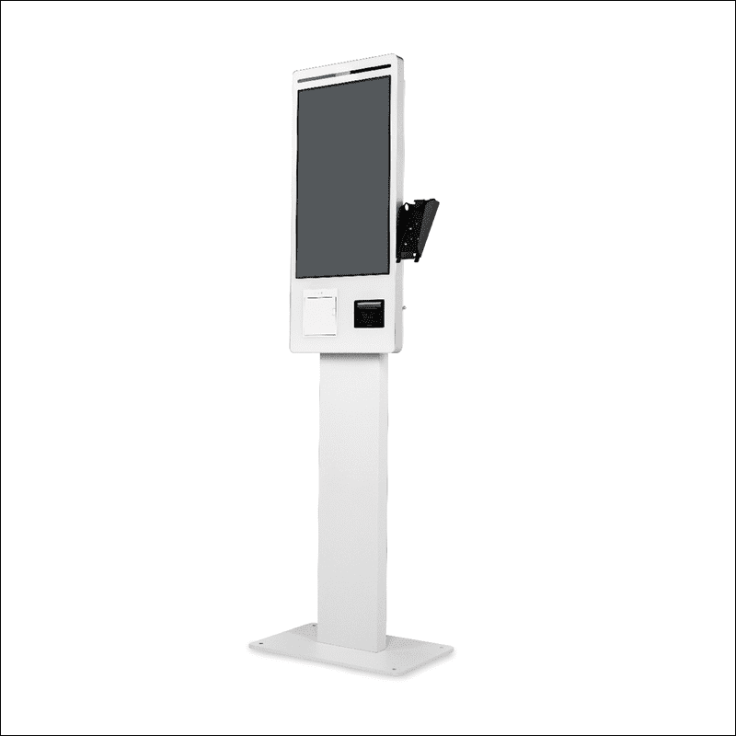
Instruction: Show the kiosk like this with a menu screen and card machine on the sisde. One kiosk should be mounted on the wall. Another should be on the stand. A card machine should be on the side of each. Don’t use this image. Use the high resolution images I have given u separately and add a card machine and screen to them.
Pick up the menu from this link. https://app.order-buddy.co/SUNSHINE/menu1/menu.php
Show the menu like u see in the pics below and add some items to the cart. More items for the kiosk in the stand and less items for the kiosk on the wall.

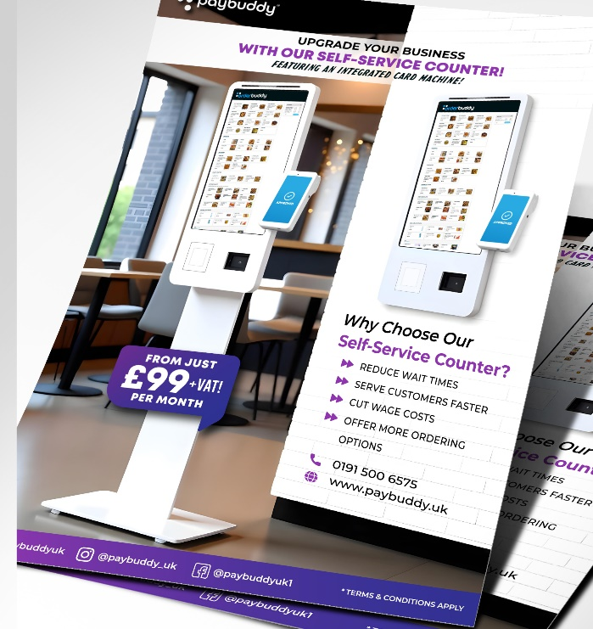

• Tablet-Based EPOS Solution: A portable tablet system that syncs instantly with your EPOS, ideal for tableside ordering and streamlined service.
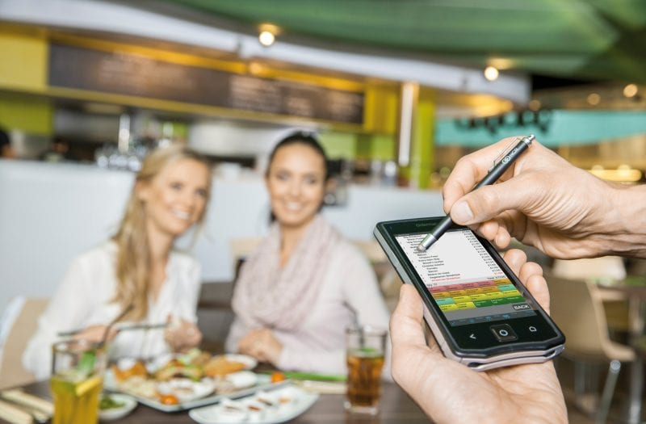

Everything You Need to Run Your Business Effectively
- Chef Kitchen Screen: Real-time digital display that organizes orders for kitchen staff, reducing errors and speeding up food preparation during busy periods.
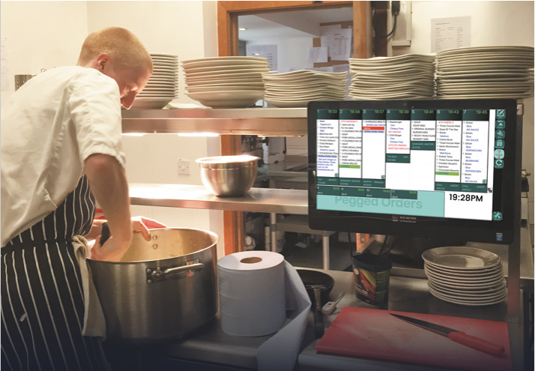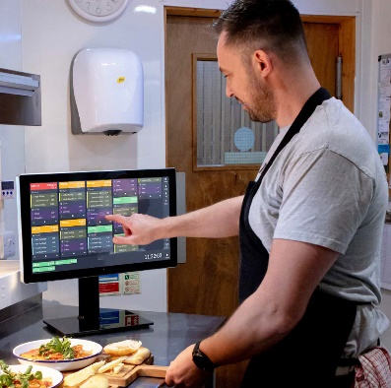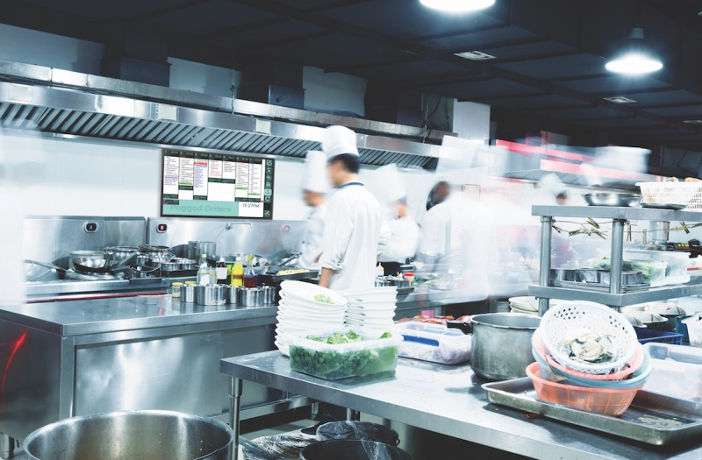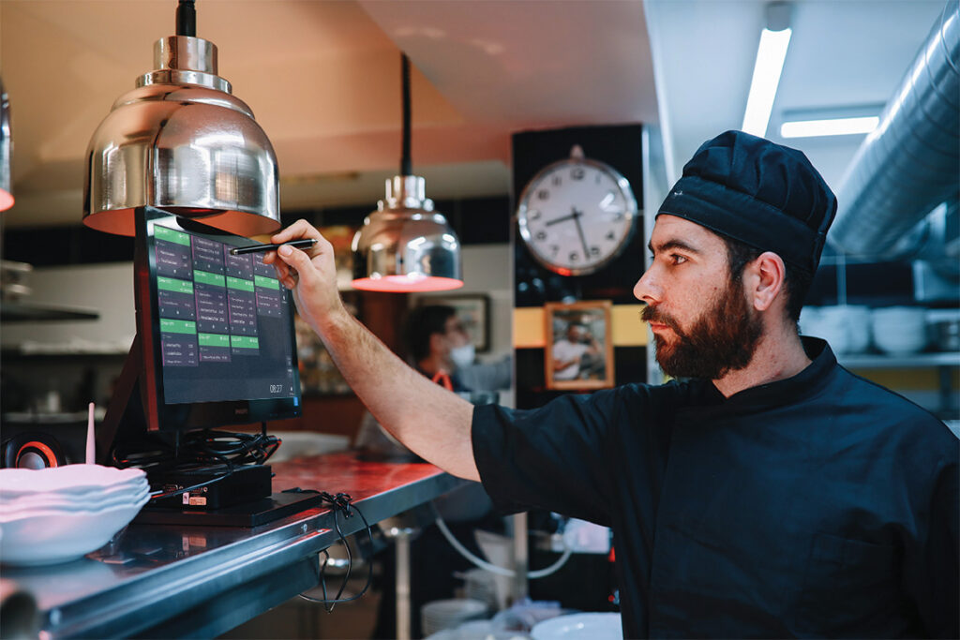
- Digital Menu Display: Customizable, real-time digital menu board for displaying promotions, menu changes, and item availability, keeping customers informed and engaged. 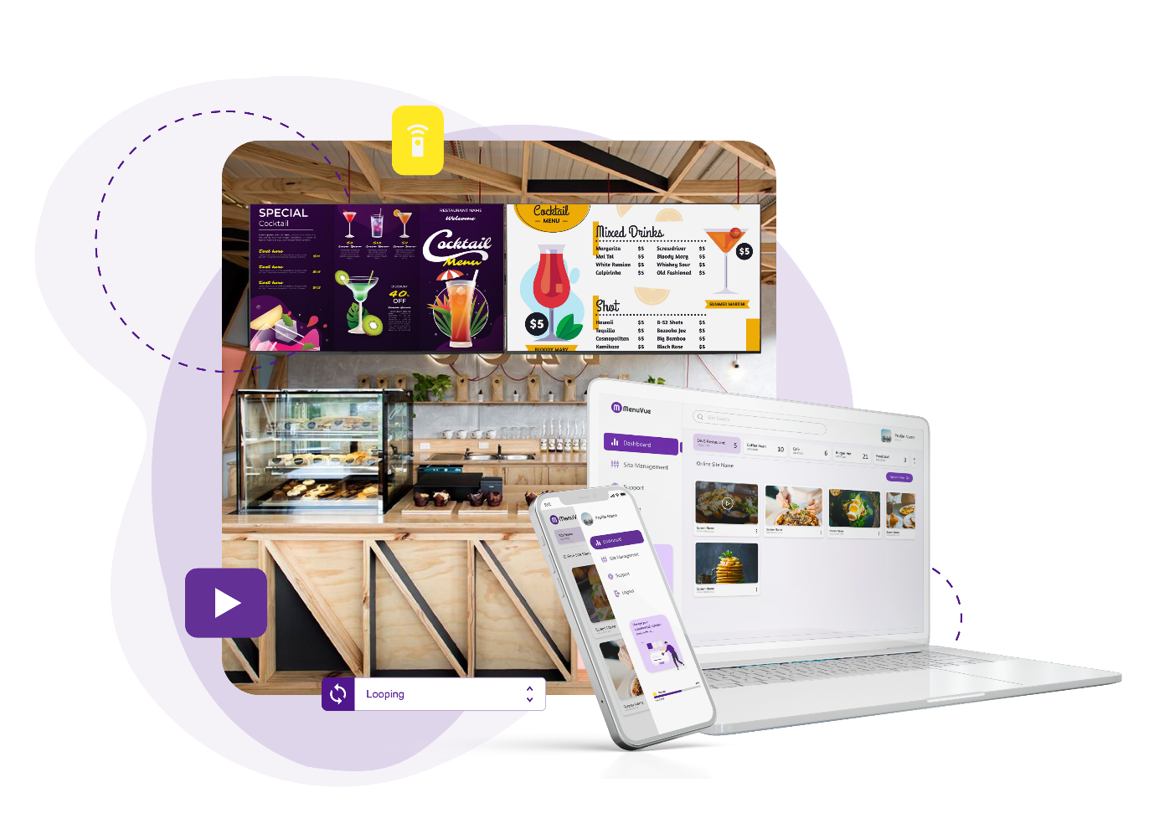
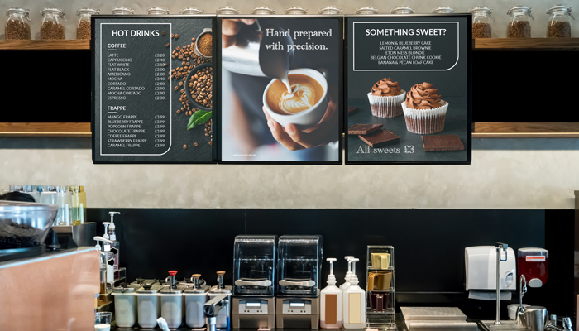

- Collection Point Display: A customer-facing display at the pickup area that shows real-time order statuses, reducing wait times and enhancing customer satisfaction.

Instruction: Create a similar image like the one below. We don’t like the counter. And it has airport info. Instead of airport info, show a counter with menus and a Order status board like the one given here.
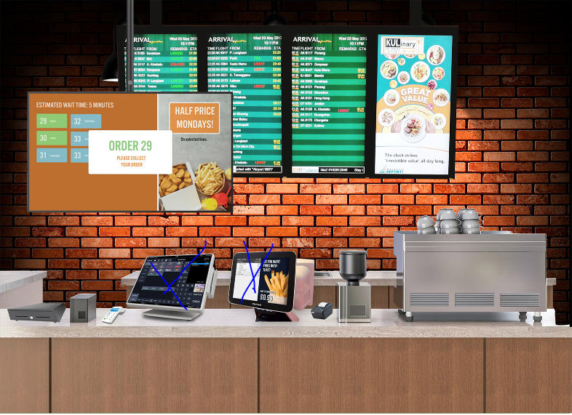
Instruction: For the following points, take the picures from order-buddy.co and https://menuvue.co.uk/
Don’t show their logos
- QR Code & Table Ordering: Allow customers to scan a QR code to view the menu and place orders directly from their table, enabling a contactless and streamlined ordering experience.
- Online Ordering Platform: A web-based ordering solution that lets customers place orders from their mobile devices or computers, ideal for takeout, delivery, or pre-ordering services.
- Remote Management Capabilities: Manage EPOS data, multi-site operations, real-time updates, stock alerts, and secure cloud storage for consistent, efficient operations.
- Comprehensive Reporting & Analytics: Access reports, custom dashboards, employee tracking, CCTV, and customer insights to improve performance and security.
- Customer Promotions & Loyalty Programs: Set up loyalty rewards, dynamic pricing, and real-time promotions, tracking customer preferences to build loyalty with personalized offers.
- Own Branded Google & iOS Apps: Get free Google & Apple apps for table bookings, orders, and payments. We handle hosting and app store fees, so you can focus on delivering great service.
- Facebook Ordering: Add an order button to your business Facebook page, enabling customers to place orders directly through social media and seamlessly integrating it with your ordering system.
- Table Reservations & Deposits: Allow customers to reserve tables and take deposits to reduce no-shows and ensure better planning for your establishment.
- Stock Control: Real-time tracking with automated reordering and low-stock alerts to manage suppliers, control costs, and maintain optimal inventory across sites.
- Multiple Payment Options: Allow customer to pay with card, Apple Pay or Google Pay.
Instructions: Find these pics online.
- Training & Support: We provide comprehensive training and support to ensure your staff is well-equipped to utilize our systems effectively, maximizing efficiency and service quality.

