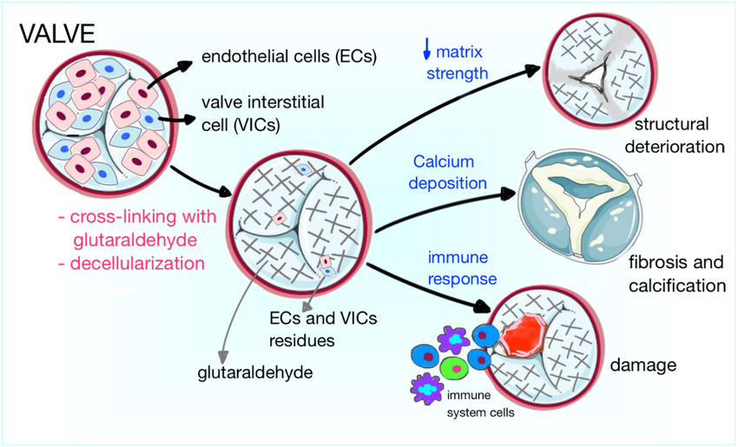
I want it to have the look and feel of this = high tech, more professional vs. illustration that looks drawn

