Logo Information

Below is the correct NHS trust Information. However I understand the quality is bad.



You can create a better quality one using the guidelines below.

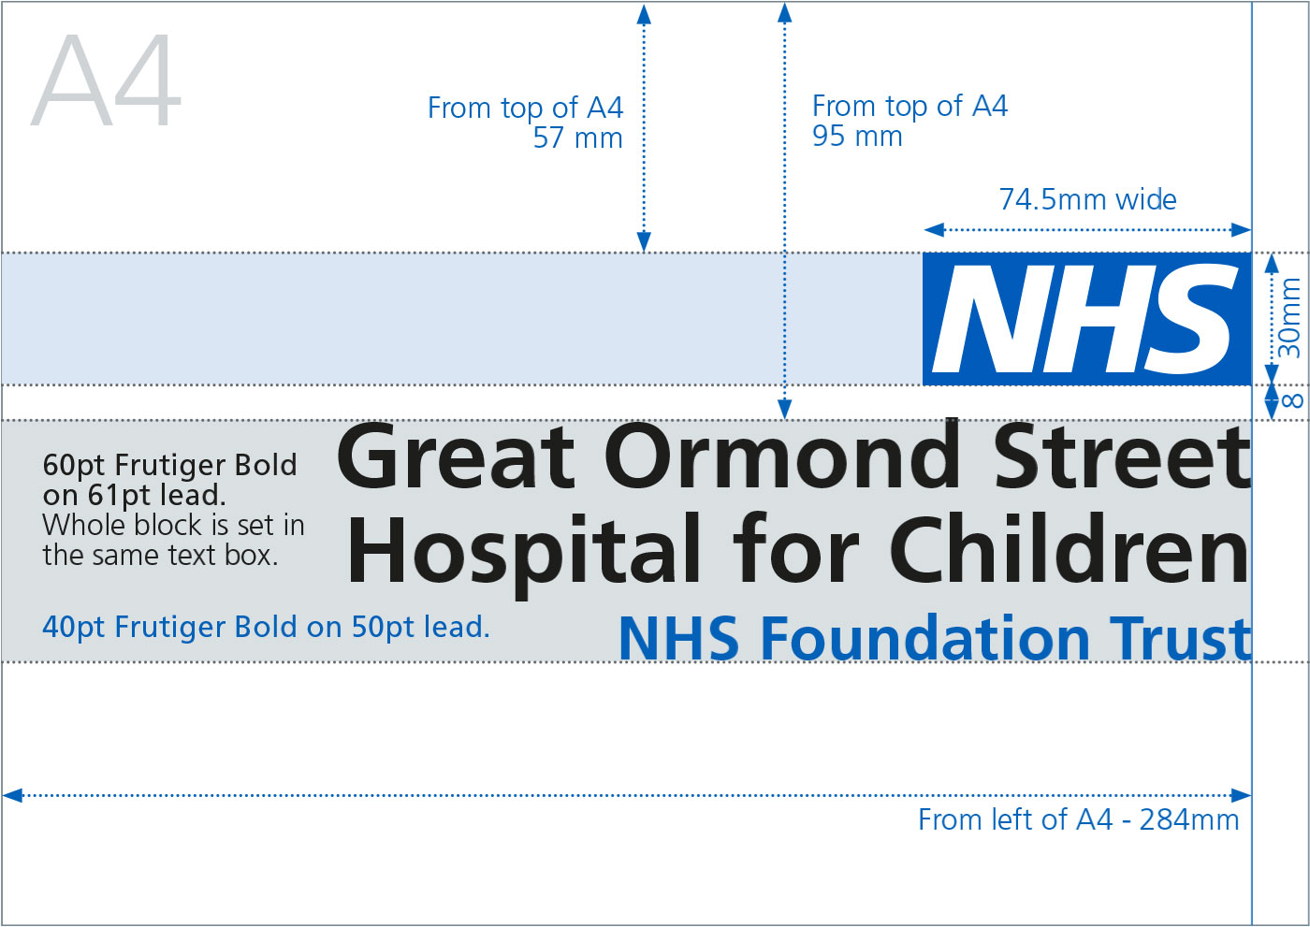

NHS Logo

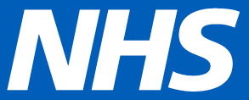
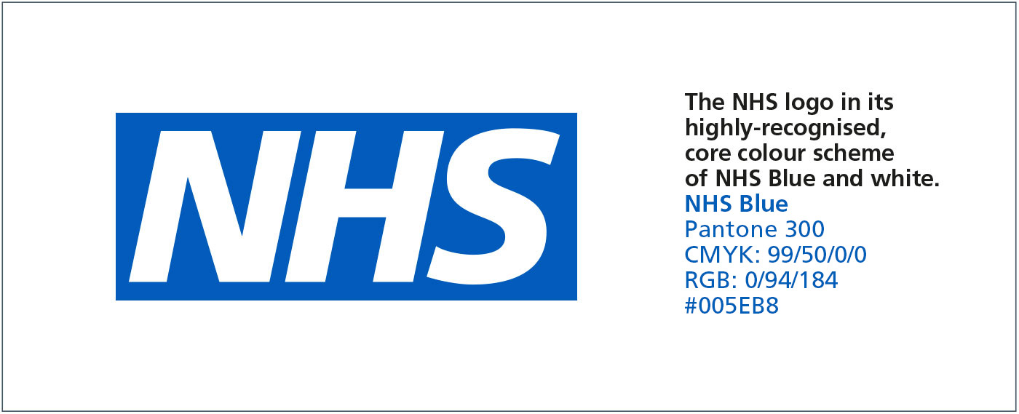

Typical advertising poster sizes

The following summarises NHS logo height and margin sizes for typical advertising poster formats:

A0 (841 x 1189 mm) Margin 40mm. NHS logo height 35mm.

