Design of Logo for Simisco:

We are looking to design a logo for a biotech company that develops tetravalent antibodies for drug development.

Theme:
- Shield/crest with simple letters for "Simisco" and a simplified design of a tetravalent antibody molecule - see some examples below
What a tetravalent antibody looks like - need a simplified design of this:
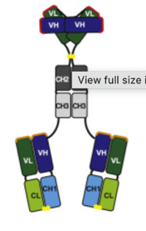
- Keywords:
Biotech/Bioscience company
Cutting edge
Protein
Antibody/Tetravalent antibody
Aggressive (in a positive way - driven)
Seriousness
No-Nonsense approach
Medicine with attitude (MWA) - reminiscent of NWA hip hop group
Public enemy hip hop group
East Bay company
Oakland Raiders - similar logo but in biology form
Pirates
"Destroying the past"

Color scheme: black and grey/silver, with potential a touch of gold

