Cover Slide-
Please change the & sign to one that is clearer.
Change the word Appraisal to Value

Side one (Top moving Left to Right) Please add the logo to the top left of every page
Remove the cartoon Envelope and Bell
Remove the yellow graphic and put the logo for Quick2Credit, Textium, Facebook, and Instagram
Make the wording under Lead Life Cycle Program:
JF Marketing's Lead Life Cycle Program nurtures leads through our two primary, cutting-edge technologies: Quick2Credit and Texitum. Quick2Credit is our industry-leading pre-qualification tool powered by TransUnion, offering the highest quality pre-qualified credit leads available. Texitum, in partnership with Black Book and Kelley Blue Book, provides accurate trade value insights to all direct mail and email responders. Together, these tools create the automotive industry’s only “Trade-Ready Prequalified Credit Lead,” delivering unmatched value and readiness in every lead generated.
Lets get TRADE READY PRE-QUALFIED LEAD in the center of the circle.
Make the bubbles on the outside of the circle
- Qucik2Credit Leads
- Textium Trade Value Leads
- All Other Unsold Leads
- Service Customers that Have not Purchased
- Website Traffic
- Sold Customers that are now in Equity
- Conquest Prospects
Slide 2
Put these sources in the funnel (you will need to add a level) starting at the top (keep the callouts and icons but make them this:
Conquest Prospects – All Marketing Efforts
Web Traffic – Visitors that must be converted
Unsold Leads – Leads your team has failed to close in the first 30 days
Textium Trade Value Leads – Leads that have received the value of their trade
Quick2Credit – Prequalified Leads Based on credit profile
Service Customers that have not purchased – Conquest Sales
Sold Customers that are now in equity – Clients we must keep engaged to retain their business
Below the funnel show a graphic and put SOLD
Slide 3
(Change words in red to) We will offer Trade-In Value with Textium Marketing
Add the words after Pre-Qualified Flow :TO TRADE READY PREQULIFED CREDIT LEADS
Make this image in the phone: This is Quick2Credit Success

The words in blue:
Once a lead is pre-qualified through Quick2Credit, our automated follow-up sequence initiates timely engagement across multiple channels. On day one, we reach out by email, followed by text messages on days 3, 7, and 30, ensuring consistent contact. Additionally, we reinforce these touchpoints with targeted direct mail, creating a comprehensive and effective outreach strategy to keep potential clients engaged and moving forward in the sales process.

Change step two to reflect sending Textium Email and Direct Mail to get the Pre Qualified client to also enter a trade for evaluation. Show this Mailer and Email in a clever way. (Images below)
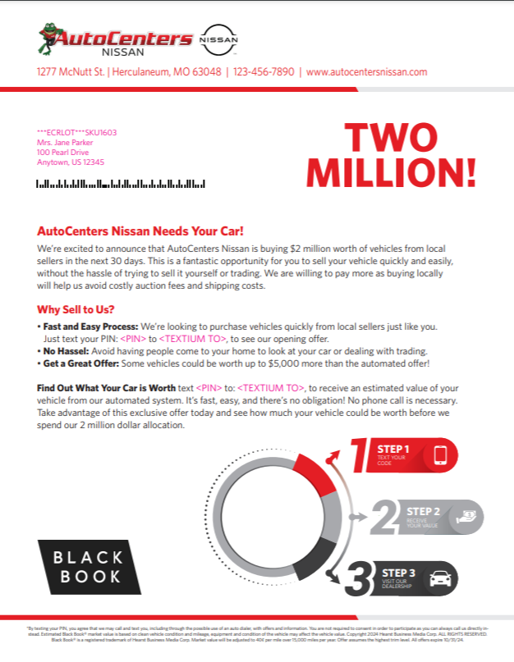

Please also show a FB/Instagram Ad as the three methods we use to get credit customers to become Trade Ready Prequalified Credit Leads.
Here is a sample FB ad

More social ads


Step 3

Should show that the consumer is both Prequalified and has a trade value. Trade value success look like this:
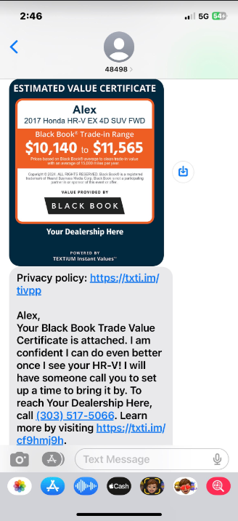
Slide 4
The overall goal of this slide is just like slide 3 so please show the steps but with a different look and feel.

Step One should be the trade success look above. Step 2 should show mail and email being used to get someone to take the step to use Quick2Credit. You can use the same email and social logos but switch the mailer to this one:
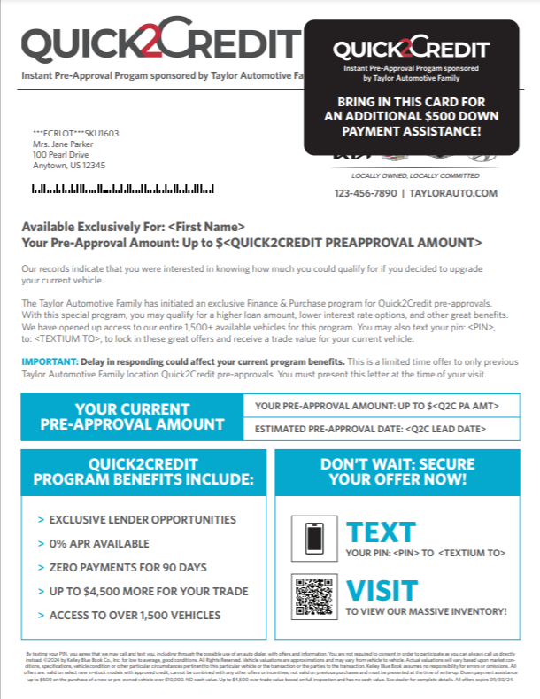

Slide 5 (I want to combine the content of 5 and 6 into one )
Use the header on 5
Remove the paragraph that starts with “ A successful” Replace it with the words in re on slide 6 but add the word Mail so that is says Leverage Mail, Email, and Social…..
Lets use the graphic at the bottom left of 5 and the words below the words in red on slide 6. As for the main image lets use the phone and icons on slide 6.

The new slide 6 (Use the header from side 8 Converting Leads into sales (The rest of side 8 can be deleted unless you like that image.
Needs to feature our outbound call center. It should say something about how we use it to convert the trade ready prequalified credit leads to showroom visits.
Here is the main wording:
Our specialized outbound call center is dedicated to converting Trade-Ready Prequalified Leads generated through Texitum and Quick2Credit. Our team is expertly trained in engaging this unique lead type, ensuring a higher likelihood of successful conversion. Each call is recorded to maintain accuracy and quality, and all appointments are seamlessly integrated into the dealer’s CRM for streamlined follow-up and tracking. This approach maximizes lead engagement and delivers ready-to-act customers directly to the dealership.

Here is some content (you don’t have to use the images) but I need better graphics
Unique Features:
- Dedicated, Automotive Experience BDC
  - Specifically trained to handle TEXTiUM’s unique Text leads, thus driving higher conversions
  - Trained for all inbound lead types; equity, buyback, credit, BK, event, and/or Service
- State-Of-The-Art Technology for quality dealer and customer experience
- Thorough campaign and audience kick-off review
- Up to 4 Outbound Call attempts per lead
- CRM and HTML Appointment Lead Push
- All calls recorded
- Call Appointment Details with Confirmation Script
- Data Mining and Outbound Prospecting Options

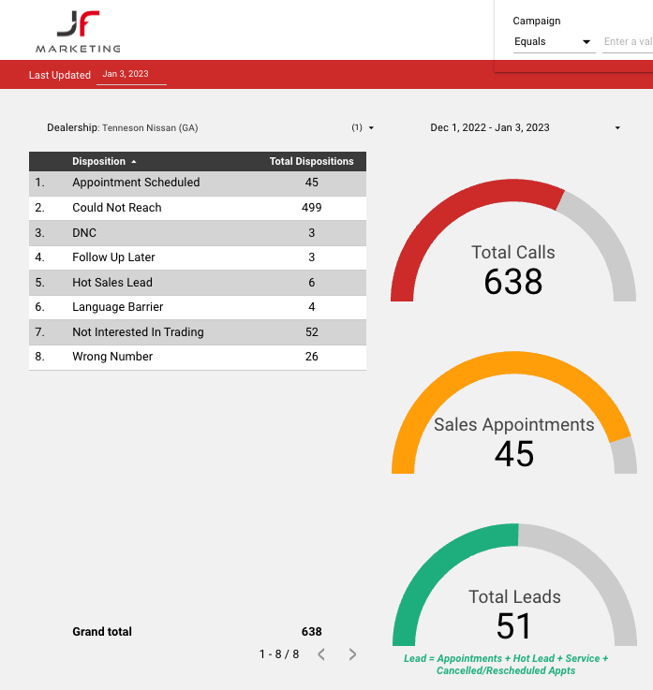

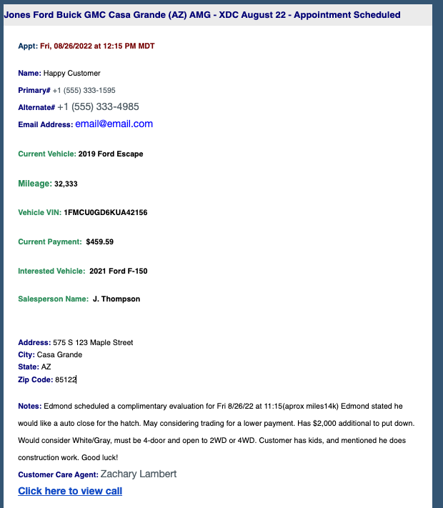

Slide 7
This looks good just change the things on the inside to
Quick2Credit
Textium Email
Textium Mail
Facebook Marketing
Instagram Marketing
Call Center
Back cover- No Changes

