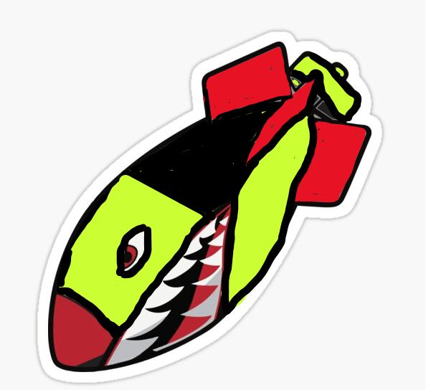
IMPACT MISSILE
Requirements of Missile…See rough sketch above for context of inspiration:
- Colors: RED / VOLT / BLACK (Possibly Checkered pattern of Volt and Black)
  - This logo primarily used as a clothing logo so looking for it to catch the eye with a pattern and brightness that will stand out on dark clothing
- IMPACT MISSILE Font: Bodoni Book on back wings of logo
- Smile: See Figure 1 (looking for a missile design with a face and without a face)
- Shape of Missile: See Figure 2 for Inspiration
- Angle: Nose of Missile should be pointing up to Right
- Tone of Brand Image: Power / Force / Edgy / Explosive /Impactful / Borderline Controversial

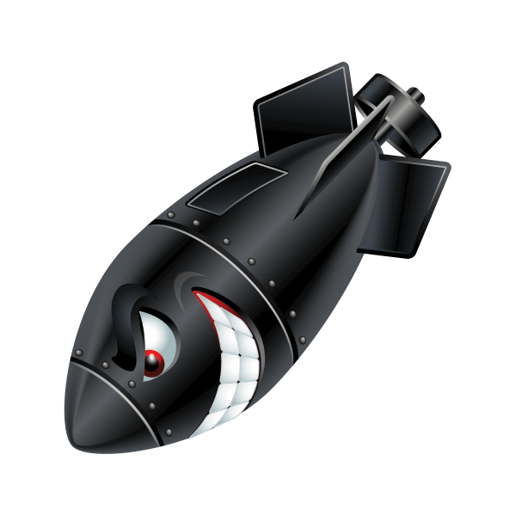
Figure 1: Smile and eyes on Missile’s face matching less teeth and more of a onery smirk

Figure 2: Shape and Design working in name of Brand on wings

