Website Pages Structure

Landing Page
User Sign-In
Dealership Sign-In
About Page - “what we do”
All Listings
Saved Listings
Account Management
Billing
Dashboard
My Listings
Account Management
Dealership Inquiries
Dashboard
View Post
Sell Vehicle

Landing page

The landing page will be the first thing users see when clicking into the site. It needs to have a concise and attention grabbing indication of what we provide. Something along the lines of “Sell your car, hassle free” for example.

Required Components:

- Attention grabbing statement
  - Large letters and easily visible
  - A button prompting the user to “sell your car now” should immediately follow
References
  - Company contact information
  - Social media links
- Testimonials
- Statistics
  - Statistics about the service that may be persuasive to potential users
- Navigation bar
  - Should be horizontal
  - Should have the company logo
  - Clear hyperlinks
    - “Sign in”
    - “Dealership Login”
    - “What we do” or “about”

Sign in page

A page for customers to sign in. We will have a native login alongside OAuth (login with google, facebook, etc.). It should include a message allowing users to sign up if they don’t have an account already.

Required Components:

- Native login with an email and password combination
- O-auth links (should be clear they are alternative sign in methods)
  - Sign in with google
  - Sign in with facebook
  - <whatever other o-auth login options we decide to include>
- A message prompting the user to “sign up” or “create an account” if they don’t have one already

Dealership sign in page

Similarly to the customer sign in, this login portal is for dealerships (a separate account type). It should only contain a native login with no alternative sign in methods. Maybe it should include the company contact information for dealerships who are interested in acquiring the service.

Required Components

- Native login with an email and password combination
- Company contact information for dealerships who may want to acquire the tool

Dealership dashboard page

Once dealers log into their account, this is the first page they will see. We should have some easy to understand information specific to the account here. This information should be things you think dealerships would find useful from the moment they sign in.

Dashboard Component Ideas

- Show a few recent car listings in the dealerships area
- A map with with car image pins showing where recent listings have popped up in their area
  - Ex:
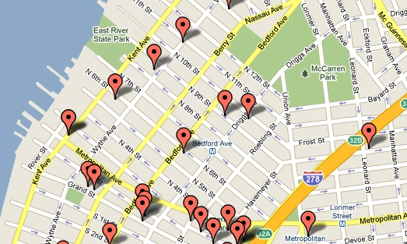

- Statistics about their previous activity
  - How many/which cars they have inquired about

Listings Page

The listings page will be where dealerships can view every posted car. It should have a comprehensive system of filters to make it easier for users to find exactly what they are looking for. Below is a screenshot of carmax.com, this is a very similar concept of what we need.
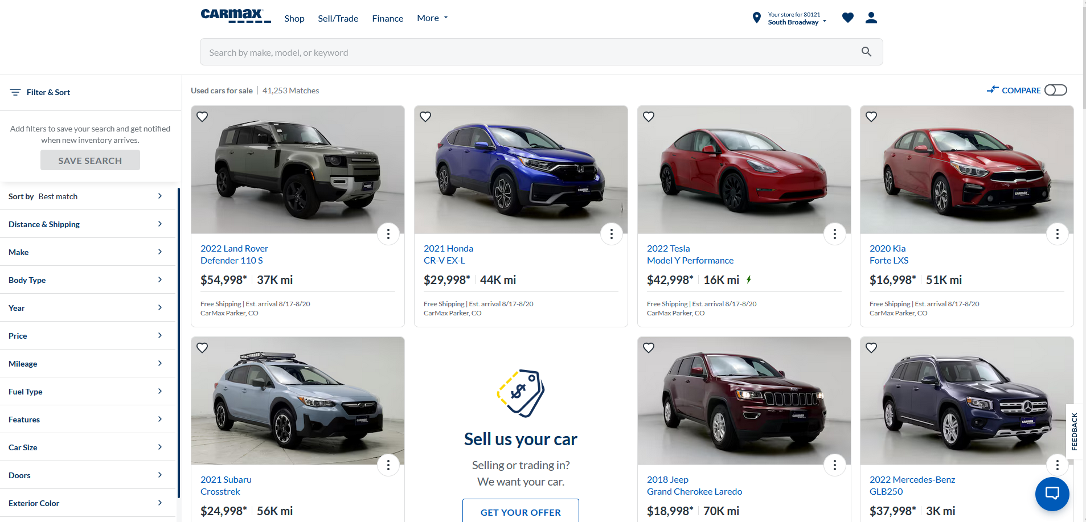
Required Components

- List of “cards” showing individual car listings
  - Clear thumbnail of the vehicle
  - Shown information such as: year, make, model, price, mileage, etc.
  - Icon allowing users to quickly bookmark the listing
  - Results should be paginated
- Main search bar
  - Search listings based off keywords
- Search filters
  - Adjust distance radius where results are shown
  - Adjust price range
  - Filter by make, model, year, and trim
  - Etc

Saved listings page

When a dealer views a listing they may be interested in, they have the ability to bookmark it. This page should simply show all the listings that have been bookmarked.

Required Components
- List of “cards” showing individual car listings
  - Should be in the same style as the Listings Page
- Searchbar
  - Keyword search
  - I don’t think a comprehensive list of filters is necessary for this page

Account Management (dealership)

Dealerships should be able to view and update information about their account. This page should display that information.

Displayed Information
- Dealership Name
- Email
- Phone number
- Address

Account Actions
- Change password
- Update phone number
- <Any other dealership settings you think we may need>

User Dashboard

Once users/merchants log into their account, this will be the first page they see. It should contain relevant information to users who have posted their cars on sale.

Components
- A list of the cars they have posted for sale
  - Re-use the card style used for dealership listings
- An inquiry notification list that tells the user if:
  - A dealership has inquired about one of their vehicles
- A button prompting the user to sell a vehicle

Account Management (User)

Users should also be able to manage their accounts. This will be similar to the dealership account management, just with different data.

Displayed Account Information:
- Name
- Email
- Avatar (maybe not necessary)
- Phone number
- Address (optional)
  - We can give users the option to save their address, to avoid re-entering it every time they post a new vehicle

View Listing Page

When a dealership account clicks on a car listing, this page should provide additional information and actions. This page should also be shown if a user account clicks on any of their own listings.

Example of what we had
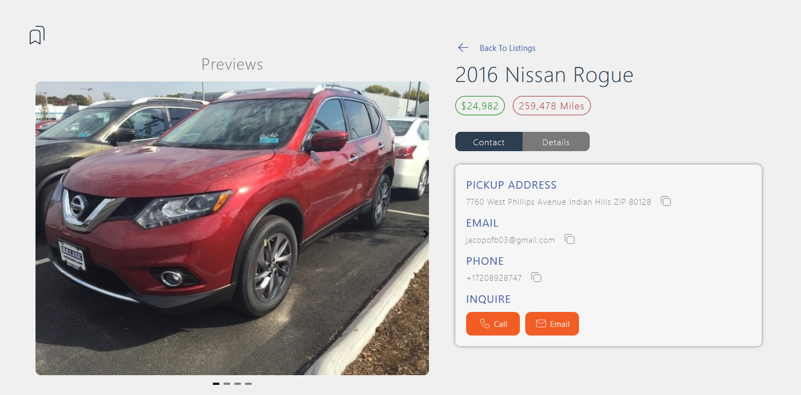

Shown details
- Year, make, model, trim
- Price
- Preview images
  - Thumbnail
  - Interior photos
  - Front, left, right, and rear view
- Mileage
- VIN (check legality of displaying this information)
- Vehicle condition

Instead of showing the merchants contact information, we should have a single button to “inquire”. When a user gets notified of an inquiry, they can reach out to the dealership to make the sale.

Sell Vehicle (users only)

When a user clicks to sell their vehicle, this page should be displayed. It will be a three stage page:

- VIN Lookup
  - Provide the option for plate to VIN instead
- Return an estimate
- Prompt for information and car preview images

VIN Lookup -

Two options for users to get an estimate will be available. They can either enter their vehicle's VIN number, or license plate.

Estimate -

Upon submitting a VIN no. or plate, our API will return an estimate for what we think dealerships will pay. This shown estimate should also preview the year, make, model, and trim (which will be decoded from the VIN).

Unfinished Example
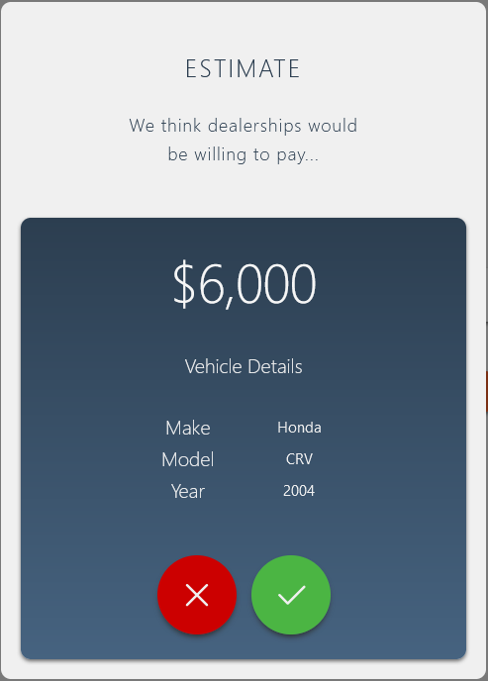

Instead of an ‘X’ or checkmark in the above example, the user should have the option to ‘Sell’, or ‘Edit’. If the user chooses to edit the estimated price, a dialogue should appear allowing them to select the price they would like to list their vehicle as.

Prompt for Information -

Once the user is happy with the price, the page should switch to prompting the user for all the needed information. Below is another unfinished example.
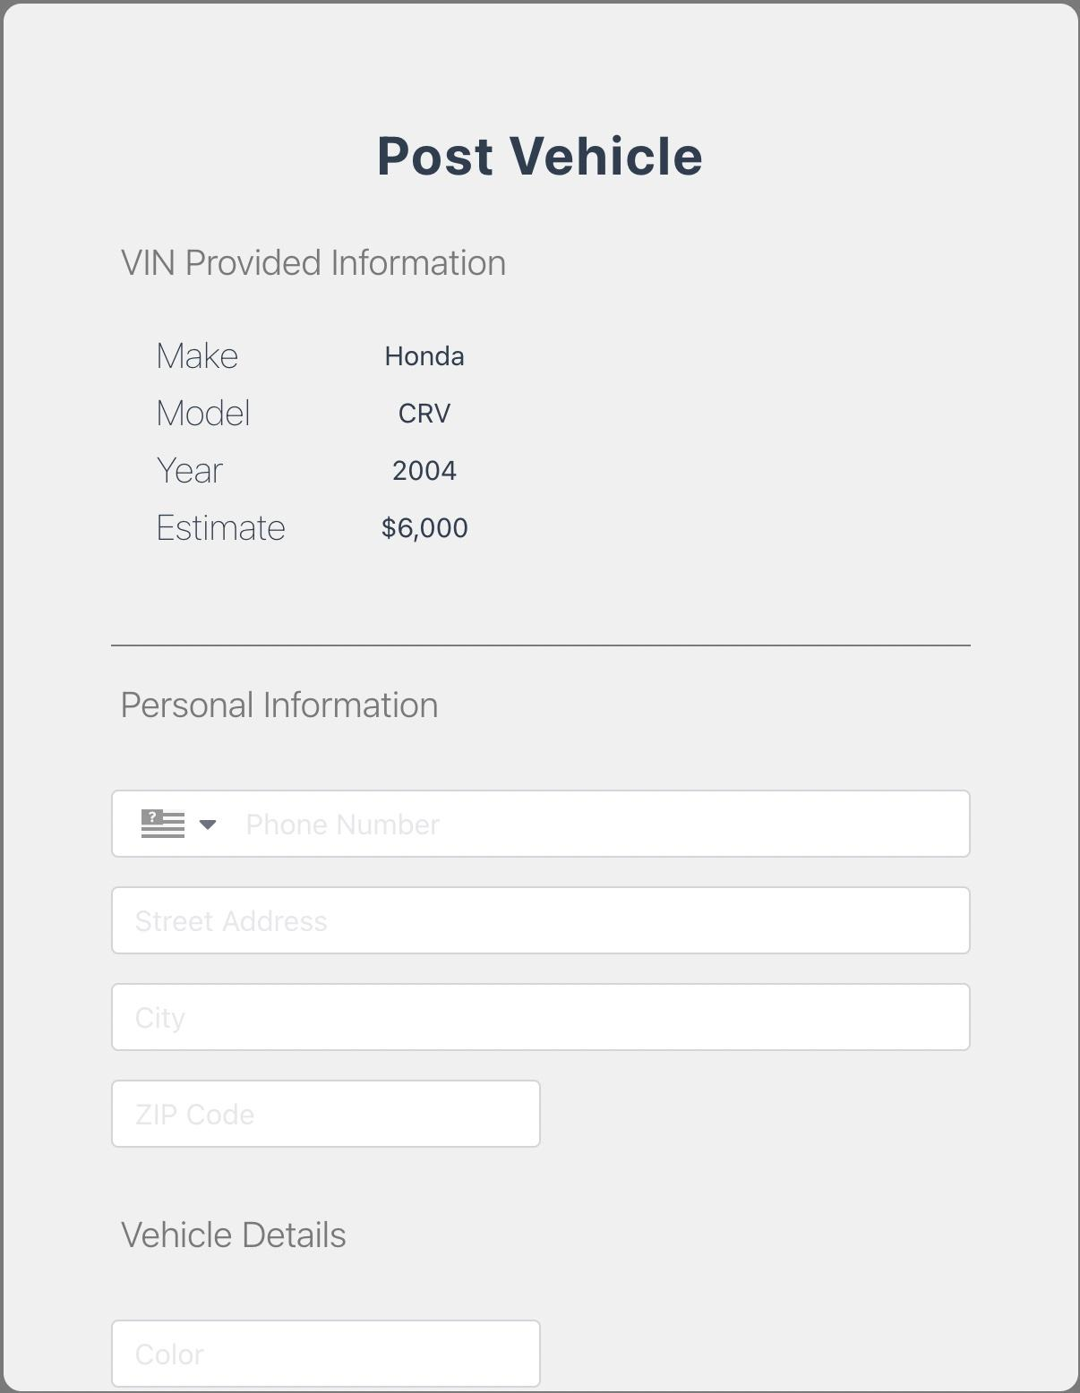

Required Information

- Phone number
- Street Address
- City
- ZIP Code
- Country?
- Vehicle mileage
- Vehicle condition
- Preview images
  - Thumbnail
  - Interior photos
  - Front, left, right, and rear views
- <Any other relevant information>

