Key CANVVA design concept

Location | Design Principles | Pictures
Logo | - Chemex symbol  - Four Beans  - Plain and simple  - Emphasise the four owners  - Black and white | 
Back side | Design – Focused on the story of Origin of Alchemist  - Mission – Elevating Asian Coffee , One Bean at a time  - Our Mission is to showcase the quality and diversity of Asian coffee beans.  - We strive to build direct relationships with farmers to ensure fair trade practices.  - We are committed to providing a premium coffee experience that highlights the unique flavors of Asian coffee.  - Showing and highlight central part of Vietnam | 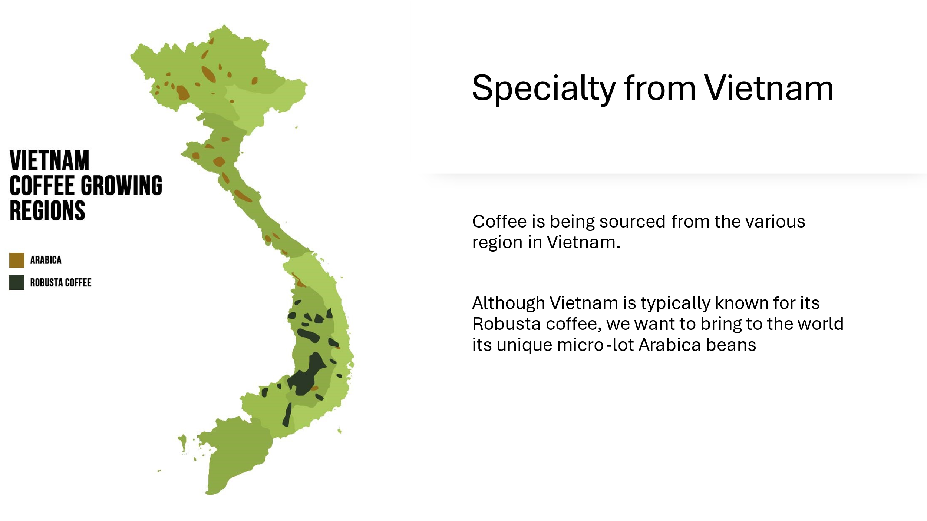
Front Packaging | - Simple, white, with the Logo of the Alchemist
Stickers | Colours with Bold writing  - Sage – Filter Coffee  - Black – Espresso  - Blue – Cold Brew  - Yellow – Drip Coffee

- Stickers

