Design Crowd Brief.

The attached document, [QuickFind - Design & Requirements Document - v1.2], outlines the full design and functional requirements for the QuickFind App. The key sections include:
- Company overview: Mission and vision statements
- High-level application overview
- App design guidelines
- App functional requirements
- Navigation information
To expedite app development, we are planning to use a Multi-Purpose PWA Mobile App Template. This template offers pre-built UI elements and layouts that are flexible and responsive, allowing for quicker development while maintaining a modern design.
Design Crowd Requirements:
We require designs for 11 app pages and 1 pop-up, as outlined in sections 3.13 and section 4 of the document. These designs should be delivered in Adobe format (as a minimum), ready to be handed over to our developers who will build the app using the template and corresponding code base.
Important Notes:
- Leverage the Multi-Purpose PWA Mobile App Template: The designs must make use of the components and features available within the template. You can explore the template using the following link to view the pages, features, and styles:
  - Template link: Odis: Multi-Purpose PWA Mobile App Template
- Sample screens for Visual Reference: To aid in visualizing the app's navigation, please refer to the sample screens. This serves as a high-level guide to demonstrate the user flow but is not a literal requirement for the design.
  - Note:
    - Not all features and pages from the requirements document are represented in these screen samples
    - The flow is provided purely to showcase the navigational paths within the app.

Pages to be Designed (Note I have also denoted the screens that are a priority to be designed first) ** Priority screen **
- Register Page
  - Sample not included
  - Part of the design requirements
- Sign-in Page - Sample not included
  - Sample not included
  - Part of the design requirements
- Password Reset Request Page
  - Sample not included
  - Part of the design requirements
- Profile Page
  - Sample not included
  - Part of the design requirements

- Search Page
  - Sample not included
  - Part of the design requirements
  - ** Priority screen **
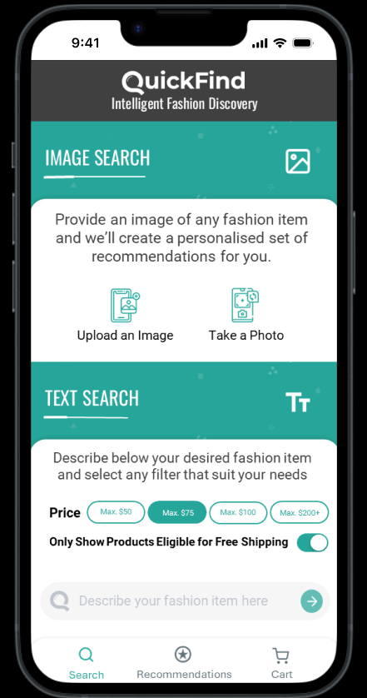

- Analyse Image Page
  - Access after selecting “upload an image” on the search page, follow these steps:
    - Select the top left image (lady wearing a white top, blue jeans, and white shoes)
    - Select the share icon → Select QuickFind
    - Screen not part of the design requirements, to show flow ONLY.
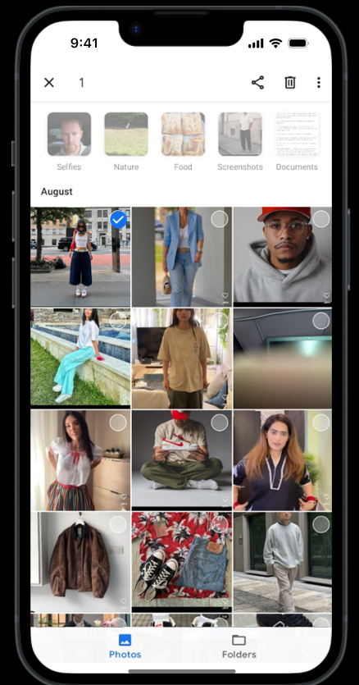

    - Screen not part of the design requirements, to show flow ONLY.
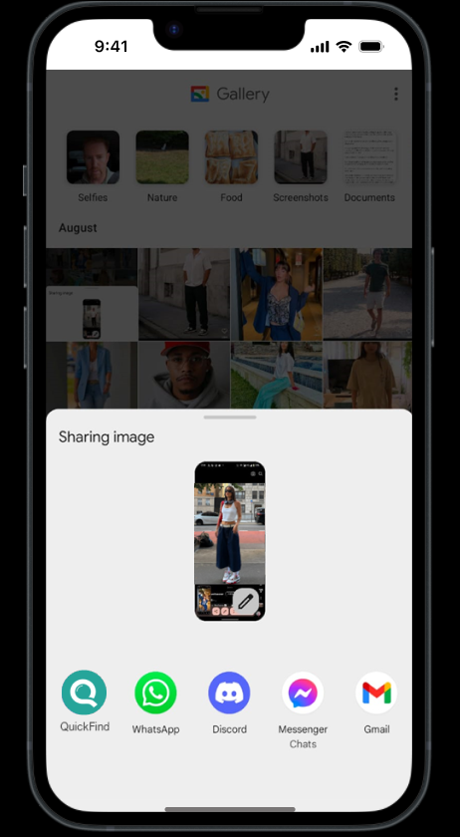

    - Part of the design requirements
    - 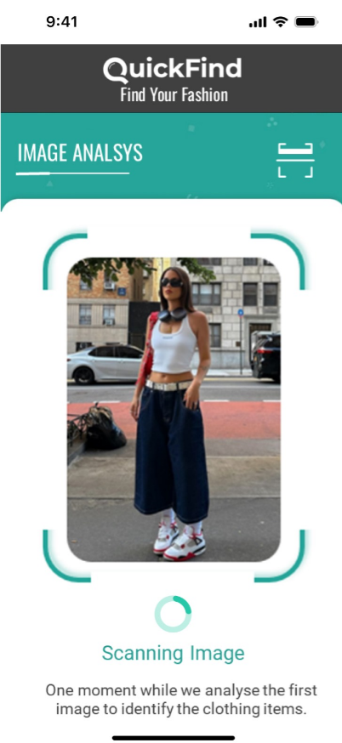

- Detect & Select Page
  - After selecting the "top" image
  - Part of the design requirements
  - ** Priority screen **
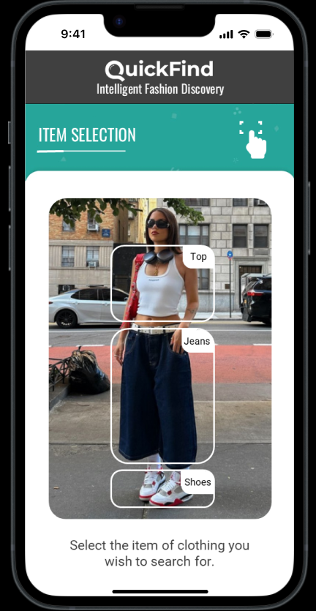

- Recommendations Page
  - Screen shot shows 4 recommendations (up to 20 possible)
  - Select the top left image
  - Part of the design requirements
  - ** Priority screen **
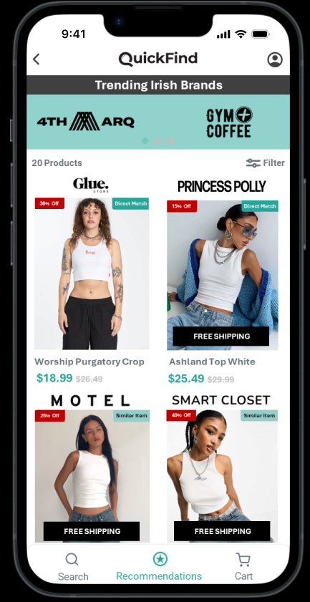

- Product Page (Main)
  - View details of the selected product
  - Add the product to cart
  - Part of the design requirements
  - ** Priority screen **
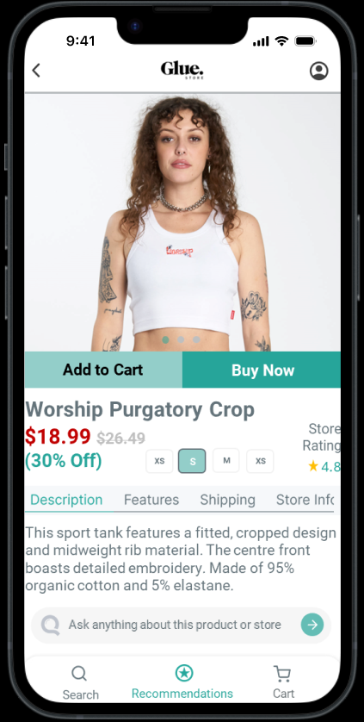

- Product Page (Chatbot Section/Interaction)
  - Select the text bar and follow this flow:
  - “Does this store offer free returns?” → green arrow
  - Add the product to cart
  - Part of the design requirements
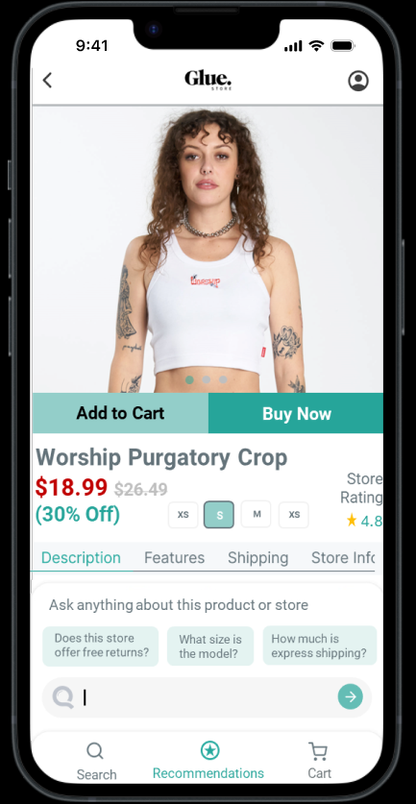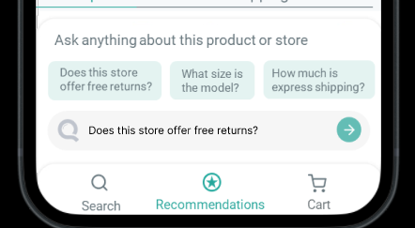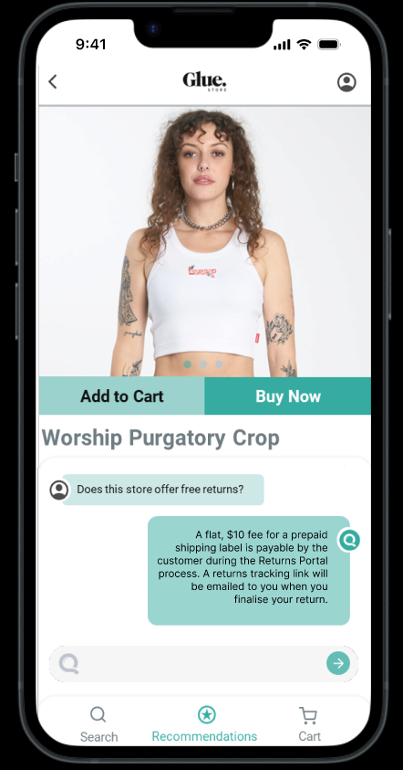

- Product Page (Error Popup)
  - Show an "Out of Stock" message after the ‘Add to Cart’ or ‘Buy Now’ is selected
  - Sample not included
  - Part of the design requirements
- Cart Page - Displays products added to the cart
  - Sample not included
  - Part of the design requirements

Deliverables:
The designs should align with the template's style, features, and UI components, with clear attention to how each page will function within the QuickFind app. The final designs are expected to be in Adobe format for smooth developer handoff.
To confirm, we are looking to see how best to utilise the template design style etc for the APP’s final design, whilst incorporating all the requirements of the APP from the requirements document.

