COME SKI OUR POWDEROY
ONLY AT ASPEN
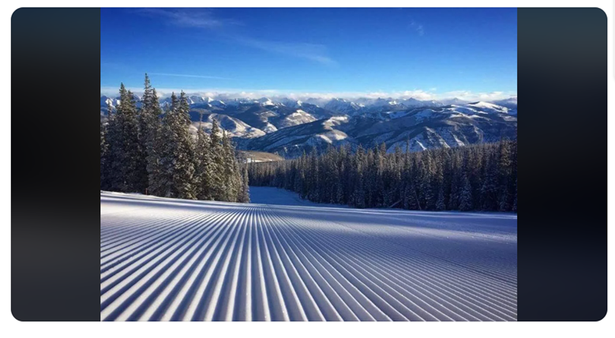

Come Ski our POWDEROY..
….Only at Aspen
