I require 3 images 1920 x 1080 pixels that should be legible on a screen if used as a powerpoint slide. Below is the content of the slides/iamges BUT I want the styling to be completely different and compliment the look and feel of the brochures and of course our logo and website at www.icttf.org

I will also upload the document I sourced these from. I will be using them in my training material so they need to be visually interesting and easy to understand

Image One: Sectors in Scope

Note: you may decide to break this into two images if you like

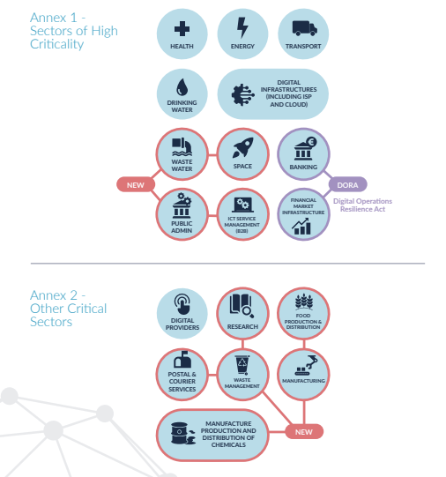
Image 2: Essential and Important Entities

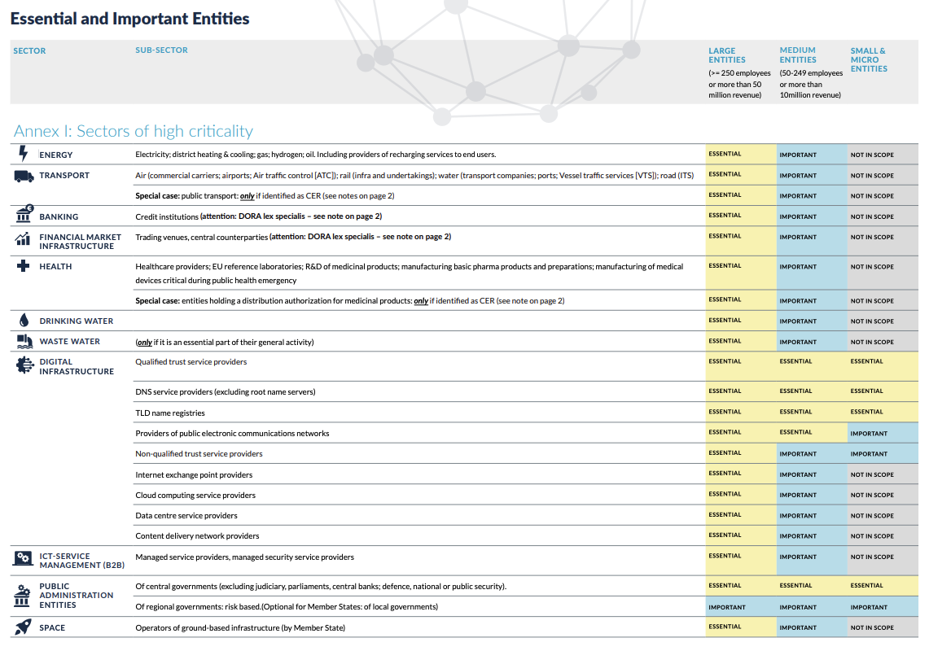

Image 3: Other Critical Sectors

