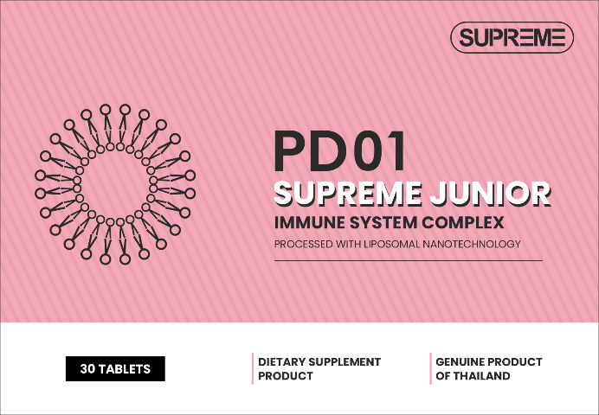 | SUPREME JUNIOR PD01  IMMUNOMODULATOR  A complex preparation consisting of vitamins and minerals, developed specifically for children to strengthen the immune system during periods of increased incidence of flu and colds. Vitamins C, D3 and E in combination with selenium, zinc and vitamin A provide complete protection of the body from various infections and support its overall health. Therefore, this drug is an excellent choice for maintaining immunity in children during periods of increased morbidity. A specially developed formula that does not contain harmful additives or allergens.

Active ingredients:
- Organic yeast selenium
- Nano-liposomal zinc
- Nano-liposomal vitamin A
- Nano-liposomal vitamin C
- Nano-liposomal vitamin D3
- Nano-liposomal vitamin E

Selenium - an antioxidant that protects body cells from damage and supports immunity. Selenium is an important trace element that helps the body fight infections and strengthen protective functions.
Zinc supports the normal functioning of the immune system and helps in the fight against infections, promotes rapid recovery of the body after illness and improves the overall health of the child.
Vitamin A strengthens the body's protective barriers and maintains the health of the skin and mucous membranes.
Vitamin C increases the body's resistance to infections and has antioxidant properties.
Vitamin D 3 helps strengthen bones and maintain immune function.
Vitamin E is an antioxidant that helps protect cells from damage caused by free radicals and supports the body's natural defenses.

Form: tasty chewable tablet weighing 1 gram, 30 tablets per pack

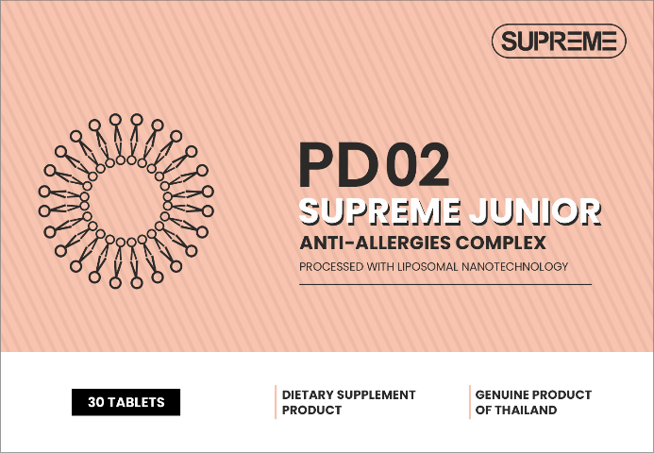 | SUPREME JUNIOR PD02  ALLERGIES  A complex preparation developed for children to reduce allergy symptoms and support the body during allergic reactions. It is recommended to take during the season of increased allergic activity or as needed to relieve symptoms. A specially developed formula that does not contain harmful additives or allergens.  A specially developed formula that does not contain harmful additives or allergens.

Active ingredients:
- Bromelain
- Nano-liposomal quercetin
- Nano-liposomal zinc
- Nano-liposomal vitamin C
- Nano-liposomal vitamin D3

Bromelain is an enzyme extracted from pineapple that helps reduce inflammation and support a healthy respiratory system. Bromelain is beneficial due to its antihistamine properties, reducing the body's reaction to allergens. It may also help relieve asthma symptoms.
Quercetin is a natural flavonoid that has anti-inflammatory and antihistamine properties that help reduce allergy symptoms.
Zinc can help reduce inflammation and itching associated with reactions to allergens, it strengthens the immune system and helps the body cope with allergic reactions.
Vitamin C strengthens the immune system and reduces histamine levels in the body, which can help reduce allergy symptoms. Additionally, vitamin C is an antioxidant that can help protect cells from exposure to allergens.
Vitamin D3 supports immune function and helps the body respond to allergens.

Form: tasty chewable tablet weighing 1 gram, 30 tablets per pack

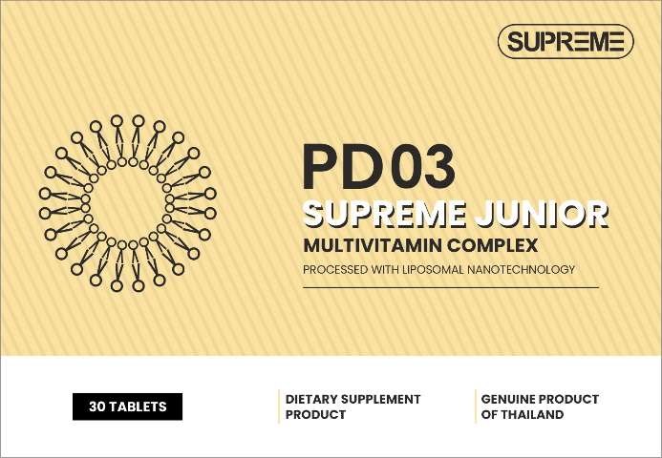 | SUPREME JUNIOR PD03  MULTIVITAMIN COMPLEX  A complex preparation designed for children to compensate for the deficiency of essential vitamins necessary for their normal growth and development. It provides the body with all the necessary vitamins, helping to prevent and eliminate vitamin deficiency. It also helps strengthen the immune system and improve the overall health of the child.  A specially developed formula that does not contain harmful additives or allergens.

Active ingredients:
- Nano-liposomal vitamin A
- Nano-liposomal vitamin B1
- Nano-liposomal vitamin B2
- Nano-liposomal vitamin B3
- Nano-liposomal vitamin B5
- Nano-liposomal vitamin B6
- Nano-liposomal vitamin B7
- Nano-liposomal vitamin B9
- Nano-liposomal vitamin B12
- Nano-liposomal vitamin C
- Nano-liposomal vitamin D 3
- Nano-liposomal vitamin E
- Nano-liposomal vitamin K2

Vitamin A supports healthy vision and immune system.
B vitamins promote the health of the nervous system and improve metabolism.
Vitamin C improves immunity and protects the body from oxidative stress.
Vitamin D3 helps strengthen bones and teeth.
Vitamin E protects cells from damage and maintains skin health.
Vitamin K2 promotes strong bones and heart health as it helps manage calcium in the body and prevents calcium deposits in blood vessels. Vitamin K2 can also boost immunity and protect the body from various infections due to its antibacterial properties.

Form: tasty chewable tablet weighing 1 gram, 30 tablets per pack

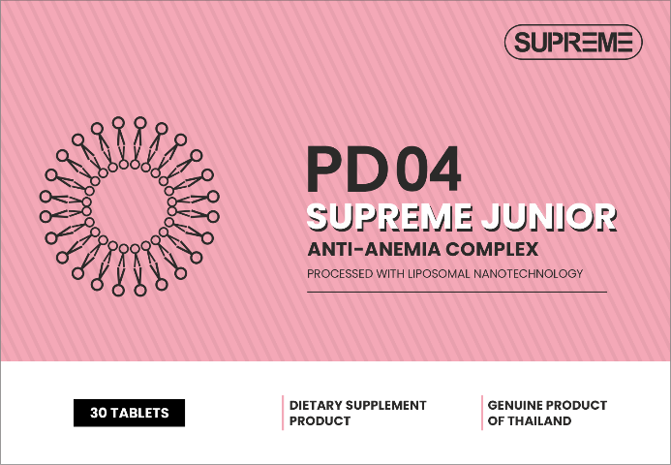 | SUPREME JUNIOR PD04  ANTI-ANEMIA COMPLEX  A complex preparation developed for the prevention and treatment of anemia. It helps maintain healthy iron levels in the body and provides essential vitamins for blood formation.  It is recommended to take daily to prevent or treat anemia, especially during periods of rapid growth or increased iron requirements.  A specially developed formula that does not contain harmful additives or allergens.
Active ingredients:
- Nano-liposomal iron -III
- Micronized glycine
- Nano-liposomal vitamin B 9
- Nano-liposomal vitamin B 12
- Nano-liposomal vitamin C

Iron is a key element for the production of hemoglobin, which transports oxygen throughout the body. Lack of iron can lead to anemia, which causes fatigue, weakness and other serious health problems.
Glycine is an amino acid that improves the absorption of iron and maintains the general condition of the body. Glycine also plays an important role in the synthesis of hemoglobin, which promotes more efficient oxygen consumption.
Vitamin B 9 (folic acid) and B12 participate in the production of red blood cells and support the nervous system. A lack of these vitamins causes the body to produce abnormally large red blood cells that cannot function normally. This condition is known as megaloblastic anemia and can lead to symptoms such as fatigue, weakness and shortness of breath, but can also lead to more serious complications such as nerve damage.
Vitamin C increases iron absorption and supports the immune system. If there is a lack of vitamin C in the body, there may be a problem with the absorption of iron, which can lead to the development of anemia. Therefore, it is important to consider the sources of both iron and vitamin C in your diet.

Form: tasty chewable tablet weighing 1 gram, 30 tablets per pack

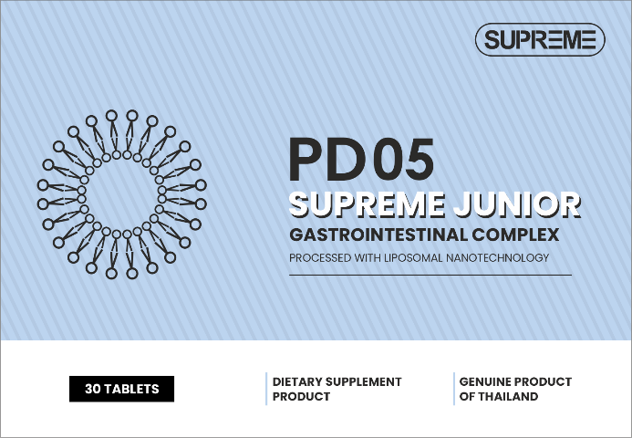 | SUPREME JUNIOR PD05  DIARRHEA AND FOOD POISONING  A complex preparation designed for the quick and effective treatment of diarrhea and food poisoning. The product helps restore intestinal microflora and help the body cope with illness faster. It is recommended to take it at the first symptoms of diarrhea or food poisoning, as well as to restore intestinal microflora after illness.  A specially developed formula that does not contain harmful additives or allergens.
Active ingredients:
  - Prebiotics
  - Probiotics​
  - Postbiotics
  - Parabiotics
  - Nano-liposomal berberine
  - Nano-liposomal ginger
  - Nano-liposomal zinc
  - Nano-liposomal vitamin D3

Prebiotics are food components that promote the growth of beneficial bacteria in the intestines. They help improve digestion, support the immune system, and reduce inflammation in the body.
Probiotics contain live microorganisms that improve digestion and immunity. Probiotics can also help restore the balance of microflora after taking antibiotics or gastrointestinal diseases.
Postbiotics are metabolic products of microorganisms that have a positive effect on health. Postbiotics may also be useful in the treatment of various diseases such as allergies and chronic inflammation.
Parabiotics are products containing components of microorganisms that can help restore and maintain the balance of microflora. Parabiotics also help strengthen the immune system and overall health of the body.
Berberine is a natural antibiotic that helps fight infections and inflammation.
Ginger helps improve digestion and immunity, and also has anti-inflammatory properties.
Zinc may help reduce the duration and severity of symptoms as it plays an important role in the immune system. Zinc also promotes healing of the intestinal mucosa, accelerating the healing process.
Vitamin D3 helps strengthen children's immunity for a quick recovery. Vitamin D3 also helps normalize calcium levels in the body, which is especially important in case of food poisoning.

Form: tasty chewable tablet weighing 1 gram, 30 tablets per pack

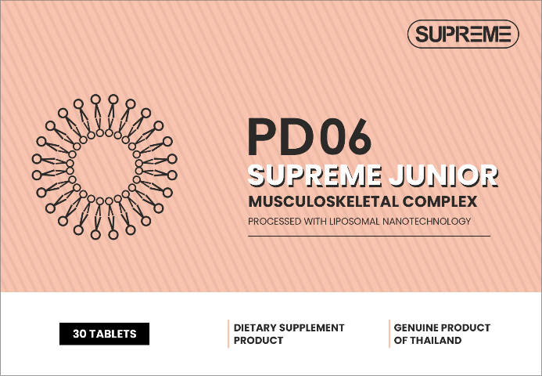 | SUPREME JUNIOR PD06  HEALTHY BONES COMPLEX  A complex preparation specially designed to support bone health and promote the development of the child's musculoskeletal system. Contains important vitamins and minerals necessary for the growth and development of children. It has a pleasant taste, which makes its use more attractive for children. Does not contain artificial additives or allergens. Recommended for children of all ages, especially during periods of active growth.  A specially developed formula that does not contain harmful additives or allergens.
Active ingredients:
- Micronized calcium
- Nano-liposomal iron -III
- Nano-liposomal vitamin D3
- Nano-liposomal vitamin K2
- Whey protein

Calcium is a key element for strengthening bone tissue and teeth, maintaining skeletal health.
Iron promotes oxygen delivery to cells and maintains overall health, which is important for growth.
Vitamin D3 increases calcium absorption and strengthens bones, promoting healthy growth.
Vitamin K2 is necessary for the proper distribution of calcium in the body and strengthening bones, and plays a key role in the process of mineralization of bone tissue.
Whey protein provides the body with the amino acids needed for healthy bones and muscles.

Form: tasty chewable tablet weighing 1 gram, 30 tablets per pack

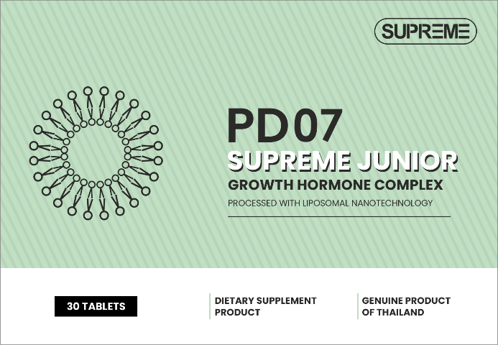 | SUPREME JUNIOR PD07  GROWTH HORMONE COMPLEX  A complex preparation designed to stimulate the production of growth hormone, helping to increase height and develop muscle mass. The product contains amino acids and minerals that play a key role in the process of growth and development. It is recommended to take daily to support muscle growth and development, especially during periods of active growth.  A specially developed formula that does not contain harmful additives or allergens.
Active ingredients:
- Micronized arginine
- Micronized glutamine
- Nano-liposomal zinc
- Nano-liposomal vitamin D3
- Whey protein

Arginine is an amino acid that stimulates the production of growth hormone and supports muscle growth.
Glutamine promotes tissue repair and supports the immune system, important for active growth.
Zinc supports normal growth and development of the body, participates in the synthesis of proteins and DNA.
Vitamin D3 promotes the absorption of calcium and phosphorus, strengthens bones and supports healthy skeletal development.
Whey protein is an important component of this product, providing the body with essential nutrients for optimal growth.

Form: tasty chewable tablet weighing 1 gram, 30 tablets per pack

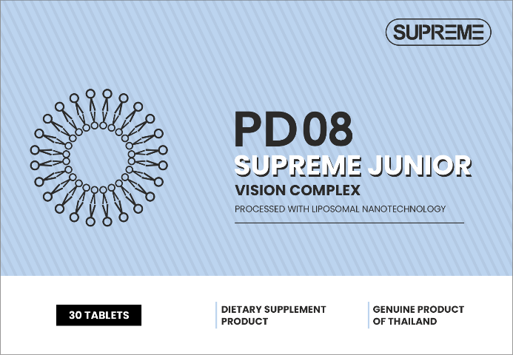 | SUPREME JUNIOR PD08  VISION COMPLEX  A complex preparation specially designed to protect the eyes from fatigue and strain caused by prolonged use of electronic devices. The product contains important vitamins and minerals that support eye health.  A specially developed formula that does not contain harmful additives or allergens.
Active ingredients:
- Nano-liposomal vitamin A
- Micronized taurine
- Nano-liposomal zinc
- Nano-liposomal vitamin C
- Nano-liposomal vitamin E

Vitamin A supports retinal health and improves vision in low light. This vitamin also helps protect the eyes from the harmful effects of ultraviolet rays, which helps prevent the occurrence of various eye diseases.
Taurine is an amino acid that supports the function of retinal cells and protects the eyes from damage. Taurine may help improve blood circulation in the eyes and reduce the risk of various eye diseases. In addition, taurine helps protect the eyes from free radicals and reduces the likelihood of degenerative changes.
Zinc helps maintain retinal health and improves visual function. Zinc plays an important role in protecting the eyes from free radicals and helps maintain good vision. A lack of zinc can lead to various vision problems, especially at an early age.
Vitamin C is an antioxidant that protects the eyes from oxidative stress and supports vascular health. A deficiency of this vitamin can lead to various eye diseases such as cataracts or retinal degeneration.
Vitamin E protects eye cells from damage caused by free radicals. It helps strengthen the blood vessels of the fundus and prevent possible vision problems. Also helps protect eyes from harmful ultraviolet rays.

Form: tasty chewable tablet weighing 1 gram, 30 tablets per pack

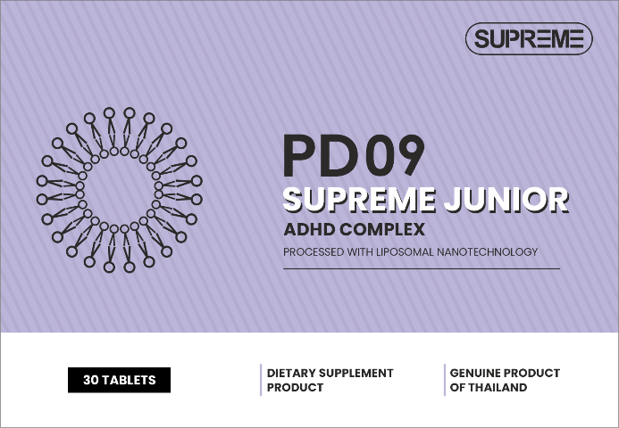 | SUPREME JUNIOR PD09  ATTENTION DEFICIT HYPERACTIVITY SYNDROME (ADHD)  A complex preparation designed to improve concentration and reduce symptoms of hyperactivity. The product helps reduce symptoms of hyperactivity, increase focus and improve behavioral control.  A specially developed formula that does not contain harmful additives or allergens.
Active ingredients:
- Nano-liposomal iron-III
- Nano-liposomal zinc
- Nano-liposomal magnesium
- Nano-liposomal gamma-aminobutyric acid (GABA)

Iron is an important element for cognitive development and maintenance of nervous system function. Iron is necessary for the production of hemoglobin, which is responsible for transporting oxygen throughout the body. Lack of iron can lead to anemia and poor memory and concentration.
Zinc promotes normal functioning of the brain and nervous system, improves cognitive function.
Magnesium reduces anxiety, improves sleep and promotes muscle relaxation, which is important for controlling hyperactivity. Magnesium is also involved in the regulation of the nervous system and helps reduce stress levels. Its deficiency can lead to irritability and nervousness.
Gamma-aminobutyric acid (GABA) is a neurotransmitter that calms the nervous system, reduces anxiety and improves focus.

Form: tasty chewable tablet weighing 1 gram, 30 tablets per pack

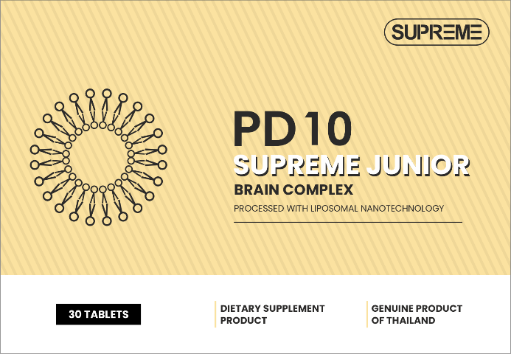 | SUPREME JUNIOR PD10  BRAIN DEVELOPMENT COMPLEX  A complex preparation designed to improve memory, learning skills and concentration. Contains amino acids and vitamins that support cognitive function and promote mental development.  A specially developed formula that does not contain harmful additives or allergens.
Active ingredients:
- Micronized glycine
- Micronized choline
- Nano-liposomal resveratrol
- Nano-liposomal vitamin B9
- Nano-liposomal vitamin B12
- Nano-liposomal vitamin E

Glycine is an amino acid that improves memory, promotes relaxation and reduces stress levels.
Choline helps improve brain function and develop cognitive functions such as memory and attention. Choline is also necessary for the synthesis of acetylcholine, which is an important neurotransmitter involved in the transmission of nerve impulses. Acetylcholine plays a key role in the processes of learning and remembering information.
Resveratrol is and an antioxidant that protects brain cells and improves blood circulation, which is important for cognitive functions. Research shows that resveratrol can reduce inflammation and improve blood circulation in the brain.
Vitamin B9 (folic acid) participates in DNA synthesis and supports normal brain function.
Vitamin B12 promotes the health of the nervous system and improves memory. It plays an important role in the formation of myelin sheaths on nerve cells, which helps improve memory and concentration. A lack of this vitamin can lead to decreased cognitive function and the development of neurological problems.
Vitamin E is a powerful antioxidant that helps protect cells from damage and improves blood flow to the brain. This vitamin also helps improve memory and concentration, making it an important element for maintaining brain health.

Form: tasty chewable tablet weighing 1 gram, 30 tablets per pack

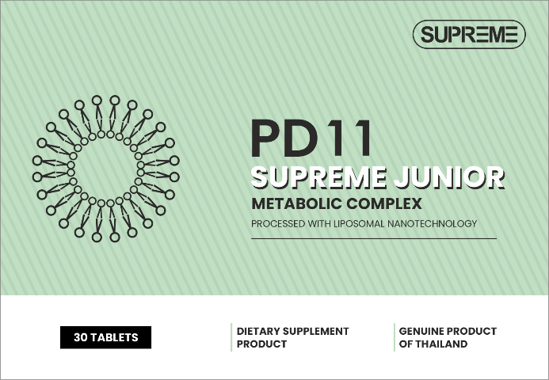 | SUPREME JUNIOR PD11  EXTRA WEIGHT COMPLEX  A complex preparation designed to support weight control and prevent obesity. Contains components that help regulate appetite and promote weight loss.  A specially developed formula that does not contain harmful additives or allergens.
Active ingredients:
- Nano-liposomal chromium
- Glucomannan
- Cocoa bean polyphenols

Chromium is a mineral, which helps regulate blood sugar levels, improves carbohydrate metabolism and reduces sugar cravings. Chromium also improves insulin function and may help lower blood cholesterol levels. Chromium deficiency can lead to metabolic problems and an increased risk of diabetes.
Glucomannan is a dietary fiber derived from konjac root that promotes satiety, slows digestion and helps control appetite. Glucomannan may also be helpful in lowering blood cholesterol and improving gut health due to its prebiotic properties.
Cocoa polyphenols may help reduce inflammation in the body and improve feelings of fullness, which helps control appetite. They can also increase feelings of energy and improve metabolism.

Form: tasty chewable tablet weighing 1 gram, 30 tablets per pack

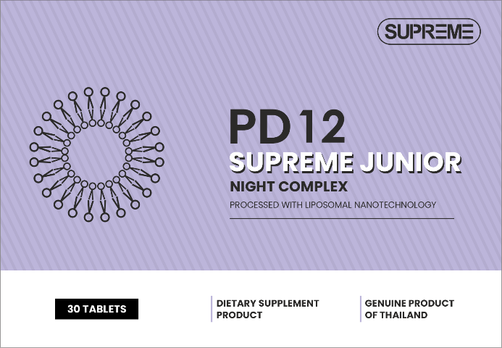 | SUPREME JUNIOR PD12  SLEEP DISORDERS COMPLEX  A complex preparation designed to support healthy sleep and help combat insomnia. Contains natural ingredients that help relax and improve sleep quality. The product promotes relaxation and reduces anxiety, which is important for good sleep. The formula is specially designed for children, does not contain artificial additives, is easily absorbed by the body and is not addictive.  A specially developed formula that does not contain harmful additives or allergens.
Active ingredients:
- Natural melatonin
- Micronized theanine
- Nano-liposomal gamma-aminobutyric acid (GABA)

Melatonin is a hormone, which regulates the sleep-wake cycle, helps you fall asleep faster and improves sleep quality. It is produced in the pineal gland and its levels in the body rise in the dark, signaling the body to prepare for sleep. Melatonin also has antioxidant properties and can help combat stress and anxiety, improving a child's overall well-being.
Theanine is the amino acid contained in green tea, which promotes relaxation, reduces stress levels and helps improve mood. Theanine and sleep have a close connection, as this component helps improve sleep quality and helps fight insomnia. Consuming theanine before bed may promote deeper, more restful sleep.
Gamma-aminobutyric acid (GABA) is a neurotransmitter that calms the nervous system, reduces anxiety and promotes relaxation. GABA also plays an important role in regulating muscle tone and sleep. A lack of GABA may be associated with insomnia, anxiety, or depression. Therefore, it is important to maintain normal levels of this neurotransmitter for the health and well-being of the child.

Form: tasty chewable tablet weighing 1 gram, 30 tablets per pack

