
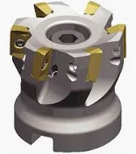
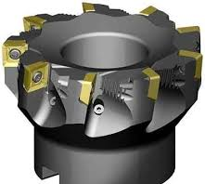

Face milling cutters. Rotate so the cutting end is a circle- the outline of the logo. Gold teeth.

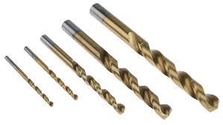
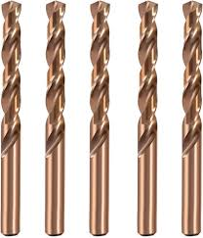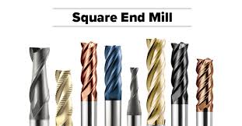
Then on top of that background, in the center make a TTM, with the 2 T’s over the M. Make the letters out of end mills and/ or drills with bright colors.
T T
M

Kind of like this:
(but much better)

