Logo Desing Guide – Visemus Migration

Guide 1
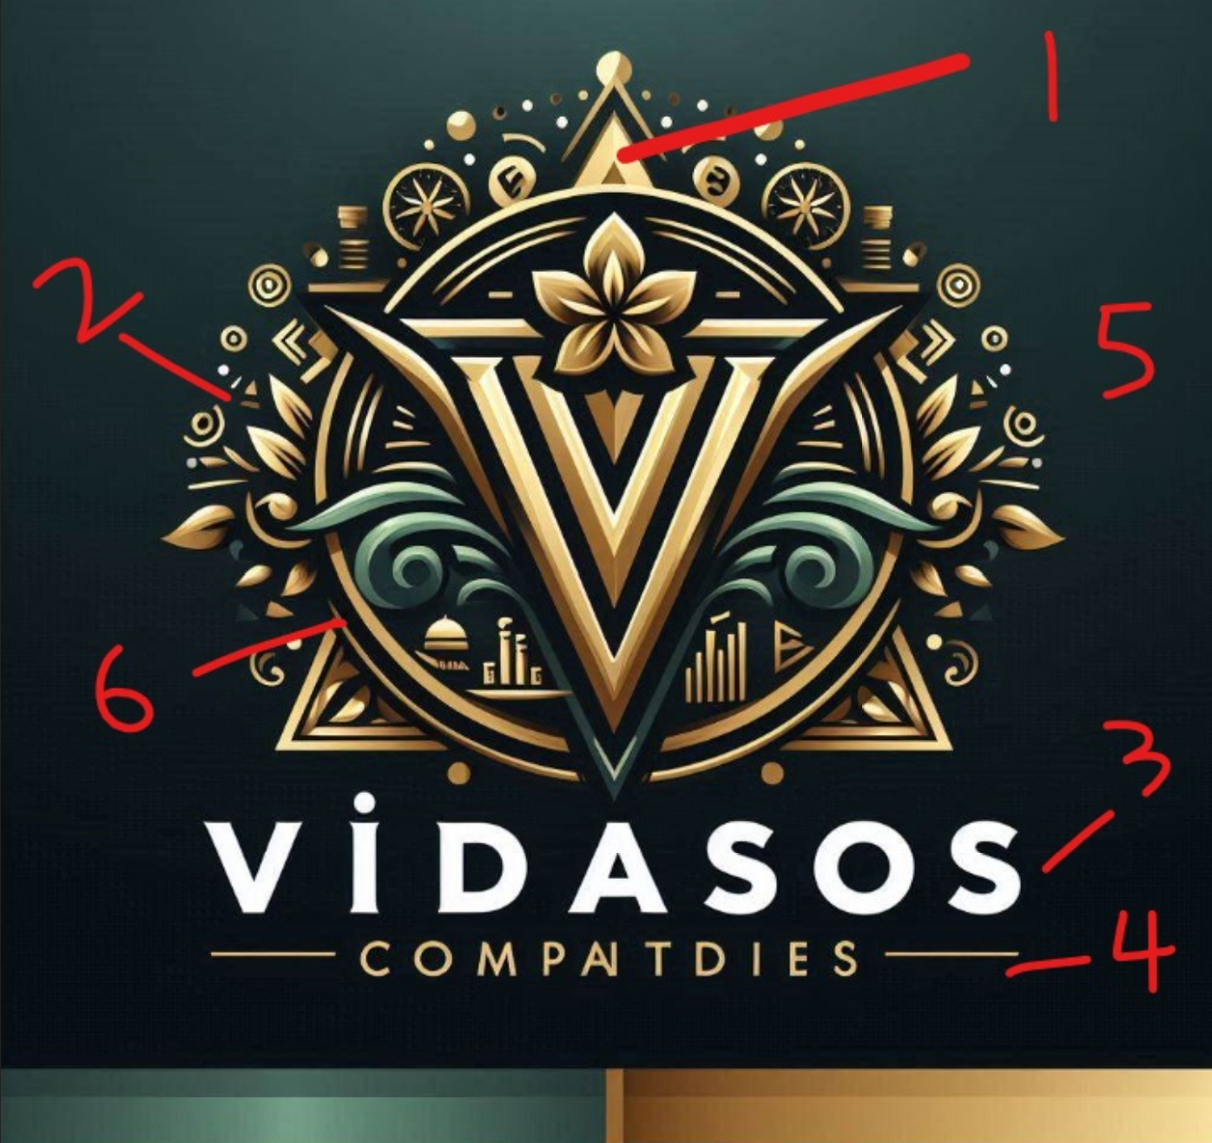
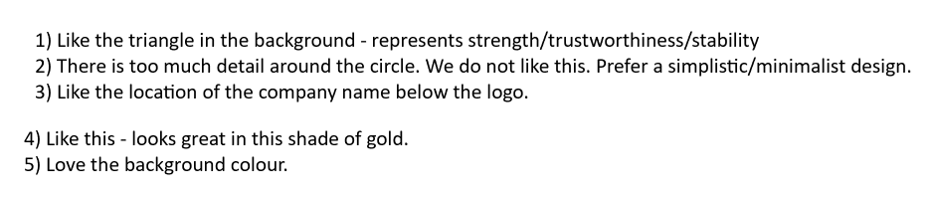

Guide 2
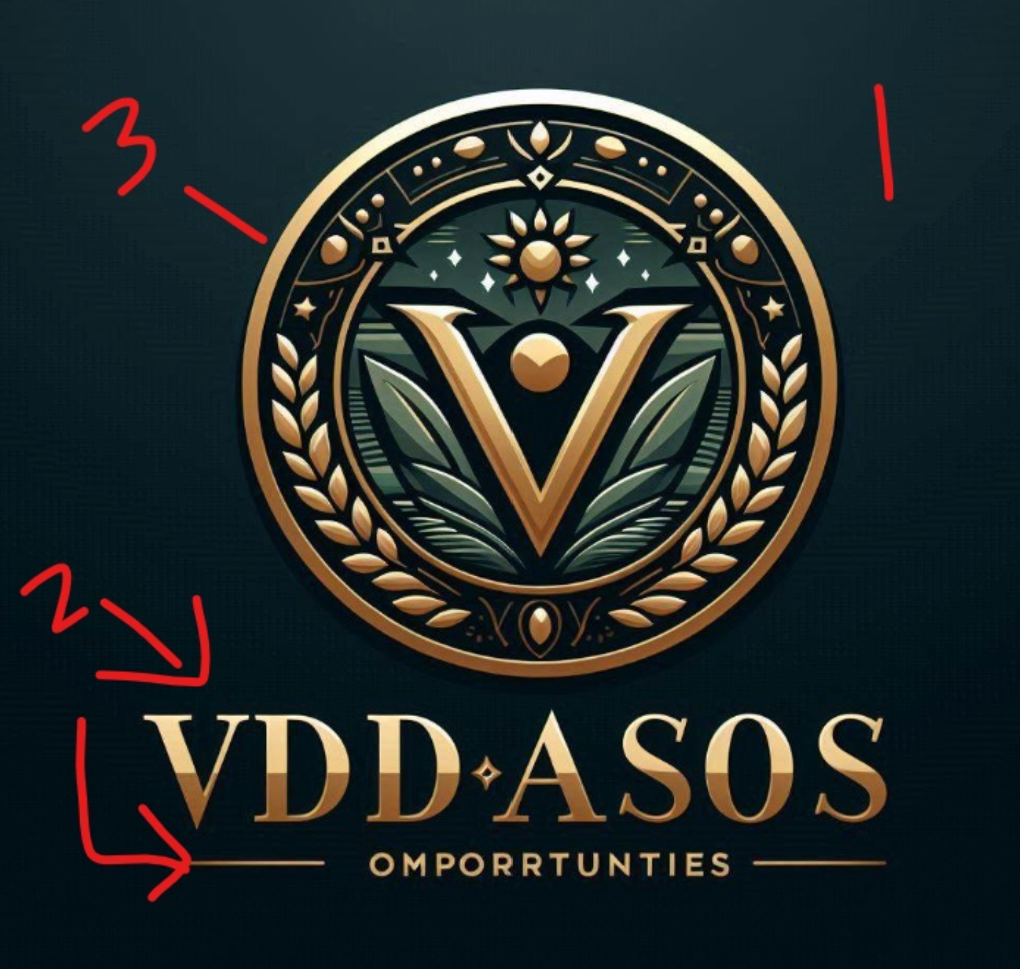

- Like the background colour
- Like the setting of the Business name and style below the logo
- Like the gold/bronze circle

Guide 3 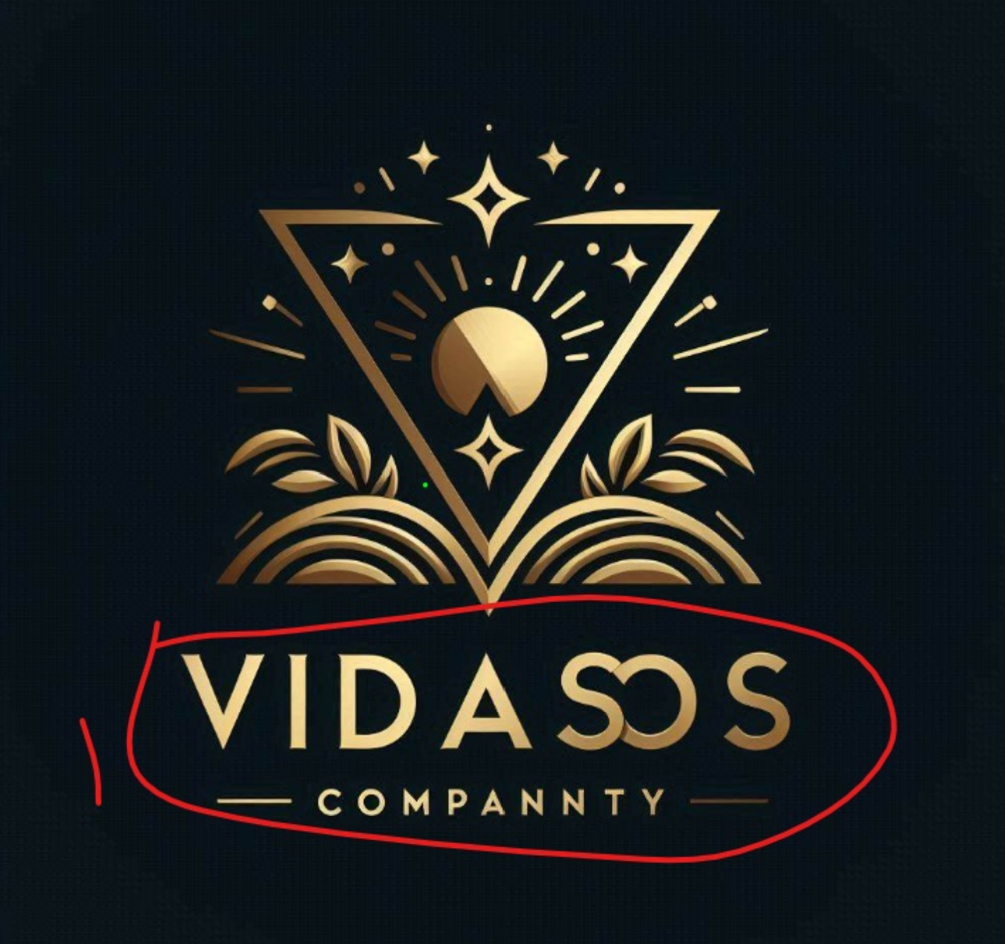
- Like the colour and style of the business name and its location
- Like how this logo is simple, elegant and has artistic flair. It is simple as it does not have too much designs. Yet it also has artistic flair as it shows some personality and creativity.

Additional information
- Must incorporate some aboriginal art into the gold/bronze circle of logo. See the circled items in red below – things we would like incorporated into logo (running water (several), emu, kangaroo tracks, campsite waterhole (several), meeting place.
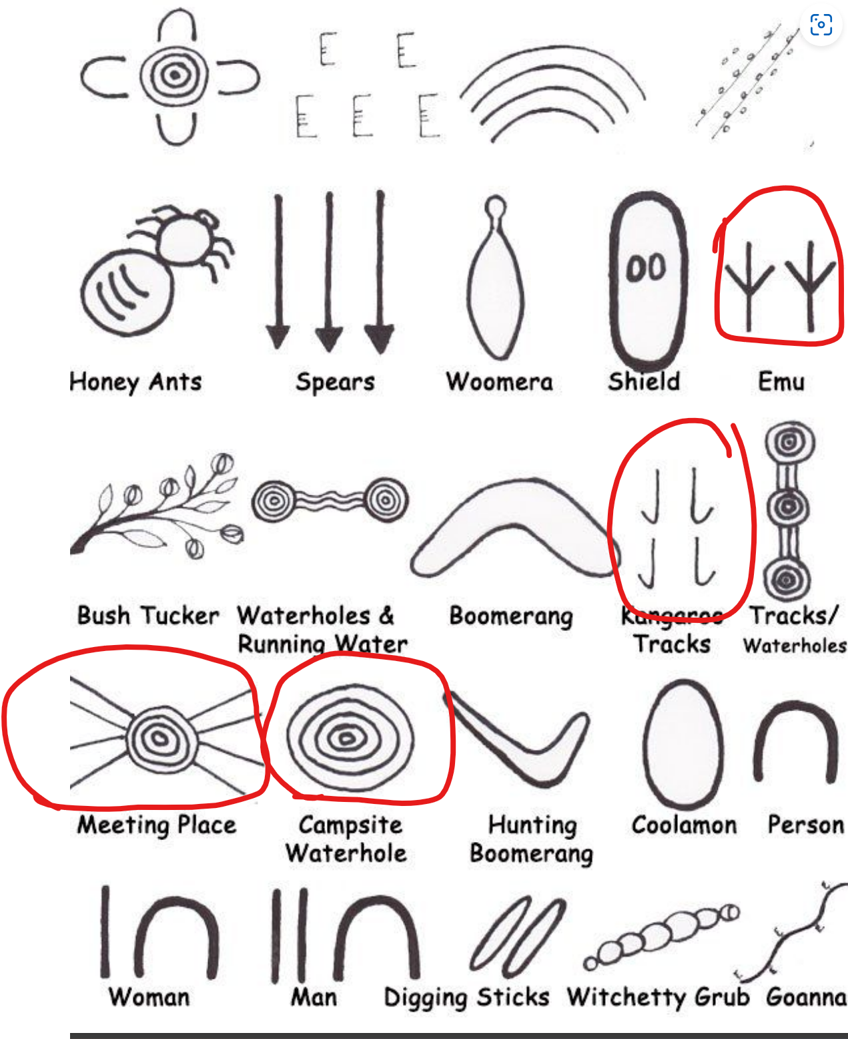

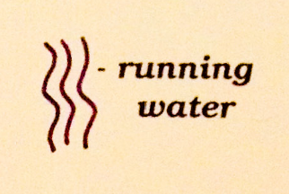

End of guide.

