SAiS Digital Rebranding
These are great designs, looking forward to the breakdown of the actual logo highlighting its description of graphical representations, typography and color schemes.

Figure 1:
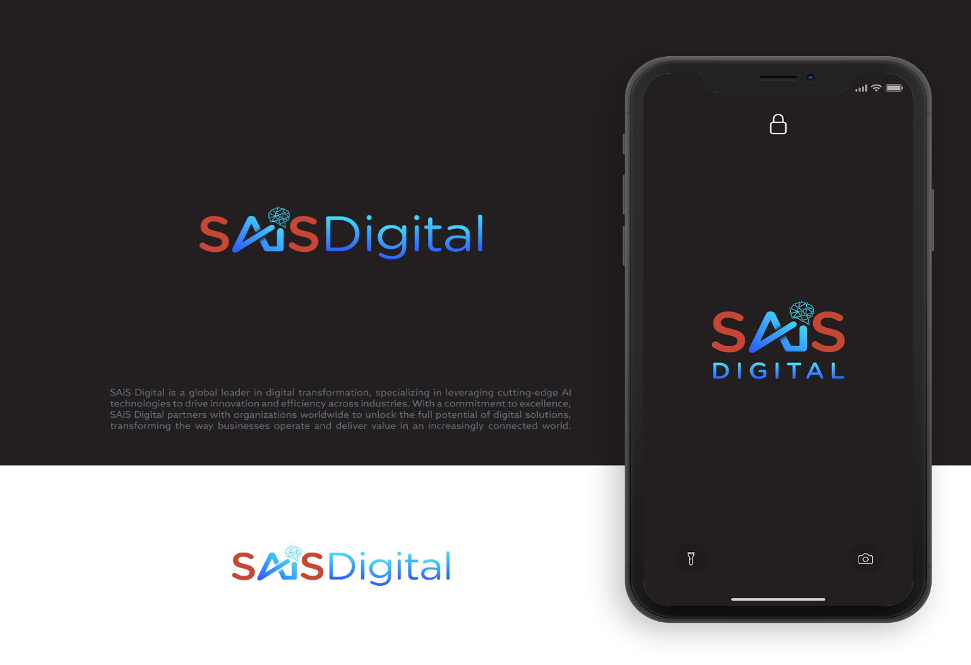

Figure 2:
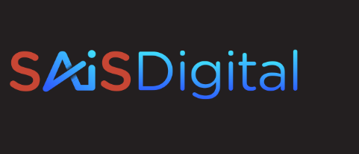

Figure 3:
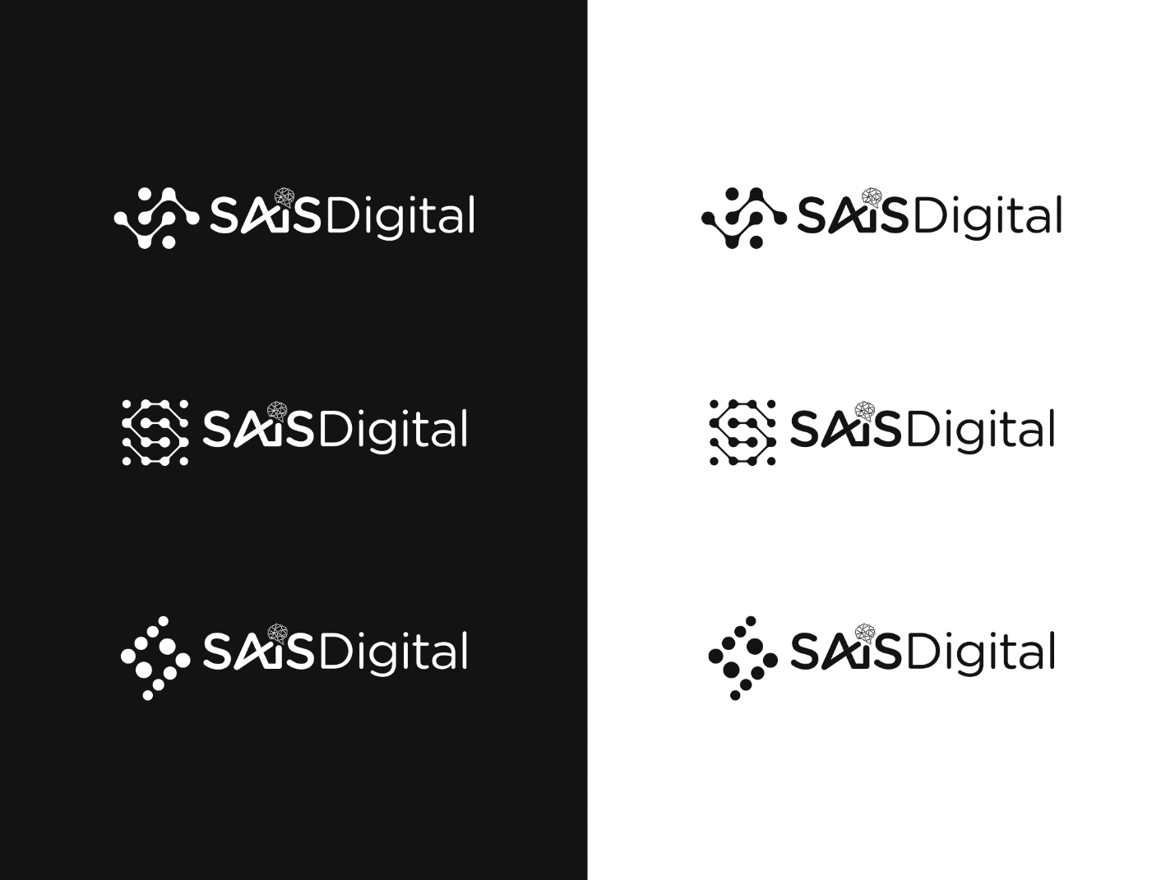

Logo review
The designs below are my final two, as variations of each other depending on usage.
- Colour Combination: We opt as per Figure 1.

- Ai icon used on the company name has clustered detail (from a UX/UI perspective; one has to zoom in to appreciate the detail, it also borderlines a flower representation), my recommendation is that we explore a simialr design with a simpler pattern.

- We also want to keep another option as Figure 2, to avoid stitching challenges.

- Side Icon: We opt for the one Figure 3. However, please provide two sizes of side icon to match the sizes for a) SAiS Digital in single line b) SAiS and Digital are in two separate lines as per Figure 1.
Rebranding Activities
Please provide detailed Brand Manual with brand Mascot or Character
Expectations: Logo, Trademarks,Typography, Color scheme, Tone, Character and Brand collateral mockups.

